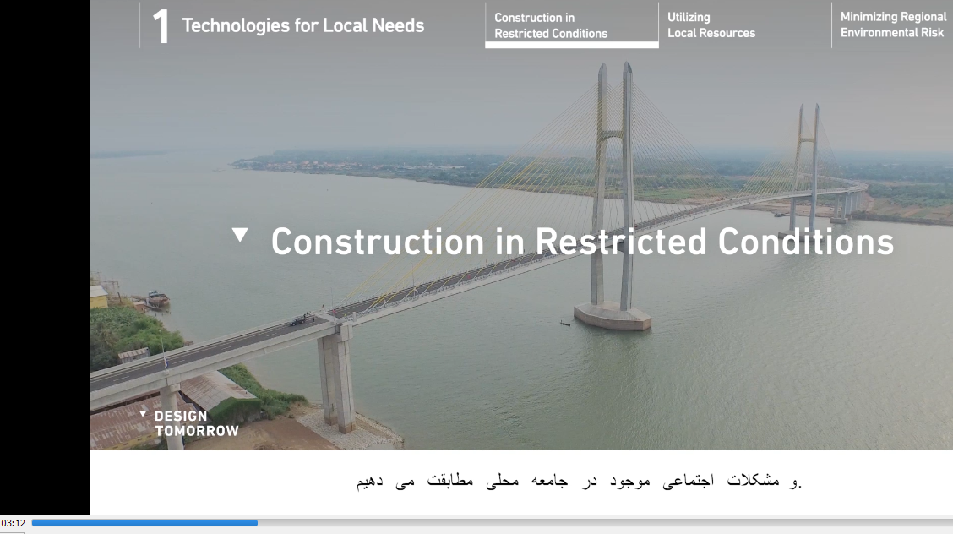
This subtitle should be as “ساخت وسازدرمحیط های سخت
“

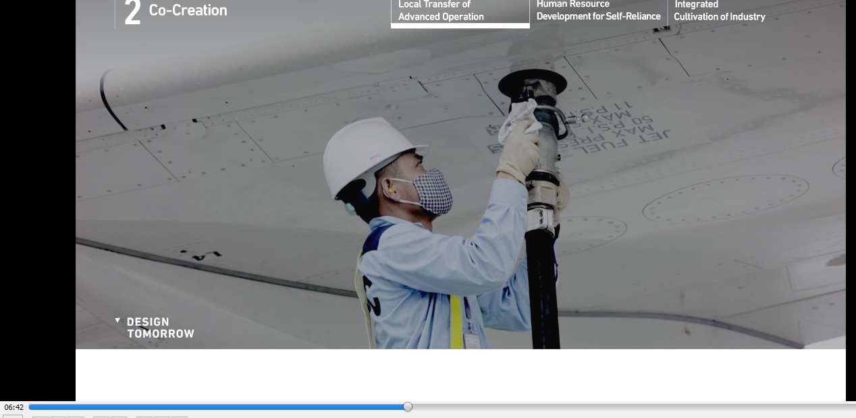

No subtitle here .

