The features of the integrated diagnostics of the discs of gas turbines of gas-compressor units using eddy-current and dye-penetrant testing are considered. The effectiveness of the detection of the crack-type defects in HPT and LPT discs under the first tooth of the fir-tree slots of the discs along the contact line of the teeth of the comb and blade butt are demonstrated. The calculations of the stress–strain state allowed the estimation of the occurrence of cracks in the fir-tree slots of discs, as well as the service life of discs up to crack formation at extraordinary operating temperatures. Integrated quality control by eddy-current and color capillary nondestructive testing provides reliable crack detection in details without serious costs for mechanical preparation of items for inspection along with a substantial reduction of the labor-intensiveness and depth of the inspection.

Quality Control on a Large Scale: testing of large-scale gas turbine components
13 November 2015 - Gas turbines with dimensions of up to 13 meters in length, 5 meters in height and weighing up to 400 tons: components of this magnitude are the core business of the Siemens factory in Berlin-Moabit. From here, the high-tech components are delivered to power plants around the world where they must meet the highest requirements. Extremely high combustion temperatures, large centrifugal forces as well as vibrations and transient loads – the gas turbines are exposed to highly demanding operating conditions.
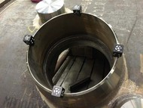

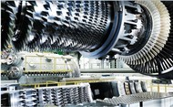

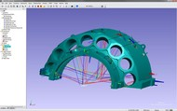
© Image: Siemens
Exact dimensional accuracy is therefore of prime importance in the production of gas turbines and their components. Steel components must be machined evenly in order to ensure maximum stability. The data for the CAD comparison is obtained with AICONs MoveInspect DPA.
The path to sustainable energy systems leads through electric power, creating the need for innovative technologies. With its innovative products, solutions and services, as well as unique global expertise on the energy market, Siemens supplies answers to address these challenges for the entire energy system.
The Siemens portfolio of power plant gas turbine is perfectly tailored to the challenges of a dynamic market environment. The models with a capacity of 4 to 400 MW meet the stringent requirements of a wide range of applications and ensure efficiency, reliability, flexibility and environmental compatibility, low life-cycle cost and high profitability.
The steel construction parts are mainly machined mechanically and by joining technique in the gas turbine factory in Berlin. The question arises during the machining process: Is there enough raw material to be removed at all points to be processed? To find out, the actual situation must be compared with the CAD data. The data are obtained with AICONs MoveInspect DPA that works with a hand-held digital camera as recording sensor and the fully automatic image processing software AICON 3D Studio.

Quality Control on a Large Scale

Siemens is testing large-scale gas turbine components with AICON's photogrammetry MoveInspect DPA
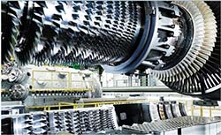© Images: Siemens
Gas turbines with dimensions of up to 13 meters in length, 5 meters in height and weighing up to 400 tons: components of this magnitude are the core business of the Siemens factory in Berlin-Moabit. From here, the high-tech components are delivered to power plants around the world where they must meet the highest requirements. Extremely high combustion temperatures, large centrifugal forces as well as vibrations and transient loads - the gas turbines are exposed to highly demanding operating conditions. Exact dimensional accuracy is therefore of prime importance in the production of gas turbines and their components. Steel components must be machined evenly in order to ensure maximum stability. The data for the CAD comparison is obtained with AICON's MoveInspect DPA.

Energy efficiency as success factor
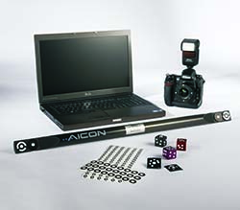
The path to sustainable energy systems leads through electric power, creating the need for innovative technologies. With its innovative products, solutions and services, as well as unique global expertise on the energy market, Siemens supplies answers to address these challenges for the entire energy system.
The Siemens portfolio of power plant gas turbine is perfectly tailored to the challenges of a dynamic market environment. The models with a capacity of 4 to 400 MW meet the stringent requirements of a wide range of applications and ensure efficiency, reliability, flexibility and environmental compatibility, low life-cycle cost and high profitability.

Individualized measurement for demanding tasks
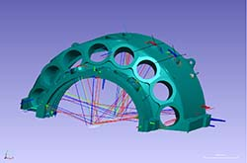© Images: Siemens
The steel construction parts are mainly machined mechanically and by joining technique in the gas turbine factory in Berlin. The question arises during the machining process: Is there enough raw material to be removed at all points to be processed? To find out, the actual situation must be compared with the CAD data. The data are obtained with AICONs photogrammetry system MoveInspect DPA that works with a hand-held digital camera as recording sensor and the fully automatic image processing software AICON 3D Studio. First, the steel component is signalized with individualized, coded targets or measuring adapters at relevant points. The object is photographed from different directions with the digital camera, so that all significant areas are captured. Working with coded targets allows trouble-free automation of evaluation because the position of each point on the component is predefined. Each user can define this process individually.
The coordinates detected are automatically compared with the CAD in the SpatialAnalyzer in order to control the basic quality of the raw cast parts, such as the dimension and position of openings and flanges. The measurement is also used to determine the optimum machining position (split joint marking). This achieves enormous time and cost savings! After evaluating, the employee transfers the recorded values ​​for the split joint marking to the component. To this end, it works according to an approach developed by Siemens. Using the coded targets, the split joint is marked via distance intersection and a tangential line.
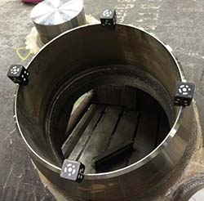© Images: Siemens
Siemens uses two special features of the AICON software: The "Adapter" module allows the user to independently create specific adapters and measure them using the AICON software. Siemens has developed its own adapter for edges and split joints. The coded target on the component fixes their position. The CodeMaker module also allows the user to create own targets. Each specific adapter and each target can be labeled according to the task (e.g. split joint).
An individual measuring instruction is created for each component. This contains information about the positioning of the component, drawings to be used, protocols and CAD models and the position of the targets. The use of "personalized" targets and adapters enable a high degree of automated analysis.

A forward-looking solution
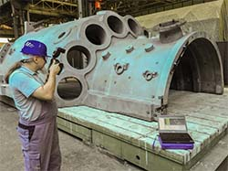© Images: Siemens
In the past, Siemens used laser trackers for this measurement task. However, such systems must be repositioned during the measurement at least five times in order to detect all relevant measurement points. This large expenditure of time is significantly reduced with a photogrammetry system. The DPA is hand-held, does not require any fixed positions and is insensitive to vibrations and shocks.
Siemens chose AICON's measuring system over that of competitors in the field of industrial photogrammetry. Bernhard Gauger, Quality Management staff member in the area of ​​special measuring technology, was impressed by the performance of the DPA and supported the decision: "We wanted photogrammetry to replace conventional measurement methods for quality control and the creation of split joint marks. Our aim was higher accuracy at a reduced workload. This goal has been met by AICON's DPA. Another advantage: The mobility of the system permits process qualification and quality control at the suppliers' premises."
AICON's DPA is a tried-and-tested system that has proven its worth over many years in a variety of measuring tasks and companies. Thanks to the modular design of MoveInspect Technology, the system can be tailored to the individual measurement tasks of a company by means of add-ons. A universal solution!

