CMS-MS uses custom tags to extend the functionality of Smarty. You can make references to and employ custom tags within templates. Not only does this process save a lot of time, it also removes the need to employ inline PHP or add new functions directly to the codebase. Obviously, having a custom tags mechanism such as this will probably not matter much to the end user, but for a developer building a website from scratch, extending CMS Made Simple can be really, well, simple!

The Disadvantages
CMS Made Simple has ‘simplified’ the concept of website creation — which, by all means, is a wonderful thing. You can have custom tags and modules to extend the software in whichever manner you see fit.
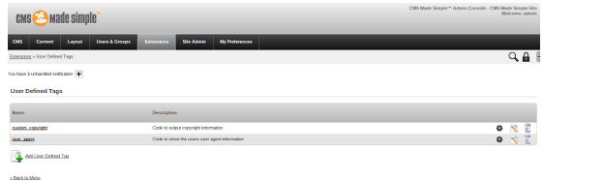
This is where a drawback surfaces. In certain areas, CMS-MS seems to have overdone the concept of custom modules and tags. Take a look at the inclusion of a blog in a website, for example. In most genres of websites — corporate, portfolio, et al — a blog often forms a vital component of the overall site. CMS-MS can accomplish the creation of a blog, but you will need to turn towards custom modules (unless all you want is a chronological appearance of articles). This beats the purpose of modules and templates: instead of saving efforts, a developer might just end up repeatedly turning to third party modules for additional functionality, simply because it is missing from the CMS’s core. Event calendars and image galleries too are available as modules — with the advent of HTML5, such features belong in the central core.
Furthermore, the integration of modules with CMS-MS often leaves a bitter taste. Agreed, CMS Made Simple has enhanced its agility and speed of operation by offloading a good section of features to modules and plugins; but the absence of certain core features is also hindering CMS Made Simple from projecting itself as a viable CMS for a wide genre of websites. Beyond that, it must also be mentioned that most of the time, the module developers are not the same people as the core developers; this leads to even poorer integration, followed by issues and at times, inconsistency of code and functionality.
عملکرد مید سمپل
CMS Made Simple has three different ways of adding PHP code to the system: Plugins, User Defined
Tags, and Modules.
•
Plugins are a single file located in the 'plugins' directory of CMSMS and usually perform a
single task—either displaying data, or reformatting it. Plugins typically never write data
anywhere, and, in a good design, should not.
These are true Smarty plugins, and can either be function plugins, block plugins, modifiers, or
compiler plugins.
Examples of plugins are the {title} and {description} plugins that are shipped with CMSMS
that output the title and description fields, respectively, of the current content page
User Defined Tags (UDT's) are Smarty plugins that are stored in the database. Again, they are
normally small and perform a single task. CMSMS provides an interface in the admin console
to create and manage UDTs.
UDTs are implemented as Smarty function plugins so that they can be called within a template.
Within CMSMS, UDTs can also be used as event handlers.
Other than auditing, etcetera, UDTs typically should not store any data anywhere, and should be
used for the exact same purpose as plugins. They also should not output complex HTML code,
as that is the task of the template.
•
Modules are larger sets of code that solve a single problem. They may create and manage one
or more database tables, create numerous views including forms, process forms, and have a
great deal of functionality.

Modules can also have functionality not available to plugins or UDTs. e.g: creating a new
content page type, a new page block type, or interacting as a WYSIWYG or Syntax
Highlighting module. This extended functionality will be discussed in subsequent documents.

Below is a brief chart that illustrates the primary differences modules, UDTs, and plugins. This chart
should help you to understand why modules are usually the best answer when writing new code.
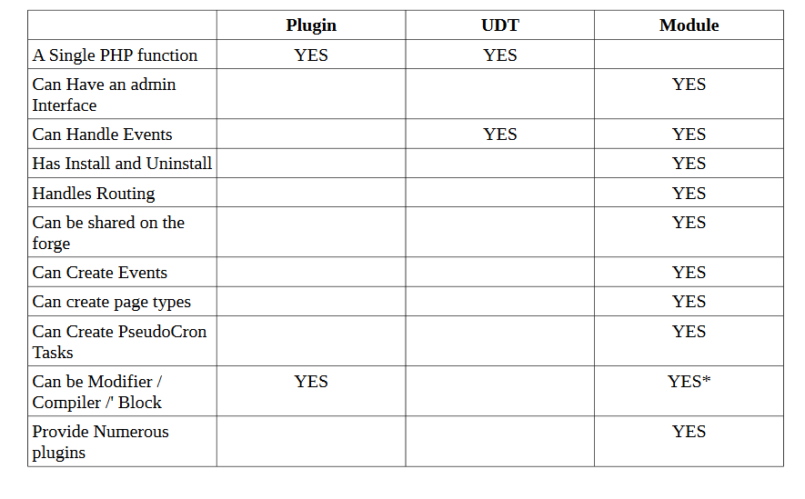

CMSMS 2.0 and CMSMS 1.0
CMSMS 2.0 is a renewal, a refactoring, and a re-generation of a great content management system making it even better. Thousands upon thousands of hours of effort have gone into development, testing, documenting, and supporting CMSMS 2.0.
CMSMS 2.0 cleans up much of the detritus left from earlier technologies and past mistakes, and creates provides a great foundation for building better websites and better applications. CMSMS 2.0 is simultaneously faster, lighter, more flexible, and more powerful than its predecessors.
Though there will be some adapting to learning the new tools CMSMS 2.0 provides, and web developers will experience some grief with upgrading websites to use CMSMS 2.0, we feel that the extra effort will be worth it.
CMSMS 1.x will continued to be supported for critical bugs and security issues one year (365 days) after the release of CMSMS 2.0. This will give you time to ensure that all of the modules that you use are ready for CMSMS 2.0 and to learn about the fantastic features of this new version on some new websites before you start upgrading. But don't wait till it’s too late!
CMS Made Simple is a complete content management system that provides many new and unique features unavailable on other systems. In this guide I will give you a concise introduction into CMS Made Simple that includes installation instructions, an overview of the features CMS Made Simple Offers, along with a tutorial on how to create custom templates in CMS Made Simple as well as creating a page from that template.
CMS Made Simple has some exciting features available which include:
Creation of user accounts that can perform selected tasks based on permissions.
Simple integration into existing site designs/templates, along with the ability to set which template each page will use.
A modular structure along with a growing community that offers extra modules.
Actual coding is done on the server’s end, for example to add content you would put the tag ‘{content}’ and the content written on page creation is automatically put there.
This may seem like a lot; however it is only the tip of the ice burg. There are many more reasons which make CMS Made Simple one of the best choices when it comes to content management systems.
First up we have to install CMS Made Simple, you will need to download the latest version which can be found on the download page. For safety reasons it is recommended that you download the latest stable release.
To install and manage CMS Made Simple you will need to have the following:
Basic HTML and CSS knowledge.
A server with MySQL and PHP.
Know the basics of MySQL database management (creation, backup, etc.).

مقایسه با سایر ابزارها ( ورد پرس ، جوملا، )
It definitely isn’t one of the more well-known open source content management systems out on the web but it is slowly growing in popularity. CMS Made Simple is exactly that – an easy to use open source content management system. This CMS program is worth checking out.

CMS Made Simple Vs WordPress
Let’s compare CMS Made Simple Vs WordPress to help you find the best PHP Content Management System for your next website. In this review I will be comparing ease of use, support, reviews, features, and more.

CMS Made Simple is an open source (GPL) Content Management System that was released in July 2004. It is built using PHP, which provides website developers with a simple, easy to use utility to allow building small-ish (dozens to hundreds of pages), semi-static websites.
WordPress is an online, open source website creation tool written in PHP that allows you to easily create a website or blog in minutes. WordPress powers over 25% of the entire web.
SEO
WordPress
SEO is extremely important. You need good SEO to rank better. All my WordPress sites rank well and WordPress is one of the main factors. You are given proven built in SEO. Most top sites are WordPress sites. That is saying something. One of the things that makes WordPress so special are their SEO plugins that can instantly be installed inside your dashboard.

