They offer plugins like Yoast, All in One, image optimization, cache plugins, and more that really speed up your site and help to improve your rankings. On top of the built-in SEO and the plugins you can also install several SEO themes. I strongly recommend Genesis for more speed and SEO performance.

CMSMS
With CMS Made Simple you get the basic SEO tools that all website builders have to offer such as SEO Friendly URLs, META tags, and SEO page titles. While there is nothing wrong with what CMSMS has to offer WordPress offers more.

Ease of use
WordPress
WordPress is the easier platform to use. There is basically no learning curve and you do not have to be a techie to get your site up and running. All you need is SiteGround for hosting your site. It will take a beginner 5 minutes to create a WordPress website with SiteGround because they will automatically install WordPress for you. Below I will walk you through the process.

CMSMS
It does take some learning to use CMSMS effectively. If you want to avoid a time-consuming learning curve you are better off using WordPress. However, when you get the hang of CMSMS it does become easier, but I still recommend WordPress for beginners.

Themes comparison
CMSMS does not offer a large amount of themes. To find the right look for your site you must be able to code a theme or hire a developer.
WordPress offers 2,000 free themes and over 10,000 premium themes. WP is rich in themes and you will not run into any trouble finding the right theme for your site. WordPress has far better looking themes and a quick look at ThemeForest will reveal that. For those who want a powerful SEO theme check out Genesis.

Modules, extensions, plugins, add-ons
CMSMS
With CMS Made Simple you are given over 400 modules to choose from. While it might seem like a lot CMSMS lacks in plugins to extend your website. Some of the plugins are AceEditor, Banckle Chat, BComments, Cart Made Simple, DebugSwitch, EMoney Payment Gateway, Form Builder, etc.
There are some unique modules that you can look forward to, but for the most part most of the modules are basic things that you would expect and some should already be built in. If you are in need of a module you are more than likely going to have to code your own plugin or hire a developer to get the right feature for your site.

WordPress
WordPress on the other hand offers over 30,000 more plugins. It is easier to search and find the plugin that you want. Unlike CMSMS you will not to have to go through every page in search of the plugin.
It will take a long time and there will be a chance that you will not find it. WordPress has a beautifully organized plugin search area to help you find the plugin that you want. All plugins will contain a beautiful thumbnail and an accurate description to let you know what you are installing.
Best of all these plugins are free. Some of the plugins that you will be given are the most popular plugins in the world. Woocommerce which allows you to sell on your website powers more ecommerce sites than other platform. Yoast is the top SEO plugin in the world. If you want more features as your website grows WP is the best option.

Popularity
According to w3techs.com as of 2016 WordPress is used by 26.5% of all the websites. CMSMS is used by 0.1% of all websites.
In my Keyword Planner the “CMS Made Simple” keyword has an average monthly search of 5,400. The keyword “WordPress” has an average monthly search of 3,350,000.
When it comes to popularity it is not even close. Why does popularity matter you ask? It matters because it shows you what most website owners are choosing. I’ll talk more about why popularity is important below.

Support
CMSMS has a lot of support features for their users. You are given official CMSMS documentation, you can hire a developer, you are given end user tutorials, you are also given a forum.
WordPress is the largest CMS so it will have the largest community. When you have a larger community everything becomes cheaper and you have more help. There is nothing that you will not find online about WordPress. There are a plethora of forums, blog posts, tutorials, YouTube Videos, plugins, developers, popular bloggers, etc. Everything is at your fingertips. WordPress obliterates CMSMS when it comes to support for your website. You feel more secure.

Which should I choose?
CMSMS is more geared towards professional web developers who desire a corporate website. CMSMS is available for those who want a challenge. Overall I strongly recommend WordPress for everybody.
A WordPress site can be built in 5 minutes. If you want to code, then WordPress allows you to be a coder as well. It is great for both beginners or developers. WP is easier, it offers for SEO options, more support, more features, more themes, more complex themes, etc. I will show you how to create your website or business.

Comparison of the usage of Joomla vs. CMS Made Simple for websites
Request an extensive market report of specific content management systems.
Learn more
This report shows the usage statistics of Joomla vs. CMS Made Simple as content management system on the web. See technologies overview for explanations on the methodologies used in the surveys. Our reports are updated dai

Usage and market share
This diagram shows the percentages of websites using the selected technologies.
How to read the diagram:
Joomla is used by 3.2% of all the websites, that is a content management system market share of 6.5%.
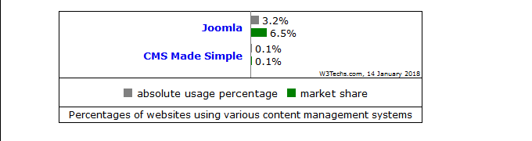

Usage broken down by ranking
This diagram shows the percentages of websites using the selected technologies broken down by ranking.
How to read the diagram:
Joomla is used by 6.5% of all the websites whose content management system we know.
Joomla is used by 5.0% of all the websites whose content management system we know and that rank in the top 1,000,000.
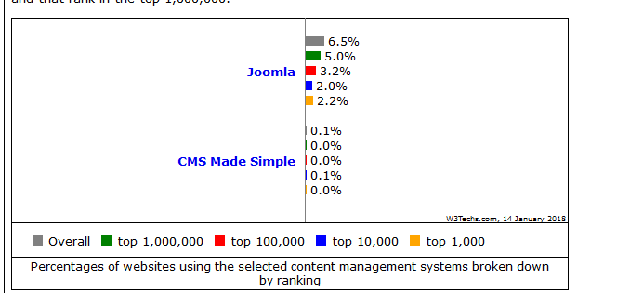
Technologies > Content Management > Technology usage comparison

Comparison of the usage of Joomla vs. CMS Made Simple for websites
Request an extensive market report of specific content management systems.
Learn more
This report shows the usage statistics of Joomla vs. CMS Made Simple as content management system on the web. See technologies overview for explanations on the methodologies used in the surveys. Our reports are updated daily.

Usage and market share
This diagram shows the percentages of websites using the selected technologies.
How to read the diagram:
Joomla is used by 3.2% of all the websites, that is a content management system market share of 6.5%.
Joomla | 3.2%  6.5%
CMS Made Simple | 0.1%  0.1%
 | W3Techs.com, 14 January 2018
absolute usage percentage
market share
Percentages of websites using various content management systems

Usage broken down by ranking
This diagram shows the percentages of websites using the selected technologies broken down by ranking.
How to read the diagram:
Joomla is used by 6.5% of all the websites whose content management system we know.
Joomla is used by 5.0% of all the websites whose content management system we know and that rank in the top 1,000,000.
Joomla | 6.5%
 | 5.0%
 | 3.2%
 | 2.0%
 | 2.2%
CMS Made Simple | 0.1%
 | 0.0%
 | 0.0%
 | 0.1%
 | 0.0%
 | W3Techs.com, 14 January 2018
Overall
top 1,000,000
top 100,000
top 10,000
top 1,000
Percentages of websites using the selected content management systems broken down by ranking

Historical trend
This diagram shows the historical trend in the percentage of websites using the selected technologies.
Our dedicated trend survey shows more content management usage and market share trends.
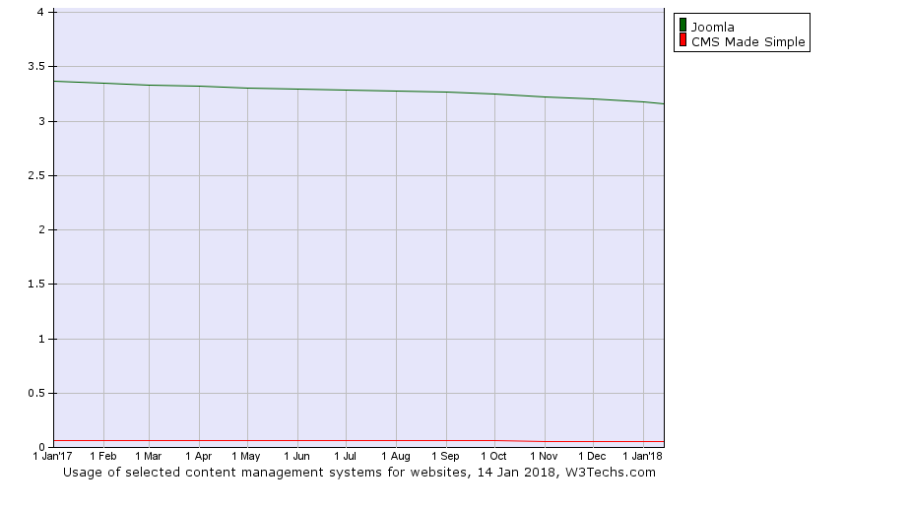

Market position
This diagram shows the market position of the selected technologies in terms of popularity and traffic compared to the most popular content management systems.
Our dedicated market survey shows more content management market data.
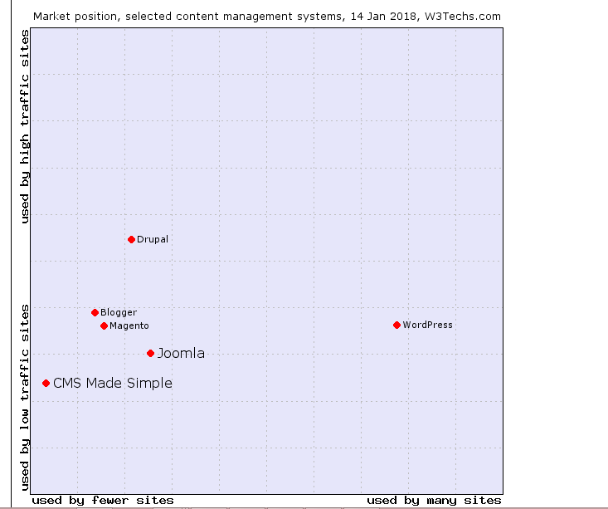
منابع

