Resources, Conservation & Recycling 141 (2019) 431–440

Contents lists available at ScienceDirect

Resources, Conservation & Recycling

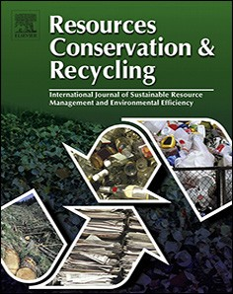journal homepage: www.elsevier.com/locate/resconrec

Full length article

Environmental behavior research in resources conservation and management: A case study of Resources, Conservation and Recycling
Fang Wanga,b,⁎, Xiao Penga, Ran Weic, Yuelei Qina, Xiaohua Zhud

a NSFC-DFG Sino-German Cooperation Group on Urbanization and Locality (UAL); College of Architecture and Landscape Architecture, Peking University, Beijing,
100871, PR China
b Key Laboratory for Earth Surface Processes, Ministry of Education, Peking University, Beijing, 100871, PR China
c School of Design, University of Pennsylvania, Philadelphia, PA, 19104, USA
d Institute of Geographic Sciences and Natural Resources Research, Chinese Academy of Sciences, Beijing, 100101, PR China

A R T I C L E I N F O

Keywords:
Environmental behavior
Resources Bibliometric analysis Text mining
Resources, Conservation and Recycling (RCR)
A B S T R A C T

Considered as an approach to protect the environment and foster sustainability in severe environmental and ecosystem deterioration conditions, environmental behavior has received extensive, multidisciplinary research in recent decades. The general trend of environmental behavior research is proﬁled based on bibliometric analysis, which is set as the background of behavior research in the resources conservation and management ﬁeld. Using materials from Resources, Conservation and Recycling (RCR) as well as its parent journals (RCRs), text mining is conducted to determine environmental behavior research scales, topics receiving focus, principle methods, and current research gaps. Future research and management practices are also suggested.

1. Introduction

From the agricultural revolution to the expansion of cities, espe- cially after the industrial revolution began and expanded globally, the inﬂuence and control of human populations over the Earth’s environ- ment is increasing due to the unimaginable size and speed of the or- ganization and ﬂow of natural materials and energy (Daniels et al.,
2010). Therefore, concepts such as the Anthropocene epoch were cre- ated to represent the state of human-dominated ecosystems (Crutzen,
2002). However, the development of society and quality of life is not accompanied by an equivalent increase in the Earth’s carrying capacity (Barrett and Odum, 2000), therefore, many environmental problems have arisen and ensuring human development without causing the Earth’s ecosystem to collapse has become the main challenge (O’Neill et al., 2018).
Some of the environmental issues may only aﬀect a few small-scale
ecosystems, while others may dramatically change the Earth’s land- scape and human territories. With the changing climate, many extreme weather events and unpredictable weather patterns occur and lead to natural disasters, such as ﬂoods and droughts (Aghakouchak et al.,
2015). Heatwaves would threaten outdoor workers and limit the ha-
bitability of the most populous regions, such as the North China Plain
(Kang and Eltahir, 2018). Other environmental problems, such as ocean acidiﬁcation and ozone layer depletion, would also impact the Earth’s ecosystem. Deforestation, unsustainable exploitation of natural re- sources, such as overgrazing, pollution, and over-population would change ecosystem processes and functionalities, damage habitat resi- lience, and cause losses in biodiversity (Abman, 2018; Zhu et al., 2018).
The gradual deterioration of the environment has drawn attention to environmental protection and the relationship between human be- havior and the environment (Banks and Sokolowski, 2011; Raymond et al., 2013), as the relationship is always changing (Muduli et al.,
2013). Published in 1962, Silent Spring by Rachel Carson (1962) ﬁrst brought attention to the environmental concerns surrounding pesti- cides. A large number of environmental protection movements, reg- ulations, and research to protect the environment followed this (UNEP,
1972; UN., 1992). With the awareness that human activities have be- come a major force on the environment, the human-nature relationship has shifted towards living with nature and employing sustainable de- velopment (Fischer and Hajer, 1999; Bill et al., 2010; Crutzen, 2002).
Human behaviors play a key role in shaping the environment and achieving sustainability. Although a uniﬁed deﬁnition has not yet been reached, environmental behavior is characterized as conscious actions adopted by diﬀerent subjects, from individuals to society, to minimize

⁎ Corresponding author at: NSFC-DFG Sino-German Cooperation Group on Urbanization and Locality (UAL); College of Architecture and Landscape Architecture, Peking University, Beijing, 100871, PR China.
E-mail addresses: wfphd@pku.edu.cn (F. Wang), pkupengxiao@pku.edu.cn (X. Peng), ranw@design.upenn.edu (R. Wei), qinyuelei@foxmail.com (Y. Qin),
zhuxh@igsnrr.ac.cn (X. Zhu).

https://doi.org/10.1016/j.resconrec.2018.10.024
Received 29 November 2017; Received in revised form 20 October 2018; Accepted 22 October 2018
0921-3449/ © 2018 Elsevier B.V. All rights reserved.

negative impacts on environment, avoid or resolve environmental problems, and directly or indirectly improve environmental sustain- ability (Hines et al., 1987; Diane et al., 2006; Chen et al., 2017). It is necessary to elucidate the relationship between human behavior and the environment, how human behavior aﬀects the environment, and what are the inﬂuencing factors. Therefore, suggestions for future stu- dies and solutions for policy-making and management could be pro- vided.
Many theoretical models have been developed to explain the in- ﬂuencing factors and mechanisms of environmental behavior. As well as empirical study, several models introduce explanatory frameworks from other disciplines, such as behavioral phycology and institutional economics (Truelove et al., 2014; Guo, 2014). In general, inﬂuencing factors could be divided into two categories: internal variables, such as cognition, emotion, attitude, and belief; and external environmental variables, such as laws, social norms, and pressures. Diﬀerent models adopt diﬀerent factors, and can be categorized into three types con- sidering their diﬀerent interactive pathways.
The ﬁrst category includes models that emphasize the importance of
external environmental variables. Environmental behavior is con- sidered to be a product of external inﬂuences. For example, the norm activation model regards social norms as the direct factor inﬂuencing pro-social behavior, which could be extended as the individual’s moral responsibility leading to their actions (Schwartz, 1977; Farrow et al.,
2017). The second type of model stresses internal variables, such as the planned behavior theory, which suggests that individual behavior is directed by rational choice, and intention is inﬂuenced by other factors, such as attitude (Icek, 1991). The third type of model states that in- ternal and external variables inﬂuence one another, and they can be combined and lead to environmental behavior. For example, the Value- Belief-Norm theory deﬁnes environmental behavior as “en- vironmentally signiﬁcant behavior” (Stern, 2000: P408), which means that human behaviors or actions aim to protect the environment and ease environmental deterioration, therefore, environmental behavior is not only an individual issue; its signiﬁcance is increasing up to that of a social behavior to protect the planet and the human population (Stern,
2000; Guo, 2014). Another typical model is responsible environmental behavior (Hines et al., 1987; Sia et al., 1985), which states that personal economic ability, social pressure, and the opportunity to select actions are also strongly related to behavior.
Other than these models, the features, measurement methods, and interactions with the environment have also been discussed at great length. For example, the attributes of pro-environmental behavior (Bamberg and Möser, 2007; Han, 2015), environmental innovation behavior (Long et al., 2017), and their relationships with factors such as the economy and diﬀerent explanatory theories have received much attention. The determination and measurement of environmental ac- tions (Klöckner, 2013; Gatersleben et al., 2002), the inﬂuence of ma- terialistic values and environmental attitudes on environmental beha- vior (Hurst et al., 2013), and diﬀerences between multiple regions and cultures (Morren and Grinstein, 2016; Chen et al., 2017) have also been discussed. Children’s environmental behavior is also used to describe how the environment inﬂuences children’s actions and shapes their attitudes (Knafonoam et al., 2017; Tucker and Izadpanahi, 2017; Mahasneh et al., 2017).
As described above, the topics in environmental behavior research are diverse and disciplines are broad, including environmental science, social psychology, and ecology. Therefore, the concept of “environ- mental behavior” has many subdivisions and it is diﬃcult to reach a uniﬁed deﬁnition. Focusing on resources conservation, recycling, and management areas, environmental behaviors from individual/house- hold to company/organization levels, and even to regional/national or cross-border levels, are important to achieve sustainable development. Therefore, extensive research eﬀorts have been devoted to waste re- cycling, food waste prevention, factors inﬂuencing green industrial practices, and material ﬂow in consumption and production process
(Quested et al., 2013; Saphores et al., 2012; Muduli et al., 2013; Dubey et al., 2016), and more research interests have gradually arisen.
A summarization of existing research, such as research scales, pri- mary topics, commonly used methods, and current research gaps, would be useful to improve future environmental behavior studies in the resources conservation and management ﬁeld. Thus bibliometric analysis was conducted to proﬁle the existing, overall environmental behavior research as the background for comparison to current re- sources-related research. The Resources, Conservation and Recycling (RCR, 1988-present) journal was used as the case study for resources conservation and management in environmental behavior. This journal, supplemented by its parent journals that include Resource Recovery and Conservation (RRC, 1975–1981), Resources and Conservation (RC,
1981–1987), and Conservation and Recycling (CR, 1976–1987), has published resources-related research for over 30 years as the main platform for resources conservation and sustainable management. Therefore, RCR can be taken as a representative example to investigate resources-related environmental behavior research.

2. Materials and methods

A literature review of environmental behavior research was con- ducted on two levels. First, based on the classical literature review, we summarized the main deﬁnitions and theories in environmental beha- vior, as shown in the introduction, and collected meta-information, such as the titles, abstracts, and references, of papers related to en- vironmental behavior from the Web of Science website, as a supple- mentary material for determining the general trend of environmental behavior research in resources conservation and management. Second, environmental research from RCR and its parent journals (RCRs, in- cluding RCR) was selected to summarize the research scales, con- centrated topics, and preferred methods. Bibliometric analysis and text mining are the two main methods applied in the analysis process.

2.1. Source of data

The “environmental behavior” and “environment behavior” key- words were searched following the “title matching” searching method in the Web of Science Core Collection (WOSCC), which includes mainstream databases, such as SCI and SSCI, and is considered to be an inﬂuential dataset of multidisciplinary academic literature. The valid results have 3150 records, with a time range spanning from 1960 to August 2017. These records were marked, exported, and named the EB (Environmental Behavior) database for further analysis.
For literature published in RCR, all available full-text papers on the
ScienceDirect website (http://www.sciencedirect.com/science/journal/
09213449) were downloaded. After removing announcements, author indices, volume content pages, editorials/guest editorials, meeting no- tices, prefaces, and publisher’s notes, 2217 full-text papers were ob- tained. The other 318 papers only contained the title, abstract, and year. For RCR’s parent journals, the major information of all available papers, including their title, abstract, and year, were downloaded from ScienceDirect, and 820 records were obtained for further research after following the same ﬁltering process as RCR. All of these materials constitute the RCRs database.

2.2. Analysis methods and tools

Citation analysis software, such as CiteSpace, can detect and vi- sualize trends and frontiers in a speciﬁc research ﬁeld and reveal the transitional patterns in scientiﬁc literature (Chen, 2006). Therefore, CiteSpace was introduced to analyze the EB database and proﬁle re- search conditions. Paper titles, abstracts, and keywords were retrieved to determine the word frequency statistics using a clustering algorithm to divide these words into diﬀerent groups and identify sub-ﬁelds and common research topics.

A “pdftotxt” tool was used to convert .pdf format papers into the .txt format so that the text mining approach could be applied to these materials. Each of the 2217 RCR papers is an element containing the title, abstract, content, and year of publication, while each of the 820 papers of parent journals only contains the title, abstract, and year of publication. The titles and abstracts of all RCRs papers were segmented to construct the corpus. Based on the identiﬁed keywords and the se- lection process, papers related to environmental behavior in RCRs were identiﬁed, and the text mining process used in the EB database analysis was applied to the selected contents. After this, the literature was read so more detailed information was obtained to study the characteristics of RCRs’ environmental behavior research.
The main tools applied in this research are the CiteSpace software and R language. Version 5.1.R6 of CiteSpace was used, and the RStudio platform with R version 3.3.2 was used in the data collection and text mining process.

3. Results

3.1. Basic statistical characteristics of RCRs

RRC was ﬁrst published in 1975, and renamed to RC in 1981. Another parent journal, CR, was ﬁrst published in 1976. In 1988, RC and CR were merged into RCR. This process is reﬂected in the number of papers published by these journals, as shown in Fig. 1.
Among all the papers published in RCRs, those directly related to environmental behavior were selected as examples of environmental behavior research in resources conservation and management. Among all 3445 RCRs’ papers, 378 papers were directly related, including 290 full-text papers. The 378 related papers are compared with the EB da- tabase results in the following section.

3.2. Locate resources-related research in environmental behavior

3.2.1. Trends of publication
For overall environmental behavior research trends, discussions gradually emerged with the environmental protection movement in the
1960s and 1970s. From 1980 to 2000, the number of published papers slowly but steadily increased. After 2000, environmental behavior re- search surged (Fig. 2). Resources-related environmental behavior re- search exhibits a similar trend in the RCRs. For example, growth has continued since the 1980s, and surged after 2000 (Fig. 3).
3.2.2. Comparison of keywords
A cluster net-graph was produced from the EB database to de- termine the high-frequency words and their relationships based on correlations between the papers (Fig. 4). In the graph’s network, the size of a node represents the frequency of the word, and the color re- presents the degree of similarity between keywords. Four main clusters in environmental behavior were elucidated based on the associative network matrix, and each of these clusters could be subdivided into further categories, such as environmental attitude and values, policy and decisions for environment protection, and speciﬁc behavior types (Fig. 5). The various categories and topics reﬂect the complexity and range of environmental behavior research.
The four clusters shown in Fig. 5 indicate the four dimensions in environmental behavior research. Cluster 1 mainly contains environ- mental protection and related topics, such as the environmental atti- tude and values, policy and decisions, the motivation and actions of people, diﬀerent types of environmental behavior, including planned, pro-environmental, and conservation behaviors, and so on. Cluster 2 focuses on the interactions of human behavior and the environment, revealing how environmental attributes inﬂuence people’s behavior, especially children and their abnormal and unhealthy activities. Cluster
3 focuses on how people and some animal’s behaviors respond to en- vironmental conditions and changes. Cluster 4 focuses on resources utilization and material transportation and degradation in the natural environment, which goes down to chemical and molecular levels.
Research of resources conservation and management in environ- mental behavior is connected to Clusters 1 and 4. Although Cluster 4 contains the least amount of research, many of the studies in Cluster 1 investigate the problems and topics contained in Cluster 4 with well- developed theoretical frameworks, therefore, they are categorized into Cluster 1 and the actual number of resources-related studies in en- vironmental behavior is actually higher.
To further illustrate the current situation of resources conservation and management research, the keywords in Fig. 5 were searched in RCRs’ environmental behavior paper titles, abstracts, and keywords. The keyword frequency was counted, the RCRs and EB databases were compared (Fig. 6).
Among all the 107 words searched in the EB database, only 87 keywords were found in the RCRs database. The frequency percentage was calculated in each database, and the results reveal diﬀerences in the keyword distribution patterns of the two databases (Fig. 6). In the RCRs database, “recycling” is mentioned more times than it is in the EB database. Further, “water”, “management”, “system”, “product”, “im- pact”, “policy”, “design”, “food”, and “soil” are more frequent in RCRs,

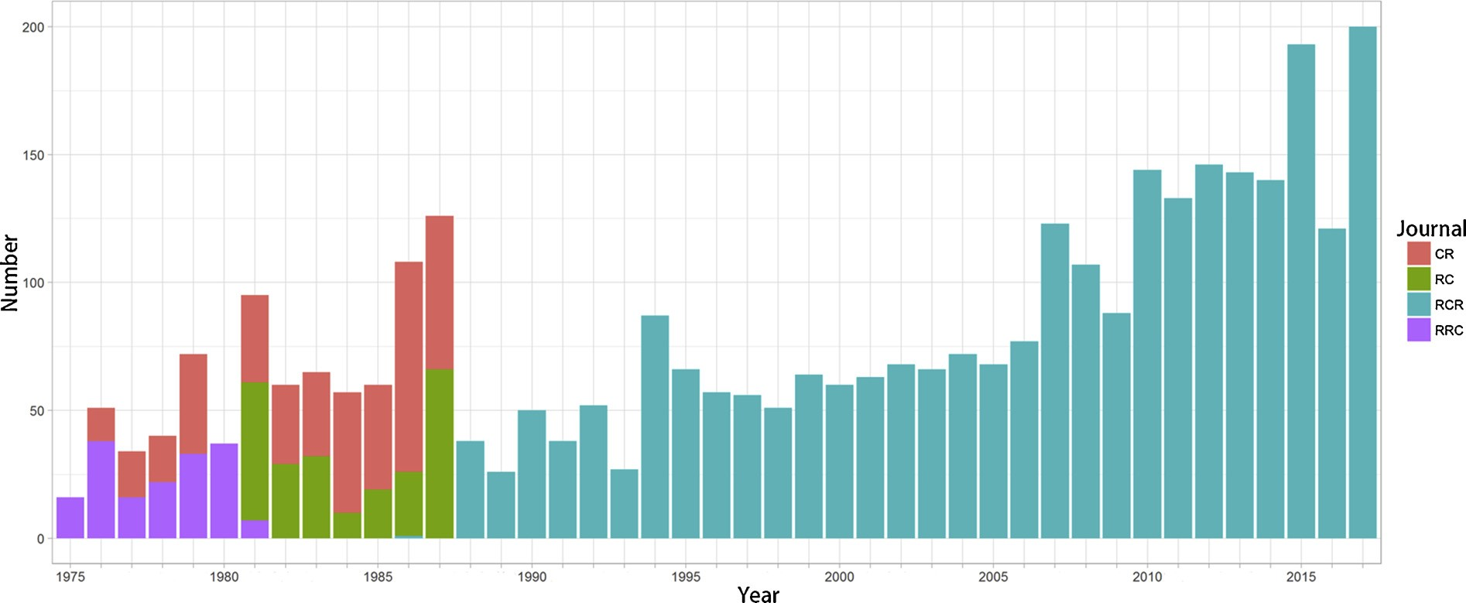

Fig. 1. The numbers of papers published in RCRs on the ScienceDirect website (In 2017, only papers published from January to August included). (Source: Authors).

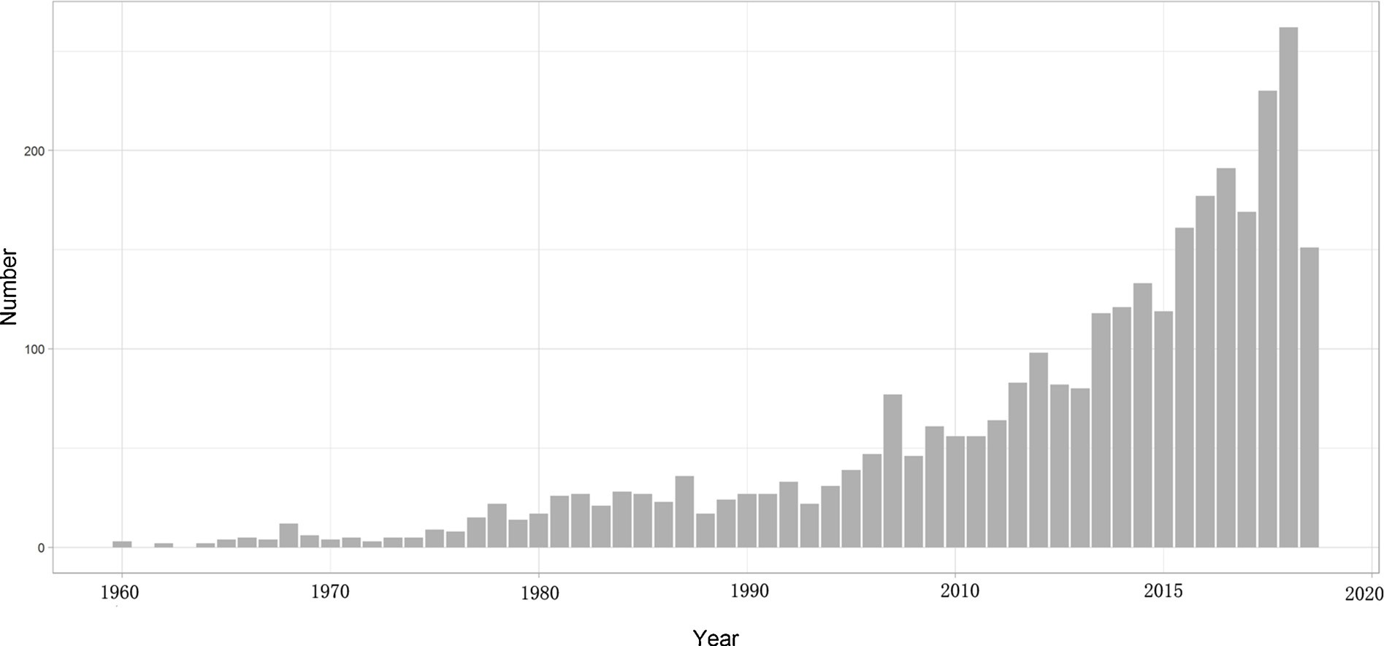

Fig. 2. Published records of environmental behavior in WOSCC (In 2017, only papers published from January to August were included). (Source: Authors).

while “environmental”, “model”, “conservation”, “sustainability”, and “consumer” account the similar proportions. Notably, “value”, “beha- vior”, “attitude”, “planned”, “stress”, “motivation”, “intention”, “per- ception”, “enrichment”, “welfare”, “norm”, “children”, “adult”, and so on, occur more frequently in the EB database than they do in the RCRs database. Words such as “resource”, “waste”, and “residual” in the re- sources ﬁeld are not present in the EB database, therefore, resources research in environmental behavior has not been a main focus. In the resources conservation and management ﬁeld, some topics, such as water, food, soil, and policy design, have received attention in the EB database, while more research eﬀorts have been devoted to environ- mental values, attitudes, motivation, and perceptions of people.

3.3. Characteristics of RCRs’ environmental behavior research

Based on the selected RCRs papers in environmental behavior, de- tailed characteristics of the 290 full-context papers were summarized and categorized by the following themes: research scale, topic, method,
sampling method, and sample size.

3.3.1. Research scale
Research scales were characterized according to the organizational hierarchy and size of the spatial area, although the two criteria may be not independent in a study. The category includes individual, house- hold, company/industry, park/district, regional/urban, national, in- ternational, and global scales, with general scale as a separate category (the research is conducted in a broad sense). Each paper’s research scale was determined by the main scale considered, while other scales may also be involved in this paper (Table 1).
Regional/urban is the most researched scale in all the 290 papers, followed by the national scale. These two scales account for approxi- mately 60% of the research. Each of the individual, household, com- pany/industry, and park/district scales accounts for 6%–10%, while the international and global scales each constitute 1–2%. Therefore, re- gional/urban and national are the scales considered most frequently in RCRs, international and global scales are the least considered, and the

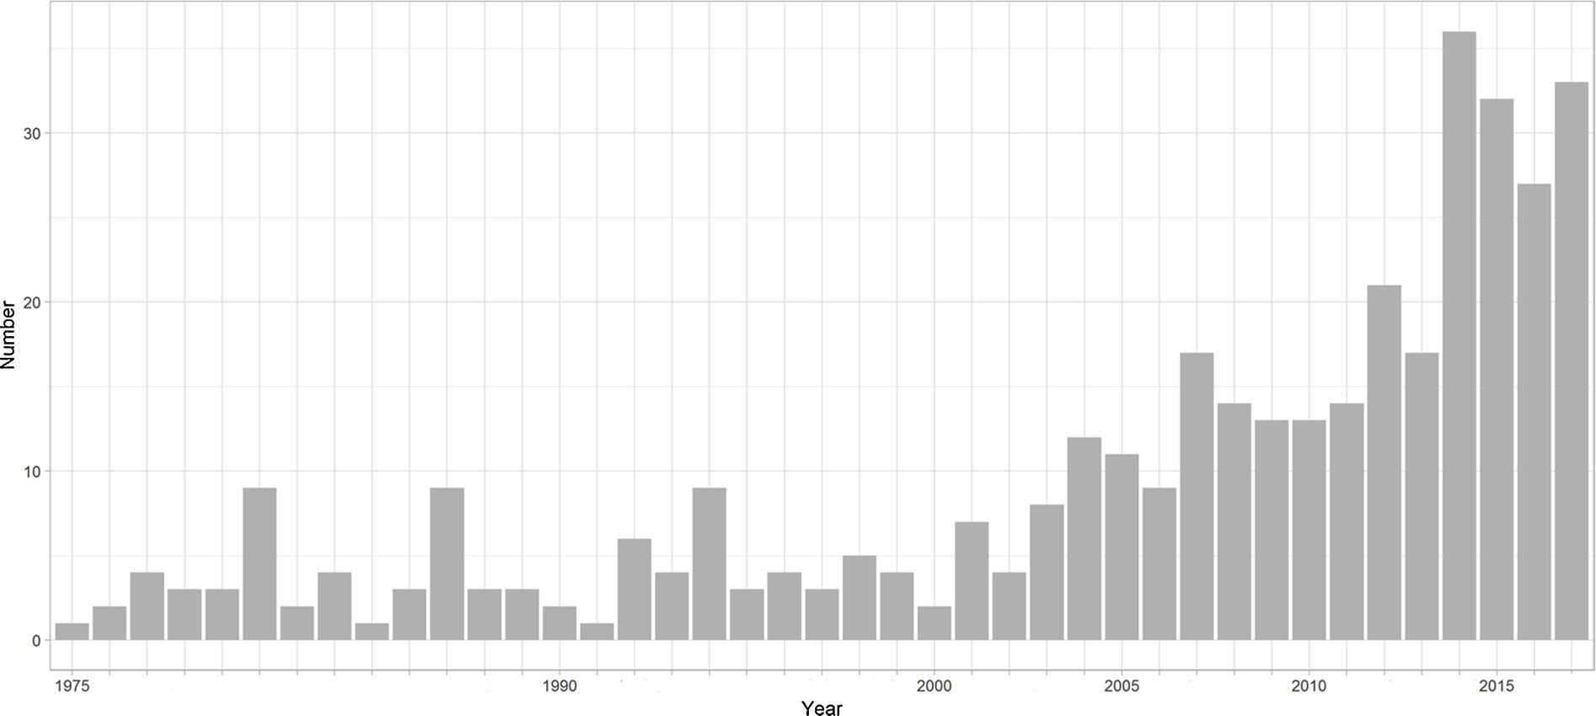

Fig. 3. Published records of the 378 directly related papers. (Source: Authors).

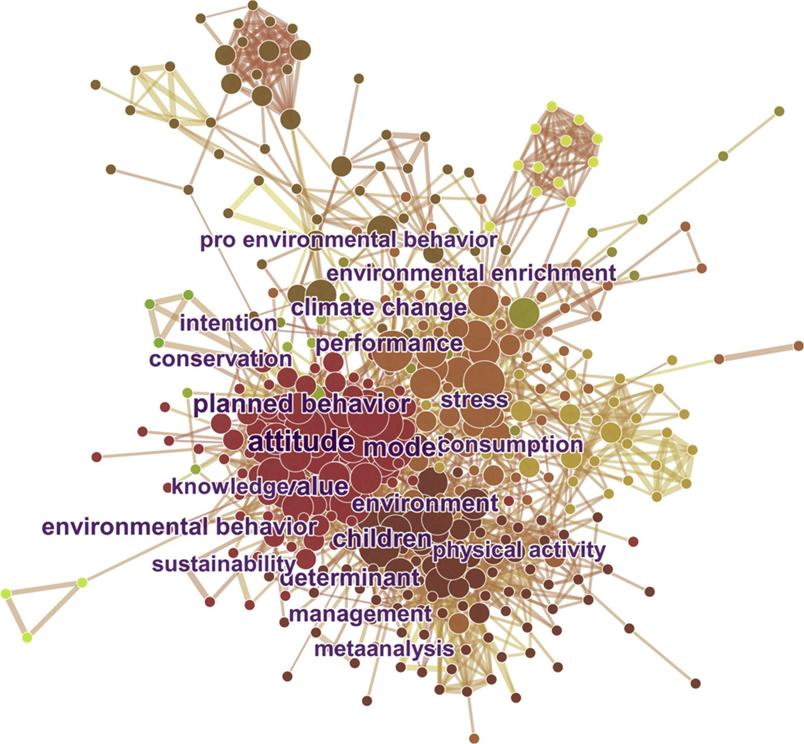

Fig. 4. Cluster graph based on the degree of similarity between keywords. (Source: Authors).

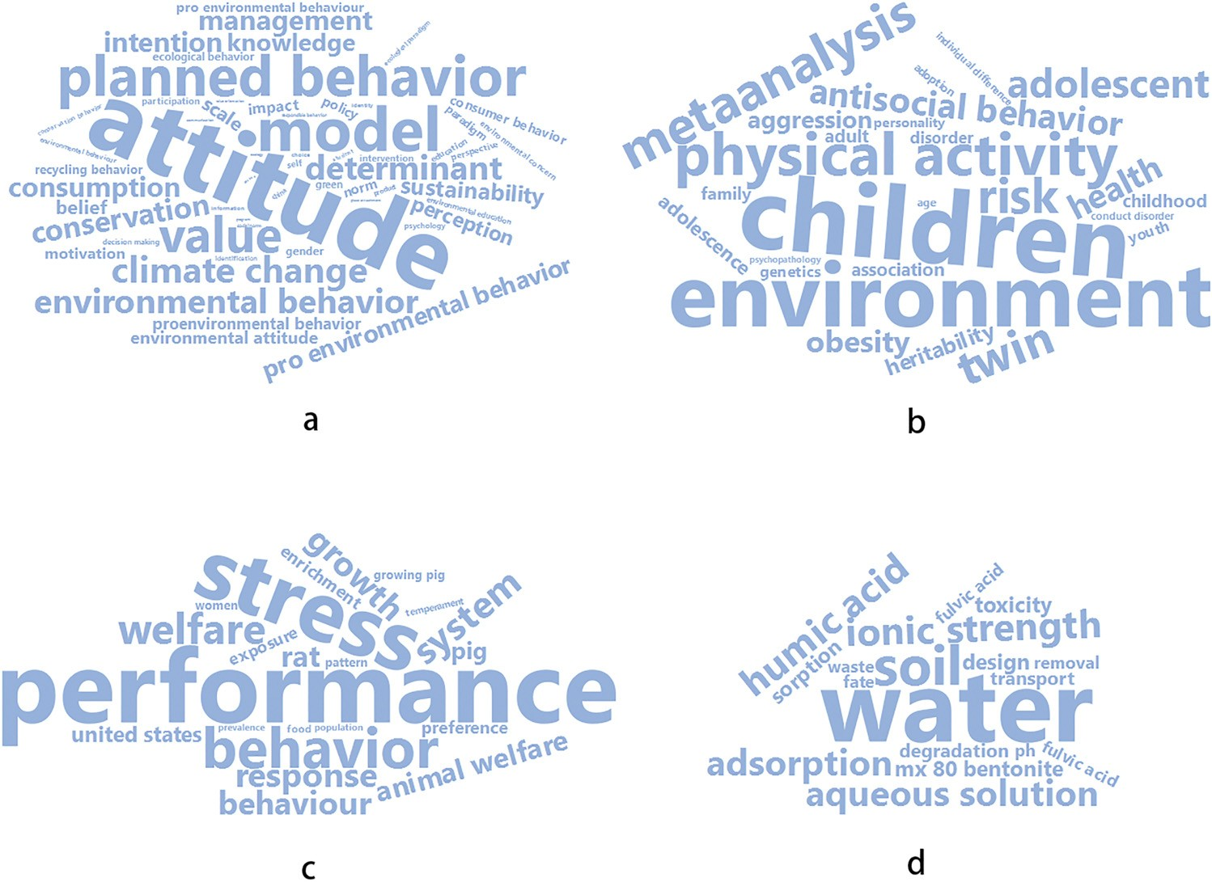Fig. 5. Word cloud graphs of four main clus- ters：a) Cluster 1: environmental protection and related topics; b) Cluster 2: human beha- vior interactions with the environment; c) Cluster 3: behavioral performance responding to environmental conditions; d) Cluster 4: re- sources utilization and material transportation and degradation.
(Source: Authors).

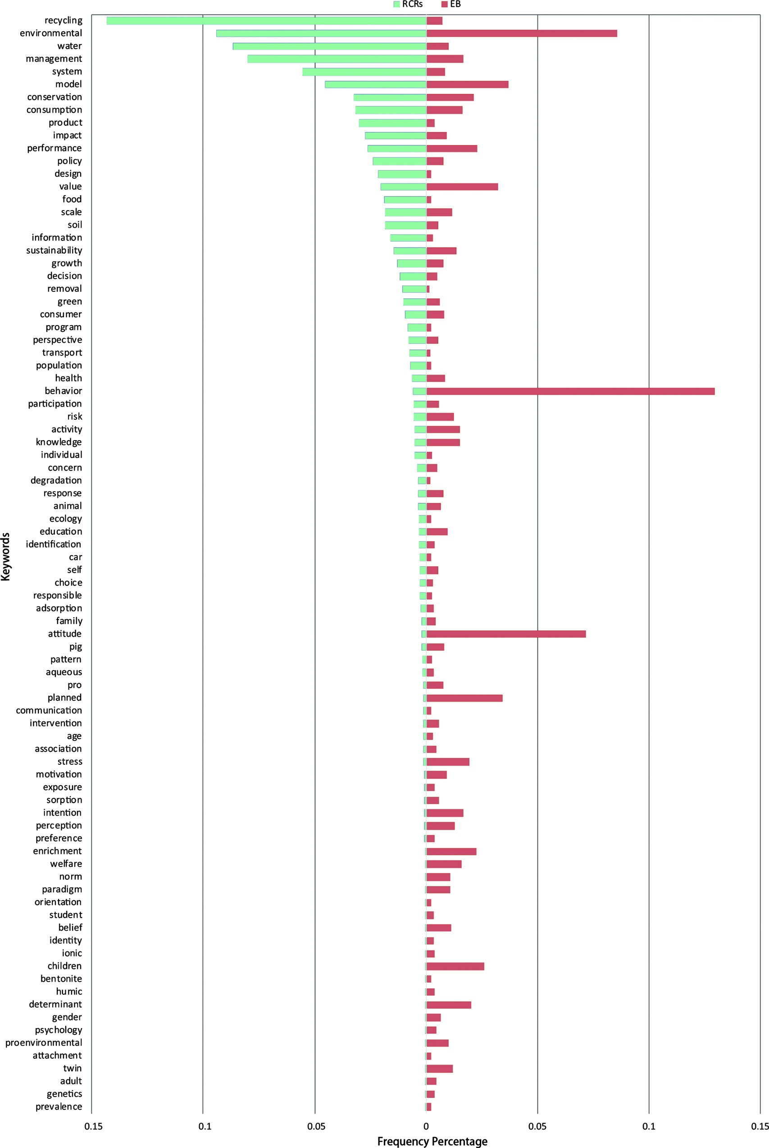

Fig. 6. Comparison between the keyword frequency percentages of the RCRs and EB databases. (Source: Authors).

Table 1
Summary of the research scales of the papers.

Research Scale Frequency Percentage

Individual 18 6.2% Household 24 8.3%
sustainability. The behavior type is only recognized separately when it is discussed in a general sense. Keywords and categories are listed in Table 2 with their corresponding percentages, in which the “others” category refers to the keywords that appear less than three times and are not included in other categories (“pro-environmental behavior” is an exception).

Global 4 1.4% General 18 6.2% Summary 290 100.0%
Company/industry 19 6.6%  Park/district 27 9.3% |  |  | According to Table 2, waste and materials account for almost 50%
Regional/urban | 99 | 34.1% | of all resources-related environmental behavior research in RCRs, with
National | 76 | 26.2% | waste having the highest percentage of 31%, and materials, which are
International | 5 | 1.7% | more recyclable than waste, having a percentage of 18.6%. Water is the

Table 2
Summary of the research topics of the papers.

Category Keywords Frequency Percentage

Waste Waste 39 13.4% 31.0% Solid waste 24 8.3%
Food waste 8 2.8%
next most frequent topic, accounting for 13.1%. Sustainability, bio- mass, and energy are sometimes discussed, while speciﬁc research on behavior types is scarce.
In the waste category, solid waste is the most mentioned object, and has been included in studies such as the community’s participation in household solid waste reduction (Dhokhikah et al., 2015). In the ma- terials category, packaging waste management (Ferrão et al., 2014;

Vassanadumrongdee, 2012; Borthakur and Govind, 2016), scrap
Márquez | et | al., 2008), | e-waste | (Manomaivibool and

ﬂuorescent lamps (Tian et al., 2016), batteries and battery packs
(Arbués and Villanúa, 2016; Borthakur and Govind, 2016), and so on
Construction
demolition
12 4.1%
are studied. The studies in the water category incorporate the inﬂuen-
Household waste 7 2.4%
cing factors and motivations of household water use (Rathnayaka et al.,
Materials Battery and electronic Material management
15 5.2% 18.6%

5 1.7%
2014; Makki et al., 2015; Liu et al., 2015), the inﬂuence of perceptions of water quality in drinking water and the environmental outcomes of water conservation at the household level (Prouty and Zhang, 2016;
Vehicle 4 1.4% Packaging 7 2.4% Paper 6 2.1% Plastic 11 3.8% Polymer material 3 1.0% Aluminum 3 1.0%
Biomass and energy Biodiesel 6 2.1% 6.6% Energy 6 2.1% Composition 4 1.4%
Forest 3 1.0%
Water Wastewater 11 3.8% 13.1% Water 27 9.3%
Industrial ecology Green supply chain 3 1.0% 2.4% Industrial ecosystem 4 1.4%
Fielding et al., 2016), water reuse in an industrial park (Taskhiri et al.,
2011), and so on. The major issues in the sustainability, pro-environ- mental behavior, and so on category include the sustainable and pro- environmental behavior of a corporation and its employees (Lu et al.,
2017), the consistency and spatial diﬀerences between individuals’ environmental and sustainable behaviors (Chen et al., 2017; Eppel et al., 2013).

3.3.3. Research method and sample size
Research methods were roughly divided based on whether a qua- litative or quantitative method was used when the research method was
Sustainability Sustainable
development Environmental impact
3 1.0% 8.3%

16 5.5%
deﬁned. For the sampling method, random samples refer to samples
collected by questionnaires, web-based surveys, and so on, while se- lected samples refer to samples that were directly selected by the re-
Climate change 5 1.7%
searchers, such as a case study of a selected city with its statistical data.
Pro-environmental behavior
Pro-environmental behavior
2 0.7% 0.7%
A cross-classiﬁcation chart is produced to show the research methods and corresponding sampling methods (Table 3), and the “unclear”
Recycling behavior Recycling behavior 8 2.8% 2.8%
Others Others 48 16.6% 16.6% Summary 290 100.0% 100.0%

consideration of the remaining four scales is almost equal.
The aforementioned traits diﬀer from the extensive discussion of individual responsibilities or motivations in the theoretical research of environmental behavior (Schwartz, 1977; Icek, 1991). Researches on motivations, attitudes, and values are conducted in a speciﬁc manner in RCRs, and are usually based on a particular resource or behavior type, such as the identiﬁcation of motivations and barriers to minimize household food waste, actions to minimize residential waste (Graham- Rowe et al., 2014; Farrelly and Tucker, 2014), the attitudes and norms of households, and the eﬀect of the perceived distance to the recycling facilities on recycling behavior (Byrne and O’Regan, 2014; Lange et al.,
2014; Hage et al., 2009).

3.3.2. Research topic
Research topics were categorized by classifying resource types, such as waste, material, biomass, and water, with some unavoidable over- lapping. If the paper does not concentrate on one speciﬁc resource, it is added to either of the following two categories: industrial ecology and
classiﬁcation in the table indicates that it is diﬃcult to deﬁne the re- search and sampling methods due to the paper’s mixed characteristics or unclear statements.
For the research methods, quantitative methods account for ap- proximately 70% of the papers, while qualitative methods account for
30%. For the sampling methods, papers using selected samples are three times as frequent as papers using random samples. Moreover, the qualitative method mostly uses a selected sample, usually in a case study.
Studies such as literature reviews and interviews to determine people’s awareness and behavior utilize more qualitative methods, for instance, a literature review has been used to determine social norms and people’s understandings (Thomas and Sharp, 2013), and empirical

Table 3
Cross-classiﬁcation of research methods and sample ways.

Method/Sample Random sample Selected sample Unclear Summary

Qualitative 2 59 14 75
Quantitative 57 120 30 207
Unclear 1 3 4 8
Summary 60 182 48 290

research has been used to determine a ﬁrm’s developing circular economy (Liu and Bai, 2014). Although some research involved cal- culations, they are still categorized as qualitative research as the data are used in a descriptive manner, rather than an analytical manner (Klang et al., 2003).
For quantitative and semi-quantitative methods, econometric and statistical methods are the primary methods of analyzing questionnaire results, especially at regional/urban and national scales, which are characterized as social economic data studies. Meanwhile, other methods, including demand forecasting models (Makki et al., 2015), decision models based on survey data (Meng et al., 2015), structural equation modeling (Li et al., 2015), and cost-beneﬁt analyses (Pickin,
2008) are also employed. Simulation methods, such as agent-based
modeling (ABM), are applied in household solid waste recycling be- havior research (Meng et al., 2018). Life cycle analysis (LCA) is ex- tensively used as an approach to analyze the environmental impacts of resources or products and determine the role that the behavior plays at all product stages (Silva et al., 2015; Manfredi and Goralczyk, 2013).
The distinction between qualitative and quantitative methods is not absolute, as a study often establishes a conceptual framework, which is a qualitative method, before conducting quantitative analysis (Sinha et al., 2016). Besides, case studies for single or multiple cases are ex- tensively applied to explore recycling and water conservation (Fielding et al., 2016), the recycling of agricultural plastic wastes (Muise et al.,
2016), recyclable material collectors (Cruz et al., 2013), and so on. Questionnaires, online and oﬄine surveys, semi-structured interviews, and face-to-face interviews provide a wide range of data.
Among the 290 papers, 97 clearly state sample sizes ranging from 1 to over 2000. However, many papers used over one data source, therefore, a single number could not be extracted, for example, a study on paper recycling analysis in Japan used response data from 1242 consumers and 60 paper makers (Kishino et al., 1998), and a research evaluated biodiesel potential in Singapore by investigating 26 pro- viding companies, 48 suppliers, and 32 users (Ho et al., 2014). Some research was conducted using statistical or aggregated data with a na- tional or industrial case study, so the sample size was considered as 1. After removing these papers, the remaining 82 papers were in- vestigated, most of which have a sample size of 101–1000 (Table 4).
The average sample size of papers with 101–1000 samples is
326.86, while the average sample size of 82 papers is 377.79. Excluding primary and statistical data, secondary investigation data are occa- sionally used, for example, a study on battery collection behavior in Spain used data from the "Survey on Households and the Environment
2008" project, with over 20,000 samples (Arbués and Villanúa, 2016).

4. Conclusions and suggestions

4.1. Conclusions and limitations

Through conducting an overall analysis of RCRs environmental behavior literature following the bibliometric and text-mining methods, the current research on environmental behavior in terms of resources conservation and management can be concluded as follows.

(1) Of all environmental behavior research, resources-related research has not received the same attention as other ﬁelds, such as

Table 4
Summary of paper sample sizes.
motivations, beliefs, values, and interactions between human be- havior and the environment.
(2) RCRs’ environmental behavior research diﬀers from general re- search. Water, food, soil, products, and policy design are the main focuses among the existing research related to resources conserva- tion and management, while more general research focuses on en- vironmental values, attitudes, motivation, and the perception of people.
(3) Regional/urban and national research scales are the most common scales, accounting for approximately 60%, while the household scale is the most common among the individual, household, and company/industry scales. International and global scales receive the least focus.
(4) Waste and materials account for almost 50% of research among the diﬀerent topics. Solid waste, construction demolition, battery and electronics, and plastic are widely discussed issues, while water, biomass and energy, concepts and problems related to industrial ecology, and sustainability are mentioned less.
(5) For research and sampling methods, the quantitative method is used more than the qualitative method, while sampling is primarily conducted by the selected method or a case study. The average sample size is approximately 400.

It is noteworthy that data collection by searching with one keyword on one platform for proﬁling environmental behavior research is lim- ited to an extent, and may be insuﬃcient to cover all aspects of this domain. Therefore, the outcomes of this method are only used as a background to locate resources-related research, with the belief that this method of searching could indicate the issues discussed most commonly in environmental behavior research. Meanwhile, RCR and its parent journals are believed to be suﬃciently representative to reﬂect the basic characteristics of environmental behavior research in re- sources-related ﬁelds. RCRs is thus used as the investigative case. More materials could be included to obtain a more comprehensive under- standing in future studies.

4.2. Suggestions

Based on comparisons between general environmental behavior research and RCRs’ speciﬁc resources-related papers, some suggestions for future research are provided, which are hopefully useful for man- agement and practice.

(1) As resources are the core issue in all RCRs’ research, ongoing at- tention should be given to resources-related topics. Values and at- titudes should be researched, and other theoretical frameworks should only be included when they are associated with speciﬁc resource types or problems.
(2) The quantitative method is a distinct feature of RCRs’ environ- mental behavior research, which could continue in future RCR studies. However, the qualitative method could provide a diﬀerent perspective for understanding the individual distinctions in detail through methods such as participant observation and in-depth in- terviews, which could be used as supplementary research.
(3) Future studies could integrate data from multiple sources, including data from the Internet of Things. For example, smart sensors in buildings and cities can monitor the utilization of resources, and reveal human behavior patterns embedded in these data. Furthermore, big data technologies have great potential for ana-

Sample size range | Frequency | Average size | lyzing data and broadening the scope of traditional research.
 |  |  | (4) More research conducted on international and global scales could
2–10 | 24 | 3.75 | be included in the future, as local and national actions may be in-
11–100 | 20 | 42.65 | suﬃcient for understanding increasingly complicated environ-

101–1000 28 326.86
> 1000 10 2088.40
Summary 82 377.79
mental issues. Communication and collaboration between countries should be promoted, with actions such as establishing global re- sources conservation and management mechanisms. The Paris

Agreement on climate change has provided a good demonstration of this.
(5) In the case of the waste-utilization eﬃciency and recycling, more research should be conducted on biomass and energy, as well as sustainability. As global environmental problems, such as climate change, are becoming central issues in this century, RCR can lead environmental behavior research towards sustainability based on its long-term concerns in sustainable management and resource protection. Conducting studies and implementing practices in the resources conservation and management ﬁeld would contribute to a sustainable society.

Acknowledgement

