Subject: Solution for unclearable failure code after instrument panel wiring harness was replaced | Number: | TB-TE-2019004
Model: M1A+PEPS | Date: | 15-Feb-19
Fault phenomenon：
In April 2017, M1A dashboard wiring harness (J60-43030CA/EA/EC) was changed from three low frequency antennas to two low frequency antennas.
When the failure code (B1503-13) appears and can not be cleared after the instrument panel wiring harness replacement by the after-sales market, please refer to the following table:
Solution：
 | The status before wiring harness replacement | The status after wiring harness replacement | Solution
Solution 1st | New status | New status | OK
Solution 2nd | New status | Old Status | OK
Solution 3rd | Old Status | New status | Solution of Rewriting Configuration Code in PEPS with Diagnostic Instrument
Solution 4th | Old Status | Old Status | OK

Annex： Method for Distinguishing New and Old Status parts
Old Status parts | New Status parts
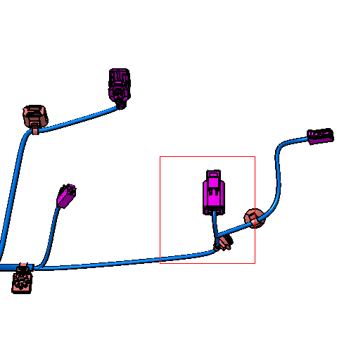  WITH | 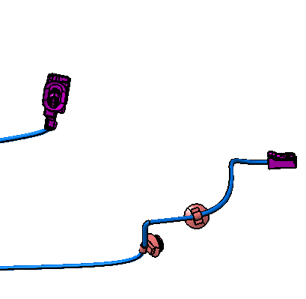  WITHOUT

Writing instructions：
- Guarantee that the version of the diagnostic instrument is over V58.00；
- Keep the key in ON gear and the engine does not start.；

Complied: | Checked: | Approved:

The writing process of the configuration code and requirements thereof are as follows:
- Click to enter the diagnostic menu of M1A：
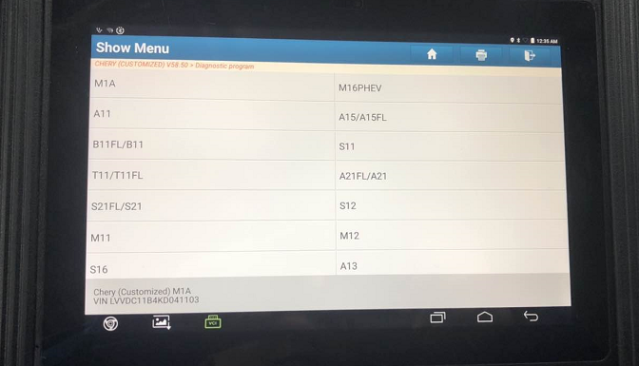

- Click to enter PEPS system：
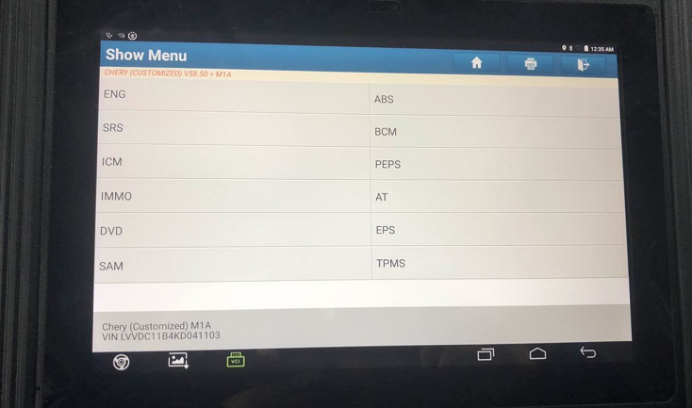

- Click to enterSpecial Operations Menu：
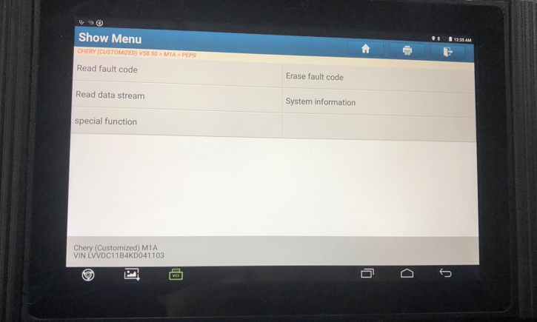

- Click to enter Configuration Code Menu点击进入配置代码菜单：
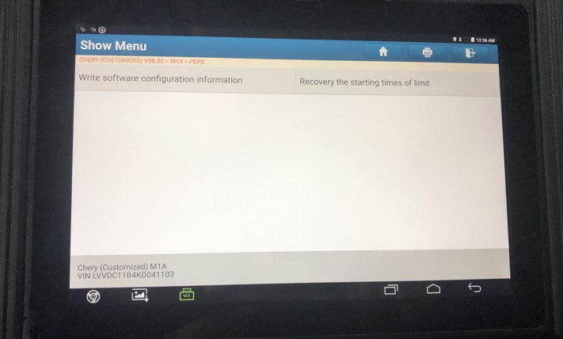
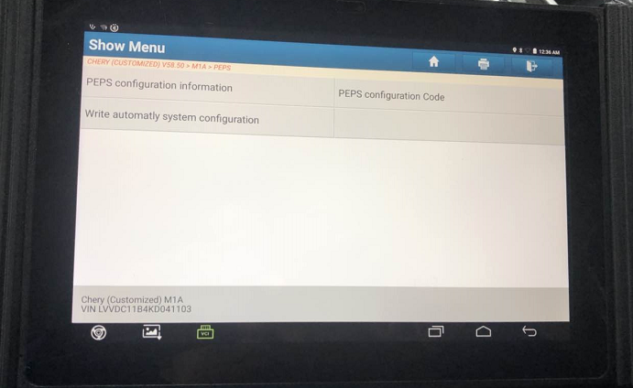

- Write the configuration code of low frequency antenna：03，According to the system prompt, enter the secondary configuration code：03；Make sure that the code entered twice is consistent：
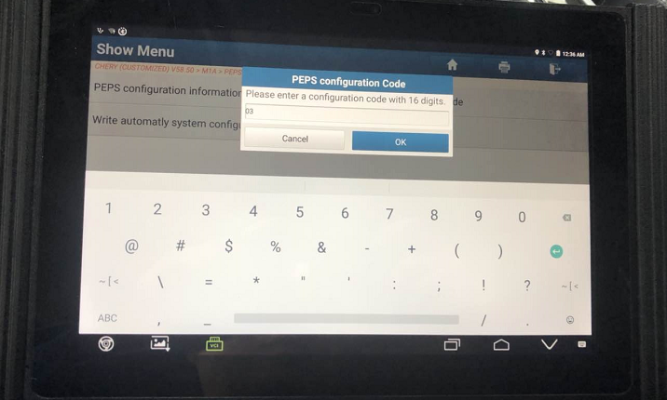

- After writing, click OK and write that the configuration code is finished and the vehicle low-frequency antenna configuration is completed：
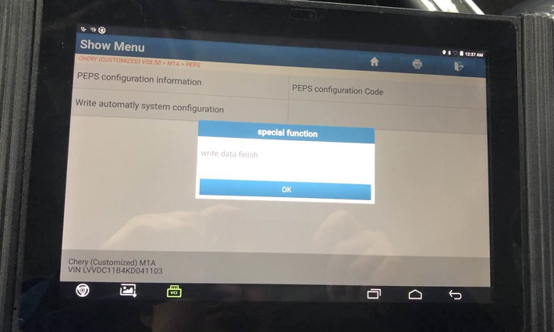

Check whether the configuration code "03" is successfully written

Click to enter Read Data Stream Menu：
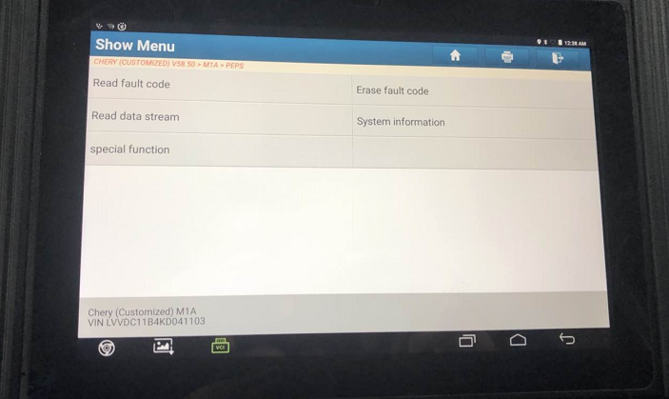
- Click to enter the PEPS System Configuration Information Menu：
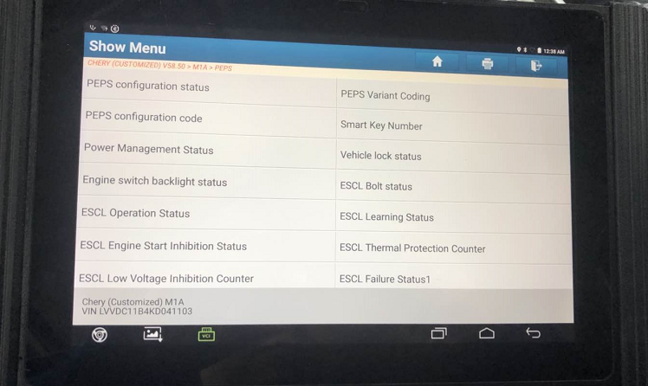
- The display of configuration code "03" indicates that the configuration has been successfully finished. 

