**Important message regarding payment gateway:**

You should make the user to be able to use the currency he would like to pay. At this time the users can choose Iranian currency and USD. Please note the currency change rate is different for freelancers and clients. This is because of the fact that we I sell paypal dollar in Iran, I receive less money but when I want to buy PayPal dollar I have to pay more. We should put it in this way:

* Example1: A local client posts a job and wanted to hire a freelancer from another country so he has to use exchange rates. For this case we put the exchange rate $1= 4100 Toman.
* Example 2: A local freelancer wants to bid on a project he bids on the project and put his bid onToman, he and the client can see the rates in dollar and Iran currency (Toman). But here the exchange rate would be $1= 3800 toman.

In other cases when the freelancer and the client uses the same currency, there would be no problem.

**Client side**

1-we don’t have ticket system. The users should be able to send the problems via ticket system in the support system.

2-When a client registered he did not receive any email from the site. I also registered as a freelancer and I received it after 1 minute. This is not good, the user cannot wait to receive confirmation email.

3- when a client sends message to freelancer in his dashboard he should be able to attach documents.

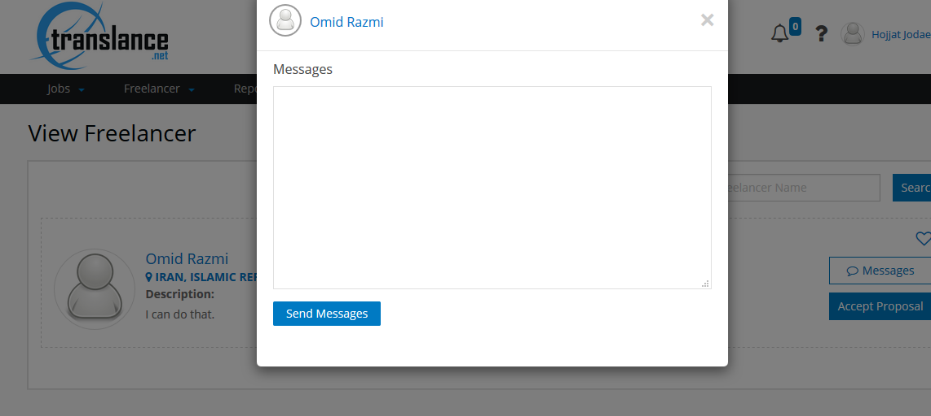

4-A client or freelancer should not be able to see each others’ feedbacks until he provides his feedbacks. These are minor but very important issue. You should look at Upwork working process for this. I really tired checking these points.

Also the freelancer/client should not be able to see the basic details of each others.

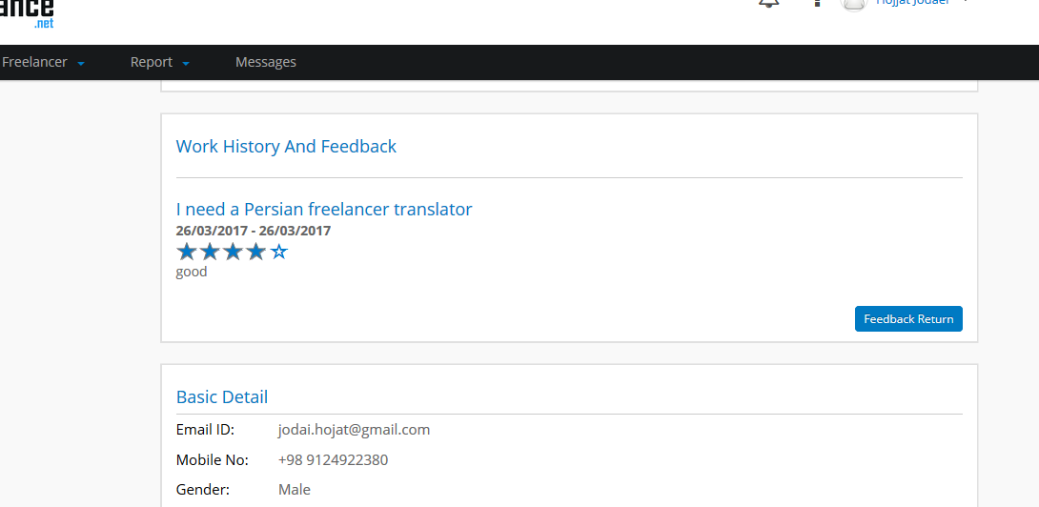

5-This is client (below image) so no need to have create as client.

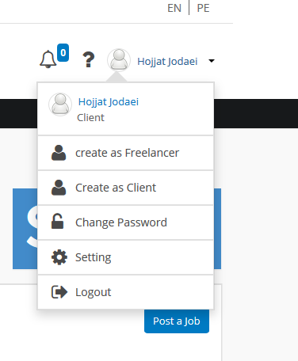

6-The message center should be “right to left” not “left to right”.

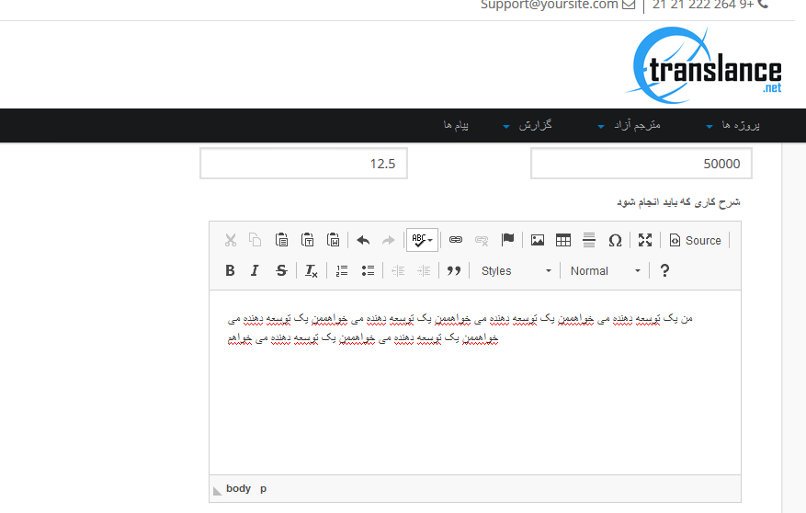

7-At this time the client can remove the money in escrow without freelancer permission. How is it possible? Look upwork rules and policies for this.

8-I don’t see any dispute section in client side. What if the client is not satisfied and doesn’t want to release the payment to freelancer. I think you should put and option namely create dispute in the + section so when the client or freelancer clicks on it they will be directed to the dispute section. I think you did not understand the meaning of dispute.

“Dispute only applied to the money in the Escrow, when a client is not satisfied with the freelancer work or wants to pay less than agreed amount in the escrow, here he enters to dispute. Suppose that there is $100 in the escrow, In the Dispute the client say I would like to pay $30 of this money, he sends this message via dispute system. The freelancer has 5 days to respond the dispute, if he fails to respond it in 5 days, the money in escrow will be back to the client. If the freelancer answers, he may accept or not accept the dispute, if he accepts it, the dispute will be ended, if he the freelancer does not agree the dispute continues, for example the client says I would like to pay $40, if it accepted the dispute will be finished if not accepted it will be continued. If they don’t reach to an agreement, they will ask the referee as the third party to come to make the decision. The person who asks for referee should pay the referee fee. After that the referee will decide based on the freelancers and clients’ evidences. You can look at freelancer.com policy for this.

When a dispute is created the contract will be on hold.

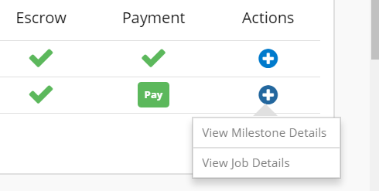

**8-Still don’t have Perfect Money gateway**

**Freelancer side**

1-when a freelancer submits a proposal he does not see any converter for currency. Put this converter in any place you have payment issue.

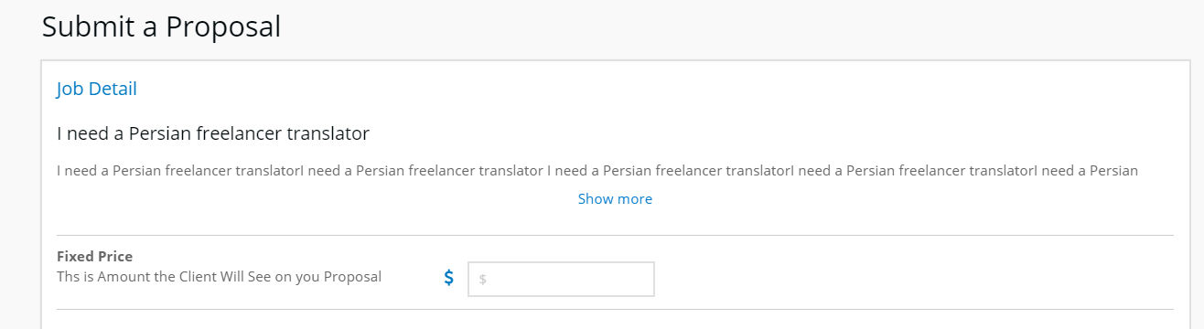

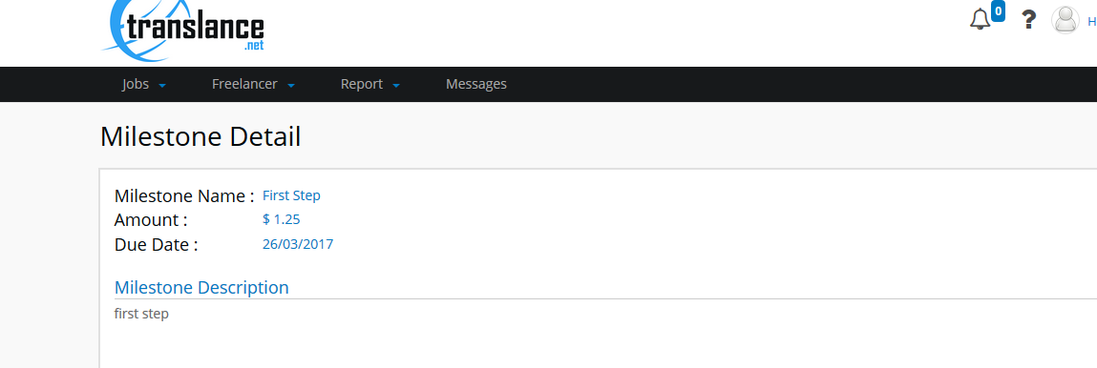

2-The freelancer cannot see the price in local currency

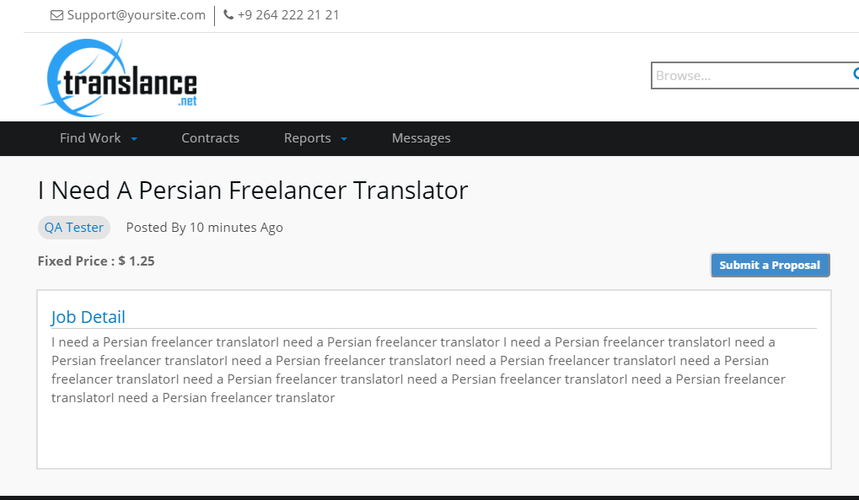

3-The freelancer does not receive messages in the message center in real time.

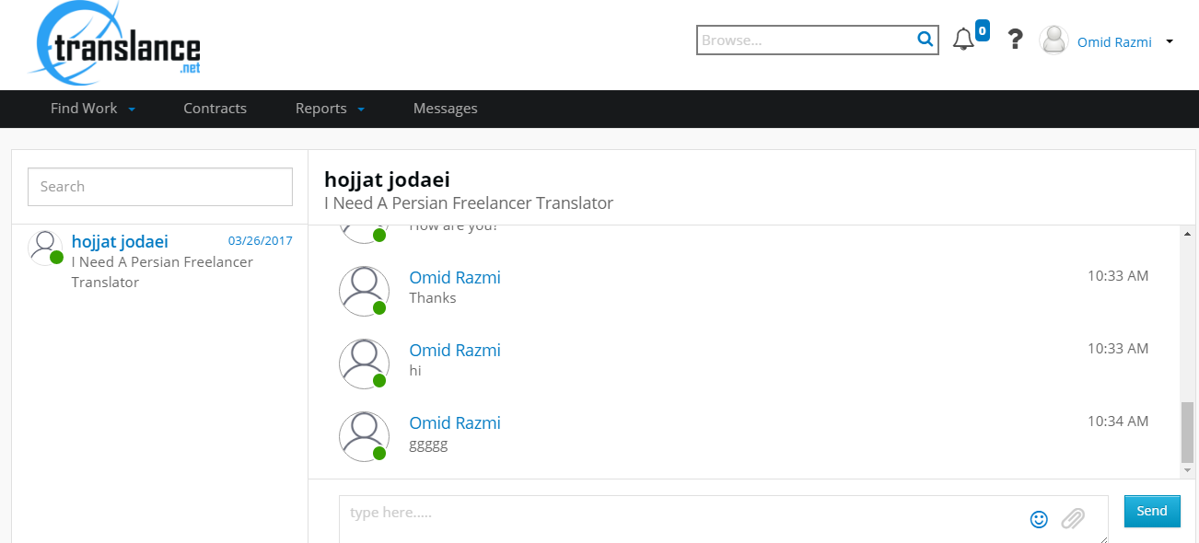

4-in the message center both of the freelancer and client are online but one of them is green.

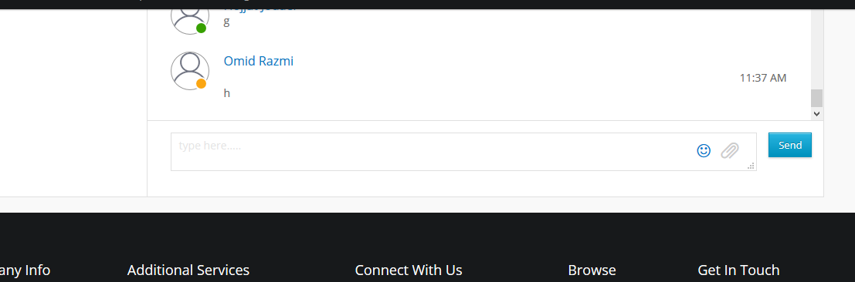

5-This is the email that the freelancer gets when the client approves his proposal. Make the job title clickable, when a client click on the job title he will be redirected to the original job posting in the site.

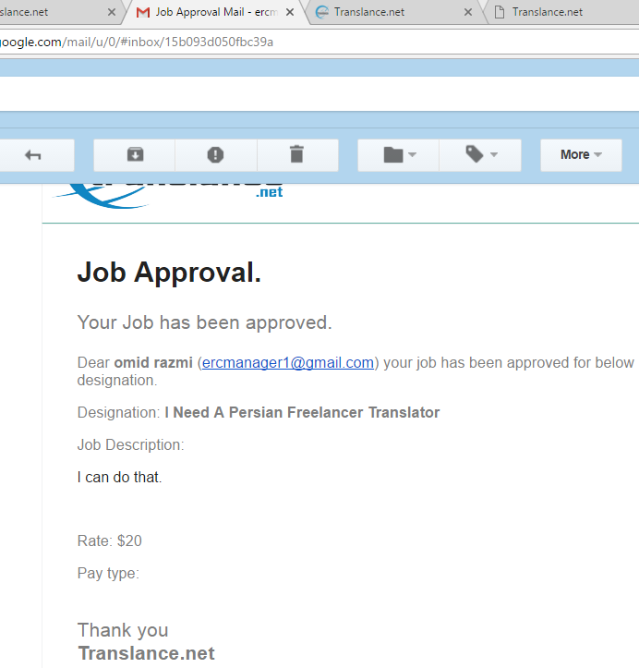

7-The freelancer requested payment, and the client wants to release the payment. The client clicks on “Pay” . Put this message before final release “are you sure to release the payment Yes Cancel”.

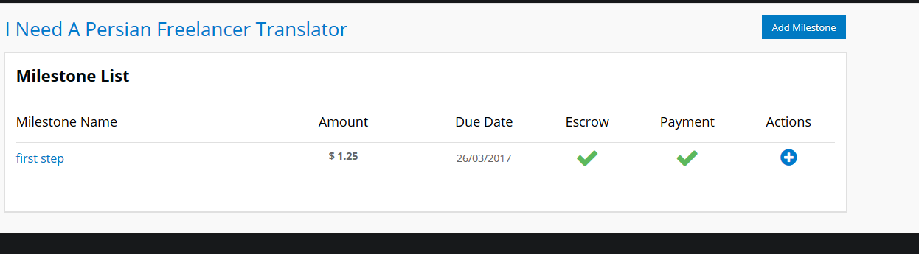

8-There is not ticket system in the help and support section. In the help and support section freelancers can see the site guides and if they have any question they can send it via ticket system.