The Structure of Cross-Sector Financial Supervision

BY RICHARD J. HERRING AND JACOPO CARMASSI

In this paper the authors note that, over the last decade, in many countries the financial supervisory functions that were once performed by central banks have been combined with those performed by other official agencies and/or self-regulatory organizations to form a single financial services regulator. They consider three questions: (1) Why has this change occurred? (2) What role in supervision, if any, should the central bank continue to play? and (3) Do these organizational changes in financial supervision pose risks to financial stability?

I. INTRODUCTION

Central banks are famous (some would say notorious) for their conservatism and bureaucratic inertia. Moreover, as Goodhart (2000) has noted, they have a propen- sity to argue “that whatever their present structure may be, it is optimal, or at least would be if some slight additional funding and powers could be made available”. Their independence also tends to insulate them from fads or changes in fashion that sometimes affect other institutions. Nonetheless, over the last decade, one traditional aspect of central banking, financial supervision, has been reorganized in ways that can be described as revolutionary. In most major industrial countries and many emerging markets, the financial supervisory functions that were once performed by central banks have been combined with those performed by other official agencies and/or self-regulatory organizations to form a single financial services regulator.
In this paper we will consider three questions. Why has this change occurred? What role in supervision, if any, should the central bank continue to play? Do these organizational changes in financial supervision pose risks to financial stability?
We will first review the basic regulatory and supervisory functions and how they are traditionally organized. Next, after an overview of alternative supervisory models and their application in different countries, we will consider the various factors that have led to the adoption of an integrated financial supervisor. Then we will evaluate where such a supervisor should reside institutionally. In particular, we will consider whether it should be housed in the central bank. Finally, we examine how the integrated financial supervisor can be insulated from political pressures, yet still be accountable for meeting its objectives.

C 2008 The Authors. Journal compilation c 2008 New York University Salomon Center, Financial Markets, Insti- tutions & Instruments, V. 17, No. 1, February. Published by Blackwell Publishing, Inc., 350 Main St., Malden, MA
02148, USA, and 9600 Garsington Road, Oxford OX4 2DQ, UK.

II. TRADITIONAL SUPERVISORY FUNCTIONS

Financial supervision1 includes three key functions: (1) macroprudential super- vision, (2) microprudential supervision and (3) conduct of business supervision.2
The objective of the macroprudential function3 is to limit financial system dis- tress that might damage the real economy. It focuses on systemically important institutions and the consequences their behavior may have for financial markets. It tends to be top down surveillance with emphasis on the exposures of systemically important institutions to a variety of shocks. This involves not only monitoring the compliance of these institutions with safety and soundness standards, but also evaluating whether these standards are sufficient to protect the rest of the economy adequately from financial distress in a systemically important firm. Pillar 2 of the Basel II agreement makes this duty explicit by requiring that bank supervisors impose capital charges above the minimum requirement (or require banks to re- duce their risk exposures) if they believe that an institution’s exposures to the risk of insolvency are not adequately captured by the Pillar 1 framework for assess- ing capital adequacy. Since the evaluation of macroprudential risk is based on an understanding of macroeconomic and financial relationships, economists tend to dominate in this function.
Crisis management is closely related to the macroprudential function. If macro- prudential surveillance fails to prevent a large institution from experiencing finan- cial distress, officials may decide that intervention is necessary to limit the systemic consequences. This may involve the provision of liquidity support to the institu- tion itself, or to other institutions through discount-window lending. By permitting institutions to borrow against their assets rather than selling them into a disorderly market, the authorities may be able to prevent a liquidity crisis from turning into a solvency crisis that could jeopardize a broader range of financial institutions and the real economy. Or it may involve the provision of liquidity to the broad market through open market operations. Because the central bank is the ultimate custodian of liquidity in an economy, it has traditionally played both of these roles.4

1 Although it is important in some contexts to distinguish regulation from supervision, for convenience and brevity we will use the two interchangeably to refer to both the rule-making function and the surveillance and enforcement of rules.
2 This is the general taxonomy. More detailed responsibilities can be identified within each broad func- tion. For example Llewellyn (2005, p. 112) offers an extended classification: 1) prudential regulation for the safety and soundness of financial institutions; 2) stability and integrity of the payments system;
3) prudential supervision of financial institutions; 4) conduct of business regulation; 5) conduct of busi- ness supervision; 6) safety net arrangements (deposit insurance and lender of last resort); 7) liquidity assistance for systemic stability (for solvent institutions); 8) the handling of insolvent institutions; 9) crisis resolution 10) market integrity.
3 This distinction between macroprudential and microprudential supervision broadly follows the defi- nitions introduced by Borio (2003).
4 We shall assume that a central bank has control over monetary policy and the overall level of liquidity in the economy whether through open market operations or discount-window lending. The central banks of members of the European monetary system have only indirect influence over the money supply and the overall level of liquidity. They have become, in effect, financial stability agencies. The economies of scope and moral hazard arguments emphasized below are, therefore, less relevant for these institutions.

Central banks generally provide liquidity assistance only on a fully collateralized basis. If a systemically important institution becomes insolvent, the participation of the deposit insurer (if any) or some entity representing tax payers, such as the Ministry of Finance, may be necessary to recapitalize the bank or subsidize a merger with a stronger institution.
The microprudential function is closely related to the macroprudential func- tion, but focuses on the solvency of individual institutions rather than the financial system as a whole. Its objective is to protect consumers from loss by monitoring the compliance of individual institutions with prudential regulations, bringing en- forcement actions when compliance falls short. The approach tends to be bottom up rather than top down and may rely on peer group analysis to highlight areas where an individual institution may appear to be more risky than other similar institutions.
These functions are clearly interdependent. The optimal resolution decision will depend on data and institution-specific knowledge acquired through micropruden- tial surveillance and the insights from macroprudential analysis. And the need for crisis management may depend on the efficiency of resolution tools and the res- olution process for dealing with insolvent institutions. If the exit of systemically important institutions can be facilitated without significant spillover costs, last resort lending and/or subsidized mergers may be completely unnecessary.
Conduct of business regulation is also concerned with consumer protection. But rather than focusing on the protection of clients from the insolvency of individ- ual financial institutions, it emphasizes safeguarding clients from unfair practices. Conduct of business surveillance involves monitoring potential conflicts of interest between a financial institution and its clients. Conduct of business regulation may also include disclosure requirements, competition issues and anti-money launder- ing regulations. Since enforcement of conduct of business standards relies heavily on the interpretation of rules, standards and codes of conduct, lawyers tend to dominate this function.

III. SECTORAL DIFFERENCES

These three basic functions can be organized in a variety of different institutional structures. Until the 1990s, however, sectoral and/or functional supervision pre- vailed in most major markets. Different financial sectors – banking, insurance and the securities industry – offered distinctive products, with the boundaries between sectors often reinforced by regulation. Moreover, sectoral differences corresponded not only to regulatory differences but also to differences in distribution channels, accounting practices, business practices and risk profiles.5 With regard to pruden- tial regulation these include differences in regulatory objectives, differences in the definition of regulatory capital and differences in capital charges.
The United States provides a particularly good example of these differences across banks, investment banks and insurance companies. Regulators in all three

5 For additional discussion of cross-sectoral differences see Half and Jackson (2002).

sectors undertake microprudential supervision and emphasize conduct of business rules, particularly customer protection measures. The most striking differences are with regard to systemic risk.6 Systemic risk has long been the preoccupa- tion of bank regulators reflecting the central role that bank runs have played in financial panics, recessions and depressions. Because of concerns about the con- tagious transmission of shocks across members of the same banking group, bank supervisors have insisted on consolidated supervision of banking groups and the application of prudential standards not only to each separate entity in the group, but also to the group as a whole.
In contrast, systemic risk has not been a concern of insurance regulators. This may well reflect the fact that an insurance company has never been implicated as the primary cause of a financial panic or significant downturn in economic activity.7 Since a contagious loss of confidence is not a central concern, insurance supervisors typically focus on the solvency of individual legal entities and do not insist on consolidated supervision.
Similarly, systemic risk has not been a concern of the primary supervisor of in- vestment banks in the United States, the Securities Exchange Commission (SEC).8
Instead the SEC has typically focused on the broker/dealer function, rather than the consolidated entity. Only in response to intense pressure from the European Union did the SEC implement consolidated supervision of investment banking groups that choose to form an investment bank holding company. These differences in objectives correspond to differences in procedures for dealing with faltering firms and differences in what counts as capital as well.
The primary objective of insurance regulators is the protection of policy holders and so rather than trying to rehabilitate a faltering firm, they will tend to ring fence it to protect its assets for the benefit of policyholders. Since the main role of capital is to guarantee the claims of policyholders, insurance supervisors place very heavy emphasis on technical reserves (an allocation of assets to meet policy commitments).
Securities regulators are primarily concerned with protecting the customers of broker- dealers (and not the broker-dealers themselves). They want to insure that clients have unimpeded access to their assets and can continue to trade whatever the

6 As noted by Caprio and Klingebiel (1996, p. 5), “there is no objective, generally accepted definition of when a problem in the banking sector becomes systemic. Central bank governors tend to behave as though they know a systemic problem when they see one”. Nonetheless, the definition employed by the G-10 is widely used: “Systemic financial risk is the risk that an event will trigger a loss of economic value or confidence in, and attendant increases in uncertainty about, a substantial portion of the financial system that is serious enough to quite probably have significant adverse effects on the real economy” (Group of Ten 2001, p. 126).
7 The collapse of HIH, one of the largest insurance companies in Australia, is sometimes mentioned as a counterexample. The collapse of HIH did, in fact, have an adverse effect on the real economy, but this was because of its status as the near-monopoly supplier of insurance to the construction and medical sectors. The collapse of HIH had virtually no impact on other financial institutions or financial markets.
8 For a detailed analysis of structural differences between banking and securities market in terms of systemic risk see Allen and Herring (2001, pp. 27–28).

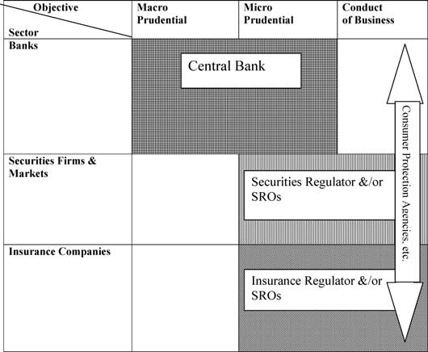

Figure 1: The Traditional Structure of Financial Supervision.

condition of their broker-dealer. The emphasis is on early intervention, before in- solvency occurs, in order to transfer client accounts to a stronger institution before the faltering broker-dealer becomes ensnared in bankruptcy proceedings. Because it does not view the rehabilitation of faltering broker-dealers as part of its mission, the SEC places less emphasis than bank regulators on equity capital and has tradi- tionally permitted substantial amounts of subordinated debt as regulatory capital. Although regulators in all three sectors count net worth as part of regulatory cap- ital, the measures of net worth are not comparable because accounting conventions differ markedly across the three sectors. Securities firms practice mark-to-market or fair value accounting. Since assets and liabilities are always valued at current prices, the concept of valuation reserves is entirely irrelevant. Securities regulators tend to favor a high degree of transparency to enhance customer protection and to
improve the efficiency of markets.
The traditional organization of supervision can be summarized in Figure 1.9
Oversight of banks was often (but not always) conducted by the central bank.10

9 These figures depicting alternative regulatory structures are based on diagrams introduced by Kre- mers, Schoenmaker and Wierts (2003).
10 For an historical overview of central banks’ role in supervision see Hawkesby (2000).

Central banks generally conducted both micro and macro prudential surveillance, in part because they might be called upon to act as lender of last resort in the event of a banking crisis. They often shared conduct of business regulation with consumer fraud agencies, industry associations or law enforcement agencies.
Oversight of insurance and securities firms was conducted by specialist regula- tors and/or self-regulatory organizations. Securities firms and insurance companies were generally not subject to macroprudential supervision and, indeed, financial history provides little justification for extending macroprudential regulation to these institutions.
Functional supervision aimed at various aspects of the conduct of business sometimes overlapped this sectoral (or institutional) supervision (see Figure 1). Examples include disclosure regulation, anti-money laundering surveillance and protection against fraud. In large, decentralized economies this structure can be even more complex with regional regulation layered over (or sometimes in lieu of) national regulation. In the U.S., for example, insurance supervision is conducted at the state level, with no national oversight.

IV. THE INTEGRATION OF FINANCIAL SUPERVISION: ALTERNATIVE MODELS

Over the last two decades, 30 countries have formed a unified financial supervisor. Recently, the pace has accelerated. Indeed, twenty-three countries have established a single regulator in the last decade alone (see Figure 2). In the next section, we will discuss the rationales for these institutional innovations, but first we will describe the range of innovations.

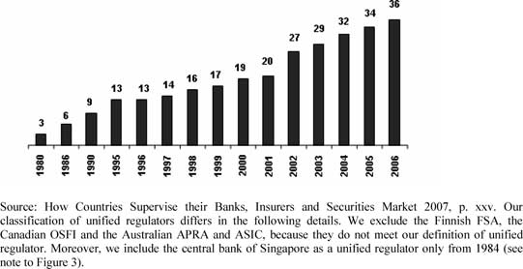

Figure 2: The Cumulative Number of Unified Financial Regulators, by Year.

After Singapore created a unified regulator in 1984, Norway (1986), Denmark (1988) and Sweden (1991) soon followed.11 The most influential reorganization took place in the United Kingdom in 1997. Its role as a major international financial center ensures that supervisory initiatives taken in the U.K. engage the interests of leading financial institutions and supervisors everywhere. Figure 3 describes the structure and the evolution of the organization of supervision in 35 countries.
The details of the reorganization varied from country to country, but usually in- cluded oversight of banks, investment banks, and asset managers. Sometimes they included insurance companies and occasionally finance companies and pension funds as well. In general the integrated financial supervisor was given responsibility for microprudential and conduct of business supervision. Often the responsibility for macroprudential supervision was shared with other official agencies, especially the central bank. Sometimes the integrated financial supervisor was housed in the central bank, but more often it was not.
Four basic supervisory models can be identified. Supervision can be organized (1) by sector, (2) by objective, or (3) by function.12 Alternatively, all supervision can be combined in a single (or unified) financial regulator13 that has responsibility for both microprudential and conduct of business supervision for all financial institutions and activities (see Figure 4). Within a single regulator, the nature and intensity of supervision may vary based on the systemic importance of a financial institution and the sophistication of its customers. Large, systemically important institutions with retail customers would receive the greatest scrutiny. Small institutions with predominantly wholesale customers, in contrast, would be supervised with a very light touch (see Figure 5).
Sometimes the term “integrated regulator” is distinguished from single or uni- fied regulator. An integrated regulator has responsibility for only microprudential supervision or conduct of business supervision, but not both. The “twin peaks” model is an example of integrated regulation.14 Figure 6.A illustrates a version of this model in which micro and macroprudential supervision are combined and housed inside the central bank.
As shown by Figure 3, European countries have adopted a variety of supervi- sory structures. Fourteen of the 27 EU countries have adopted a single financial regulator, even though they have implemented it in different ways. In 10 countries

11 For details regarding the organization of supervision in north-European countries see Taylor and
Fleming (1999), Bjerre-Nielsen (2005), and Bonde (2005).
12 The model “by function” has found limited application, with the notable exceptions of the U.K. before the introduction of the single regulator and certain aspects of regulation by the SEC in the U.S. Merton (1992) has argued that functions performed by financial intermediaries are more stable than the institutions that perform them, so supervision should focus on functions rather than types of intermediaries.
13 For a detailed analysis of alternative supervisory models, see for example Di Giorgio and Di Noia
(2001). For additional discussion of unified financial regulators see Mwenda (2006).
14 See Taylor (1995). The twin peaks model is integration by objectives. Another option for integration is by sector, in which one authority is responsible for two of the three sectors, while the third sector is supervised by a different authority.

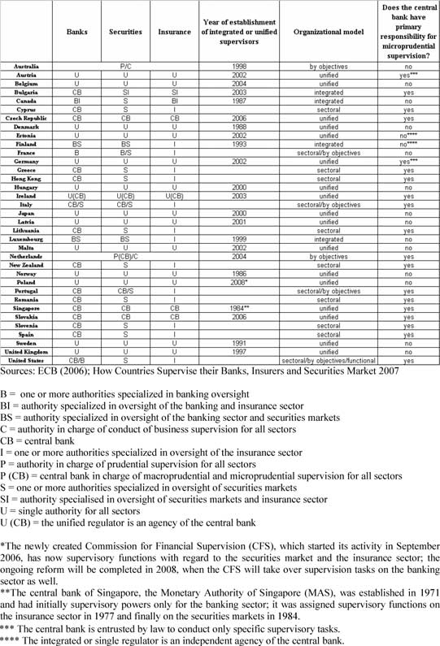

Figure 3: Supervisory Architectures in 35 countries (2006).

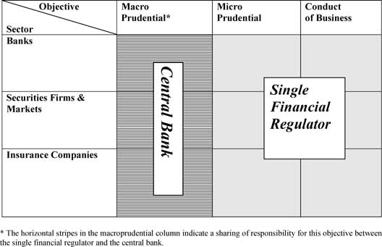

Figure 4: The Single Regulator Model.

(Austria, Belgium, Denmark, Germany, Hungary, Latvia, Malta, Poland, Sweden, United Kingdom) the unified supervisor is separated from the central bank, while in 4 countries either the central bank is the single regulator (Czech Republic, Slovakia) or the single regulator is an agency of the central bank (Ireland) or an independent agency affiliated with the central bank (Estonia). Of the remaining 13 countries, 6 follow the sectoral approach (Cyprus, Greece, Lithuania, Romania, Slovenia, Spain), 3 introduced an integrated, sectoral model (Bulgaria, Finland and Luxembourg), and 3 have combined regulation by sector with regulation by objectives (France, Italy and Portugal). Finally, the Netherlands chose the twin peaks model, with the central bank responsible for macro and microprudential supervision (see Figure 6A).

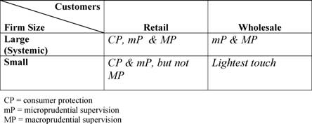

Figure 5: Supervisory Differences Based on Size & Customer Sophistication.

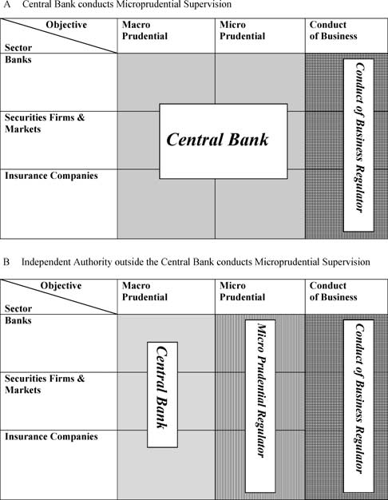

Figure 6: The Twin Peaks Model (A) Central Bank conducts Microprudential Supervision (B) Independent Authority outside the Central Bank conducts Microprudential Supervision.

Australia adopted a different kind of twin peaks model in which the prudential supervisor, the Australian Prudential Regulation Authority (APRA), is located out- side the central bank and another independent authority, the Australian Securities and Investments Commission (ASIC), performs conduct of business regulation (see Figure 6B).
Japan has also had a single regulator outside the central bank since 2000. Hong
Kong and New Zealand follow the sectoral approach and in Singapore the central

bank is the unified regulator. Since 1987 Canada has integrated the supervision of banks and insurance companies in the Office of the Superintendent of Financial Institutions. In Canada, as in the U.S., where supervision by objective is mixed with sectoral and functional supervision,15 the supervisory structure is complicated by the presence of both federal and state (or provincial) authorities.
The U.K. adopted the single regulator model, housed outside the central bank (like Figure 4). Beginning in 1997, the U.K. consolidated 9 different regulatory entities into the Financial Services Authority (FSA).16 The FSA is the sole supervi- sory authority for microprudential and most conduct of business issues, but it shares macroprudential oversight with the Bank of England (and with Her Majesty’s Trea- sury (HMST)). The FSA has tended to focus on the fifty largest financial firms in the three combined sectors for prudential supervision. Other firms are supervised mainly to protect consumers and enforce compliance with conduct of business regulations and codes.
The Bank of England, FSA & HMT have monthly meetings to address mutual concerns, assess threats to financial stability, recommend measures to reduce risks and prepare to manage financial crises. The Bank of England retains primary responsibility for macrostability and controls the lender-of-last resort function, but must consult with HMT if taxpayer funds are to be put at risk.
The German Bundesanstalt fu¨ r Finanzdienstleistungsaufsicht (BaFin) has im- plemented a different approach to integration. The three sectoral agencies remain more or less intact within the BaFin with separate directorates in charge of banks, insurance activities and securities/asset management activities. In addition, three cross-sectoral departments were created (International/Financial Markets, Con- sumer and Investors Protection/Certification of Pension Contracts, Integrity of the Financial System). Only the International/Financial Markets division, however, has been explicitly assigned supervisory tasks with regard to financial conglomer- ates.17 The BaFin shares responsibility for oversight of banks with the Bundesbank, which remains independent from the BaFin.
Regulators in the Netherlands have implemented the “twin peaks” version of the integrated supervisory model, which separates conduct of business supervision from macroprudential and microprudential supervision. The Dutch Central Bank is responsible for both macroprudential and microprudential oversight of firms in all three sectors and the newly established Authority for Financial Markets has responsibility for supervision of conduct of business issues in all three sectors.

15 For example, the SEC acts not only as a sectoral supervisor, but also as a functional supervisor that cuts across institutions. Similarly the CFTC is a functional supervisor, while the FED has significant consumer protection responsibilities.
16 The FSA, however, received its full range of supervisory powers on December 1, 2001, when the
Financial Services and Markets Act (2000) came into force.
17 On the internal organization of the BaFin see Schu¨ ler (2005), who identifies cross-sector integration in the financial industry and the growing importance of “Allfinanz” (one-stop financial services) as the main drivers for the introduction of the single regulator in Germany; the author also uses data on cross-industry M&A in the period 1990–1999 and market share of financial conglomerates to show that the degree of cross-industry integration has been significant in Germany.

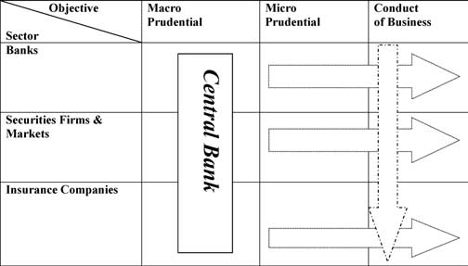

Figure 7: The Gramm-Leach-Bliley Model.

In the United States, the recent financial modernization legislation, the Gramm- Leach-Bliley Act of 1999 (GLBA), created a new organizational architecture for oversight of financial conglomerates. GLBA established a new category of finan- cial service holding companies for firms that wished to combine banking activities with securities or insurance activities. The financial services holding company would be subject to prudential oversight by the Federal Reserve, while specialist sectoral supervisors would retain responsibilities for microprudential supervision of the individual entities in their sector. Moreover, existing functional supervisors
– for example, the Treasury with regard to money laundering regulations and the SEC with regard to disclosure regulations for publicly traded securities – would continue to oversee particular functions (see Figure 7).
For most nonbanks the anticipated gains from operating a financial conglomerate do not appear to have been sufficient to overcome the prospective costs of prudential oversight by the Federal Reserve Board because only two – the securities firm, Charles Schwab, and the insurer, MetLife – have chosen to establish financial services holding companies. All other financial service holding companies have been established by banks, whose holding companies were already subject to prudential oversight by the Federal Reserve Board.

V. RATIONALES FOR THE INTEGRATION OF SUPERVISION

Why have several countries abandoned the traditional, sectoral model in favor of integrated financial supervision? What is the advantage to forming an integrated financial supervisor?18 Three main rationales are frequently offered. First is the

18 See also Abrams and Taylor (2000).

need to respond to the convergence of lines of business across sectors to prevent inconsistencies or gaps in oversight. Innovations in products and institutions have tended to blur the traditional boundaries between sectors. Advances in information technology and financial knowledge have enabled producers of financial services to create close substitutes for profitable products that were once the exclusive domain of financial institutions in another sector. Boundaries separating institutions could have been maintained by strengthening regulation, but heightened international competition in goods and services placed pressure on governments to liberalize regulations to reduce the cost of financial services.
Some firms responded to these forces by forming financial conglomerates that combined banking with investment banking or insurance activities or both. The prospect of achieving economies of scope appears to have influenced corporate strategy in some major markets, although the realized gains have been difficult to quantify. For example, in the Netherlands, financial conglomerates control 90 percent of banking, 70 percent of securities activities and 60 percent of the in- surance market (Kremers, Schoenmaker and Wierts, 2003, p. 230). Nonetheless, cross-sector mergers and acquisitions (M&A) have not trended upwards in the period 2000–2006. Moreover, cross-sector M&A in Europe and the United States continues to be small relative to within-industry M&A, whether measured by value or number of deals (See Figures 8 and 9).19
Although many firms have expanded into other lines of business across sectors, most are still firmly anchored in their original core business in a single sector. Nonetheless, even though sectoral differences remain significant, the rise of fi- nancial conglomerates intensifies questions about the efficiency and equity of the traditional, sectoral approach to supervision. When applied to conglomerates, this approach may lead to substantial overlaps in supervisory efforts with correspond- ingly heavy compliance costs for conglomerates as they supply similar (but seldom identical) information to multiple supervisors.
The sectoral approach may also give rise to gaps in oversight if some of the activities of the conglomerate fall outside the scope of the sectoral supervisors. Given the size of most conglomerates, macroprudential concerns inevitably arise. Whether specialist, sectoral supervisors can provide adequate oversight for a con- glomerate managed in an integrated fashion remains an open question. In addition, differences in supervision across sectors inevitably raise questions about compet- itive equity.
The German draft legislation20 to establish the BaFin explicitly cited the ra-
tionale of convergence of lines of business across sectors, noting that “Banks, insurance companies, and securities firms are now competing in the same markets

19 Note that the increase in the percentage of cross-sector M&A in terms of number of deals in the period 2000–2006 relative to 1990–1999 is due mainly to a significant reduction of number of within- sector deals in the banking and insurance sector, not to an increase in the number of cross-sector deals. For a detailed analysis of M&A in the financial sector in Europe and the United States from 1985 to
2002, see Walter (2004).
20 As quoted by Clive Briault (2002, pp. 7–8).

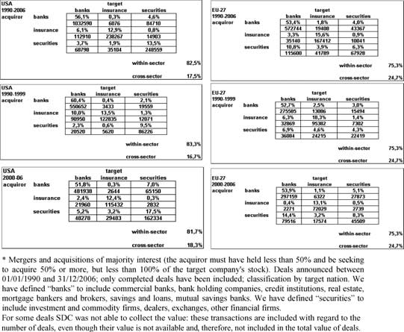

Figure 8: Value of M&A∗ Deals in the Financial Sector in the United States and
Europe, 1990–2006 (percent and millions of U.S. dollars).

for the same customers, with similar and often identical products and with the same distribution channels ... .” Moreover, in a survey of supervisors in 15 coun- tries21 that adopted integrated or unified regulators, De Luna Martinez and Rose (2003) report that 14 out of the 15 indicated the need to better supervise a finan- cial system in which convergence of lines of business across sectors was growing. They also showed that the market share of financial conglomerates in these coun- tries increased from 1990 to 2001, especially in the banking and in the insurance industry.22
A second commonly cited rationale for integrating supervision is to level the regulatory playing field. Consistency in rule-making and oversight will eliminate opportunities for regulatory arbitrage across sectors and eliminate the possibility that firms in one sector can gain market share at the expense of firms in another

21 Australia, Canada, Denmark, Estonia, Hungary, Iceland, Korea, Latvia, Luxembourg, Malta, Mexico, Norway, Singapore, Sweden, and the United Kingdom.
22 De Luna Martinez and Rose (2003) show that the market share of conglomerates in the banking sector increased from 53% in 1990 to 71% in 2000. For insurance, the comparable increase was from
41% to 70%. And, for the securities industry, the comparable increase was from 54% to 63%.

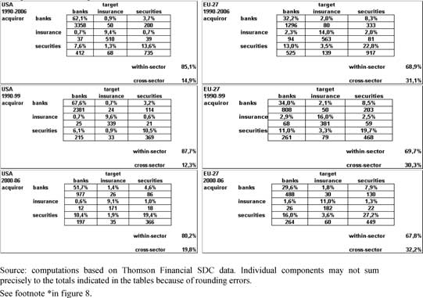

Figure 9: Number of M&A∗ Deals in the Financial Sector in the United States and Europe, 1990–2006 (percent and number of deals).

sector because of regulatory advantages. Whether competitive equity should be an objective of regulatory reform is open to question,23 but it has often appeared to be the primary motive for reform.
The third rationale for the integration of supervision is efficiency in oversight and compliance. With less duplication of supervisory effort and the potential for achieving economies of scale and scope in the production, transmission and inter- pretation of information, it should be less costly to produce supervisory services under one roof. Similarly, if supervised firms can provide information once in one integrated format, compliance costs should diminish. Like economies of scope in the production of financial services, economies of scope in supervision are difficult to verify empirically. Cˇ iha´k and Podpiera (2006) found no evidence that super- visory integration brings costs reduction in terms of the number of employees in supervisory organizations.24 Of course, the appropriate measure of cost should include much more than the regulatory head count. It should encompass all of the direct costs of regulation borne by the supervisory authorities as well as the direct

23 See, for example, Herring and Litan (1995, pp.151–152).
24 The authors conjecture that too little time may have passed since the establishment of many of the integrated authorities to observe a decrease or that cost savings may not be realized because new tasks have been assigned to the new integrated supervisors.

and indirect costs borne by the supervised entities and the consumers of financial services.25
Some proponents of the integrated supervisor model also advance a fourth ratio- nale: that separating macroprudential oversight from microprudential and conduct of business oversight can improve outcomes for all three kinds of supervisory objectives. The hypothesis is that financial stability would be enhanced if cen- tral banks focus solely on macroprudential supervision without the distractions of microprudential concerns or conduct of business issues. Similarly, customer protection would improve if the integrated supervisor focuses on the conduct of business rather than the solvency of individual firms or macroprudential issues.
While there is certainly a presumptive case for clarity and focus in supervi- sory organizations, conflicts among objectives will inevitably arise. The question then becomes whether trade-offs can be managed more effectively within or be- tween supervisory agencies. Decisions can be made more readily when they take place within an organization that can deploy a full range of institutional incen- tives to reach agreement. But decisions taken within an agency are often opaque. Transparency and therefore accountability for such decisions may be enhanced if conflicts occur between agencies.

VI. CONCERNS ABOUT THE TREND

The move toward widespread adoption of the single supervisor model has raised some concerns, however. First is the threshold question of whether integrated su- pervision is feasible. Is it possible, for example, to treat the fifty largest firms in exactly the same way regardless of the sector in which each firm conducts its pri- mary line of business? While there has been a definite blurring of the lines between financial institutions, sectoral differences still do matter. Differences in account- ing conventions, for example, defy meaningful consolidation of insurance business with banking and investment banking activities. Very few financial conglomerates actually run an insurance business in a totally integrated fashion with a banking business. This raises the question of whether oversight should be integrated even when the businesses are not.
A second concern is whether a single supervisor can strike an appropriate balance between conduct of business supervision and microprudential or macroprudential supervision. Typically conduct of business issues are more politically charged and publicly visible than the necessarily confidential microprudential problems in financial services firms. Will conduct of business objectives tend to dominate over time?
A third, related concern is potential cultural conflicts within a single supervisor. As noted above, lawyers tend to dominate in the supervision of conduct of business rules, while economists tend to dominate in the supervision of macroprudential issues. The U.S. experience with the SEC suggests that when conduct of busi-

25 See Alfon and Andrews (1999), Briault (2003), and Franks, Schaefer and Staunton (1998). For empirical work on the direct costs of regulation see Coffee (2007) and Jackson (2005).

ness issues are the primary objective, lawyers will shape the supervisory culture and control the supervisory agenda and even the information the agency collects. Whether this is welfare enhancing is open to question.
A fourth concern is that a single supervisor, with monopoly supervisory pow- ers, may be more inclined to over-regulate. The possibility for users of financial services to shift from one firm to a differently regulated firm and the possibility for firms to shift regulators protects against the arbitrary or excessively burden- some regulation. The argument for regulatory competition is made most often by scholars in the United States,26 which gives rise to the suspicion that it is mainly an ex post rationale for the complex and overlapping U.S. regulatory system. Yet the numerous financial innovations that have started in the United States over the last 50 years are consistent with the concept of regulatory competition.
A fifth and closely- related concern is whether a single supervisor with monopoly powers may be less flexible over time. If we were certain about what the rules should be and how they should be enforced, then an integrated supervisor would have obvious efficiency advantages.27 But if we are uncertain about optimum reg- ulations and how they may change over time, an integrated supervisor may achieve static efficiency gains at the cost of dynamic efficiency. A degree of regulatory competition may enhance the efficiency of the financial system over the long run by increasing the likelihood that regulations will be responsive to changing circumstances.
Both of these concerns regarding the implicit monopoly powers of an integrated supervisor have less force in an open economy without capital controls or restric- tions on entry by foreign financial institutions. International competition among regulators can achieve many of the gains associated historically with domestic regulatory competition in the United States.

VII. THE INTEGRATION OF FINANCIAL SUPERVISION AND THE CENTRAL BANK

Given the case for integrating supervisory powers, how should the new entity re- late to the central bank? Wherever it is located, close cooperation with the central bank is essential because microprudential supervision requires an understanding of the macroeconomic context and macroprudential supervision requires an un- derstanding of systemically important institutions and markets. Moreover, the for- mulation and implementation of monetary policy benefits from an understanding of financial markets and institutions. The Federal Reserve Board insists that with- out direct involvement in microprudential oversight of banks, its monetary policy would suffer and it would be less able to manage the full range of crises from bank failures to terrorist incidents. The Chairman of the Federal Reserve Board, Ben Bernanke (2007), has reiterated the case recently arguing that “[T]he information,

26 See, for example, Coffee (1995) and Scott (1977).
27 Similarly, if we were certain about what level market prices should be, there may be efficiency gains from a centrally planned economy.

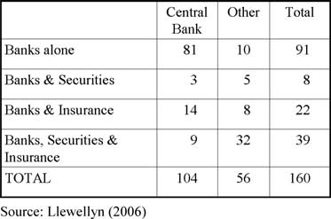

Figure 10: The Supervisory Role of Central Banks in 160 Countries.

expertise, and powers that the Fed derives from its supervisory authority enhance its ability to contribute to efforts to prevent financial crises; and, when financial stresses emerge and public action is warranted, the Fed is able to respond more quickly, more effectively, and in a more informed way than would otherwise be possible.”
If cooperation between the microprudential supervisor and the central bank is critical, why not concentrate supervisory powers in the central bank? Although central banks are involved in supervision in a majority of countries (see Figure 10), very few countries have established a single regulator in the central bank.28
A number of rationales have been advanced for placing microprudential pow- ers outside the central bank. Goodhart and Shoenmaker (1995) have noted that macroeconomic objectives may conflict with microprudential objectives. For ex- ample, the monetary authority may be hesitant to impose the appropriate degree of monetary restraint out of concern for the solvency of the banks that it super- vises.29 Bernanke (2007) denies the relevance of this concern in the United States arguing that “U.S. monetary policy has been quite successful for some time, and I am not aware of any evidence that monetary-policy decisions have been dis- torted because of the Fed’s supervisory role”.30 He notes that although research on the value of supervisory information in the formulation of monetary policy has yielded mixed conclusions, the Federal Reserve’s experience suggests “[T]hat

28 Masciandaro (2004, 2005, 2006) termed this phenomenon as the “central bank fragmentation effect”. He also finds that the probability that a country adopts a unified regulator is higher the smaller the financial system, the more equity dominated the private governance model and the higher the standards of public governance. Moreover, the probability seems to be higher in Civil Law countries, especially if the legal framework has German or Scandinavian roots.
29 Di Giorgio and Di Noia (1999) found evidence of a higher and more volatile inflation rate in countries where the central bank has sole responsibility for bank supervision.
30 The European Central Bank does not have responsibility for microprudential or macroprudential supervision. See, for example, Eijffinger (2005).

supervisory information is likely to be most useful for monetary policymaking in times of financial stress.”
Goodhart (2000) raises an additional concern regarding the possibility of a con- tagious loss of reputation risk. Experience in several leading economies during the
1970s has demonstrated the heavy cost to real economy of a loss in confidence in the monetary authority. The U.S., for example, endured a double-dip recession and very high real interest rates for a number of years in the 1980s before confidence was restored in the Federal Reserve’s commitment to a low inflation rate. If the cen- tral bank is responsible for both monetary policy and microprudential supervision, it is possible that a highly visible failure in the latter may undermine confidence in the former. As Goodhart notes, successes in microprudential supervision are usually confidential while “failures” receive considerable adverse publicity – even when they should be regarded as evidence that the microprudential supervisor is performing its job effectively.31
Concerns about excessive concentration of power in an independent, unelected body may also lead to the establishment of a single supervisor outside the cen- tral bank. It may not be coincidental that the shift of microprudential supervision outside the central bank occurred more or less at the same time that central banks gained greater independence in monetary policy. Padoa Schioppa (2003, p. 168) observed that the prospect of combining unified supervisory powers in the cen- tral bank raises concerns about concentration of power and conflicts of interest. Although he acknowledges that this is probably the strongest argument against the central bank taking on the role of single regulator, he questions its practical relevance.
The most serious concern, however, may be that the formation of an integrated microprudential supervisor within the central bank may intensify pressures to ex- tend the safety net to nonbank financial institutions. This is particularly worrisome in countries where the central bank has extended support to faltering banks (re- gardless of proclamations to the contrary) and resolution tools are cumbersome to deploy.
This problem may be even more acute in emerging markets, where supervision of banks is weak and supervision of nonbanks is virtually nonexistent. In an effort to meet international standards, a country may establish a single supervisor. For reasons of cost and related expertise, it is likely to be housed in the central bank. But this may convey the implication that nonbank institutions will receive bank-like protection.
When the capacity to undertake a bailout is combined with the responsibility for microprudential oversight, it may be politically difficult to favor some kinds of institutions over others. It is hard to persuade the public that some of the institutions that a central bank supervises are less likely to receive support in the event of financial distress than others.

31 Goodhart (2000) also notes that a central bank may have the resources and discretion to sustain an insolvent institution even when it should be resolved. It may be motivated to do so out of concern for its reputation.

These are all principled rationales for placing the microprudential supervisor outside the central bank and they may well have influenced decisions to do so. But J. P. Morgan once observed that all men have two reasons for taking action – a good reason and the real reason. The same may be true of institutions as well. In several cases the removal of microprudential powers from the central bank came after one or more notable lapses in supervision or, more generally, in the wake of a financial disaster.
The main concern about establishing the microprudential supervisor outside the central bank is whether it will be able to cooperate effectively with the central bank during a crisis. Crisis management requires rapid transmission and interpretation of information. In principle, interagency cooperation could ensure that information flows between agencies as readily as within agencies. In the U.S., however, several incidents have raised questions about how effective cooperation may be in practice. In two recent cases coordination problems across supervisors have exacerbated losses to the deposit insurer. In 2001, the Office of Thrift Supervision banned the FDIC from participation in the examination of an insolvent bank. A similar problem occurred between the Office of the Comptroller of the Currency and the FDIC with regard to the First National Bank of Keystone West Virginia.
Since crisis management often requires overcoming coordination and collective action problems, this is a serious concern. An interagency crisis management committee may not function as effectively as an institution that can deploy the full range of bureaucratic incentives to make decisions and initiate actions.
No major country has sustained a significant crisis after the formation of a single supervisor outside the central bank. While it may be tempting to conclude that the organizational change has enhanced supervision to such an extent that crises will no longer occur, that would surely be unwarranted. We simply don’t know how well interagency cooperation can substitute for a central bank with microprudential responsibilities and so in this respect, at least, the new configuration must be regarded as untested.

VIII. THE ISSUE OF INDEPENDENCE

Recent history has provided a number of instances in which political interference in macro and microprudential supervision have precipitated or exacerbated crises. Examples would include the U.S. S&L crisis, experiences in several countries during the debt crises in the 1980s, the 1990s in Japan, 1997 in much of Asia and Argentina in 2001.
Independence has multiple dimensions.32 Regulatory independence connotes
the discretion to set and change rules within broad guidelines. Supervisory inde- pendence requires budgetary independence, appropriate levels of compensation, and protection against personal liability for supervisory actions. Institutional inde- pendence of the integrated supervisor from the executive hierarchy and legislative

32 See Quintyn and Taylor (2002).

control should yield better transparency, facilitate the accumulation of expertise and enhance the efficiency and stability of financial markets and institutions. But independence without accountability can lead to arbitrary and abusive exercise of regulatory power. Moreover, insulation from public accountability can facilitate regulatory capture, in which regulated firms exercise undue influence over the integrated supervisor. The main safeguard against these potential problems is to establish clear accountability for the conduct of the integrated financial supervisor and require a high degree of transparency.33
The FSA has set a laudable standard for transparency in rule making. The FSA submits each new proposed regulation to a two part test: (1) Is there a market fail- ure? (2) And, if so, is it worth mitigating? In short, do the benefits of implementing the regulation exceed the compliance costs? Ideally, this cost-benefit test should be publicly disclosed and audited by another agency. This approach should deter over regulation and will help clarify the trade-offs involved in achieving regulatory objectives.

IX. CONCLUDING COMMENTS

Do global financial conglomerates require an integrated global supervisor? Many of the same arguments that are made for establishing a national, integrated super- visor to deal with domestic financial conglomerates have equal force with regard to international financial conglomerates. In principle, an integrated global super- visor could achieve significant efficiency gains in oversight and compliance and would level the playing field. Of course, no serious proposals have been made to establish a global, integrated supervisor. Even though the European Union is engaged in a series of efforts to achieve cross-country harmonization within each sector – CESR, CEBS, and CEIOPS – discussion of an integrated EU supervisor is quite speculative.
Nonetheless, there has been considerable effort to coordinate the activities of home and host supervisors. The Basel Committee on Banking Supervision fos- ters cooperation among banking supervisors. The International Organization of Securities Commissions plays a similar role in the securities industry. And the International Association of Insurance Supervisors facilitates international coop- eration among insurance supervisors. Cross-sectoral issues are addressed in the Joint Forum. Anyone who has had the experience of dealing with the multiple U.S. regulators in any of these coordinating bodies will readily see the advantage for international negotiations in establishing a single or integrated supervisor in each country.
The impetus for reorganizing financial supervision is often a financial crisis or at least a financial scandal that was perceived to reveal weaknesses in the existing supervisory structure.34 In the United States, for example, the stock market crash of

33 See Hu¨ pkes, Quintyn and Taylor (2005) regarding the accountability issue. For a cross-country study of supervisory independence and accountability, see Quintyn, Ramirez and Taylor (2007).
34 See Petschnigg (2005).

1929 and its aftermath led to the introduction of functional regulation for securities activities. Outside the United States over the last decade the response has often been either the creation of a single regulator (e.g., Japan, Latvia, South Korea and the United Kingdom) or the establishment of an integrated regulator (e.g., Finland). In each case officials undoubtedly believed that they were strengthening regulation.35
However, as Carmichael observes (2004, pp. 95–96), “restructuring in response to regulatory failure is probably the weakest grounds for reform.... New structures do not guarantee better regulation. More appropriate structures may help but, fundamentally, better regulation comes from stronger laws, better-trained staff and better enforcement”.
During normal times, with stable economic and financial conditions, many al- ternative supervisory models appear to function well. The integrated supervisor, located outside the central bank, has the potential to achieve economies of scope in the collection and analysis of information and to mitigate conflicts of interest and moral hazard problems. But what matters most is how this model will perform in a crisis. The recent experience with the run on Northern Rock in the UK suggests that crisis management by committee may not be an adequate substitute for the traditional model in which macro- and micro-prudential supervision are combined within the central bank.
If the central bank retains significant lender-of-last-resort and crisis management responsibilities, it may be unwise to split micro- from macroprudential supervi- sion. But if the central bank does not have this role or if the Ministry of Finance or Treasury will take the leading role in any major crisis, it may not matter where the integrated supervisor is located. In any event, the organization of financial super- vision surely matters less than the number and quality of supervisory personnel, their policies and procedures, their independence from political pressures and their accountability for meeting regulatory objectives.36

X. REFERENCES
Abrams, Richard and Michael Taylor. 2000. “Issues in the Unification of Financial
Sector Supervision,” IMF Working Paper 00/213.
Alfon, Isaac and Peter Andrews. 1999. “Cost-Benefit Analysis in Financial Reg- ulation – How to do it and how it adds value,” Financial Services Authority, Occasional Paper Series.
Allen, Franklin and Richard Herring. 2001. “Banking regulation vs. securities market regulation,” The Wharton Financial Institutions Center, working paper n. 01–29.

35 Taylor and Quintyn (2007, pp. 8–9) refer to this phenomenon as to the “institutional strengthening”
argument.
36 Goodhart (2000) has made a persuasive case that in emerging markets the number and quality of personnel and independence are likely to be greater if the integrated supervisor is housed in the central bank.

Bernanke, Ben. 2007. “Central Banking and Bank Supervision in the United States,” Remarks before the Allied Social Sciences Association Annual Meet- ing, Chicago, January 5.
Bjerre-Nielsen, Henrik. 2005. “Denmark,” in Handbook of Central banking and Financial Authorities in Europe: New Architectures in the Supervision of Fi- nancial Markets, edited by Donato Masciandaro, Cheltenham: E. Elgar Pub., pp. 175–181.
Bonde, Ingrid. 2005. “Sweden,” in Handbook of Central banking and Finan- cial Authorities in Europe: New Architectures in the Supervision of Financial Markets, edited by Donato Masciandaro, Cheltenham: E. Elgar Pub., pp. 182–
202.
Borio, Claudio. 2003. “Towards a macroprudential framework for financial super- vision and regulation?,” BIS working papers no. 128, February.
Briault, Clive. 2002. “Revisiting the Rationale for a Single National Financial
Services Regulator,” Special Paper 135, LSE.
Briault, Clive. 2003. “The costs of financial regulation,” Conference on Regulation and Supervision of Financial Markets and Institutions in the EU, Mannheim, July 10.
Caprio, Gerard and Daniela Klingebiel. 1996. “Bank Insolvency: Bad Luck, Bad Policy or Bad Banking?,” Annual World Bank Conference on Development Economics.
Carmichael, Jeffrey. 2004. “Australia’s Approach to Regulatory Reform,” in Aligning Financial Supervisory Structures with Countries Needs, edited by Jeffrey Carmichael, Alexander Fleming and David Llewellyn, World Bank Institute.
Cˇ iha´k, Martin and Richard Podpiera. 2006. “Is One Watchdog Better than Three? International Experience with Integrated Financial Sector Supervision,” IMF Working Paper 06/57.
Coffee, John. 1995. “Competition versus consolidation: the significance of organi- zational structure in financial and securities regulation,” in The Business Lawyer
50, February.
Coffee, John. 2007. “Law and the Market: the Impact of Enforcement,” Columbia
Law and Economics Working Paper, n. 304, March.
De Luna Mart´ınez, Jose´ and Thomas Rose. 2003. “International Survey of Inte- grated Financial Sector Supervision,” World Bank Policy Research Working Paper 3096, July.
Di Giorgio, Giorgio and Carmine Di Noia. 1999. “Should banking supervision and monetary policy tasks be given to different agencies?,” in International Finance, Blackwell, 2, n.3, pp. 361–378.
Di Giorgio, Giorgio and Carmine Di Noia. 2001. “Financial Regulation and Su- pervision in the Euro Area: A Four-Peak Proposal,” The Wharton Financial Institutions Center, working paper n. 01–02.
Eijffinger, Sylvester. 2005. “The European Central Bank and Financial Supervi- sion,” in Handbook of Central banking and Financial Authorities in Europe:

New Architectures in the Supervision of Financial Markets, edited by Donato
Masciandaro, Cheltenham: E. Elgar Pub., pp. 457–484.
European Central Bank, 2006. “Recent developments in supervisory structures in
EU and acceding countries,” October.
Franks, Julian, Stephen Schaefer, and Michael Staunton. 1998. “The direct and compliance costs of financial regulation,” Journal of Banking & Finance 21:
1547–1572.
Freshfields Bruckhaus Deringer, 2007. “How Countries Supervise their Banks, Insurers and Securities Markets 2007,” Central Banking Publications.
Goodhart, Charles and Dirk Shoenmaker. 1995. “Should the Functions of Mone- tary Policy and Banking Supervision Be Separated?,” Oxford Economic Papers
47 (October): 539–560.
Goodhart, Charles. 2000. “The Organisational Structure of Banking Supervision,”
FSI Occasional Paper, No. 1, 25 October.
Group of Ten, 2001. “Report on Consolidation in the Financial Sector”.
Half, Cameron and Howell Jackson. 2002. “Background Paper on Evolving Trends in the Supervision of Financial Conglomerates,” working paper, Harvard Law School, June.
Hawkesby, Christian. 2000. “The Institutional Structure of Financial Supervision: A Cost-Benefit Approach,” The Journal of International Banking Regulation 2 (July): 236–254.
Herring, Richard and Robert Litan. 1995. “Financial Regulation in the Global
Economy,” Brookings Institution Press, Washington.
Hu¨ pkes, Eva, Marc Quintyn, and Michael Taylor. 2005. “The Accountability of
Financial Sector Supervisors: Principles and Practice,” IMF Working Paper
05/51.
Jackson, Howell. 2005. “Variation in the intensity of financial regulation: pre- liminary evidence and potential implications,” Harvard Law and Economics Discussion Paper n. 521, August.
Kremers, Jeroen, Dirk Shoenmaker, and Peter Wierts. 2003. “Cross-Sector Supervision: Which Model?,” in Brookings-Wharton Papers on Financial Services: 2003, edited by Richard Herring and Robert Litan, pp. 225–
243.
Llewellyn, David. 2005. “Integrated Agencies and the Role of Central Banks,” in Handbook of Central banking and Financial Authorities in Europe: New Archi- tectures in the Supervision of Financial Markets, edited by Donato Masciandaro, Cheltenham: E. Elgar Pub., pp. 109–140.
Llewellyn, David. 2006. “Institutional Structure of Financial Regulation: the Basic Issues,” paper presented at the World Bank and IMF confer- ence Aligning Supervisory Structures with Country Needs, Washington DC, June 5–6.
Masciandaro, Donato. 2004. “Unification in financial sector supervision: the trade off between central bank and single authority,” Journal of Financial Regulation and Compliance 12, n. 2: 151–169.

Masciandaro, Donato. 2005. “Central Banks and Single Financial Authorities: Economics, Politics and Law,” in Handbook of Central banking and Finan- cial Authorities in Europe: New Architectures in the Supervision of Financial Markets, edited by Donato Masciandaro, Cheltenham: E. Elgar Pub., pp. 67–
105.
Masciandaro, Donato. 2006. “Reforms of financial supervision regimes and central banks: exploring the nexus,” paper presented at the IMF Macropru- dential Supervision Conference: Challenges for Financial Supervisors, Seoul, November.
Merton, Robert. 1992. “Operation and Regulation in Financial Intermediation: a Functional Perspective,” Harvard Graduate School of Business Working Paper, n. 93–020.
Mwenda, Kenneth. 2006. “Legal aspects of financial services regulation and the concept of a unified regulator,” Law, Justice, and Development Series, The World Bank.
Padoa Schioppa, Tommaso. 2003. “Financial supervision: inside or outside cen- tral banks?,” in Financial Supervision in Europe, edited by Jeroen Kremers, Dirk Shoenmaker and Peter Wierts, Cheltenham: E. Elgar Pub., pp. 160–
175.
Petschnigg, Reinhard. 2005. “The institutional framework for financial market policy in the U.S.A. seen from an EU perspective,” ECB Occasional paper, n.
35, September.
Quintyn, Marc, Silvia Ramirez, and Michael Taylor. 2007. “The Fear of Free- dom: Politicians and the Independence and Accountability of Financial Sector Supervisors,” IMF Working Paper 07/25.
Quintyn, Marc and Michael Taylor. 2002. “Regulatory and Supervisory Indepen- dence and Financial Stability,” IMF Working Paper 02/46.
Quintyn, Marc and Michael Taylor. 2007. “Building Supervisory Structures in Sub-Saharan Africa – An Analytical Framework,” IMF Working Paper
07/18.
Scott, Kenneth. 1977. “The Dual Banking System: a Model of Competition in
Regulation,” Stanford Law Review 30, n.1: November.
Schu¨ ler, Martin. 2005. “Germany,” in Handbook of Central banking and Finan- cial Authorities in Europe: New Architectures in the Supervision of Financial Markets, edited by Donato Masciandaro, Cheltenham: E. Elgar Pub., pp. 288–
310.
Taylor, Michael. 1995. “Twin Peaks: a Regulatory Structure for the New Century,”
December, London, Center for the Study of Financial Innovation.
Taylor, Michael and Alex Fleming. 1999. “Integrated Financial Supervision: Lessons from Northern European Experience,” Policy Research Working Paper n.2223, World Bank, Washington.
Walter, Ingo. 2004. “Mergers and Acquisitions in Banking and Finance: What
Works, What Fails and Why?,” Oxford University Press.

XI. NOTES ON CONTRIBUTORS/ACKNOWLEDGMENTS

Richard Herring is Jacob Safra Professor of International Banking and Professor of Finance at The Wharton School, University of Pennsylvania where he is also Co-Director of The Wharton Financial Institutions Center. Outside the University he serves as Co-Chair of the U.S. Shadow Financial Regulatory Committee. He is the author of more than 90 articles, monographs and books on various topics in financial regulation and international finance.

Jacopo Carmassi is a visiting scholar at the Wharton Financial Institutions Center and a PhD candidate in Law and Economics at the University Luiss Guido Carli, Rome.

