Oxygen Uptake Kinetics Following Six Weeks of Interval and
Continuous Endurance Exercise Training –
An explorative pilot study

CCF CCFlag CCFmax  CON | [s] [a.u.] | cross-correlation function lag of CCFmax  maximum (peak) of cross-correlation function  continuous
HR | [min-1] | heart rate
INT |  | interval
POST |  | after
PRE |  | before
PRBS |  | pseudo-random binary sequence
Q’ | [L·min-1] | cardiac output
Q’rem | [mL·min-1] | perfusion of non-exercising tissues
SV | [mL] | stroke volume
τ | [s] | time constant
TD | [s] | time delay
V’O2 | [L·min-1] | oxygen uptake
V’O2peak | [L·min-1] | maximum V’O2 attained during incremental exercise test to exhaustion
V’O2musc | [L·min-1] | exercising muscle oxygen uptake
V’O2pulm | [L·min-1] | pulmonary oxygen uptake
V’O2rem | [L·min-1] | oxygen uptake in non-exercising tissues
Vv | [mL] | venous volume
WR | [W] | work rate

Oxygen uptake (V’O2) kinetics is a key parameter to evaluate the multi-systemic responses of the body to exercise stress (Wasserman 1984; Bassett and Howley 2000). For example, the efficiency of V’O2 kinetics depend on the oxygen (O2) supply and the O2 extraction, and the O2 delivery relies on the capillary density and the amount of muscle perfusion. The O2 extraction is affected by muscle fiber distribution, enzyme activities, and by the number and size of mitochondria (e.g. Hughson, 2009).

To quantify V’O2 kinetics, the time constant tau (τ) can be estimated. The τ is defined as the time to reach 63% of the difference amplitude between two work rate (WR) intensities or as transition from rest to moderate or WR intensities. In this regard, smaller τ of V’O2 imply faster kinetics responses, which in turn reflect a high rate of adenosine triphosphate (ATP) delivery through the aerobic metabolism to the ATP demands during transient exercise. Therefore, faster V’O2 kinetics are associated with increased exercise tolerance. In this regard, improvements in V’O2 kinetics are also linked with greater aerobic capacities (Chilibeck, Paterson, Petrella and Sunningham, 1996) and are speeded as a result of endurance exercise training (e. g. Fukuoka et al., 2002; Murias, Kowalchuk and Paterson,
2010).

V’O2 kinetics are of interest for all kinds of sports with focus on the endurance component of the complex sport specific performance (e.g. Millet et al., 2003; Rodriguez, Keskinen, Keskinen and Malvela, 2003; Hettinga, De Koning and Foster, 2009). Endurance exercise training is also a prevalent treatment for patients suffering from diabetes mellitus (Ivy, 1997), obesity (Boulé, Haddad, Kenny, Wells and Sigal, 2001), arterial hypertension (Guimaraes et al., 2010), and chronic obstructive pulmonary disease (Casaburi et al., 1997). For elderly, endurance exercise training and a speeding of V’O2 kinetics is of relevance for quality of life (Alexander, Dengel, Olson and Krajewski, 2003) as well. Nowadays, training performance and exercise testing is a practical and relevant application, for instance, for astronauts involved in long-term missions staying on the International Space Station (Moore et al., 2014; Hoffmann, Moore, Koschate, and Drescher, 2016).

The mentioned examples comprise different training procedures or methods (e.g. work durations, intensities, repetitions, series, work-to-rest ratios) with its particular objectives. A more fundamental discrimination is interval-type and continuous-type endurance exercise training. Available investigations with focus on only continuous (CON) exercise training reveal that V’O2 kinetics are significantly improved after the training intervention (Hickson, Bomze and Hollozy, 1978; Fukuoka et al., 2002; Zoladz et al., 2014; Phillips, Green, MacDonald and Hughson, 1995). In contrast, investigations with focus on only interval-type

training show a speeding of V’O2 kinetics as well (Christensen et al., 2016; Turnes et al.,

2016a; Turnes et al., 2016b; Jacobs et al., 2013). Furthermore, studies comprising both, interval (INT) and CON exercise training, indicate that either INT (Daussin et al., 2008) or CON (Murias et al., 2010) improve V’O2 kinetics, or both training procedures are equal in speeding of V’O2 kinetics (Berger, Tolfre, Williams and Jones, 2006; McKay, Paterson and Kowalchuk, 2009; Da Boit, Bailey, Callow, DiMenna and Jones, 2014). However, there is no clear consensus, whether INT or CON may provoke superior improvements in V’O2 kinetics.

Concerning this matter and regardless of INT or CON exercise training, the impacts of endurance exercise training can roughly be categorized into adaptations related to capacities and kinetics. Capacities are the maximal limits of the physiological systems involved during exercise, like maximal V’O2, (V’O2peak) maximal heart rate, and maximal cardiac output (Q’). In contrast, the kinetics reflect the speed of adaptation to exercise demands to relative changes, like the dynamic responses of V’O2, heart rate (HR), or Q’ in response to changing metabolic demands during transient exercise.

Both the capacities and the kinetics seem to be interconnected with each other and should not be subdivided into physiological-independent variables or parameters for an isolated evaluation of the endurance performance (Wüst, van der Laarse and Rossiter, 2013). Accordingly, the complex endurance performance depends on both the capacities and the kinetics responses of the cardiopulmonary and respiratory system.

In this context, different cardiopulmonary exercise testing procedures can be applied accounting for either testing at submaximal and maximal levels (e.g. V’O2max testing) or in moderate exercise intensities below gas exchange threshold for kinetics testing. However, kinetics testing can also be applied above gas exchange threshold, which intensifies the complexity of the observed responses (Whipp and Rossiter, 2005).

From a practical point of view, the interest for evaluation of the aerobic metabolism is on the muscle site (Christensen et al., 2016), because adapted mitochondria and the micro-cellular alterations are the predominant explanations for an increased exercise tolerance. In this regard, during non-steady-state conditions, there could be prominent differences between the pulmonary measurement of V’O2 at the mouth and the oxygen consumption at exercising musculature (Grassi et al., 1996; Benson, Grassi, and Rossiter; 2013; Hoffmann, Drescher, Benson, Rossiter, and Essfeld, 2013; Drescher, Koschate, Schiffer, and Hoffmann, 2016). This possible mismatch is based on the time-delaying and distortive effects of venous return which is based on the non-linear transit times of deoxygenated blood draining from exercising muscles to lungs and additionally the smearing effect of Q’ on pulmonary V’O2. Therefore, it is essential to account for these differences by appropriate approaches

(Barstow and Molè, 1987; Barstow and Molè, 1991; Eßfeld, Hoffmann, and Stegemann,

1991; Cochrane and Hughson 1992; Benson et al., 2013; Hoffmann, et al., 2013). The discrimination between pulmonary (V’O2pulm) and muscle V’O2 (V’O2musc) kinetics becomes therefore of relevance by focusing on the systemic (e.g. changes in venous return and whole body perfusion) and peripheral (e.g. alterations in mitochondria cells, muscle perfusion) points of interest.

Therefore, we aimed to compare the kinetics responses of V’O2pulm and V’O2musc before and after CON and INT in untrained participants. The following hypothesis was tested: endurance exercise training speeds the responses of V’O2pulm and V’O2musc kinetics, respectively. In addition, we tried to illustrate possibly different impacts of CON and INT on V’O2musc kinetics in form of a pilot trial.

2. Methods

2.1 Subjects

The study was approved by the Ethics Committee of the German Sport University Cologne according to the Helsinki Declaration (1964) and its later amendments or comparable ethical standards. Furthermore a medical check-up of the volunteers and their written informed consent was needed to participate in the study.

Nine healthy and physically non-active male volunteers participated in the endurance exercise training study with cardiopulmonary exercise testing before (PRE) and after (POST) the intervention (age: 44 ± 9 years; height: 179 ± 5 cm; body weight (PRE, POST): 89.9 ±
10.1 kg, 89.8 ± 8.4 kg [mean ± SD]).

2.2 Cardiopulmonary exercise testing

At PRE and POST intervention, all subjects performed an identical WR protocol for the cardiopulmonary exercise testing (see Fig. 1) on a cycle ergometer (Cardiac Stress Table, Lode B.V., Netherlands) in a semi-recumbent position (seat back at 45°, leg exercise device at 42° relative to ground level) to focus mostly on exercising leg musculature. The PRE exercise tests were performed 10 ± 5 days before and the POST tests 4 ± 2 days after the training intervention.

After a resting phase in which the subjects were instructed to sit calmly, the cardiopulmonary exercise testing started with a constant WR phase at 30 W for 200 s. The next phase contained two identical pseudo-random binary sequences (PRBS) which were switching between 30 W and 80 W, each sequence for 300 s. This section was followed by a high constant WR phase (80 W; 200 s) which then lead to the last section which included step increases (25 W · min-1) until voluntary exhaustion. During the cardiopulmonary exercise testing the frequency of the pedals was set to 60 rpm during the moderate and PRBS phases (time: 0 s to 1000 s), while during the increasing WR steps (time > 1000 s) the pedal frequency was chosen between 60 rpm and 90 rpm individually.

<< Fig. 1 >>

During the cardiopulmonary exercise testing, V’O2pulm was estimated breath-by-breath (ZAN

680, ZAN Messgeräte GmbH, Oberthulba, Germany) with applying the algorithms of Beaver et al. (1981) for the corrections of alveolar gas exchange, which was included in the metabolic cart software.

HR and stroke volume (SV) were determined beat-to-beat by electrocardiography (ECG; by R─R intervals) and impedance cardiography (Task Force Monitor, CNSystems Medizintechnik AG, Austria; see Fortin et al., 2006). All measurement devices were calibrated in accordance with the manufacturer’s instructions before testing.

2.3 Intervention procedures

After the initial cardiopulmonary exercise test, the nine volunteers were divided into two equal groups matched by the absolute peak V’O2.

The difference between resting oxygen consumption and peak V’O2 was defined as 100% V’O2 reserve (V’O2Reserve; ACSM's guidelines for exercise testing and prescription, 2010). Four subjects were trained with a CON intervention method at 60% V’O2Reserve (equal to
73% of peak power output) in the first week of intervention of PRE testing values, the other five subjects with an INT training method with upper limits of WR at 90% V’O2Reserve (equal to 98% of peak power output) in the first week of intervention of PRE testing values and lower limits of WR at 50 W. Both training groups were trained three times per week for six weeks.

<< Fig. 2 >>

For both training groups each of the training sessions comprised a five minute warm-up phase at 50 W, followed by either a constant WR phase (CON) or by dynamic WR changes (INT), followed by a five minute cool-down phase at 50 W (see Fig. 2).

The training intervention was performed with Life Fitness Integrity Series Upright Lifecycle® Heimtrainer (CLSC) cycling ergometers. With these ergometers it was possible to program specific WR protocols for each participant individually as needed for the intervention. During each training session, HR was monitored (Sigma Sport RC 14.11, Sigma-Elektro GmbH, Neustadt, Germany) and the study participants were supervised by experienced trainers. While participating in the study, the participants were encouraged to keep their common nutrition and to avoid additional supplementations.

Both groups were matched to identical total work demands (CON: 4474 ± 308 kJ (n = 4); INT: 4423 ± 433 kJ (n = 5)) on a leg cycle ergometer with 70 rpm pedal frequency in the upright position during the six weeks of intervention.

One participant of the INT group suffered from arterial hypertension, who took 5mg of Amlodipin (calcium-channel-blocker) per day. Another participant of the INT group suffered from hemochromatosis, who took no medications. These two participants showed no contraindications at PRE and POST exercise testing and during the training intervention.
2.4 Data processing

The breath-by-breath as well as the beat-to-beat data were time-aligned and linearly interpolated in equidistant time intervals (1 s) for the subsequent time-series analysis. The
1s-interpolation procedure is a prerequisite for calculating the auto-correlation function (ACF) of WR and the cross-correlation functions (CCF) of WR with HR, V’O2pulm and V’O2musc, respectively. The calculations of ACF and CCF imply stepwise shiftings of 1 s of one data set against the same (resulting in ACF) or another data set (resulting in CCF). This shifting is defined as lag (see next section for detailed information). In addition, the estimation of V’O2musc kinetics utilizes a circulatory model which requires equidistant data for calculating the venous volume transit times between exercising musculature and the lungs. Thus, the
1s-interpolation is twofold essential: 1st for the application of the time-series analysis procedures (e.g. ACF, CCF) and 2nd for the estimation of V’O2musc kinetics by means of the circulatory model. For parameters of interest, averages were calculated during resting phase, both PRBS (53.3 W), and at the end of the low (30 W) and high (80 W) constant WR phases (see Fig. 1).

2.5 Muscle oxygen uptake prediction and kinetics analysis

Muscle oxygen uptake (V’O2musc) was estimated as described by Hoffmann et al. (2013) applying a circulatory model allowing for venous return (Vv – venous blood volume) between exercising leg muscles and the lungs, as well as oxygen consumption (V’O2rem) and perfusion (Q’rem) of the non-exercising body compartments. This approach was applied to account for the distortive and time-delaying effects of venous return and Q’ between V’O2musc and V’O2pulm. By means of this approach, it is possible to discriminate between V’O2pulm responses with its cardiovascular distortions and the estimated V’O2musc kinetics responses. For further information see Hoffmann et al. (2013).

For the analysis of the kinetics responses of HR, V’O2pulm, and V’O2musc, the cross- correlation functions (CCF) of WR and the specific parameter (HR, V’O2pulm, V’O2musc) were estimated in consideration of the two PRBS phases. The maximum of the CCF (CCFmax) and its related lag (CCFlag) indicate the kinetics responses of the parameter, whereas higher CCFmax-values indicate faster and greater CCFlag-values denote delayed system responses, and vice versa.

Applying the approach of Hoffmann et al. (2013), which assumes 1st order system properties for V’O2musc kinetics, CCFmax- and CCFlag-values can be transferred into time τ and time delays (TD), which allows a comparison with multi-phase exponential models (Barstow & Molè 1987; Barstow & Molè 1991). TDs were calculated as the difference between the
measured CCFlag of the specific parameter with WR and the anticipated CCFlag calculated from the real-estimated CCFmax-value of the respective parameter. The CCFmax- and the CCFlag-values are linked straightly (see Hoffmann et al. 2013, Fig. 2c), so it is possible to derive the CCFlag-value by the CCFmax-value, and vice versa, and this is meant with

‘anticipated’ (see above). Assuming 1st order system properties no TD is expected in the system response and all CCFlag─CCFmax data points are placed on the descending part of the ACF of WR by definition. The V’O2pulm response does not show pure 1st order system properties due to the distorting effects of venous return and Q’, so it is intended to calculate the TD for V’O2pulm to demonstrate possible discrepancies to 1st order system characteristics. Accordingly, deviation from zero (positive as well as negative values) of TD- values denote, that the CCFmax-values of the measured parameter (e.g. CCF(WR/V’O2pulm), CCF (WR/V’O2musc)) are left- (negative TD values) or right-shifted (positive TD values) compared to the ACF of WR, which imply therefore contradictions to 1st order system properties as mentioned above. In this regard, negative TD-values are logical results from the computational rationale behind the approach using time-series analysis and are not one- to-one comparable to negative TD of the mono-exponential function fitting applying the repeated step transition approach.

2.6 Statistical analyses

We applied the non-parametric Wilcoxon signed-rank-test for single PRE to POST comparisons of variables of interest, because of the small sample size (n = 9). Whereas, we utilized two-way (repeated) measures analysis of variance (ANOVA) for the evaluation of interaction effects, which cannot be realized by the Wilcoxon signed-rank-test. Subsequently, we will present the applied statistical tests in detail as follows:

To compare the peak values and exercise-relevant parameters between PRE and POST training intervention we applied the non-parametric Wilcoxon signed-rank-test, irrespective of the training group; dependent variables were: peak power output, peak V’O2, resting heart rate, peak heart rate, and exercise time (n = 9 each).

To test for static linear relationships between WR with HR and V’O2pulm, respectively, we applied a two-way repeated measures analysis of variance (ANOVA) with factors Work rate (30 W, PRBS1 (53.3 W), PRBS2 (53.3 W), 80 W) and Time (PRE, POST), irrespective of training groups; dependent variables were: HR, V’O2pulm (n = 9 each).

For the analysis of the slopes of HR and V’O2pulm as functions of WR between PRE and POST intervention, the non-parametric Wilcoxon signed-rank-test was applied, irrespective of training group; dependent variables were: HR, V’O2pulm (n = 9 each).

For the dynamic kinetics analysis of the CCF courses we applied a two-way repeated ANOVA with factors Lag (10 s-intervals from ─20 s to 120 s) and Time (PRE, POST) accounting for possible differences in the entire CCF course and between PRE and POST changes, irrespective of training groups; dependent variables were: HR, V’O2pulm, V’O2musc (n = 9 each).

The non-parametric Wilcoxon signed-rank-test was used to test for differences in CCFmax- values between PRE and POST intervention, irrespective of training group; dependent variables were: HR, V’O2pulm, V’O2musc (n = 9 each).

On a trial basis, we applied a two-way ANOVA with factors Group (INT, CON) and Time (PRE, POST) trying to show possible interaction effects between the training groups and PRE and POST testing; dependent variables were: HR, V’O2pulm, V’O2musc (INT: n = 5 each; CON: n = 4 each).

For the analysis of the relationship between the relative changes in CCFmax (ΔCCFmax) of V’O2musc kinetics and the average WR intensities during the six weeks of intervention, the Spearman’s rank correlation coefficient was applied, irrespective of training group; dependent variable was ΔCCFmax (n = 9).

Statistical significance was set to 0.05 for the alpha level (software package: IBM SPSS

statistics 24).

3. Results

Fig. 3 shows in each case an example of the measured breath-by-breath data of one participant of the INT (3a) and CON (3b) training group. In addition, the individual CCF courses for V’O2pulm and V’O2musc kinetics of PRE and POST intervention testing is displayed as embedded panels.

<< Fig. 3a, 3b >>

3.1 Intervention characteristics

Tab. 1 gives an overview about the average week-to-week recordings of the training realization for the mean training WR and its percentage peak power output related to PRE intervention testing, the training duration with its range (minimum, maximum) for both, the CON and INT group. In addition, the upper limits of WR for the INT training group are also recorded during the six weeks of intervention.

<< Tab. 1 >>

3.2 Peak responses

Tab. 2 summarizes the peak responses of power output, V’O2, HR, as well as the resting values of HR and the exercise time PRE and POST the exercise training intervention as averages over all nine subjects. In addition, the same parameters were separated for the INT and CON training group. Significant differences between PRE and POST intervention have been observed for all parameters (p < 0.05 and p < 0.01, respectively, Wilcoxon signed-rank- test), with exception of peak HR (p > 0.05).

<< Tab. 2 >>

By comparing the two training groups, the INT group showed a smaller increase in peak V’O2 from PRE to POST, in contrast to a greater increase in the CON group. However, this numerical smaller increase cannot be statistically analyzed because of the small sample sizes of the two training groups (CON = 4; INT = 5). The mentioned relation in peak V’O2 can also be observed in peak power output. For resting HR this relationship is reversed comparing the two training groups.

3.3 Static kinetics analysis

The indication of a linear relationship (static linearity) between WR and both HR and V’O2pulm is an essential requirement for the subsequent time-series analysis at moderate exercise intensities – in particular in the range of the PRBS WR phases (30 W to 80 W).

Tab. 3 illustrates the averages of PRE and POST HR and V’O2pulm in the time domain for

WRs at 30 W, 53.3 W and 80 W, respectively.

Applying a two-way repeated measures ANOVA with factors Time (PRE, POST) and Work rate (30 W, PRBS 1 & 2 (53.3 W), 80 W), both HR and V’O2pulm showed significant effects of factor Time (p < 0.05) and Work rate (p < 0.001), respectively. For V’O2pulm, but not for HR, significant interactions (Time x Work rate; p < 0.05) could be observed.

In addition, the slopes of HR and V’O2pulm as functions of WR were estimated for static linearity analysis. The PRE to POST comparisons of HR and V’O2pulm slopes – by Wilcoxon signed-rank-test – revealed no significant differences (p > 0.05) for both parameters. The coefficients of determination derived from the WR comprising 30 W, PRBS1 & 2 (53.3 W each) and 80 W were calculated as R2 = 0.9765 ± 0.0204 (PRE) and R2 = 0.9614 ± 0.0262 (POST) for HR and as R2 = 0.9828 ± 0.0281 (PRE) and R2 = 0.9944 ± 0.0066 (POST) for V’O2pulm.

<< Tab. 3 >>

3.4 Dynamic kinetics analysis

Fig. 4 illustrates the PRE and POST kinetics responses for all study participants (n = 9) of HR (4a), V’O2pulm (4b) and estimated V’O2musc (4c) as CCF of the specific parameter with WR, regardless of the training group. The upper smaller panel in each graph demonstrates the intervention group-specific CCF maxima with its lags (CCFlag, CCFmax; INT versus CON) for each parameter, also as PRE and POST averages and as individual data points.

<< Fig. 4a-c >>

The CCFmax-values, its lags (CCFlag) and derived parameters (τ, TD) of the kinetics responses are commonly used as an approximation for analysis of the kinetics responses. Therefore, we will focus on these values for a first evaluation of the kinetics responses. For all illustrated parameters in Tab. 4 no significant differences (p > 0.05, n = 9, Wilcoxon signed-rank-test) could be observed between PRE and POST training intervention independent of groups. In addition, the TD values of HR, V’O2pulm, and V’O2musc kinetics were analyzed for differences to zero, at PRE and POST intervention, separately. The TDs of HR and V’O2pulm kinetics showed marked differences to zero (p < 0.05, one-sample Wilcoxon signed-rank-test) at PRE and POST intervention, respectively. In contrast, the TD of estimated V’O2musc kinetics showed no differences to zero (p > 0.05, one-sample Wilcoxon signed-rank-test) at PRE and POST intervention testing.

<< Tab. 4 >>

For a sophisticated analysis of the kinetics responses we performed a two-way repeated measures ANOVA with factors Time (PRE, POST) and Lag (10-s-intervals from -20 s to 120 s) for HR, V’O2pulm and V’O2musc kinetics, regardless of training group. In each case, we found no significant influences of factor Time and interactions (Time x Lag; p > 0.05), but each factor Lag was significant (p < 0.001).

Noteworthy, for HR, V’O2pulm as well as for V’O2musc in each case the CCFmax-values show negative trends from PRE to POST for the CON group and positive trends for the INT group. Due to these observations we performed a two-way ANOVA with factors Group (INT, CON) and Time (PRE, POST) on a trial basis for the CCFmax-values of HR, V’O2pulm and V’O2musc kinetics separately. For HR and V’O2pulm kinetics no significant effects for factor Group and Time as well as for interactions (Group x Time) could be observed (p > 0.05 each). For V’O2musc kinetics the factors Group and Time showed no significant effects (p >
0.05), but for the interaction (Group x Time) a trend (p = 0.054) could be identified.

<< Fig. 5 >>

Fig. 5 shows the relationship between the changes (Δ) in CCFmax of V’O2musc kinetics from PRE to POST intervention as function of averaged training WR, with highlighting the INT (open rectangles) and CON (full rectangles) training groups. It can be observed that all participants of the INT group show increases in ΔCCFmax of V’O2musc kinetics. In contrast, three of the four participants of the CON training group show declines in ΔCCFmax of V’O2musc kinetics, with the exception of one participant, who illustrated increases in V’O2musc kinetics. For analysis of a systematic relationship between ΔCCFmax of V’O2musc kinetics and the averaged training WR we calculated the Spearman-rho. A negative relationship can be observed (rSPEARMAN = -0.633, p = 0.034 (1-tailed), n = 9), independent of training group.

4. Discussion

The aim of the present study was to analyze the influence of endurance exercise training in terms of the responses of HR, V’O2pulm and estimated V’O2musc kinetics. The major findings are:

a) V’O2pulm, V’O2musc and HR kinetics showed no significant changes from PRE to

POST intervention, regardless of training group.

b) Endurance exercise training showed significant increases in peak V’O2 independent of training group.
c) A relationship between the PRE to POST alterations in the kinetics responses of V’O2musc as function of averaged training WR could be observed (rSPEARMAN = -0.633; p = 0.034; 1-tailed; n = 9).
d) On a trial basis: For V’O2musc kinetics an interaction effect (Group x Time) could be identified in tendency (p = 0.054), denoting that INT training may accelerate V’O2musc kinetics at moderate WR intensities.

4.1 Peak responses

The overall alterations of peak responses between PRE and POST intervention represent the typical and expected results of endurance exercise training (Jacobs et al., 2013; Burgomaster, Heigenhauser, and Gibala, 2006; Lindsay et al., 1996; Little et al., 2011a; Zoladz et al., 2013, Murias et al., 2010, McKay et al., 2009, Dausin et al., 2008, Helgerud et al., 2007, Berger et al., 2006, Fukuoka et al., 2002, Hickson et al., 1978). Peak power output, peak V’O2 and exercise time show significant increases POST intervention. In contrast, but also a typical adaptation onto endurance training, resting HR is significantly reduced after the training intervention.

Milanovic, Sporiš and Weston (2015) conclude in their review, that both endurance and high- intensity INT training can improve V’O2max, which was also mentioned by Poole and Gaesser (1985). They also assume that less fit participants would profit more than trained individuals, regardless of the applied training procedure. Additionally, Milanovic and colleagues constitute, that the high-intensity INT training mode would produce greater gains in V’O2max adaptations. Turnes et al., (2016a) performed four weeks of two different training procedures in the severe intensity domain, and conclude these intensities seem to be a promising application for endurance adaptations, whereas higher exercise intensities may improve sprint performance much more clearly. The mentioned studies above support the results in our study: higher training WR may provoke higher improvements in peak V’O2. This

is also in line with Helgerud et al., (2007) who demonstrated that aerobic high-intensity

intervals improve V’O2peak more than moderate exercise intensities.

Furthermore, there is suggestion from high-intensity INT training, that positive adaptations in peak power output and peak V’O2 is related to increases in skeletal muscle mitochondrial function (Jacobs et al., 2013). Because the focus of the present study was on the kinetics responses of V’O2pulm and estimated V’O2musc, we have no additional information about mitochondrial enzyme activity and protein expression. Therefore, it is not possible to reflect about fat oxidation, tricarboxylic acid cycle or the electron transport chain (Burgomaster, Hughes, Heigenhauser, Bradwell, and Gibala, 2005; Burgomaster et al., 2006; Perry et al.,
2010; Talanian et al., 2010; Hood, Little, Tarnopolsky, Myslik, and Gibala, 2011; Little, Safdar, Bishop, Tarnopolsky, and Gibala, 2011b) in relation to the present study results.

4.2 Kinetics analysis

4.2.1 Static linearity

The slopes of HR and V’O2pulm show no significant changes from PRE (0.0097 ± 0.0018

L·min-1·W-1) to POST (0.0112 ± 0.0014 L·min-1·W-1) intervention testing. The slopes of V’O2pulm are in the expected range compared to other studies (Poole, Gaesser, Hogan, Knight, and Wagner, 1992; Whipp, 1996). As demonstrated above, there is a high linear relationship between V’O2pulm responses as function of WR with coefficients of determination > 0.96, which is a prerequisite for the subsequent kinetics analysis.

4.2.2 Time-series analyses

For the analysis of HR, V’O2pulm and V’O2musc kinetics we performed a two-way repeated measures ANOVA with factors Time (PRE, POST) and Lag (10s-intervals) resulting in no significant effects for factor Time and interactions, but factor Lag was significant (Fig. 4a-c).

Because factor Time and interactions are not significant for HR, V’O2pulm and V’O2musc kinetics, it has to be assumed that the endurance exercise training – regardless of training procedure – has no effect on HR, V’O2pulm or V’O2musc kinetics.

Because of single CCFmax-values are located at different CCFlag-values in comparison to the other participants, the fundamental information about the kinetics responses may be distorted when averaging the entire CCF course across conditions and participants. Therefore, a common approach to analyze kinetics responses of HR, V’O2pum and V’O2musc, are the comparisons of the CCFmax-values in each case. The CCFmax-values are based on the changes over time of the respective parameter and comprise therefore compressed kinetics information, which seem to be sensitive to changes in the dynamics of
the observed parameter (e.g. Drescher, Koschate, and Hoffmann, 2015). By analysis of these CCFmax-values, we found an interaction effect (Group x Time) by trend (p = 0.054) for V’O2musc only. The potential interaction effect for V’O2musc kinetics between the INT and CON training group from PRE to POST testing is encouraging to assume, that the two different training procedures may have complex impacts on the exercising musculature. To support this assumption we computed the post hoc achieved power for the interaction effect (G*Power 3.1.9.2) for the CCFmax-values of V’O2musc kinetics with effect size f = 0.874 (partial η² = 0.433), revealing a power (1-β) of 0.941. If the number of trained subjects would be increased the difference between the training groups could either become statistically significant or, on the opposite, loose the observed tendency. However, this assumption is speculative, because the sample size is very low and limits therefore the predication.

The available literature reveal that INT (Christensen et al., 2016; Turnes et al., (2016b; Zoladz et al., 2013), CON (Hickson et al., 1978; Fukuoka et al., 2002; Phillips et al., 1995; Zoladz et al., 2014) as well as both INT and CON training procedures (Berger et al., 2006; McKay et al., 2009; Da Boit et al., 2014; Murias et al., 2010) have positive effects on the V’O2 kinetics responses. The literature also shows, that there is no clear indication, whether INT training may have specific impacts on the kinetics responses of the cardiopulmonary and respiratory system measured at pulmonary level, and in particular the impact on V’O2musc kinetics. Further, the inability to compare the training investigations (e.g. different work durations, intensities, repetitions, series, work-to-rest ratios) impede precise conclusion about the effects of its applied exercise training regime.

4.2.3 Context analysis

The observed relationship between the changes in V’O2musc kinetics (ΔCCFmax) and the averaged training WR of each participant (see Fig. 5) illustrate, that all INT group participants show increases in the kinetics responses. In contrast, only one participant of the CON group shows an increase in CCFmax of V’O2musc kinetics from PRE to POST testing. The other three participants of the CON group illustrate negative differences in CCFmax of V’O2musc kinetics. These – for the most parts – consistent group-specific adaptations may be based on the two different training procedures, which was an additional aim on a trial basis of the present study. Namely, fast and repetitive changes in WR as INT training may provoke increases in the kinetics responses of the cardiopulmonary und respiratory system.

There is the possibility that smaller averaged training WR may be related to higher increases in CCFmax-values of V’O2musc kinetics as can be seen in Fig. 5. This means, that exercise intensities which are too high would not provoke positive increases in V’O2musc kinetics. Derived from Fig. 5, the limit for a positive or negative adaptation of V’O2musc kinetics could
be determined at about 150 W to 160 W, which represents ~75% and ~68% of peak WR at

PRE and POST testing, respectively.

4.2.4 Limitations

The small sample sizes for the CON (n=4) and the INT (n=5) training group is a clear limiting factor in the present study. Concerning this matter, the applied non-parametric statistical procedures (e.g., Wilcoxon signed-rank-test, Spearman’s rank correlation coefficient) which were used regardless of the training groups, show no limitations with respect to the statistical significance and conclusions.

Both trainings groups started with five participants. During the training phase one participant of the CON group became ill and withdrew from the study. All participants were untrained at the beginning of the study and followed their normal life habits and occupations. Due to the study restrictions (e.g., three training sessions per week for six weeks at specific time slots) only few participants could be recruited for the study, which were compliant with the study conditions.

For the estimation of V’O2musc kinetics Hoffmann et al. (2013) applied a circulatory model comprising the variables Vv (venous blood volume), Q’rem (perfusion of the non-exercising tissue), and V’O2rem which is a proxy for the O2 consumption of the remaining body compartments (e.g., ventilation). However, this is just a simplification and has to be mentioned as limitations of the approach of Hoffmann et al. (2013).

4.3 Practical considerations

For sports with emphasis on the endurance exercise component it is of particular interest to improve both, the capacities and the kinetics fractions for an overall improvement of the specific sports related endurance performance. The kinetics responses are of relevance during exercise transients, e.g. from lower to higher exercise intensities and therefore during increasing exercise demands. The capacitive fractions seem to be more important for maximal performances of the cardiopulmonary and respiratory system. However, the kinetics responses may be a limiting factor for the capacitive fractions of the endurance sports performance, in fact, if the kinetics are very slow, so that the time duration to higher exercise demands cannot be sufficiently conducted within the aerobic metabolism. Therefore, the kinetics responses of the cardiopulmonary and respiratory systems are some kind of basis for the development and usability of the capacities. From there, all kinds of sports related to mostly endurance performance should consider the simultaneous and complex improvement of both, the capacities and regulative components of the involved physiological systems.
Another practical point in the view of exercise testing is, that without the differentiation between measured V’O2pulm and estimated V’O2musc the analysis of the different exercise training procedures would not be possible or hardly impeded. This is in particular of interest for those who are interested in a more discriminative evaluation of influences of different impacts on the cardiopulmonary und respiratory system. Often the muscle site is of greater interest than the pulmonary measurement at the mouth, and it is known that there could be differences between the measurement at the mouth and the oxygen consumption within the exercising muscles in transient WR phases (Barstow and Molè, 1987; Barstow and Molè,

1991; Eßfeld et al., 1991; Cochrane and Hughson 1992; Benson et al., 2013; Hoffmann et al.

2013). Therefore, the practical aspect is a differentiation between lungs and muscle site for a more sophisticated evaluation of the site of interest: exercising musculature.

4.4 Conclusion

In the present study we analyzed the kinetics responses of V’O2 and HR before and after six weeks of an INT and CON endurance training. To account for cardio dynamic and venous return distortions between exercising musculature and the lungs, we separated V’O2 into a pulmonary (V’O2pulm) and an estimated muscular component (V’O2musc).

In summary, the results reveal that (a) V’O2pulm, V’O2musc and HR kinetics showed no significant changes from PRE to POST training intervention (b) endurance exercise training caused in a significant increase in peak V’O2, (c) a relationship between the changes in the kinetics responses of V’O2musc (PRE to POST) as function of averaged training WR was observed, and (d) on a trial basis: for V’O2musc kinetics an interaction effect (Group x Time) could be identified in tendency (p = 0.054), denoting that INT training may increase V’O2musc kinetics.

Six weeks of endurance exercise training increases V’O2peak, but it has no effect on the cardiopulmonary and respiratory kinetics responses. Discrepancies in the adaptations of the involved exercise induced physiological systems seem to be responsible for the observed significant alterations in V’O2peak after six weeks of the training intervention in contrast to no changes in the kinetics responses. Possible alterations in the kinetics responses of the cardiopulmonary and respiratory systems could be assumed as delayed in time adaptations, if the training intervention would be extended.

Currently, there is no clear consensus, whether INT or CON endurance training may provoke an explicit speeding of V’O2 kinetics. Nevertheless, the discrimination between V’O2pulm and estimated V’O2musc kinetics seem to be a promising approach to differentiate between different impacts of interval-like or continuous-like exercise endurance training on the site of interest: the exercising musculature, involved mitochondria and muscle perfusion.

Legends

b
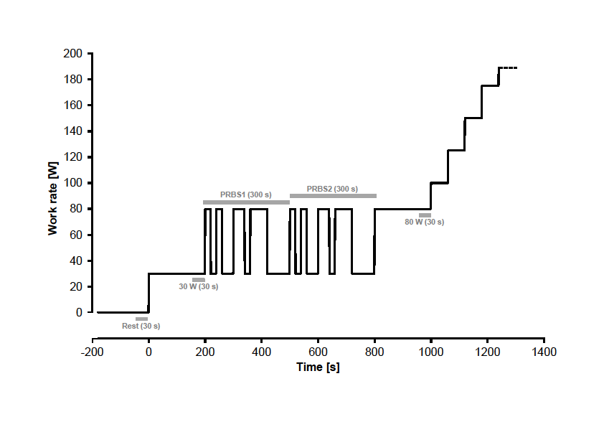

Fig. 1: Work rate (WR) protocol for cardiopulmonary exercise testing before and after the training intervention. Grey horizontal bars indicate time periods for mean value calculations during rest (30 s), at low and high constant phases (30 s), and during the two pseudo-random binary sequence (PRBS)
WR phases (300 s each).

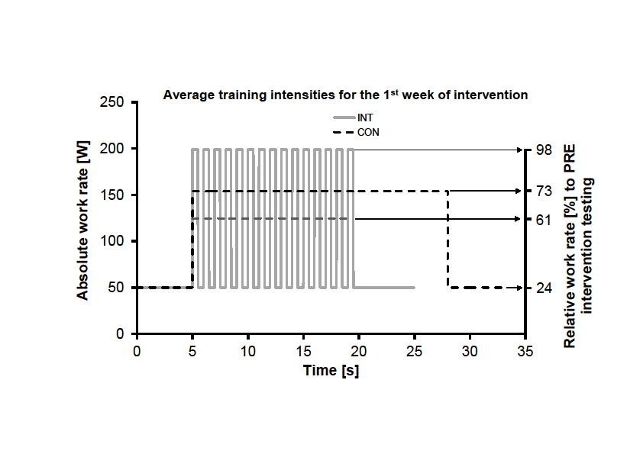

Fig. 2: One example of the training protocols during the first week of intervention for the continuous (CON: black dotted line; work rate is equal to 73% PRE peak power output: 154 W) as well as for the interval training group (INT: grey line; upper work rate limit is equal to 98% PRE peak power output:
199 W; lower work rate limit is equal to 24% PRE peak power output: 50 W; average work rate is displayed by the horizontal grey dashed line: 61% PRE peak power output (125 W)). Each training

session started with a warm-up phase (duration: 5 minutes at 50 W), followed by the interval or continuous procedures, and was finished with a cool-down phase (duration: 5 minutes at 50 W).

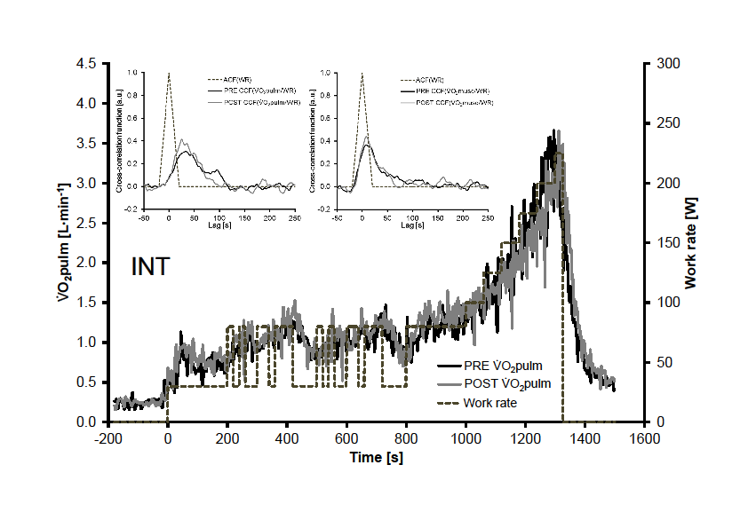

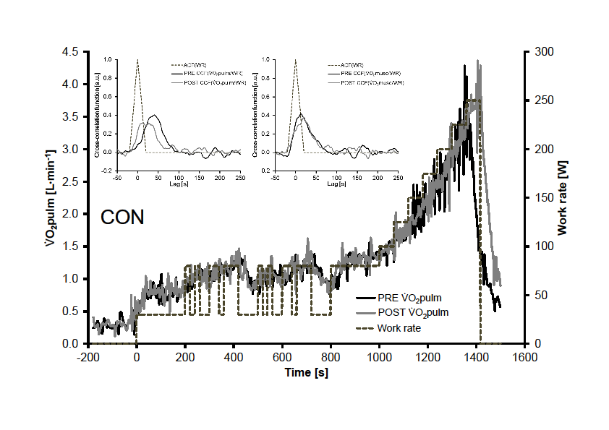

Fig. 3: Individual PRE and POST V’O2pulm data of one participant of the INT (3a) and the CON (3b) training group. In each case, in the main graph the grey dotted line represents the work rate protocol, the black solid line show the PRE and the grey solid line the POST V’O2pulm data (mean ± SE). The upper left panels show the auto-correlation function (ACF) of WR as grey dotted line, and the black

solid line the PRE and the grey solid line the POST cross-correlation function (CCF) of WR with
V’O2pulm. The upper right panels show the V’O2musc responses equivalent to the left panel.

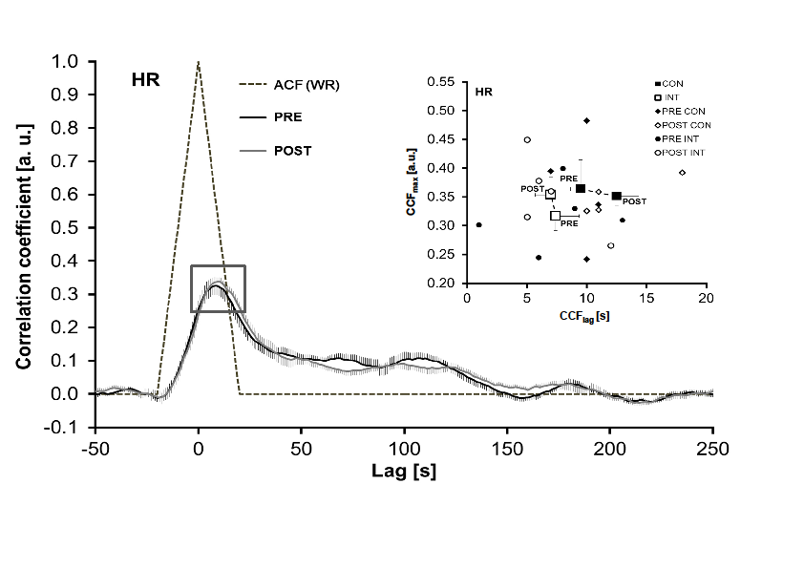

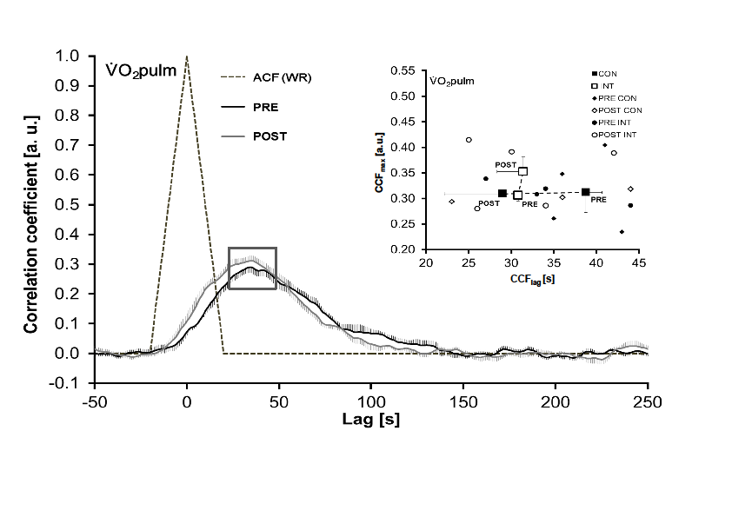
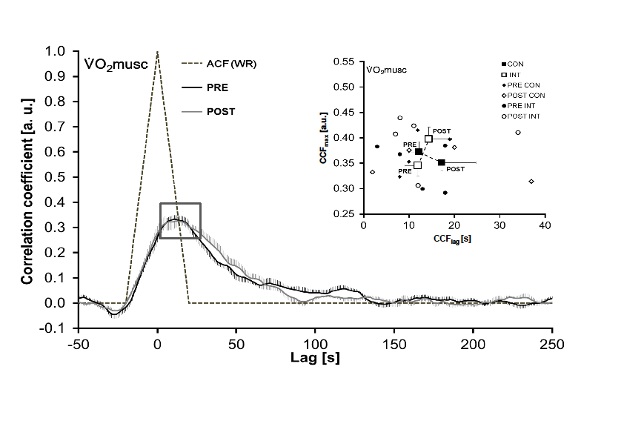

Fig. 4: Cross-correlation functions (means ± SE) of work rate (WR) with heart rate (HR; 4a), pulmonary (V’O2pulm; 4b) and estimated muscle (V’O2musc; 4c) oxygen uptake before (PRE) and after (POST) the endurance training intervention for all subjects (n=9), regardless of training group. The grey dotted triangles illustrate the auto-correlation function (ACF) of WR. In addition, the upper panels show the training group-specific (interval (n=5) versus continuous (n=4)) maxima of the cross- correlation functions (CCFmax; means ± SE) for the respective parameters from the main panel. For completeness, we added in the upper panels all data points of the INT and CON training group before
(PRE) and after (POST) the training intervention.

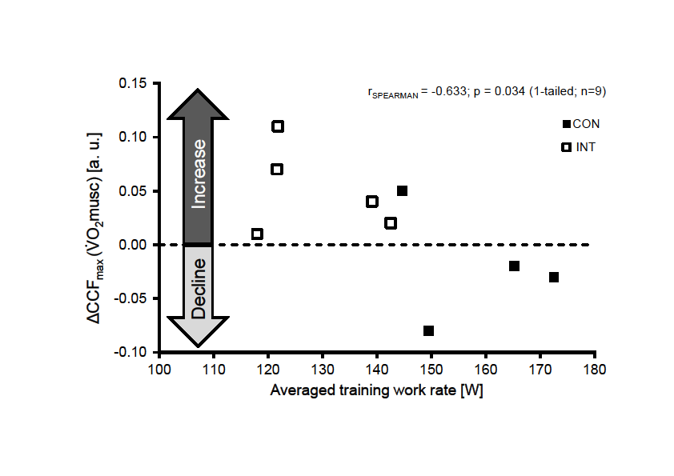

Fig. 5: Relationship (Spearman-rho) between the difference in the cross-correlation function maxima (ΔCCFmax: POST-PRE) between work rate (WR) and estimated muscle oxygen uptake (V’O2musc) as function of averaged training WR during the intervention. Open rectangles display the individual responses of the interval (INT) and full rectangles of the continuous (CON) training group.

Tab. 1 Averaged (mean ± SD) absolute and relative training work rates, training durations (inclusively range [minimum, maximum]) for both, the continuous (CON) and the interval (INT) exercise training group. In addition, for the INT group the upper
limits (UP) of the high intervals were presented as mean ± SD values and percentage of peak power output (PRE).

Group Training description
Week

1 2 3 4 5 6

Mean training work rate (W) Percentage of peak power output  (PRE) |  | 154 ± 5 | 155 ± 7 | 157 ± 13 | 161 ± 16 | 162 ± 19 | 158 ± 12
 |  | 73 | 73 | 74 | 76 | 76 | 75
CON
 | Training duration (min) | 23.0 ± 5.2 | 20.2 ± 0.3 | 20.7 ± 0.4 | 21.4 ± 0.4 | 22.3 ± 2.0 | 31.1 ± 0.4
 | Range [minimum ─ maximum] (min) | 20.0 ─ 29.0 | 20.0 ─ 20.5 | 20.5 ─ 21.0 | 21.0 ─ 21.8 | 20.5 ─ 24.5 | 26.5 ─ 33.8

Mean training work rate (W) 125 ± 8 126 ± 8 131 ± 14 131 ± 14 130 ± 15 130 ± 14
Percentage of peak power output
(PRE) 61 62 64 64 64 64

INT
Mean training work rate UP limit (W) 199 ± 16 201 ± 16 210 ± 29 210 ± 28 210 ± 28 213 ± 27
Percentage of peak power output
(PRE) 98 99 103 103 103 105

Training duration (min) 15.0 ± 0.0 19.7 ± 0.6 25.7 ± 1.2 30.3 ± 0.6 35.7 ± 0.6 39.8 ± 0.2
Range [minimum ─ maximum] (min) 15.0 ─ 15.0 19.0 ─ 20.0 25.0 ─ 27.0 30.0 ─ 31.0 35.0 ─ 36.0 39.5 ─ 40.0

Tab. 2 Peak responses, exercise time and resting heart rate (means ± SD) before (PRE) and after (POST) exercise training intervention, and for the continuous (CON) and interval (INT) training group separately.

Overall (n=9) INT (n=5) CON (n=4)

 |  | PRE | POST | Sig. |  | PRE | POST |  | PRE | POST
Peak power output (W) |  | 208 ± 18 | 229 ± 23 | a |  | 203 ± 19 | 219 ± 10 |  | 214 ± 17 | 243 ± 28
Peak power output (W·kg-1) |  | 2.3 ± 0.3 | 2.6 ± 0.3 | a |  | 2.3 ± 0.3 | 2.4 ± 0.1 |  | 2.5 ± 0.4 | 2.8 ± 0.4

Peak oxygen uptake (L·min-1)  Peak oxygen uptake (mL·min-1·kg-1) Resting heart rate (min-1) |  | 3.2 ± 0.3  37 ± 5  77 ± 14 | 3.7 ± 0.2  41 ± 4  66 ± 10 | b b b |  | 3.3 ± 0.3  36 ± 4  77 ± 15 | 3.5 ± 0.2  39 ± 1  70 ± 5 |  | 3.3 ± 0.2  38 ± 7  76 ± 15 | 3.8 ± 0.3  43 ± 6  61 ± 13
Peak heart rate (min-1) |  | 164 ± 14 | 163 ± 11 | n.  s. |  | 164 ± 17 | 163 ± 13 |  | 161 ± 8 | 163 ± 8
Exercise time (s) |  | 1317 ± 40 | 1369 ± 54 | a |  | 1307 ± 45 | 1344 ± 35 |  | 1333 ± 41 | 1402 ± 68
a: significant difference between PRE and POST, P < 0.01 (2-tailed; Wilcoxon signed-rank-test) b: significant difference between PRE and POST, P < 0.05 (2-tailed; Wilcoxon signed-rank-test) n. s.: not significantly different between PRE and POST, P > 0.05 (Wilcoxon signed-rank-test)

Tab. 3 Averages (± SD) and slopes (± SD) before (PRE) and after (POST) training intervention of heart rate (HR) and pulmonary oxygen uptake (V’O2pulm) during low constant WR (30 W), dynamic WR changes (PRBS 1 & 2: 53.3) and high constant WR (80 W) phases.

HR _O2pulm

Time Work rate

Average [min-1] a,b
Slope [min-1 · W-1]
n.s.

Average [L·min-1] a,b,c

Slope [L

· min-1

· W-1] n.s.

PRE

30 W PRBS
1 (53.3
W) PRBS
2 (53.3
W)
93.9 ±
14.1

102.0 ±
13.9

104.0 ±
14.8

0.3831
±
0.0989
0.897 ±
0.140

1.143 ±
0.116

1.157 ±
0.122

0.0097 ± 0.0018

80 W 113.1 ±
14.9
1.386 ±
0.096

30 W 85.5 ±
12.0
0.937 ±
0.121

POST
PRBS
1 (67.3
W) PRBS
2 (67.3
W)

94.2 ±
12.2

97.0 ±
12.6

0.4193
±
0.1188

1.202 ±
0.139

1.210 ±
0.132

0.0112 ± 0.0014

80 W 106.5 ±
14.1
1.496 ±
0.137

Slope data were derived from the WR-HR and the WR-_O2pulm relationship, respectively. a: Work rate effect: p < 0.001 (two-way repeated measures ANOVA)
b: Time effect: p < 0.05 (two-way repeated measures ANOVA)
c: Interaction effect (Time x Work rate): p < 0.05 (two-way repeated measures ANOVA)
n.s.: not significantly different between PRE and POST p > 0.05 (Wilcoxon signed-rank-test)

Tab. 4 Means (± SD) of model parameter estimates and time series analysis data (CCFmax, CCFlag) for heart rate (HR), pulmonary (V’O2pulm) and muscle (V’O2musc) oxygen uptake for both, the continuous (CON) and the interval (INT) exercise training group. Time constants (τ) were derived from CCFmax-values and time delays (TD) from the CCFlag-values assuming 1st order system properties.

max
 |  |  |  | Vv |  | .  Qrem |  | _O2re m |  | HR |  |  |  |  | _O2pulm |  |  |  |  |  |  | _O2musc
 |  |  |  | [mL] |  | [mL·mi n-1] |  | [L·min-  1] |  | CCFm ax  [a.u.] | τ  [s  ] | CCFla g [s] | T D [s]  * |  | CCF [a.u.] | τ  [s  ] | CCFla g [s] | TD [s] * |  |  | CCFmax [a.u.] |  | τ  [s  ] | CCFla g [s] | TD [s]
Grou p | Time |  | Sig. (PRE- POS  T) | n. s. |  | n. s. |  | n. s. |  | n. s. | n. s. | n. s. | n. s. |  | n. s. | n. s. | n. s. | n. s. |  |  | n. s. |  | n. s. | n. s. | n. s.
CON | PRE |  | Mea n | 282  5 |  | 3535 |  | 0.303 |  | 0.364 | 3  9 | 10 | -  4.  7 |  | 0.312 | 4  8 | 39 | 24.  1 |  |  | 0.372 |  | 3  5 | 12 | -1.9
CON | PRE |  | SD | 435 |  | 995 |  | 0.041 |  | 0.101 | 1  8 | 2 | 1.  7 |  | 0.078 | 1  7 | 4 | 4.0 |  |  | 0.042 |  | 6 | 5 | 5.0
CON | POS T |  | Mea n | 202  5 |  | 1675 |  | 0.269 |  | 0.351 | 3  8 | 13 | -  1.  8 |  | 0.309 | 4  5 | 29 | 14.  3 |  |  | 0.351 |  | 3  8 | 17 | 3.0
CON | POS T |  | SD | 137  2 |  | 222 |  | 0.040 |  | 0.031 | 5 | 4 | 4.  0 |  | 0.013 | 3 | 14 | 13.  8 |  |  | 0.033 |  | 5 | 15 | 15.  0
INT | PRE |  | Mea n | 250  0 |  | 2540 |  | 0.290 |  | 0.317 | 4  5 | 7 | -  7.  2 |  | 0.306 | 4  6 | 31 | 16.  1 |  |  | 0.345 |  | 3  9 | 12 | -2.5
INT | PRE |  | SD | 543 |  | 493 |  | 0.053 |  | 0.056 | 1  1 | 4 | 4.  5 |  | 0.025 | 5 | 10 | 10.  3 |  |  | 0.046 |  | 8 | 7 | 6.3
INT | POS T |  | Mea n | 234  0 |  | 2820 |  | 0.275 |  | 0.354 | 3  9 | 7 | -  7.  3 |  | 0.352 | 3  9 | 31 | 17.  1 |  |  | 0.398 |  | 3  2 | 14 | 0.5
INT | POS T |  | SD | 100  9 |  | 942 |  | 0.035 |  | 0.069 | 1  2 | 3 | 2.  5 |  | 0.064 | 1  1 | 7 | 7.0 |  |  | 0.053 |  | 8 | 11 | 11.  2

Vv: venous blood volume between exercising muscles and lungs
Q.rem and _O2rem: perfusion and oxygen uptake for the remainder of the body
τ, TD: kinetics characteristics of the system time constant and time delay
CCFmax: maximum of cross-correlation function
CCFlag: lag (abscissa) of CCFmax
n. s.: not significantly different between PRE and POST, P > 0.05 (n=9; Wilcoxon signed-rank-test)
*: significantly different from zero (in PRE and in POST), P < 0.05 (n=9; one-sample Wilcoxon signed-rank-test)

