**The “other”, “other acceptance”, and “other antipathy” in Naser Khosrow’s poem**

Mohammad Zakeri

Dr. Heshmatollah Azarmakan

Dr. Najmeh Dari

Dr Abdollah Forouzanfar

**Abstract**

The "other" is a concept that has been raised in the works of philosophers since the twentieth century. The study of the “other” problem in Persian literature can represent the orientation of the poets in expressing the thoughts and mutual impact of these thoughts on their society’s audiences. Naser Khosrow is a religious Ismaili poet that his poems, among his many works, was chosen for this research, since it can simultaneously reflect both his world of thoughts and moral advices in looking at the "other" element. The present study utilizes a quantitative method which is based on collecting information from library resources, focusing on Naser Khosrow's poems, seeking to answer the question of how the poet defines the “other”? And, what advice does he have about the behavior and encountering with him? And what will he put in front of the audience of his poems from the other approaches of admitting “the other” or confronting with him? The result of the research shows that this poet is not so tolerant of “the other”, and his ideological perspective on literature, his religious beliefs, and his own personal experience, had the most influential impact in creating such insight in him.

**Key word:**

The other, other antipathy, other- acceptance, Naser Khosrow, philosophy and theology

**Introduction**

Philosophically, our understanding of ourselves is the product of a kind of social understanding that results from communication with others. Others, with differences in their language, belief, ethnicity, race, etc., make us understand the differences and hence lead to better definition of ourselves, so our understanding of ourselves depends on the existence and the recognition of the "other".

The concept of the “other”, its kind and the ways to encounter with, is a complex philosophical concept that can be traced in different fields from culture, literature, politics to education and ethics. How to encounter with the concept of the “other” can also be investigated in a wide range of two poles: other antipathy and other- acceptance. In other antipathy behavior, this encounter can be seen in different forms such as elimination, rejection, humiliation, neglect. In other- acceptance behavior this encounter can also be seen in the forms including having equal rights, flexibility and tolerance, and peaceful life. There is no doubt that the foundations of thought are of great importance in shaping social behavior with the "other" and sometimes they justify the ugliness and beauty of such behaviors; therefore, the examination of philosophers’ and global theorists’ perspective seems to be necessary in this case.

Along with the philosophical and theological points of view, literature has played a role in internalizing different types of “other antipathy” and “other-acceptance”, because by addressing the feelings and imagination of the audience, it may also have facilitated these beliefs in the community, and therefore, it is necessary to be investigated. Persian literature has also witnessed the emergence of poets and philosophers who have influenced the minds and behavior of the audience with their works. The aim of the presented paper is to illustrate this issue in Persian literature, focusing on the poetries of Naser Khosrow after suggesting the concept of the other in the views of foreign philosophers.

**Problem statement**

Our goal in this paper is to focus on the concept of the “other” in Naser Khosrow poetry. Our main issue in this article is first to determine the definition of the “other” using his poems, and then to examine the nature of his encounter with the “other”, and specify the reason of his “other antipathy” and “other- acceptance”.

**Background research**

Unfortunately, so far, there has not been any research that specifically refers to the “other” in the poems of Naser Khosrow. Nevertheless, a book on philosophical and verbal beliefs of Nasser Khusraw has useful discussions, published by Firouz Shirzaman, "The Ethical Philosophy of Naser Khosrow and Its Origins," published in 1374. Several articles about this poet, though have been published, perhaps the best of which are the articles presented at the World Congress of this poet and published in 1355 by the Ferdowsi University Press, Mashhad, entitled "The Memoir of Nasser Khosrow Ghobadiyani". Farzad Ballo in his article "the other in the Thoughts and Works of Naser Khosrow" in the 82nd issue of Farsi Language and Literature, has put all the works of the poet and prose of Ghobadiy in the context of adapting it to the views of Russian Mikhail Bakhtin.

**Theoretical basis:**

The "other" as a philosophical concept, appeared for the first time in the 20th century on the horizons of Western thought. However, the "other" issue does not have much history even in Western philosophy, and should be considered as a new study in this field. Philosophers like Sartre, when he comes to this concept, is surprised by the historical absurdity of the issue, and writes in his book "Being and Nothingness": "It is very surprising that the “other” issue has never attracted the attention of followers of the truth” (Sartre, 1353: 210-211). This Sartre claim can somehow be found in Plato's Sophist's Treatise. Where Theodorus discusses the meaning of the Sophists, he considers the “other” (Plato, 3/1380 : 1471-1555), or Aristotle's discussion in the eighth and ninth chapters of Nicomachus, which is devoted to friendship, can be viewed as referring to the concept of the “other” (Aristotle, 1385: 364). But these limited examples should be understood in the concept of "otherness" compared to what we now know in Western philosophy as the "other”. In general, it can be said that it is only from the twentieth century that specifically refers to the concept of the "other" in a serious and independent manner. Especially in the works of writers who were influenced by Nietzsche's and Heidegger's views, because the philosophy of modernity of the West is based on giving originality to the subject’s rationale, and the non-subject is absent or its presence depends on the subject, and only in the works Philosophers such as Deleuze, Foucault, Derrida, and Sartre it can be found independently the signs that in their philosophical works they have been talking about a subject-based death, and before the above mentioned date, there is no trace of reference to this concept. However, even among the twentieth century’s philosophers, the amount of attention and kind of dealing with this issue are not the same. Husserl is the first philosopher to be exact on the concept of “I” against the “other”. " At the outset, the concept of the “other” exists for me as the transcendental theory of another experience, the so-called empathy. The "other" can only be thought of as something that belongs to me” (Husserl, 1368: 177). But soon it goes beyond that and I will experience the "other" as subjects for this world, the subjects that experience this world, the same world that I experience, and thus they experience me (same page, 146 and 181). Heidegger considers the "other" in the world surround “I” and he has the opinion that the knowledge of me and the world is accomplished through the others, I know what I exist because of it from my possibilities, and I know what things surround me exist because of it from their response to my possibilities. This world is not a dream world, but a world with an immortal existence that is organized and realized by realizing others. (Mosleh 1387: 142).

The concept of the "other" also has been not far from feminists. They have seen their relationship with the "other" in the form of the male-female relationship, and therefore, DuBauer examines the philosophical and historical analysis of a process in which man has established as the superiority of this relationship. In her view, the woman is defined and distinguished by reference to the man, not through referring to herself. In this impression, the man is the absolute subject and the woman is the "other" (DuBauer, 1956: 15).

Levinas is one of the moralist philosopher who, in his works, examines philosophical concepts from ethical perspectives, so he deals with the concept of the “other” with the same perspective, in this sense, he believes that the responsibility against to the “other” is prior to the cognition. From his point of view, our responsibility to the "other" is not derived from our subjectness, but on the contrary, it makes us subjects in the world, and being me is based on my responsibility (Levinas, 1985:101). Levinas believes this is a confrontation with the "other" that creates ethics, the "other" questioned spontaneity and self-reliance, and ethics means the same state or experience (Olya, 1388:99).

The German philosopher, “Spurs”, also pays attention to the need for the “other" to rid humans from nothingness, and he says that in order for man to be free from nothingness and to be himself, he needs the “other”, one can trust in himself with the alliance of the "other" (Karami, 1385:66). In sum, the existentialists from Kierkegaard to Heidegger have all focused their attention on human existence and have built their philosophical thoughts on human beings (the same, 1385:19). However, they considered the existence of the “other” necessary in recognizing the human being.

Apart from the philosophers' view, some critics and literary theorists have also argued in this regard, and among them, Bakhtin maybe the most important, since the "other" issue in literature first appeared in literary critique arguments. In this regard, the ideas and thoughts of the Russian philosopher, Mikhail Bakhtin played a major role, as far as he, like Sartre and Husserl, is considered as initiator of the "other" ontological significance for cognition (Ansari, 1384:175).

The era of his life is “the atmosphere based on anti-laughing, quiescence, anti-dialogue ideologies, in which a kind of singularity is promoted, and the conversation goes to the margin (Pouyandeh, 1373:10). The main focus of Bakhtin's ideas is on the logic of dialogue, and dialogue is not achieved except with the presence of the "other" and recognition of him, and a different voice with him, not a voice that serves in his reproduction. Hence, some such as Seldin and Viduson have written that "he is anti-Stalinist in his works" (Seldin and Viduson, 1384:59). But perhaps the correct interpretation is to call him a philosopher who wants to recognize the "other" and end the totalitarianism, mono-telling and mono-listening.

The basic concepts of Bakhtin’s thoughts and the concepts that have been used extensively in conversational critique are: genre, concurrency, monotellingness, mono-telling, texture, and chronop, which is an analytic category used to understand the integrated dimensions of texts (Makarik, IRENA REMA, 1384: 417).

Apart from the Western intellectual and literary tradition, Muslims have never been referred to the "other" as an independent and rightful owner of the heritage, on the contrary, "the prevalence of all kinds of intellectual disagreements that have led to the bitter results of rejection and denial, has been based on the non-recognition of the" other "because the relationship between God and man in the jurisprudential system is a relationship between the lawgiver and the responsible, in the philosophical system it is the relationship between necessity and possibility, and in the theological system of thought, it is divided into the relationship between the creator and the creature (Balo and Abbasi, 1394:45). Only in Islamic mysticism one can see new horizons because of its new definition of man, God, and being. However, Nasser Khosrow is subordinate to the Ismaili word in his poetry system, which is considered as a kind of inter-religious discourse, and it has specific intellectual lines not only with the non-Muslim world, but also with Muslims themselves.

**The “other” in the definition of Naser Khosrow**

Nasser Khosraw is a poet who has undergone two spiritual and intellectual periods, and these changes has made him another person and in fact, another Naser Khosrow. The new character that he became, is not only to receive supreme rank of the Hojjat of Khorasan from the Fatimid Caliph, but also he truly finds a new identity and sees the world and human beings from a new perspective, "the degree of Hojjat in the hierarchy of the internal affairs In the Ismaili religion is superior accepter and admissible, and is the follower of the Imam (Vain Pour 1370:14). Naser Khosrow's thoughts in his prose books (except of the book of travelogue), such as Jamea al-Hakmatin, Zad al-Masafarin, Face of Religion, Khan and Akhavan, and Opening and Release seem to be clearer than his thoughts in his poetry books. Naser Khosro is introduced as a philosopher in Jamea al-Hakmatin and Zad al-Masafarin, and as a Ismaili devote in Face of Religion, Khan and Akhavan, and Opening and Release (Mohaghegh 1363:317). Therefore, the worldview of Naser Khosrow as a philosopher, both in his prose and poem works is heavily influenced by his religious beliefs because he "has not said anything that does not rely on his thoughts and beliefs and has not compose any poem that is not influenced by his passionate feelings (Ali Dashti 1388:45).

If we consider monotheism and prophethood as the commons of all Islamic sects, the principle of Imamate is one of the main features of the Shiite religion and especially the sect of Ismaili Shiite. The term "Imam" in this thought of the sect, although in the hierarchy of invocation, is a term, but in the general view of all the levels of invocation of the lowest order, which is the authoritative and the basis, up to the highest degree, the authoritative and conscientious, should believe in Imamate. From the point of view of Naser Khosrow, the principle of Imamate, which is the continuation of monotheism and prophethood is not only not limited to the character of Imam Ali and the seven Isma'ili Imams, but also its contemporary crystallization should be considered in the belief of al-Mustansar, the Fatimid caliph, that the poet raises him to the prophets’ rank.

They are prophets when they are aged and old

They are philosophers since they are child and small

(Divan, 1384:47)

When the perfection of the truth in the poet’s view is Ismaili interpretation of Islam and the personality of the Fatimid caliph, and also when he receives the title of Hojjat of Khorasan from a such person, this surely cause to the passionate zeal like Naser Khosrow find himself to be connected to the original source of revelation, and he inevitably sees all the people around him as the “others” immersed in ignorance:

My clear Hojjat over people is because that

I am the deputy Hojjat of the prophet

People of Khorasan are sunken and not aware

Head to knee, I'm left the same from that

(Divan, 1384:197).

As he considers his intellectual-theological doctrine, as the most original intellectual thought of the time, in the domain of belief, the particular interpretation of Ismaili Shiism is considered the most authentic type of faith; therefore, other interpretations of Islam are misleading. The poet, in both theological and jurisprudential religion, sees his findings as the very truth. These perceptions are the main basics that simultaneously create many "selves" and "others" in his poetry. And this is the monologue of his rightness leads to the definition of the "other," and he sees all thought in the horizons of thought and all nations in the religious domain as the other for himself. He does not stop at this level, and, with the spread of the others, even in the literary and racial domains, he outlines selves and the “others” for himself, as well.

**(A) The “other” in theological religion**

Naser Khosrow, in terms of the intellectual state of his own society, lived in a period that, with the interference of the Seljuk emirs, Iranian society entered the decadent era of Ash'ari from an era of wisdom. (R. K. Mojtaba 1379:40). Although the poet understood this, he could not reconcile with it, because he was rationalist, and the direct result of this rationalism was a confrontation with fate that would lead to the falsity of a fateful destiny (Farzad 1384:188). Naser Khosrow believes that his religious beliefs are from logos has been transmitted through the Prophet and the Imams and the Ismaili devotees to him. Therefore, he considers these beliefs to be reasonable and absolutely clear, so he considers those who do not think likewise as other fool “others” such as animals, who are far from rational axioms.

The one who does not have a religion is a donkey

Such a person, just like you, is not a human being

(Divan, 1384:1010)

He considers the natural consequence of rationalism to accept religion (its Ismaili type), and he found it logical to base his invitation on this criterion:

Reason is directed toward religion

Follow the religion, which is the best cane

(Divan, 1384: 101)

Perhaps this being away from the space of free thinking and the restraining the reason to the religion, led to a controversial, rigid ode of “Oh God! Latitude and width of your world/ you can put it in the ant belly” not be in a version elaborated by the late Mojtaba Minavi and Dr. Mohammad Mohaghegh. (Apart from the technical criteria and literary value of poetry), these scholars spend caution in assigning this poem to him.

Naser Khosrow is a rationalist, but he also accepts the ration of the prattler only in the area of verifying his particular religious beliefs and to confirm his sentence in religious. In this regard, even with the criterion of his contemporaries, such as Zacarias Razi, he cannot be regarded primarily as a rationalist libertarian. Therefore, in the theological religion domain, except for Motaleleh sect, all believers and thinkers who believe in a school other than the Islamists should be considered without exception as the "others" for the poet. The followers of Ash'ari and all its subcategories, followers Dahri, and followers of the philosophy of Greece, India and Persia are from this category.

**(B) The “other” in jurisprudence domain**

In the domain of jurisprudence, Naser Khosrow considers, without exception, all the Islamic jurisprudential schools as the “others”. He claims to have shared his questions with other religions (Shafe'i, Maliki, and Hanafi) and the followers of these religions were unable to answer his questions. In this way, he started a hard journey, and shares his questions with Persians, the Tazis, the Hindus, the Manucians, the Sabians and the Dahries, and he does not receive any convincing answer from them (R. K. Naderi, 1389: 32). Therefore, the proof is over for him. In the context of beliefs, the first honor of Nasser Khosrow is his own Muslims, and the “other’s” atheism. In this view, all non-Muslims are considered as atheisms and hence the “others”. But the only difference is the existence of the people of the book, although their faith excludes them from the atheisms, but because they do not accept the most perfect and last religion of truth, they do not exclude the domain of blasphemy.

If you choose Mohammad, you are faithful

The one who chose the Christ is unbeliever

(Divan, 1384, 168)

In Dar-al-Iman, Naser Khosrow also deals with the definition of "others" inside religion, and takes into account Islamic religions far from truth and inevitably the “other" with respect to the degree of their remoteness and proximity to the fundamental criterion of rightness from his own point of view.

No wonder that Nassebi

Doesn’t become saturated with atheism

No wonder that Nassebi be infidel

Because no wonder to see stupidity of a donkey

(Divan, 1384:54).

The classification of the other-thinker and other-maker of Naser Khosrow and his description about them is not so difficult and complicated. It is enough to know his identity on the basis of his own definition, the rest of human beings are naturally "others" and, depending on the remoteness and proximity to the identity defined by Naser, deserve to be treated from tolerance to indignation and murder.

**(C) The “other” in the literary domain**

Naser Khosrow is a talented poet, but specific, as some believe, "he must be considered revolutionary in introducing legal, ethical, and religious issues in an ode that was in vain at the time” (Bashiri, 1377:165). In particular, he creates self-portraying imaginary in describing nature that makes the scholars to admire. “Although Naser Khosrow does not love nature as much as Manouchehri, when he speaks of nature, he emanates from his sensory experiences. Although like any other speaker, he has the influence of the poetry culture from the preachers before him, the limits of his work are such that independence of view and his power of imagination originate from poetic imagination, and as a result, nature in his poetry is more alive than all his contemporaries. Apart from Farokhi and Manouchehri, throughout the fifth century, in terms of the form of independent imagination, there is no poem to the point of his poem (Shafiee Kadkani, 1366, 440).

The description of nature should be understood as the strong aspect of his poem, as it has been said “Naser Khosrow is one of the pioneers of nature description, and whenever he speaks, he shows nature as it is and shows it to you with new and exotic interpretations (Dashti, 1388, 89). But his created literary Boostan is the same as the utopia that a social idealist wants. Hence, human love has not any place in his poem. For this reason, he considers sonnet-composing as exaggeration of a number of unprofessional art, and panegyric as falsity. From this perspective, sonnet-composing poets and panegyrist court poets should be considered the "other" in the literature domain.

Sonnet verse wants Cursing and playing

This is for non-arts like the divine sign

(Divan, 1384:266)

Therefore, in the literary domain, all the poets of the sonnets and regarding content, all the poets of admirers and praises of the rulers and the insipient and unjust people of his time, should be clearly distinguished in the poet's literary “others”.

**(D). racial “other”**

Despite the fact that Naser Khosrow showes all manifestations of free-thinking and introduces himself as rationalist, in the racial domain, he also beleives the system of "self" and "other" division. The poet not only accepts these void assumptions about racial superiority, but also praises it, and sees this discrimination as a hidden wisdom.

Better and worse aren’t without reason

Turkish from Ethiopian and Arab from Hindu

(Divan, 1384, 164).

Like the Aad, and the Turkish are like an sterile wind

By this wind they become Hebir sand

(The same, 1384, 402)

Thanks to the Prophet, the Arabs are honored to be superior on people

From Turkey and Rome and India, and Sind and Gilli and Deylam

(The same, 1384, 81)

This racist thinking seems to be rooted in his religious foundations and religious worldview. He believes that Arab people have superiority in terms of race and language due to the Prophet of Islam, and consideres this as heavenly indissoluble matter. It seems that the humiliation of the Indians, blacks, Ethiopians, in his poetry, in addition to the color of the skin, is due to the dominant religion of these races, which was not Islam, and Turkish race is blamed probably for their tyranny and looting in Khorasan.

**Types of text encounters with the "other"**

Naser Khosrow's confrontation with the "other" element involves two cases: other “acceptance”, or "conflict" with the other. These two methods are the most important ways for the poet to deal with others. "Naser Khosrow’s view in all domains is ideological, therefore, everything has one direction and one meaning, and it is in line with his thought, which is taken from the particular approach of the Ismaili beliefs. Whatever it is, either it affirms those thoughts or is in accordance with them, or the symbol or their representative, otherwise it is false and futile (Masbough et. al, 1391). The point is, however, that as far as literary and racial areas go to the intellectual and religious areas, the poet's degree of conflict becomes more and more, and his degree of tolerance becomes less. This clearly shows the position of the element of belief in Naser Khosrow's valuations, and it seems that the position of the concept of supremacy and hating in the Shiite ideological system has been effective in this direction.

In the literary domain, where the use of the literary heritage of the past has been discussed, Nasser is an “other acceptor”, the poetry of four: Ferdowsi, Manouchehri, Sanai, and Daghighi were considered by Naser Khosrow. One of his idols (idol 26) in terms of weight, rhymes and themes is similar to the first three poems. Nasser had definitely read Rudaki's poetry, but he has paid the most attention to his contemporary poet “Kasai Maroozi”, To the extent that most scholars often say "two gems" (above the top of seven circular circles are two gems, idol 37) is welcoming to Kasaie’s idol with the beginning of “the body and wisdom are goers on this green wheel” (Naser Knosrow, p 424). Some reject this attribution to Kasaie. The elements of thought of these two poets are very close together. Most of the Kasaie’s poems, just like Nasser's poems, are in the worship and praise of the Prophet's family (Shoar, 1370:18).

But where the discussion is in sympathy with the flow of the poetry of the time, he is completely an “other antipathy” and warns us not to make mistakes in the valuation of such individuals:

Be careful brother not to consider

Writing and poetry as real knowledge

(Divan, 1384:142).

Then, he believes the social function of these groups of poets, instead of trying to awaken and knowledge is to spread ignorance and smut:

Wise person becomes happy with good words

Foolish person is happy with hymn, sonnet, hired musician, and talky

(Divan, 1384:225).

He cannot tolerate and ignore the life and manner of the poets of his time, and their abusive use of art.

If you convert your greed as a poem

The lie is wealth for the infidel

(Divan, 1364:142)

And, he even doesn’t confine himself to quip and in order to guide the audience; he has no refusal to mention the names:

Is it desirable for Ghaznavi's elemental poet Mahmud Ghaznavi

To be extolled with Ammar and Abuzar, both of which are as virtues?

(Divan, 1384:143)

In the domain of the school of thought, though he does not consider all knowledge and all knowledgeable on the straight path and far from misguidance, But the poet shows that the wisdoms of every nation is worthwhile and respectful, and that in general, the tradition of the rationalists of the world is either Hindu or Roman, and it is guided by some form of other acceptance.

Hey man! It is not comfortable to sleep in way

You should ask from knowlegable Hindu

(Divan, 1384, 499)

In theological topics, he also partly engages in a critical conversation, and, by appropriate reasoning and language, forms the contradiction between himself and the other. Naser Khosrow did not refrain from mentioning various terms in legal issues. Scientific subjects in his poems have not created contents, but rather they have been the means of understanding the purpose. In other words, he raised his most important philosophical issues, which was usually discussed, in his poems in his poetry, and using ultimate skill and ease, he has come to conclusion from his discussion (Safa, 1371:248). In the field of jurisprudence, however, the poet shows the least amount of other acceptance and the greatest amount of other antipathy.

From Shafei and Malek and Hanifi's promise

I searched for the world leader

Each of them turned to one another

This threw me from this side of Khotan to the other side of the barbarian

When I asked some reason and strong verses

They were unable to answer; one became blind and the other became deaf

(Divan, 1364: 508)

The language, which is the main sword of the poet in this struggle, goes far beyond the aesthetic criteria and reaches to humiliation and derision. And, in a foreseeable slop of “other antipathy” tends to insult and curse and wish for the “other’s” death. The types of linguistic encounters with the other are as follows:

**a. Pity:**

Is he proud of tricks of time?

Whether you know about its tricks?

How long do you want to stay in this path?

Why do not you get up? What is the excuse to stay?

(Divan, 1384, 41)

**b. Humiliation**

When people are suffering from ignorance

How can I disseminate the Ismaili religion?

(Divan, 1384, 118)

**c. Irony**

Hey boy! Be patience about his cold speech because that this devil

Still, is not aware of the onion's rate

(Divan, 1384, 114)

**d. Insult**

See the scholars who really sell science

For abduction, they are like eagles, for greedy like a hog

(Divan, 1384, 112)

**e. Curse**

This cursed place is a roller for you

Easily get around and circle

(Divan, 1384, 108)

**f. Abusiveness**

If Ahmed Mursal is the father of his people

Except Shiite and his children, they are the offspring of adultery

(Divan, 1384:248)

**g. Death wish**

Hey Hijab of religion! By wisdom

Behead Nasebi

(Divan, 1384:386)

**h. Commination**

Knowledge is the soul of body

Ignorance is the soul of infidelity

(Divan, 1384, 110)

**Causes of poet's other antipathy**

The review of the poems of the Divan of Nasser Khosrow clearly shows that the poet doesn’t have much interest in accepting different “others”, but in explaining this, the following can be cited as the most important reasons for this other antipathy:

**a. Ideological look at literature**

He regards poetry as a means to achieve the goal. As a committed poet, Naser Khosrow did not see any good in silence when he saw deviations, and he inevitably spoke and protested aloud (Bashiri, 1377:166). Hence, creating sympathy with ideological advocates and explaining lines of differentiation with ideological dissenters inevitably leaves the speaker out of tolerance and leads him conflict by proving what the truth is. Particularly, in the Shiite religion, supremacy and hating are the minutiae of religion, and gives Naser Khosrow a legal reason to taking disgust of the “others” permissible.

Even though you and I are in the same religion

You are in different path compared to mine

Inevitably, that day before God

You’ll be follower of Omar and I’ll be follower of Heidar

I’ll not call you, don’t call my name

I hate you, you hate me

(Divan, 1384:35)

Not only in religious affairs but also in politics, the Ismailis claimed themselves the most prominent of the Muslim world in conflict with the Abbasi caliphate and discourse. Inevitably, Naser Khosraw saw himself into a battle in which the poem and prose was the instrument for that battle. The one, who pulls the sword, must definitely define hatred enemy for himself, and the ideologization of poetry is the duty that the poet throws at the neck of his art. If by this instrument he can add to the congregation the believers of the Fatimid caliph and reduce the believers to the Abbasid caliph, even at the cost of bloodshed from Iraq to Syria, when he considers himself to be the right and condemns the rest of the religions of the world as "other" and void.

When you hear a Fatemian went to Mecca

It brings your heart light and warm to your body

That sunshine of dynasty of the Prophet makes

Father's blood from hungry of the Abbasis

It makes earth red from the blood of the people

For the right religion from Baghdad to Aleppo

(Divan, 1384, 209)

It seems that the reason that the poets after Nasser Khosrow don’t follow his powerful poetic style, more than consequence of religious other antipathy with the Shiites, is the result of his ideological content and his biting tone in expressing his beliefs. Because, Kasaei Marvarzi was also from a group of poets who had been Shiites before Nasser Khosrow, he was not disrespected and rejected by his social literary environment and inevitably exiled. Nasser Khosrow, in Khorasan, saw himself as "other" and marginalized on the religious, theological, religious, and political, racial and political texts, and sought to prophetically defeat the dominant text. But the result is instead of triumph, exile and humiliation caused by the “other antipathy” of social context and suffering from dissent.

**b. Invitation prophecy**

Nasser Khosrow is a Hujjat of Khorasan and a speaker in the service of the Ismaili religion. Namely, it is primarily a religious inviter to a literate, and one can say that the poem of Naser Khosrow in terms of content and form, vocabulary and song, ups and downs and pause, is made by his thought in the form of weight and words (Yousefi, 1374: 77). All early invitations in their dominant environment were known as "other" and deserved to accept all kinds of suffering and torture. The history of religions from Christianity to Islam is evidence of this other antipathy. In the eyes of the Ismaili believers, he is Hojjat of Khorasan, and his duty to expand the invitation and necessity of this mission inevitably is to reveal his otherness, because the dominant religious background of Khorasan in the era of Naser Khosrow, is Sunni, with a Hanafi jurisprudential attitude, but other than the Ismaili intellectual rationalist Shiite poet, poets such as Ferdowsi and Kasaei also touched before him and more than him. However, what has increased the contribution of Naser Khosrow and led the differences to conflicts and other antipathy has been a prophecy that the poet has seen himself as an inviter, that obviously invites people not to his poetry but his own beliefs and religion. Therefore, in the customary way of the missionaries of the time to advance and publicize the mission, he wrote invitations and sent around:

Each year one book of invitation

I send it around the world

(Divan, 1384, 220)

It seems that these writings and letters have somewhat influenced and accepted by the audience:

I made Khorasan like China market

With my songs like Chinese fabric

(Divan, 1384, 17)

In Khorasan of that era that was the focus of ethnic and religious revolts that made Abbasid caliphate afraid. And Naser Khosrow explicitly states that the purpose of the letters was to undermine the ruling power of the time, namely, the caliphs of Baghdad and the Hanafi doctrinal system of dominant Ashari religion:

My speech poured damn demon water

To Badakhshan and the cup and the fire cup and the level

(Divan, 1384:153)

Of course, this militancy, with dominant political and religious elements, could not be unanswered. At the same time, and in the ensuing conflicts like Nasser Khosrow’s, in a move against Ismaili adherents, the Abbasid Caliph embarks on Imam Mohammad Ghazzali to write a book titled “Fazayeh al-Batenieh”against the Fatimids (Dashti, 1388:119).

**c. Personal experience of an “other”**

Naser Khosrow, as justified by his life and works, is a cultured man, a righteous, rational, and with moral virtuous. The core of his thoughts on dealing with people, and even their ignorance and ugliness, is not as likely as possible to conflict and violence, but rather he recommends primarily towards tolerance, reconciliation and coexistence:

Improve the ethics of goodness and diligence

To bring perfection

(Divan, 1384:7)

Do not be sad at the world’s more or less

Be Patience about world and be nice with people

(the same, 1384:4)

Devoutness is coupled with harmlessness

For religion person, one is north and one is right

(the same, 1384:120)

But he is not Christ of Mary, who only shows forgiveness and not retribution, and therefore he believes that tolerance should be equal, and since all humans do not have sufficient knowledge, it is necessary to treat them with equal and moral conditional behavior. Although he orders not to be like a thorn, he does not like to be soft and passive and acceptance like a date.

Don’t be full of hate of others like thorn

Nor be too timid like a date

(Divan, 1384:4)

Anyone who does want trouble and grief from me

Tell him don’t bring trouble and grief for me

(the same, 1384:247)

“The humiliation and mischief that malicious enemies have had about him, has made him angry and vengeful against authorities of the time”. (Zarin koob 1374:75). It is on this basis that the high volume of “other antipathy” of Naser Khosrow must be seen to have origin from various factors, one of which is the suffering and oppression and as a victim; he has a vengeful and mocked language. And therefore, a person who has not seen kindness and has been wounded instead can only think of vengeance. Naser Khosrow, beautifully, portrays this long-suffering in a lot of literature:

Roving and being away from my loved ones in my homeland, like Scorpion, hurts me

It's as if he has not found anything less weak and debased than me in this world

When I look good and deep to the time and me

I feel sad and grieved

I say to myself, "Why do the world and the high sky of ignorant tyrant

Made me the target of time’s arrow?

Hey sky! The sister of demon

You cannot tell me what happened to me

(The same, 1384:35)

Not only he has been defined the “other” in the intellectual and literary domains, but also in the realm of personal life, and he has bitterly tolerated the heavy price of this social exclusion with his own heart and soul, and this great sense of revenge has led him toward the “other antipathy”.

**3. Conclusion**

The study of the poems of the Divan of Naser Khosraw shows that absolute rationality in the field of thought and belief makes him view the outside world as an overcrowded world of "other" that none of them are familiar. In the domain of theological, all the common tendencies in the Islamic civilization of its time are considered to be without the truth and the “other”. In the field of religion risprudence, the situation is not only better, but also reveals a greater degree of separation from others and reaches to the hostility. Because, from the perspective of the poet, all the sects of the qiblah except the Fatimids have been misled in following the right and thus are considered "other". In the literary domain, rationalism, and keeping away from panegyric for the cruel rulers, makes Hakim Ghobadian an “other” poet hence his literary language cannot be contradictory to his thought. Therefore, his encounter with the "other" in the domain of language includes a range of "other antipathy" behaviors, such as humiliation, insult, curse, and abusiveness that the poet has as his defensive and aggressive means in his attack on his defined “others”. The root cause of Naser Khosrow's inclination to this large volume of conflict with the "other" in his Divan, we shouldn’t ignore the facts, and should point out that our wise, perfectionist poet who had no dream but a world decorated with justice and virtue, when confrontation with the "other" concept, he shows the bitter language, due to the fact that he, as a victim, was an unfortunate example of the "other antipathy" of his age. And the spirit of his rejection, along with the ideological view of literature, and his religious mission, should be viewed as the result of his bitter experience, and the curse and insults in his poetry should be considered the reflections of offenses to him, as an “other”.

**Persian References**

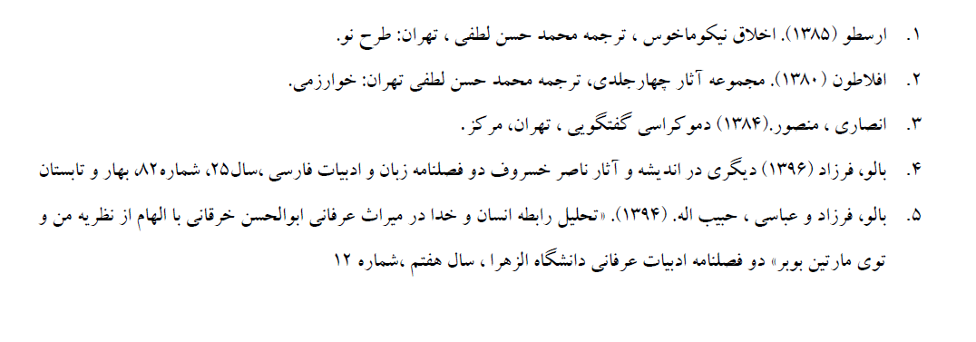 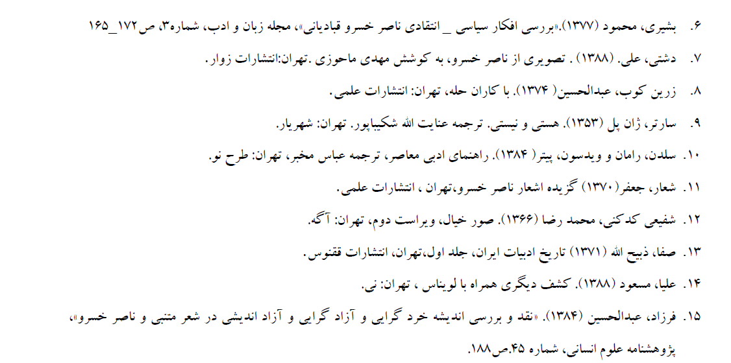

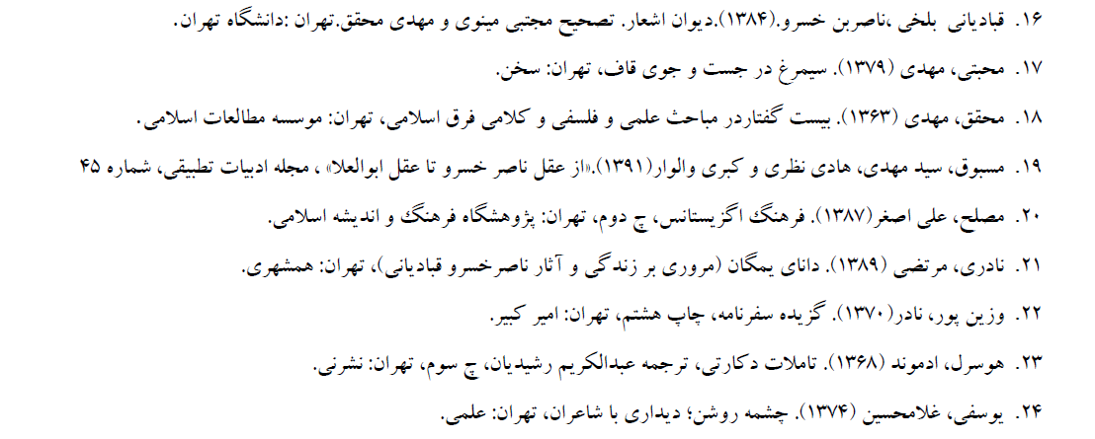

**English References:**

The “other”, “other acceptance”, and “other antipathy” in Naser Khosrow’s poem

Abstract:

Naser Khosrow is one of the greatest Persian language poet especially in didactic and ethical field. Searching in his poems could help us in the field of educative instructions and corresponding views.Explaining “The other” and tendency to “other antipathy” and “other acceptance” in the thoughts of a poet

Explaining “The other” in the thought of a poet and evaluating the rate of “other antipathy” or “other acceptance” in his instructions. It’s not achieved unless investigating text - orient research

“Naser Khosrow’s Divan-e- Ashar” was selected as the best one among his different prose and rhyme works. Because not only it could reflect the world of thoughts and emotion of poet, but also it could reflect ethical instructions correctly.

This article is a fundamental research with analytical-descriptive approach focusing on “Divan Ashar-e-Naser Khosrow “. The researcher is trying to find out these questions that, How does this poet explain “The other” in different fields such as ethnic- ethnicity, religious,

Theological religion, Juratory - literary religion. Furthermore, How does the poet advice the addressee about dealing with them and treat them.

The result of this study was shown that the poet, with extreme bias on his Esmaeeli’s belief, is not so tolerant of others. In addition, the poet’s bitter fate in life, as a rejected “other thinking”, might have the most important effect in creating such an insights in Naser Khosrow.

Key word: didactic literary, other antipathy, other acceptance, Naser Khosrow, ancient literature.