HIPPOKRATIA 2006, 10, 1: 7-21 7

Invited article

Nanotechnology in Medicine:
The Medicine of Tomorrow and Nanomedicine

Logothetidis S

Aristotle University of Thessaloniki, Physics Department
Lab for Thin Films - Nanosystems & Nanometrology, GR-54124 Thessaloniki, Greece

Abstract
Nanotechnology is an emerging technology with enormous potential in information and communication technology, biology and biotechnology, medicine and medical technology. Novel nano- and bio-materials, and nanodevices are fabricated and controlled by nanotechnology tools and techniques, which investigate and tune the properties, re- sponses and functions of living and non-living matter, at sizes below 100 nm. The current advances of nanotechnology in modern medicine are presented and discussed. The potential medical applications are predominantly in detection, diagnostics (disease diagnosis and imaging), monitoring, and therapeutics. The availability of more durable and better prosthetics, and new drug-delivery systems are of great scientific interest and give hope for cancer treatment and minimum invasive treatments for heart disease, diabetes and other diseases. Many novel nanoparticles and nanodevices are expected to be used, with an enormous positive impact on human health. The vision is to improve health by enhancing the efficacy and safety of nanosystems and nanodevices. Products based on nanotechnology in medicine and medical technology are reaching the market, with an anticipated enormous positive impact on human health, in the coming years. The development of specific guidance documents at a European level for the safety evaluation of nanotechnology products in medicine is strongly recommended and the need for further research in nanotoxicology, is identified. Ethical and moral concerns also need to be addressed in parallel with the new develop- ments. Hippokratia 2006; 10 (10):7-21

Key words: Nanotechnology, nanomedicine, nanobiotechnology, nanoparticles

Corresponding author: Logothetidis S, Aristotle University, Physics Dpt., GR 541 24, e-mail: logot@auth.gr, Thessaloniki, Greece

1. Introduction

HIPPOKRATIA 2006, 10, 1
Nanoscale is generally considered to be at a size be- low 0.1 µm or 100 nm (a nanometer is one billionth of a metre, 10 -9 m) (Figure 1). Nanoscale science (or nanoscience) studies the phenomena, properties and responses of materials at atomic, molecular and macro- molecular scales, and in general at sizes between 1-100 nm. In this scale, and especially below 5 nm, the proper- ties of matter differ significantly (i.e. quantum scale ef- fects play an important role) from that at a larger par- ticulate scale. Nanotechnology is then the design, the manipulation, the building, the production and applica- tion, by controlling the shape and size, the properties- responses and functionality of structures, devices and systems of the order or less than 100 nm.
Figure 1 shows objects and living units whose size is or occur basically in the nanoscale, are also shown higher order structures of biological units or organisms at mi- cro- meso- and macroscale, made by nature the last 4 billion years due to the ability to self- assemble and self- organize. In the same figure (on the right) are shown those objects man made at nano- and microscale during the last few years. Nowadays, scientists and technolo- gists are learning from nature, and by applying the laws
of physics, the properties of chemistry and the prin- ciples of biology, they create the era of nanotechnology.
Nanotechnology is considered an emerging tech- nology due to the possibility to advance well estab- lished products and to create new products with totally new characteristics and functions with enormous po- tential in a wide range of applications. In addition to various industrial uses, great innovations are foreseen in information and communication technology, biol- ogy and biotechnology, medicine and medical technol- ogy, in metrology, etc. It is anticipated that nanotechnology can have an enormous positive im- pact on human health. Relevant processes of living organisms occur basically at nanometer scale, elemen- tary biological units like DNA, proteins or cell mem- branes are of this dimension (Figure 1). By the means of nanotechnology, these biological units are going to be better comprehended so that they can be specifi- cally guided or directed. Miniaturisation down to na- nometer scale provides to become an essential feature of biomedical products and procedures in postgenomic era. Nanoscale devices could be 100 to 10,000 times smaller than human cells but are similar in size to large biomolecules such as enzymes and receptors. Nanoscale

devices smaller than 50 nm can easily enter most cells, and those smaller than 20 nm can move out of blood vessels as they circulate through the body.

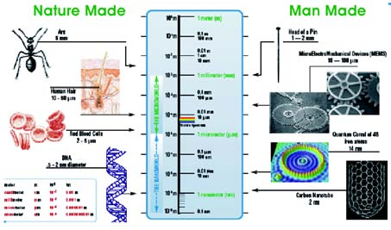
Figure 1. Objects and living organisms whose size is or occur in the nanoscale, higher order structures of biological units at mi- cro- meso- and macroscale, made by nature the last 4 billion years due to the ability to self-organize (on the left) and those man made at nano- and microscale the last few years (on the right).

Huge aspirations are coupled to nanotechnological developments in modern medicine (Nanotechnology, Biotechnology, Information Technology & Cognitive Science - NBIC developments). The potential medical applications are predominantly in diagnostics (disease diagnosis and imaging), monitoring, the availability of more durable and better prosthetics, and new drug-de- livery systems for potentially harmful drugs1, as shown in Figure 2. For example, nanoscaled diagnostics are expected to identify in the becoming, giving the oppor- tunity to intervene specifically prior to a symptomati- cally detected onset disease.
Biomedical nanotechnology presents revolutionary opportunities in the fight against many diseases. An area with near-term potential is detecting molecules associ- ated with diseases such as cancer, diabetes mellitus, neurodegenerative diseases, as well as detecting micro- organisms and viruses associated with infections, such as pathogenic bacteria, fungi, and HIV viruses. For ex- ample, in the field of cancer therapy, promising novel nanoparticles will respond to externally applied physical stimuli in ways that make them suitable therapeutics or therapeutic delivery systems. Another important field of application for nanotechnology are biomaterials used for example in orthopedic implants or as scaffolds for tissue engineered products. Nanotechnology might yield nano-structured surfaces preventing non-specific pro- tein adsorption. Control of surface properties at nanolevel was shown to increase the biocompatibility of the materials2.
While products based on nanotechnology are actu- ally reaching the market, sufficient knowledge on the associated toxicological risks is still lacking. Reducing the size of structures to nanolevel results in distinctly different properties. As well as the chemical composi- tion, which largely dictates the intrinsic toxic properties,
very small size appears to be a dominant indicator for drastic or toxic effects of particles. From a regulatory point of view, a risk management strategy is already a requirement for all medical technology applications1 .
In order to discuss the advances of nanotechnology in modern medicine, we present in Section 1 the terms and concepts of nanoscale and nanotechnology, and the relevant process and relation to living units. The impact of nanomaterials and nanoparticles in medicine is pre- sented in Section 2, following by a description of nanotechnology tools in medicine in Section 3. The im- pact of nanotechnology in medicine and medical tech- nology is presented in Section 4, first with the introduc- tion of nanomedicine and the “nanorobots”, and then through some of myriad applications in diagnosis and treatment (such as biocompatibility and implants, cardi- ology, cancer, theranostics, etc). In Section 5, a refer- ence to the possible risks for human health and a con- sideration of ethical questions is given.

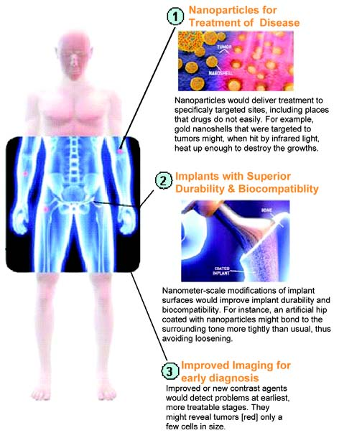

Figure 2. Great developments are expected in medicine with the use of nanotechnology, such as:, 1) use of nanoparticles for the treatment of diseases, 2) implants with superior durability and biocompatibility, 3) improved imaging for early diagnosis.

2. Nanomaterials and nanoparticles in medicine: A new concept
Novel nanomaterials and nanoparticles are envis- aged to have a major impact on a number of different relevant areas. Materials with high performance and unique properties can be produced, that traditional syn- thesis and manufacturing methods could not create.

Future nanoparticles should act as drug-delivery and drug- targeting systems. Due to their smallness they are not recognized by the human body, migrate through cell membranes beneath a critical size and are able to pass the blood - brain barrier. These characteristics are used to develop nanoscaled ferries, which transport high po- tential pharmaceutics precisely to their destination. There are different kinds of nanoparticles which are suitable to be applicable in drug- and gene- delivery, probing DNA structures, etc, and are categorized as: liposomes, poly- mer nanoparticles (nanospheres and nanocapsules), solid lipid nanoparticles, nanocrystals, polymer thera- peutics such as dendrimers, fullerenes (most common as C60 or buckyball, similar in size of hormones and peptide a-helices), inorganic nanoparticles (e.g. gold and magnetic nanoparticles).
Carbon nanotubes (diameter of 1-20 nm, as shown in Figure 3a) and inorganic nanowires exhibit extraordi- nary mechanical, electric, electronic, thermal, and opti- cal properties offering the electronic industry proper- ties that few materials platforms could ever hope to match. Carbon nanotubes, and magnetic iron oxide nanoparticles, gold-coated silica nanoshells, can trans- form electro-magnetic energy into heat, causing a tem- perature increase lethal to cancer cells merely by increas- ing the magnetic field or by irradiation with an external laser source of near infra red light at the very location where these nanoparticles are bound to or internalised within tumour cells2.
Quantum dots (nanometer sized semiconductor nanocrystals with superior fluorescent properties, as shown in Figure 3b) possess remarkable optical and elec- tronic properties that can be precisely tuned by chang- ing their size and composition, due to their very small size (2-10 nm). Due to their relatively inexpensive and simple synthesis, quantum dots have already entered the market for experimental biomedical imaging appli- cations. Quantum dots can be made to emit light at any wavelength in the visible and infrared ranges, and can be inserted almost anywhere, including liquid solution, dyes etc. Quantum dots can be attached to a variety of surface ligands, and inserted into a variety of organisms for in-vivo research2,3.
Dendrimers (complex almost spherical macromol- ecules with diameter 1-10 nm, shown in Fig.3c) have im- proved physical, chemical, and biological properties com- pared to traditional polymers. Some unique properties are related to their globular shape and the presence of internal cavities offering the possibility as medical nanovehicles. Dendrimers have a tree-like structure with many branches where a variety of molecules, including drugs can be attached. Less than 5 nm in diameter, dendrimers are small enough to slip through tiny open- ings in cell membranes and to pass vascular pores and tissues in a more efficient way than bigger polymer par- ticles. In experiments reported in Cancer Research, University of Michigan scientists attached methotrex- ate, a powerful anticancer drug, to branches of the dendrimer (Figure 3c). On other branches, they attached fluorescent imaging agents and a vitamin called folic acid2,3.
In addition to these examples of individual nanoparticles, novel biomaterials can be constructed using structural surface modifications of macro-, micro- as well as nanomaterials. Control of surface properties at nanolevel was shown to increase the biocompatibility of the materials2 .
Nanoparticles, as shown in Figure 4, being the fun- damental elements of nanotechnology, can be applied in various ways such as fluorescent biological markers, as markers for detection of proteins, probing of DNA structures and for separation and purification of bio- logical molecules and cells, and they can also be used for magnetic resonance imaging enhancement, tumour de- struction via heating, tissue engineering and drug, gene delivery. As an example, two kinds of nanoparticles that are suitable to be applicable at least in drug-delivery will be described: First, gold nanoparticles (3-20 nm), that are gold composites with dielectrical cores and golden shells. By choosing the right ratio of core to shell diam- eters the particle can be tuned to absorb highly in the near infrared, and by irradiation with such wavelength can be heated, even in deeper skin areas. If the particles are embedded in a temperature sensible hydrogenlmatrix, the matrix will collapse and the in- cluded agents will be released at a critical temperature.

Figure 3. Representative types of nanomaterials and nanoparticles: a) Carbon nanotube, b) Human breast cancer cells tagged with quantum dots, and c) Dendrimer [3].
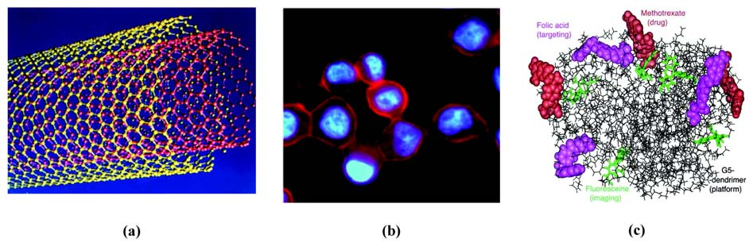

Second, magnetic nanoparticles, with controllable sizes between 2-30 nm that can be coated with biological mol- ecules to make them interact with or bind to a biological entity. Due to their magnetism they can be manipulated by an external magnetic field gradient, thereby provid- ing a controllable means of “tagging” or addressing the biological entity. They can be made to deliver a package (an anticancer drug, or a cohort of radionuclide atoms) to a targeted region of the body. The magnetic particles can be provided with energy from the exciting external field, and can be heated up making them good hyper- thermia agents, delivering toxic amounts of thermal en- ergy to targeted bodies, such as tumours.

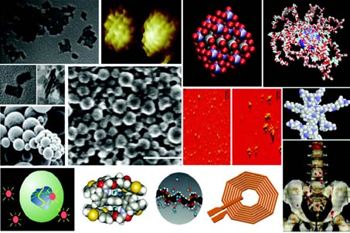

Figure 4. Various nanoparticles and dendrites and their medi- cal applications.

For applications to medicine and physiology, these nanomaterials, nanoparticles and devices can be designed to interact with cells and tissues at a molecular (i.e., sub- cellular) level with a high degree of functional specificity, thus allowing a degree of integration between technol- ogy and biological systems not previously attainable. It should be appreciated that nanotechnology is not in it- self a single emerging scientific discipline but rather a meeting of traditional sciences such as chemistry, phys- ics, materials science, and biology to bring together the required collective expertise needed to develop these novel technologies4. On the other hand, due to advances in biochemical research and molecular biology diseases can put down to molecular abnormalities. Molecular imaging should detect the corresponding molecular sig- natures of diseases and use it for medical diagnosis. This should ideally lead to a diagnose and therapy before occurrence of symptoms. In molecular imaging, an im- aging molecule is coupled to a transport molecule or particle, which possesses a targeting unit (e.g. special receptors, ligands or peptides). The target finding sys- tem should be a specific molecular marker of a certain disease thus the contrast medium accumulates within the sick tissue. Molecular imaging is developed for sev- eral diagnostic procedures such as magnetic resonance, ultrasonic imaging, as well as nuclear and optical imag- ing technologies.
3. Nanotechnology Tools in Medicine
Different methods for the synthesis of nanoengineered materials and devices can accommo- date precursors from solid, liquid or gas phases and encompass a tremendously varied set of experimental techniques. A detailed presentation of these are beyond the scope of this review. In general, however, most syn- thetic methods can be classified into two main ap- proaches: “top-down” and “bottom-up” approaches and combinations of them. “Top-down” (photolithography, microcontact printing) techniques begin with a macro- scopic material or group of materials and incorporate smaller-scale details into them, whereas “bottom-up” (or- ganic-synthesis, self-assembly) approaches, begin by designing and synthesizing custom-made molecules that have the ability to self-assemble or self-organize into higher order mesoscale and macroscale structures4.
There are several nanotechnology-based synthesis techniques of these materials. For example, carbon nanotubes, are developed by electric arc discharge, la- ser ablation, and chemical vapour deposition techniques. Various inorganic nanotubes are developed by arc dis- charge, and laser ablation, as well as through appropri- ate chemical reactions. Nanowire properties can differ distinctly from those of their corresponding crystalline bulk materials, though, some properties are similar. Nanowires can be synthesized using a large variety of materials such as metals, e.g. Ag, semimetals, e.g. Bi, semiconductors, e.g. CdS, and superconductors. The most common synthesis methods are template-assisted synthesis, including vapour and electrochemical deposi- tion, and vapour-liquid-solid growth, especially success- ful for semiconductor nanowires. Dendrimers were first synthesized by an iterative synthetic methodology. The iterative sequence of reaction steps leads to a higher generation dendrimer after each iteration. The creation of dendrimers, using specifically-designed chemical re- actions, is one the best examples of controlled hierarchi- cal synthesis, an approach that allows the “bottom-up” creation of complex systems. The functional end groups can be modified for various purposes, including sens- ing, catalysis or biochemical activity.
Other advanced applications of micro- and nanotechnology in medicine are the microchip-based drug delivery systems, which are devices incorporating micrometer-scale pumps, valves and flow channels. They allow controlled release of single or multiple drugs on demand. Micro- and nanotechnology-based methods (e.g., UV-photolithography, reactive ion etching, chemi- cal vapour deposition, electron beam evaporation) can be used for the fabrication of these silicon-based chips.
A myriad of studies is available for applications of micro- and nanotechnologies in chips for medical mo- lecular diagnostics. Key words are for example DNA microarrays (gene chips), protein microarrays (protein chips), lab-on-a-chip devices (Figure 5a), and cell chips. Basically, these devices or systems are constructed using techniques inspired from micro/nanoscale fabrication

methods, that are used for processing, manipulation, delivery, analysis or construction of biological and chemi- cal entities. Inkjet printing methods are used in DNA microarrays for human genomics and in protein microarrays (or protein chips), which are useful for molecular diagnostics. For the subsequent readout de- tection either fluorescence- or radionuclide-based mark- ers, or surface plasmon resonance spectroscopy can be applied2.
the diagnosis of human diseases. Imaging at cellular, and even sub-cellular and molecular level, is still largely a domain of basic research. However, it is anticipated that these techniques will find their way into routine clinical use. Atomic force microscopy (AFM) and AFM- related techniques (e.g. Scanning Near-Field Optical Microscopy-SNOM) have become sophisticated tools, not only to image surfaces of molecules or sub-cellular compartments, but also to measure molecular forces

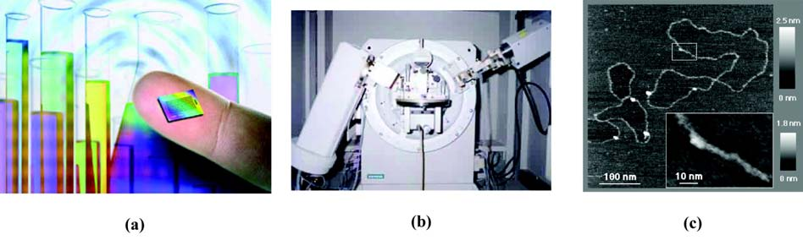
Figure 5. a) Lab-on-a-chip, for quick test results using very small samples. A lab-on-a-chip miniaturises all the steps needed to process a medical sample and detect disease, b) X-Ray Diffractometer of the Laboratory for Thin Films – Nanosystems & Nanometrology of AUTh), c) Plasmid DNA, prepared on mica (an insulator) imaged with STM in humid air5.

In order to study and explore these rich and com- plex systems, highly sophisticated experimental, theo- retical and modelling tools are required. Especially, the visualization, characterization, and manipulation of materials and devices require sophisticated imaging and quantitative techniques with spatial and temporal reso- lutions on the order of 10-6 (a micron — a red cell is 7 microns) and below to the molecular level. In addition, these techniques are critical for understanding the rela- tionship and interface between nanoscopic and mesoscopic/macroscopic scales, a particularly important objective for biological and medical applications. As such, further nanotechnological advances will necessitate par- allel progress of these physical characterization tech- niques. Examples of important tools available at the moment include: highly focused (i.e., 1–2 ìm) synchro- tron X-ray sources and related techniques that provide detailed molecular structural information by directly probing the atomic arrangement of atoms (Figure 5b); scanning probe microscopy (STM, AFM) that allow three dimensional-type topographical atomic and mo- lecular views or optical responses (SNOM) of nanoscale structures (Figure 5c); in situ monitoring techniques that allow the monitoring and evaluation of building block assembly and growth13; ellipsometry, an optical method, with the capability of measuring in liquid environment (e.g, protein solution) to study protein and cells adsorp- tion on solid surfaces6, it has been employed to discrimi- nate and identify bacteria at the species level, and is very promising for analytical purposes in biochemistry and in medicine6,7.
Imaging is becoming an ever more important tool in
between molecules. This is substantially increasing our knowledge of molecular interactions8. Figures 6a and
6b, show the SNOM and AFM microscopes, respec- tively. Figure 6c is an AFM topography image of a clus- ter of fibrinogen molecules adsorbed on amorphous carbon thin film, after incubation of 5min. The adsorbed cluster has preserved the morphological characteristics of the protein molecule9. Through these techniques, pro- tein adsorption is studied, in order to shed some light and to understand its mechanism, and improve the prop- erties of the potential materials and coatings that are going to be used for biomedical applications.

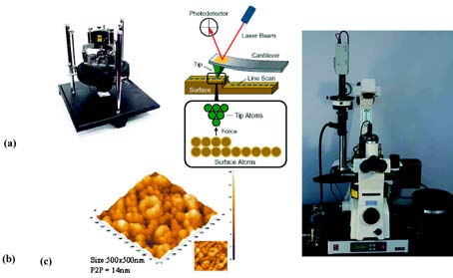
Figure 6. a) Atomic Force Microscope and how AFM works5, b) AFM topography image of fibrinogen on amorphous carbon thin film after 5min incubation time, with a 500x500nm size focus on one of the fibrinogen molecular cluster – shape fea- tures (Inset: the 2D equivalent image) and c) Scanning Near- Field Optical Microscope for reflection and fluorescence from scales below 50nm5,9,10.

Scientists have developed analytical tools to exam- ine the biological cells in great details. We now under- stand better how biological structures function in gen- eral intracellular level. However, we still do not know how to build nanostructures or “nano” biomachines that are compatible (i.e. biocompatible) with living organ, tissues, cells and biochemical systems, so that they safely operate inside the body. Once these questions are an- swered, we will be able to design better diagnostic tools and engineer structures for better treatments of dis- eases.

4. Medical Applications of Nanotechnology and Nanomedicine
Nanotechnology offers important new tools with a
great impact on many areas in medical technology.
It provides extraordinary opportunities not only to improve materials and medical devices but also to create new “smart” devices and technologies where existing and more conventional technologies may be reaching their limits. In the following these definitions related with new research areas and terms (i.e. nanobiotechnology, nanomedicine, nanodevices, “nanorobots”) will be given and then some of myriad applications of nanotechnology in modern medicine will be discussed in more de- tail.

Nanomedicine: The convergence of recent ad- vances in nanotechnology with modern biology and medicine has created the new research domain of nanobiotechnology. The use of nanobiotechnology in medicine is termed nanomedicine. Thus, nanomedicine
is an offshoot of Nanotechnology, referring to highly specific medical intervention at the molecular scale for therapeutic purposes (involving curing diseases or re- pairing damaged tissues), and for the development of diagnostics for rapid monitoring, targeted cancer thera- pies, localized drug delivery, improved cell material in- teractions, scaffolds for tissue engineering, and gene delivery systems. Successful research and development in nanomedicine where ultimately patients can benefit from these new technologies require the interaction of a multitude of disciplines including material science and engineering, cellular biology and clinical translational research.
Many scientific as well as economic activities are expected to accelerate medical research and develop- ment. Several medical devices2 have already benefited from recent developments in micro- nanotechnology (see Table 1) and are in use or are currently being commercialized (Figures 5 and 7).
Nanomaterials and biological structures are ap-
proximately of the same size, which allows for unique interactions between biological systems and synthetic materials for analytical, diagnostic and therapeutic ap- plications.
Nanomedicine can focus on several topics, such as:
Engineering Topics including, for example, Peptide nanoparticles for medical applications, the Transition from semiconductors to biochemistry in the lithography industry; Clinical Applications (like nanomedicine and protein misfolding diseases); Topics in genetics (e.g. Nanostructured probes for gene detection in living cells, Detecting UV damage to individual DNA molecules with

Table 1. Medical devices and applications currently evaluated in clinical investigations or expected to enter clinical research in the near future.

Micro- & Nanotechnology in Medicine Year
• Surgical tools
• Microcantilevers for label-free assays used in molecular in vitro diagnostics
• Novel nano-sized contrast agents for molecular imaging
• Bone replacement materials, pacemakers and hearing aids
• DNA/protein microarrays and lab-on-a-chip devices for molecular in vitro diagnostics
• Wound dressings and textiles with antibacterial and fungicidal activity now
• Microneedle-based systems
• Superparamagnetic iron oxide nanoparticles administered by stereotactic navigation based injection (hyperthermia treatment of brain/prostate tumours)
• Si-based nanocarrier system incorporating a radionuclide
(treatment of tumours via brachytherapy)
• Retinal prostheses (restoration of vision in blind patients)
• Stents coated with nanoporous hydroxyapatite 2006
• Superparamagnetic iron oxide nanoparticles conjugated with monoclonal antibodies 2007
• Injected intravenously for selective, targeted thermotherapy to treat tumours
• Dendrimer-based nanoplatforms capable of delivering drugs and genes 2008
to specific targeted cells with imaging/monitoring modality
• Targeted sensitiser nanoparticles physically triggered using heat, magnetic field, light, or radiation for tumour treatment

Atomic Force Microscopy, etc); Topics in Diagnostics, with its main focus on early diagnosis in vitro and in vivo; Policy and Commercialization Topics, including ini- tiative in nanomedicine to focus efforts in research, de- velopment and applied nanotechnology for improving the diagnostics, therapeutics and treatment of cancer; Experimental Research Topics, which are an important basis for preclinical study, like Nanodiagnostic imaging; Topics on Basic Nanomedicine, Pharmacology Topics; Topics on Oncology and on Toxicology11.
found in the human bloodstream using a digest and dis- charge protocol. Microbivores are expected to be up to
1000 times faster acting than either unaided natural or antibiotic assisted biologic phagocytic defenses and able to extend the therapeutic competence of the physician to the entire range of potential bacterial threats, includ- ing locally dense infections. The “microbivores” would be removed from the body once their mission was com- pleted.
Medical “nanorobots” may also be able to intervene

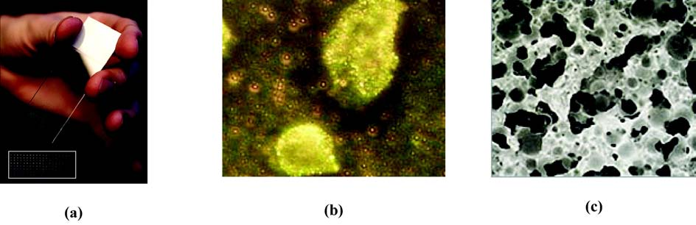
Figure 7. a) DNA-chip: glass plate containing thousands of genes to be studied. Comparison of its size with a human hand. Inset: glass plate detail, b) Image of gold nanoparticles sticking to cancer cells and c) Electron microscope image of highly porous OSferion, an artificial bone replacement material with excellent biocompatibility13.

The long-term goal of nanomedicine research is to characterize quantitative molecular-scale components known as nanomachinery, as well as to precisely control and manipulate nanomachinery in cells to improve hu- man health, understand the cellular mechanicms in liv- ing cells, and develop advanced technologies for early diagnosis and treatment of various diseases. This far the assessment of single –molecule properties in living cells has been restricted by either the size of the probe or the photobleaching of the small fluorescent labels. The sig- nificance of this research lies in the development of a platform technology that will influence nanoscale imag- ing approaches designed to probe molecular mecha- nisms in living cells.
“Nanorobots” and nanodevices: Such future devices are, for example, the artificial mechanical red blood cell or “respirocyte” (spherical shape of 1ìm diameter) and an artificial mechanical white blood cell of microscopic size, called a “microbivore” (3.4 ìm major axis diameter and 2.0ìm minor axis diameter). The “respirocyte” is expected to be able to deliver more oxygen to the tis- sues than natural red blood cells and to manage car- bonic acidity. Primary medical applications of respirocytes would include transfusable blood substitu- tion; partial treatment for anemia, lung disorders, en- hancement of cardiovascular/neurovascular procedures, tumour therapies and diagnostics, prevention of as- phyxia, artificial breathing, and a variety of sports, vet- erinary and battlefield. The primary function of “microbivore” is to destroy microbiologic pathogens
at the cellular level, performing in-vivo cytosurgery. The most likely site of pathologic function in the cell is the nucleus – more specifically, the chromosomes. In one simple cytosurgical procedure called “chromosome replacement therapy”, a “nanorobot” controlled by a physician would extract existing chromosomes from a particular diseased cell and insert new ones in their place, in that same cell. If the patient chooses, inher- ited defective genes could be replaced with non defec- tive base-pair sequences, permanently curing a genetic disease. Engineered bacterial “biobots” (synthetic mi- crobes) may be designed to produce useful vitamins, hormones, enzymes or cytokines in which a patient’s body was deficient or to selectively absorb and me- tabolize harmful substances such as poisons, toxins etc into harmless end products12.
Biocompatibility and Orthopedic implants: An important field of application for nanotechnology in medicine is the biomaterials, used for example in or- thopedic implants or as scaffolds for tissue engineered products. If the design of a hip implant, for instance (Figure 2), is carried out at nanolevel, it might be- come possible to construct an implant which closely mimics the mechanical properties of human bone, preventing stress-shielding and the subsequent loss of surrounding bone tissue2. Extra-cellular matrix (ECM) provides an excellent three-dimensional web of intricate nanofibers to support cells and present an instructive background to guide their behaviour. It takes a variety of forms in different tissues and at

different stages of development in the same tissue. This diversity arises through combinations of spe- cific molecular interactions and geometrical arrange- ments of collagens, elastins, proteoglycans, and ad- hesion proteins, such as fibronectins and laminins. Unwnding the fibers of ECM, reveals a level of de- tail unmatched outside the biological world. Each fiber hides clues that pave the way for cells to form tissues, as complex as bone, liver, heart and kidney. A key challenge is to capture the degree of complex- ity that is needed to functionally replicate the ECM of natural tissue. Nevertheless, we are still a long way from recreating the molecular architecture of the ECM and the dynamic mechanisms by which in- formation is revealed in response to challenges within the local environment. Nanostructuring of materials provides a powerful mechanism to encour- age and direct cell behaviour, ranging from cell ad- hesion to gene expression, thus enhancing their biocompatibility, by dictating the desirable interac- tions between cells and materials.
The question of how cells detect and respond to
nanofeatures is unresolved yet. However, there are early findings, where the promotion of one cell type over an- other, such as osteoblasts (bone-forming cells) over os- teoclasts (bone-resorbing cells), to stimulate bone growth, will be important in reducing aseptic loosening and failure of implants. It has been found that not only the scale of topography (5 nm to micrometer scale) modulates cell behaviour, but also the type of ordered topography (e.g., ridges, steps, grooves, pillars, and pits) and even their symmetry (e.g., orthogonal or hexagonal packing of nanopits) 32. Furthermore, surface modifications at nanolevel of biomaterials or their coatings might greatly enhance the biocompatibility by favouring the interac- tion of living cells with the biomaterial, especially by their beneficial effect on cell adhesion and proliferation. To- gether with the control of nanoporosity allowing vascularisation and the growth of cells inside the biomate- rial, the nano-structured surfaces of biomaterials also al- low the creation of novel types of scaffolds for tissue- engineered products2.
Nanotechnology in Cardiology: Nanotechnology has
various applications in the field of cardiology research not only for diagnostic but also for therapeutical pur- poses14.
On the therapeutical scope, minimally invasive
treatments for heart disease, diabetes and other dis- eases is a desirable goal for scientists, and there is hope for it, because of the use of nanotechnology. More precisely, a team led by Paul Grayburn of Baylor Uni- versity Medical Center, and Ralph Shohet of the Uni- versity of Texas Southwestern Medical School, in Dal- las, Texas, has demonstrated that ultrasound-targeted microbubble destruction (Figure 8) can deliver genes that stimulate the growth of new blood vessels in rat heart15.
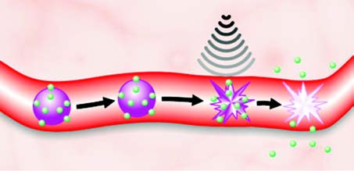

Figure 8. Gas-filled microbubbles (purple) covered with DNA (green) pass harmlessly and uneventfully through blood vessels until they are exposed to ultrasound. Then, the bubbles burst, causing not only the release of the DNA but also the opening of holes in the cells that line the vessel15.

Cardiovascular gene therapy could be realized roughly as follows: identification of a protein whose presence causes blood vessels to form, production and packaging of strands of DNA that contain the gene for making the protein and deliverance of the DNA to heart muscle. Of those steps, the last is the most challenging. In the late
1990s, physicians and physicists hit on the idea of using
ultrasound contrast agents to deliver DNA, which can be seen in Figure 8. If the ultrasound is intense enough, the bubbles can burst with sufficient force to breach the membranes of nearby cells. And if the bubbles are coated with DNA, their destruction releases the DNA, enabling it to enter the cells through the holes forced open by the burst15.
“Biobots” (a kind of nanorobots), another applica- tion of nanotechnology, is the creation of muscle-pow- ered nanoparticles having the ability to transfer infor- mation into cells, gives the potential of replacing lost biological function of many tissues such as sinoatrial node. This effect can lead to treatment of diseases which otherwise would be fatal or difficult to cure for human beings (Figure 9).

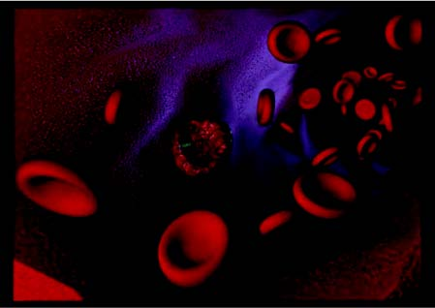

Figure 9. A futuristic representation of a “Biobot” in the area of a red cell within a blood vessel.

Nanotechnology also plays a key role in the interventional therapeutic approach of atherosclerosis

and Coronany Artery disease (CAD), by improving the biocompatibility of intracoronary stents and by regulat- ing the main limit factors for Percutaneous Transluminal Coronary Angioplasty (PTCA) at a molecular level via nanoparticles (Figure 10a). The PTCA introduced in the late 1970s and has been one of the most important treatment strategies for CAD and its landmarks were the implantation of a metallic stent introduced in the late 1980s and the production of drug - eluting stents (Figure 10b) in the early 2000s.

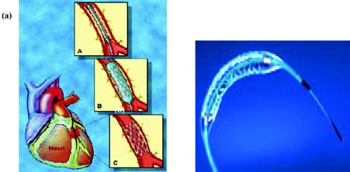
Figure 10. a) Percutaneous transluminal coronary angioplasty with stent implantation b) Drug - eluting stent.

The major drawback of PTCA has been the occur- rence of restenosis of the treated vessels, due to neointima proliferation and the negative remodelling of the artery, resulting in renewed symptoms and the need for repeated intervention in up to 50% of patients. The introduction of intracoronary bare metal stents reduced the restenosis rate within 6 months, however a smaller portion of the patients (20–30%) still suffered of so called “in-stent” restenosis. Recently, drug-eluting stents loaded with the anti-proliferative compounds paclitaxel and rapamycin have lead to the reduction of restenosis rate to 1–3% at 1 year.
However, “in-stent” restenosis remains the major limiting factor of percutaneous interventions for Coro- nary Artery Disease. That is the reason that makes nanotechology necessary for improving biocompatibility of stents. Many nanocoatings have been evaluated in- vivo and in-vitro and have been proposed to improve the biocompatibility of metallic stents or to serve as matrix for drug delivery.
Recent research data involving surface modifications of these prostheses at nanoscale as well as the loading of an antiproliferative and anti-inflammatory drug onto a stent via nanoparticles such as liposomes may lead to the prevention of early thrombus formation and late neointima development, which are the major side ef- fects of PTCA with stent implantation16.
Going beyond drug-eluting stents, many nanoparticle carrier systems may be developed in order to transfer molecules via blood stream that block both neointimal hyperplasia and negative remodeling. In Figure 11, we can see these molecules that can be used as stand-alone and without being necessary to be loaded onto stents and their potential molecular targets could be endothe-
lial cells, vascular smooth muscle cells, adventitial fibro- blasts, leukocytes and platelets which are the main cells involving in acute thrombosis and neointimal hyperpla- sia after PTCA with stent implantation.

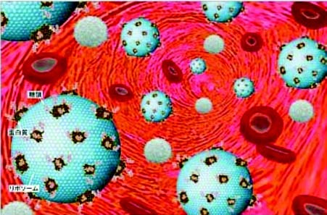

Figure 11. Molecules such as drugs targeting the area of arte- rial wall being undergone PTCA with stent implantation.

In particular, in a mouse model of vascular injury, the injection of endothelial progenitor cells was associ- ated with endothelization of the injured segment of the artery and with reduced neointimal proliferation. Many antiapoptotic agents such as caspase inhibitor or an antiapoptotic gene targeting against the activation of vascular smooth muscle cells, transferring via nanoparticles to the arterial wall being injured by stent implantation, might reduce restenosis.
In general, various inhibitors of growth factors se- creted by activated platelets such as PDGF, Il-1, TGF-â and inhibitors of proinflammatory agents relased by leucocytes upon activation (e.g monocyte chemoattractant protein-1) could be used as antithrombotic and antirestenotic agents. It can be concluded that a highly effective molecular coronary intervention by means of nanotechnology may eliminate the need for stents them- selves17.
Diagnosis of cardiovascular diseases is an application of recent advances in nanotechnology as well. Many monoclonal antibodies, peptides and carbohydrates for non-invasive targeting of atherosclerotic lesions, myo- cardial necrosis, brain infarction and various tumours can be used for their detection. As an example, an anti- body specific for the proliferating smooth muscle cells of the human atherosclerotic plaque was standardized for imaging experimentally-induced atherosclerotic le- sions in rabbits. The antibody after successful preclini- cal trials in Northeastern University is already being used for clinical studies in Italy and Spain18. Figure 12 illus- trates very small atherosclerotic lesions in-vivo, using bispecific antibodies targeted with very high specific- radioactivitiy nano-polymers.
The detection of the complementary DNA strand is another application of nanotechnology in the field of cardiology, that is based on the discovery of complexes of single-walled Carbon nanotubes with single-stranded

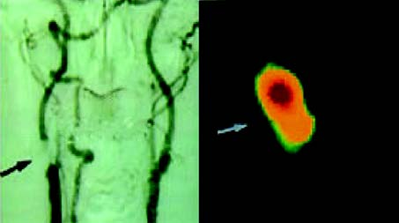

Figure 12. Atherosclerotic lesions labelled by Bispecific anti- bodies targeted with very high specific-radioactivitiy nano-poly- mers14.

DNA19. If a single nucleotide alteration occurs, the asso- ciation between the carbon nanotube and the comple- mentary DNA strand will be changed, resulting in the detection of single-nucleotide polymorphisms (SNPs). SNPs are sites in the human genome where individuals differ in their DNA sequence, often by a single base. These slight variations in DNA sequences can have a major impact on whether or not a person may develop a disease and even influence the response to drug regi- mens. Researchers in public and private sectors are gen- erating SNPs maps which can occur in genes as well as in noncoding regions. Figure 13, illustrates an example of a SNP map of human Chromosome 520.
Scientists believe that these maps will be used for the identification of the multiple genes associated with complex diseases such as Coronary Artery Disease (for example, ABCA1 gene is susceptible for CAD), hyperlipideamia, cancer, diabetus melitus and to de- tect humans with genetic predisposition to these dis- eases21.
By screening tests which are based on the above ap- plication of Nanomedicine, individuals that are prone to develop atherosclerosis might be detected and by con- trolling the main risk factors for CAD (hypertension, diabetus mellitus, smoking, hyperlipideamia, obesity) a long-term acute coronary syndrome may be avoided22. This approach can also be used for a variety of other diseases, leading to the earlier diagnosis and preven- tion.

Nanotechnology against Cancer: Nanotechnology may have an impact on the key challenges in cancer diag- nosis and therapy. Diagnosing, treating, and tracking the progress of therapy for each type of cancer has long been a dream among oncologists, and one that has grown closer thanks to parallel revolutions in genomics, proteomics and cell bio1ogy. Nanotechnology’s great- est advantage over conventional therapies may be the ability to combine more than one function.
Recently, there is a lot of research going on to de- sign novel nanodevices capable of detecting cancer at its earliest stages, pinpointing it’s location within the hu-

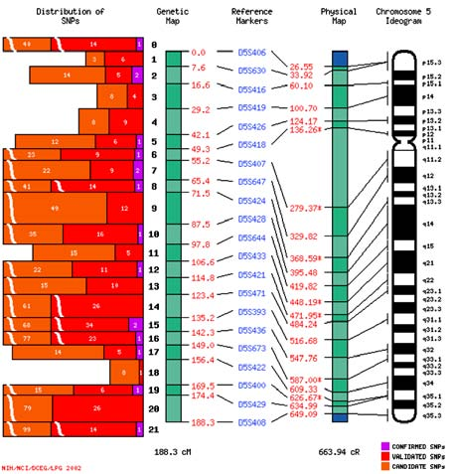
Figure 13. An example of a single-nucleotide polymorphisms - SNPs map of human Chromosome 5.

man body and delivering chemotherapeutic drugs against malignant cells. The major areas in which nanomedicine is being developed in cancer involve: a) early detection of tumour (developing “smart” collection platforms for simultaneous analysis of cancer-associated markers and designing contrast agents that improve the resolution of tumour area comparing with the nearby normal tissues), and b) cancer treatment (creating nanodevices that can release chemotherapeutic agents).

Tumour diagnostics and prevention is the best cure for cancer, but failing that, early detection will greatly increase survival rates with the reasonable assumption that an in situ tumour will be easier to eradicate than one that has metastasized. Nanodevices and especially nanowires can detect cancer-related molecules, contrib- uting to the early diagnosis of tumour. Nanowires hav- ing the unique properties of selectivity and specificity, can be designed to sense molecular markers of malig- nant cells. They are laid down across a microfluidic chan- nel and they allow cells or particles to flow through it. Nanowires can be coated with a probe such as an anti- body or oligonucleotide, a short stretch of DNA that can be used to recognize specific RNA sequences.
Proteins that bind to the antibody will change the
nanowire’s electrical conductance and this can be mea- sured by a detector. As a result, proteins produced by cancer cells can be detected and earlier diagnosis of tu- mour can be achieved23 (Figure 14).

Nanoparticle contrast agents are being developed for tumor detection purposes. Labeled and non-labeled nanoparticles are already being tested as imaging agents in diagnostic procedures such as nuclear magnetic reso-

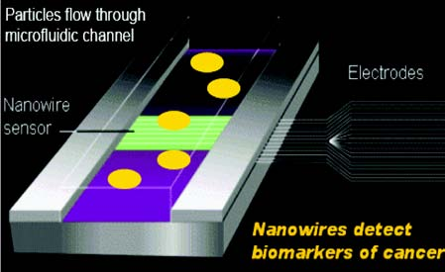

Figure 14. A representation that explains how nanowires can be used for detection of cancer biomarkers.

nance imaging24. Such nanoparticles are paramagnetic ones, consisting of an inorganic core of iron oxide coated or not with polymers like dextran. There are two main groups of nanoparticles: 1) superparamagnetic iron ox- ides whose diameter size is greater than 50 nm, 2) ultrasmall superparamagnetic iron oxides whose nanoparticles are smaller than 50nm25. Moreover, quan- tum dots being the nanoscale crystals of a semiconduc- tor material such as cadmium selenide, can be be used to measure levels of cancer markers such as breast cancer marker Her-2, actin, microfibril proteins and nuclear antigens26.

Tumour treatment can be succeeded with nanoscale devices (such as dendrimers, silica-coated micelles, ce- ramic nanoparticles, liposomes). These devices can serve as targeted drug-delivery vehicles capable of carrying chemotherapeutic agents or therapeutic genes into ma- lignant cells. As an example, a nanoparticle-based drug called “Abraxane”, consisting of paclitaxel conjunctive to protein albumin particles, was approved by the Food and Drug Administration for breast cancer treatment a year ago27.

It is worthwhile to mention that selective delivery and targeting of nanoparticles to tumours may over- come the problem of toxicity and may increase the effec- tiveness of drug delivery. The barriers involving this procedure and that should be under consideration, are a variety of physical and anatomical characteristics of solid tumours, such as the necrotic core with the sur- rounding hypoxic area, the elevated local temperature and the interstitial liquid pressure. The vascular perme- ability of the tumour influence the retention of intrave- nously administered nanoparticles, and the subsequent nanoparticle drug-delivery are shown in Figure 1514,28,29.
Several approaches have been used to target nanoparticles to tumour-associated antigens, including direct conjugation of nanoparticles to monoclonal anti- bodies, modified plasma proteins or viral vectors. Re- cent progress has been made with targeted viral vectors for gene therapy applications. Figure 16 demonstrates a

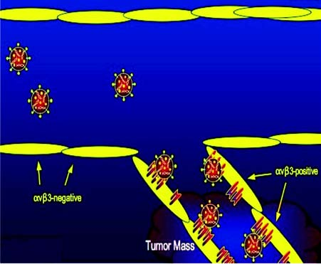

Figure 15. Nanoparticle drug – delivery accumulation at tu- mour site.

nanoparticle-delivered EGFP gene (gene coding for Enhanced Green Fluorescent Protein) (green) ex- pressed in a nerve cell (red)19.

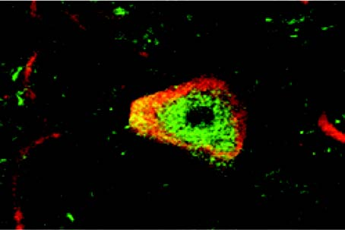

Figure 16. Gene therapy via nanoparticles19.

In addition to this, laser-induced thermal effects around nanoparticles attached to specific targets have recently been used for the treatment of cancer. The ba- sic concept for this application of Nanotechnology is the fact that nanoparticles of different properties (magnetic, optical etc.), due to their size, can be delivered more easily to target cells than can larger particles, via conju- gation with antibodies, conjugation to viruses and physi- ological transportation as shown in Figure 1714,28-30.
After reaching target cells, these nanoparticles are then self-assembled into larger nanoclusters within cells. Afterwards, these nanoclusters can be activated by laser irradiation, microwaves or magnetic fields, depending of the nanoparticles’ synthesis. By this process and its photothermal effects, destruction of cancer can be achieved.
More specifically, the nanoshell-assisted photo-ther- mal therapy (NAPT), is an non-invasive procedure for selective photo-thermal tumour destruction. It is based

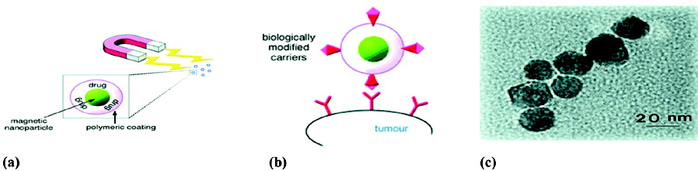

Figure 17 a) External magnetic field-guiding the magnetic drug carriers near the tumour, b) surface antigen recognition attaching the carriers to the tumour for drug release on site, c) electron microscopy image of magnetic nanoparticles.

on nanoshells that absorb light in the near infrared (NIR) region, which is the wavelength that optimally penetrates tissues. These nanoshells have a core of silica coated with a metallic layer, usually of gold. The metal shell converts the absorbed light into heat with great efficacy. Further specificity can be engineered by attaching antigens on the nanoshells which are specifi- cally recognized by the cancer cells. By supplying a light in NIR from a laser, the particles produce heat, which destroy the tumour. It has been found that, the tem- perature within the nanoshell-treated tumours rose by about 40oC compared to a rise in 10oC in tissues treated with NIR light alone. The benefit of thermal therapeu- tics is that most procedures are non-invasive and have the potential to treat tumours which can not be surgi- cally treated31.
In-vivo, Raoul Kopelman, Ann Arbor and col- leagues, of the University of Michigan, have recently created three-component nanoparticles that target, im- age and destroy tumors in the brains of rats. The par- ticles consist of an iron oxide core that serves as a mag- netic resonance imaging (MRI) contrast agent. At- tached to them are copies of a cancer-targeting peptide called F3, as well as a light-absorbing compound called photofrin that kills cells when hit with red light (Figure
18). When Kopelman’s team used their combination
particles to treat rats previously injected with cancer cells inside their brains, animals receiving the combina- tion particles survived more than twice as long as con- trol animals receiving the nontargeted photofrin com- pound32.

Gene-, Protein-, Lab-on-a-chip Devices, “Theranostics”: Medical devices for in-vitro diagnos- tics, such as gene-, protein- or lab-on-a-chip devices, do not have any of the safety concerns associated with nanoparticles introduced into the body. Numerous de- vices and systems for sequencing single molecules of DNA are feasible. Nanopores are finding use as new nanoscale technology for cancer detection enabling ultrarapid and real time DNA sequencers. In general, developments in protein-chips and lab-on-a-chip devices are more challenging compared to gene-chips. These devices are anticipated to play an important role in medi-
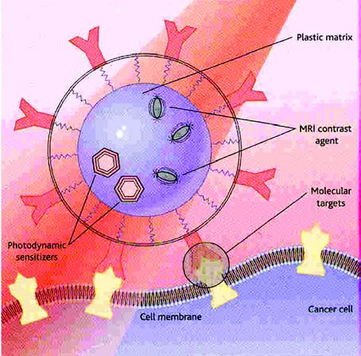

Figure 18 Triple threat-Multifunctional nanoparticles can com- bine tumor-seeking sensors, imaging agents and toxins that kill cancer cells32.

cine of the future, as they will be personalised and will combine diagnostics with therapeutics into a new emerg- ing medical area called “theranostics”.
Over the next ten to twenty years nanotechnology may fundamentally transform science, technology, and society offering a significant opportunity to enhance human health in novel ways, especially by enabling early disease detection and diagnosis, as well as precise and effective therapy tailored to the patient2. Molecular di- agnostics markets, for example, overlap with markets for non-molecular diagnostic technologies in the in-vitro diagnostic market and are less well defined than those for pharmaceuticals33.

Prospects of Nanotechnology in Medicine and vir- tual Enviroments: Intelligent imaging, robotics and, in particular, nanotechnology developments will have key implications for the development of future biomaterials in the following areas:
• External applied surgery will require biomaterial

properties to be controlled remotely, perhaps by self- assembly or development “in-situ”,
• Biomaterials that can be secured to anatomic struc- tures using less invasive surgical procedures,
• Improved accuracy in the placement of biomate- rial devices,
• Smart implants that react to implanted biosensor,
• Implanted biomaterials will be used to control the delivery of some drugs and biologics34.
To emphasize the expectations in nanotechnology in medicine, the results of the 7th Japanese Delphi Re- port and assessment of nanotechnology relevance is given in Table 2. According to this Table, there will be a widespread use of technology in the years 2010-2020, in order to elucidate, diagnose and treat several dis- eases, such as Alzheimer’s disease, diabetes amd heart diseases.
Finally, applications of special relevance to improv- ing health and enhancing human physical abilities in- clude the use of virtual environments for training, edu- cation, and interactive teaching. This will provide new ways for medical students to visualize, touch, enter, smell, and hear the human anatomy, physiological functions, and medical procedures, as if they were either the physi- cian or a microscopic blood cell traveling through the body. Similarly, impaired users, ordinary people, ath- letic coaches, and a range of health-related profession- als could train in these virtual environments.

5. Possible Risks for Human Health and Ethical
Questions
While products based on nanotechnology are actu-
ally reaching the market, sufficient knowledge on the associated toxicological risks is still lacking. The litera- ture on toxicological risks of the application of nanotechnology in medical technology is scarce.
Reducing the size of structures to nanolevel results in distinctly different properties. As well as the chemical composition, which largely dictates the intrinsic toxic properties, very small size appears to be a dominant indicator for drastic or toxic effects of particles. It is generally accepted that nanoparticles pose a separate problem within the area of toxicology, designated as nanotoxicology. Therefore, chemicals and materials in nanoformulation need to be evaluated for their activity and toxicity as nanoparticles. Chemical composition, which dictates the intrinsic toxic properties of the chemi- cal is of significant importance in determining the toxic- ity of particles.
It has been found that biodegradable substances are normally decomposed and their waste products ex- creted by the kidneys and intestines27. However, non- biodegradable nanoparticles have been studied and it seems that they accumulate in certain organs, espe- cially to the liver. It is not clarified the potential harm they may trigger, or at what dosage, but further inves- tigation is needed 35.
Based on these conclusions, the development of spe-
cific guidance documents at a European level for the safety evaluation of nanotechnology products applied in medical technology is strongly recommended and the need for further research in the field of nanotoxicology is clearly identified.
Ethical and moral concerns also need to be ad-

Table 2. Expectations of nanotechnology applications in medicine and realization time34.

Expectations of Nanotechnology in Medicine Year
• Widespread use of palliative care in the final stage of life of elderly people, of scientific 2010 guidelines for lifestyles (nutrition, rest and exercise) to prevent lifestyle-related diseases
• Widespread use of a system in which all medical data of an individual, such as test results,
medical history, and prescribed medications, are stored on a single card 2011
• Widespread use of non-invasive diagnosing methods to determine the level and extent 2012 of arteriosclerosis
• Elucidation of the arteriosclerosis contraction mechanisms 2013
• Elucidation of carcinogenic mutation mechanisms, of cancer metastasis mechanisms, of the contracting mechanisms in Alzheimer’s disease
• Widespread use of drugs to cure viral liver disease, Widespread use of an oral insulin treatment method 2014
• Development of a cell therapy method for myocardial infarction 2015
• Widespread use of early diagnosis methods based on blood tests for almost all cancers
• Development of treatment methods capable of completely curing allergies such as atopic dermatitis 2016
• Early elucidation of the appearance of unknown virulent pathogens through a global surveillance
system to prevent their world-wide spread
• Practical use of effective methods against cancer metastasis
• Widespread use of methods to prevent cancer based on genetic diagnosis 2017
• Improvement in the average five-year survival rate for all types of cancer to more than 70% 2020
• Widespread use of regenerative treatment technology for damaged organs using embryonic stem cells, of treatment methods capable of completely curing Alzheimer’s disease
• Elucidation of individual aging mechanisms 2021

dressed in parallel with the new developments in some areas, for example, neuroethics need to be investigated before brain and neural system research. Another key challenge is forecasting and addressing possible unex- pected ethical, environmental and health consequences of the revolutionary science and engineering develop- ments in nanobiosystems. Priority science and tech- nology goals may be envisioned for international col- laboration in nanoscale research and education: better comprehension of nature, increasing productivity, sus- tainable development and improving human perfor- mance36.

Conclusions
Nanotechnology in modern medicine and nanomedicine is in infancy, having the potential to change medical research dramatically in the 21st cen- tury. Nanomedical devices can be applied for analyti- cal, imaging, detection, diagnostic and therapeutic pur- poses and procedures, such as targeting cancer, drug delivery, improving cell-material interactions, scaffolds for tissue engineering, and gene delivery systems, and provide innovative opportunities in the fight against incurable diseases.Thanks to nanotechnology tools and techniques, there has been a huge progress on under- standing the function of biological structures and their interaction and integration with several non-living sys- tems, but there are still open issues to be answered, mainly related to biocompatibility of the materials and devices which are introduced into the body. Many novel nanoparticles and nanodevices are expected to be used, with an enormous positive impact on human health. The vision is to improve health by enhancing the effi- cacy and safety of nanosystems and nanodevices. In addition, early diagnosis, implants with improved prop- erties, cancer treatment and minimum invasive treat- ments for heart disease, diabetes and other diseases are anticipated. In the coming years, nanotechnology will play a key role in the medicine of tomorrow provid- ing revolutionary opportunities for early disease de- tection, diagnostic and therapeutic procedures to im- proving health and enhancing human physical abili- ties, and enabling precise and effective therapy tailored to the patient.

References
1. Jong WH de, Roszek B., Geertsma R.E., “Nanotechnology in medical applications: possible risks for human health”, RIVM report 265001002, 2005. RIVM, National Institute for Public Health and the Environment, Bilthoven, The Netherlands,
2005
2. Roszek B, Jong WH de, Geertsma RE. “Nanotechnology for medical applications: state-of-the-art in materials and devices”,
RIVM report 265001001, 2005. RIVM, National Institute for Public Health and the Environment, Bilthoven, The Nether- lands, 2005
3. http://www.nec.com/global/corp/H0602.html, http://
www.gatech.edu/news-room/release, www.nanotech-now.com/
news.cgi?story_id=10065
4. Silva G. A., “Introduction to nanotechnology and its applica-
tions to medicine”. Surg Neurol 2004; 61:216
5. http://skiathos.physics.auth.gr/thinfilmslab/ (b) http:// www.biochem.mpg.de/baumeister/spm/instruments/stm/ HSTMDNA.html (c) http://www.sciencemuseum.org.uk/an- tenna/nano/skin/123.asp (a)
6. Logothetidis S, Gioti M, Lousinian S, Fotiadou S,
“Haemocompatibility studies on carbon-based thin films by ellipsometry”. Thin Solid Films 2004; 482:126
7. Elwing H, “Protein absorption and ellipsometry in biomate- rial research”, Biomaterials 1998; 19:397; Garcia-Caurel Å, Nguyen J, Schwartz L, Drévillon B, “Application of FTIR ellipsometry to detect and classify microorganisms”, Thin Solid Films 2004; 455:722; ”Moving ellipsometry from materi- als to medicine”. III-Vs Review 2004; 17:4
8. Nanomedicine; An ESF – European Medical Research Coun- cils (EMRC) Forward Look report 2005, (www.nanoforum.org)
9. Mitsakakis Ê, Lousinian S, Logothetidis S. “Early stages of human plasma proteins adsorption probed by Atomic Force Microscope”, Biomolecular Engineering (to be published in
2006)
10. www.molec.com/ what_is_afm.html
11. Wei C. “Highlights of the first annual meeting of the American Academy of Nanomedicine”. Nanomedicine: Nanotechnology, Biology and Medicine 2005; 1:351
12. Robert A. Freitas Jr, JD, “What is nanomedicine?”,
Nanomedicine: Nanotechnology, Biology, and Medicine 2005;
1:2
13. http://www.plant.wageningen-ur.nl/news/2001-10_en.htm, http:/
/www.spacedaily.com/news/nanotech-05zzzzg.html, http://
www.biomaterial.co.jp/en/products/
14. Vladimir P, Zharov DSc, Jin-Woo Kim, et al. “Self-assem- bling nanoclusters in living systems: application for integrated photothermal nanodiagnostics and nanotherapy”. Nanomedicine: Nanotechnology, Biology, and Medicine 2005;
1:326
15. Korpanty G. “Targeting of VEGF-mediated angiogenesis to rat myocardium using ultrasonic destruction of microbubbles”. Gene Therapy 2005; 12:1305
16. Morton AC, Crossman D, Gunn J. The influence of physical stent parameters upon restenosis. Pathologie Biologie 2004;
52:196-205
17. Chen ×, Fujise Ê. “Restenosis: Emerging molecular targets.
Going beyond drug-eluting stents”. Drug Discovery Today: Disease Mechanisms/Cardiovascular diseases 2005; 2:ÍïI
18. http://www.pharmsci.neu.edu/researchcenters/center_
cardiotargeting.html
19. Everts M, Curiel DT. “Transductional targeting of aden- oviral cancer gene therapy” Curr Gene Ther4, 337(2004), http://www.hyscience.com/archives/2005/08/ nanoparticles_p.php
20. http://las.perkinelmer.com/content/snps/genotyping.asp
21. Pisciotta L, Hamilton-Craig I, Tarugi P, et al. “Familial HDL deficiency due to ABCA1 gene mutations with or without other genetic lipoprotein disorders ”’. Atherosclerosis 2004; 172:309-
320
22. Kane JP, Aouizerat BE. “Novel genetic markers for structural coronary artery disease, myocardial infarction, and familial combined hyperlipidemia: candidate and genome scans of functional SNPs”, Atherosclerosis XIII. Proceedings of the
13th International Atherosclerosis Symposium 2004; 1262:309-
312
23. Zandonella C. “The tiny toolkit”. Nature 2003; 423:10-12
24. Brigger É, Dubernet C, Couvreur P. “Nanoparticles in cancer therapy and diagnosis”. Advanced Drug Delivery Reviews 2002;
54:631-651
25. Bonnemain. “Superparamagnetic agents in magnetic reso- nance imaging: physiochemical characteristics and clinical applications – a review”. J Drug Target 1998; 6:167-174
26. Kawasaki ES, Player TA. “Nanotechnology, nanomedicine, and the development of new, effective therapies for cancer”,

Nanomedicine: Nanotechnology, Biology, and Medicine 2005;
1:101–109
27. Tachung C, Yih PE, Wie C. “Nanomedicine in cancer treat- ment”. Nanomedicine: Nanotechnology, Biology, and Medi- cine 2005; 1:191-92
28. Zharov V, Galitovsky V, Viegas M. “Photothermal detection of
local thermal effects during selective nanophotothermolysis”.
Appl Phys Lett 2003; 83:4897
29. Zharov VP, Galitovsly V, Viegas M. “Photothermal guidance of selective photothermolysis with nanoparticles”. Proc SPIE
2004; 5319:291
30. O’Neal DP, Hirsch LR, Halas NJ, Payne JD, West JL., “Pho- tothermal tumor ablation in mice using near infrared-absorb- ing nanoparticles”. Cancer Lett 2004; 209:171
31. Bradbury J. “ Nanoshell destruction of inoperable tumors”.
Lancet Oncology 2003; 4:711
32. Service R F, “Nanotechnology Takes Aim at Cancer”, Sci- ence 2005; 310, No.5751, p.1132; M.M. Stevens, J.H. George, “Exploring and Engineering the Cell Surface Interface”. Sci- ence 2005; 310, No.5751, 1135
33. www.euronanotechnews.com
34. Willems and van den Wildenberg. NanoRoadMap Project, October 2004, (http://www.nanoroadmap.it/sectoral%20reports/ sect%20report%20health.PDF)
35. Annabelle Hett. “Nanotechnology: Small matter, many un- knowns”, Swiss Reinsurance Company (2004) (http:// www.swissre.com/INTERNET/pwswpspr.nsf/ fmBookMarkFrameSet?ReadForm&BM=../ vwAllbyIDKeyLu/ulur-5yaffs?OpenDocument)
36. Roco M C. “Nanotechnology: convergence with modern bi-
ology and medicine”. Current Opinion in Biotechnology 2003;
14:337

Prof. S. Logothetidis, is Chairmen of Physics Department, Director of Nanosciences and Nanotechnology Pst graduate Program and Director of Lab for Thin Films - Nanosystems and Nanometrology, Aristotle University of Thessaloniki, Greece

