# Translating blogs on TheLuxe.London

Visit <https://theluxelondon.com/wp-admin>

Login using username and pass sent to you

On the left click on ‘Posts’

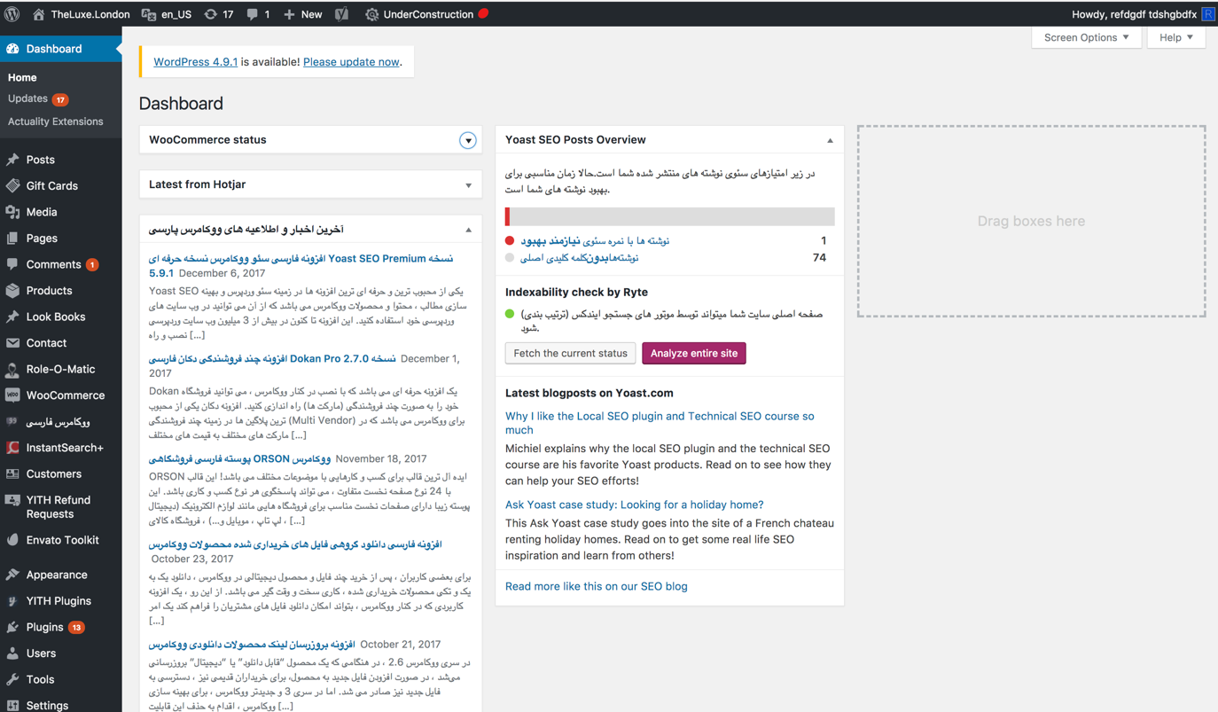

Here blog posts have been scheduled to be automatically posted. Scroll down to the first one with English subtitles and click on it

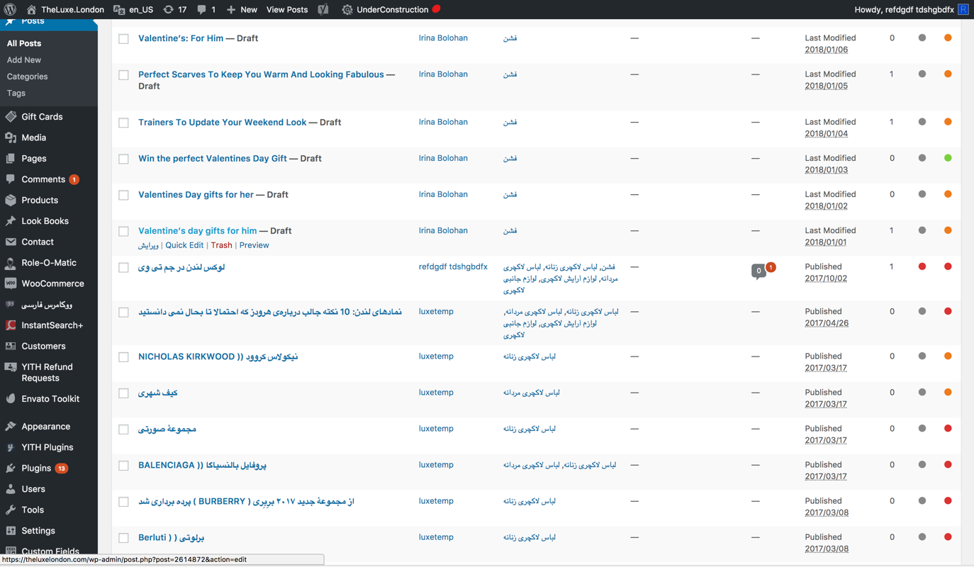

When you get to edit page firstly change the ‘Title’. The title is very important as it needs to draw the user to read it so please spend time thinking of the best title to use.

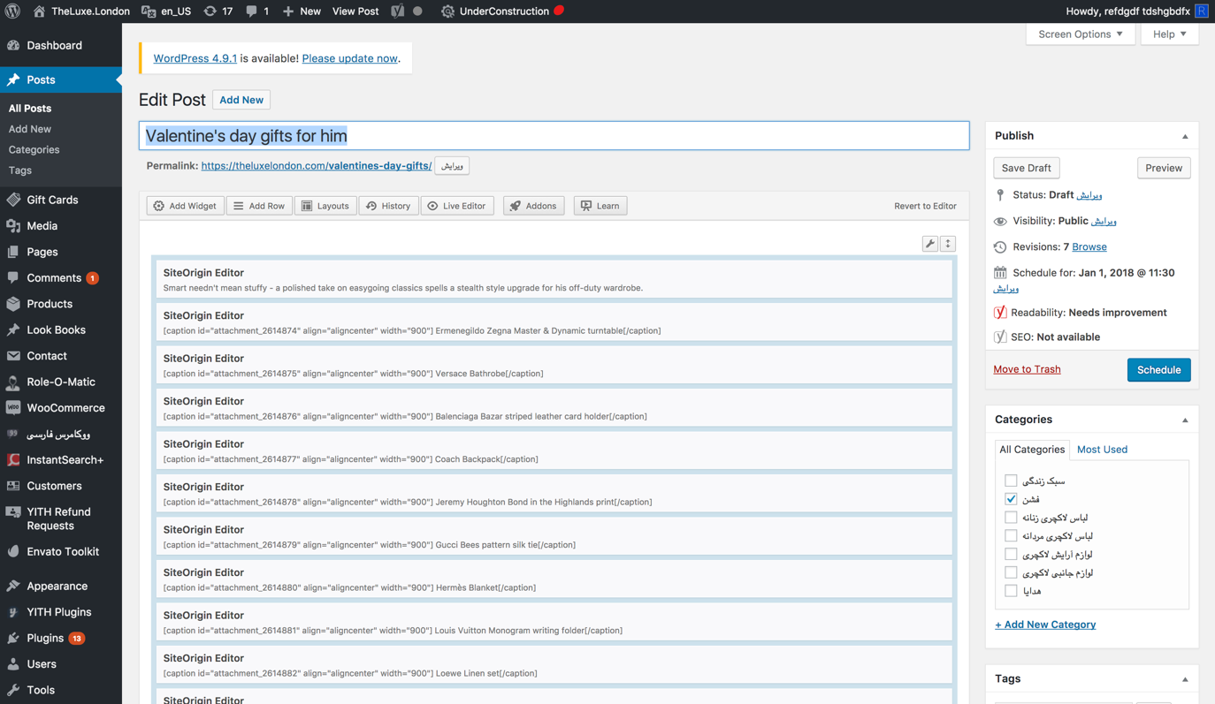

Then click on ‘Live Editor’ at the top of the edit section, this will open a visual editor which shows the blog post as the user will see it

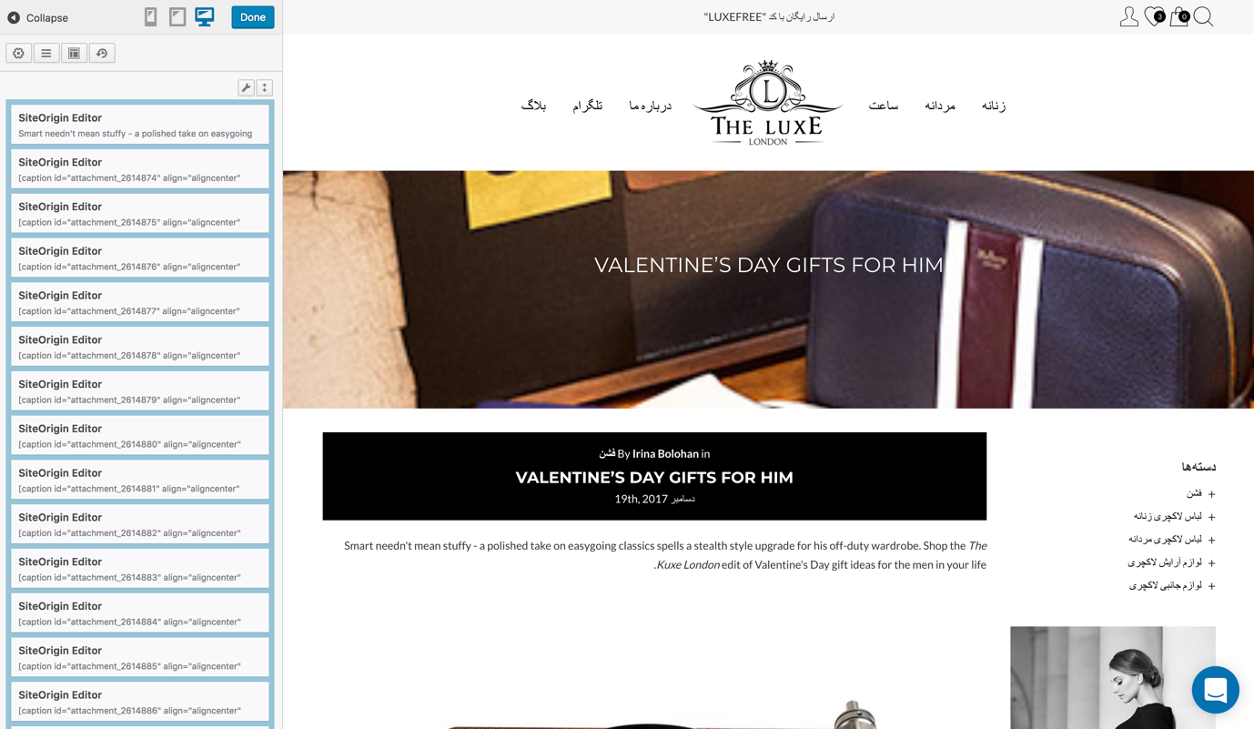

Click on every section that needs to be translated, this will bring up the editor for that section. Make sure the tab at the top is on ‘Visual’ and then translate the text

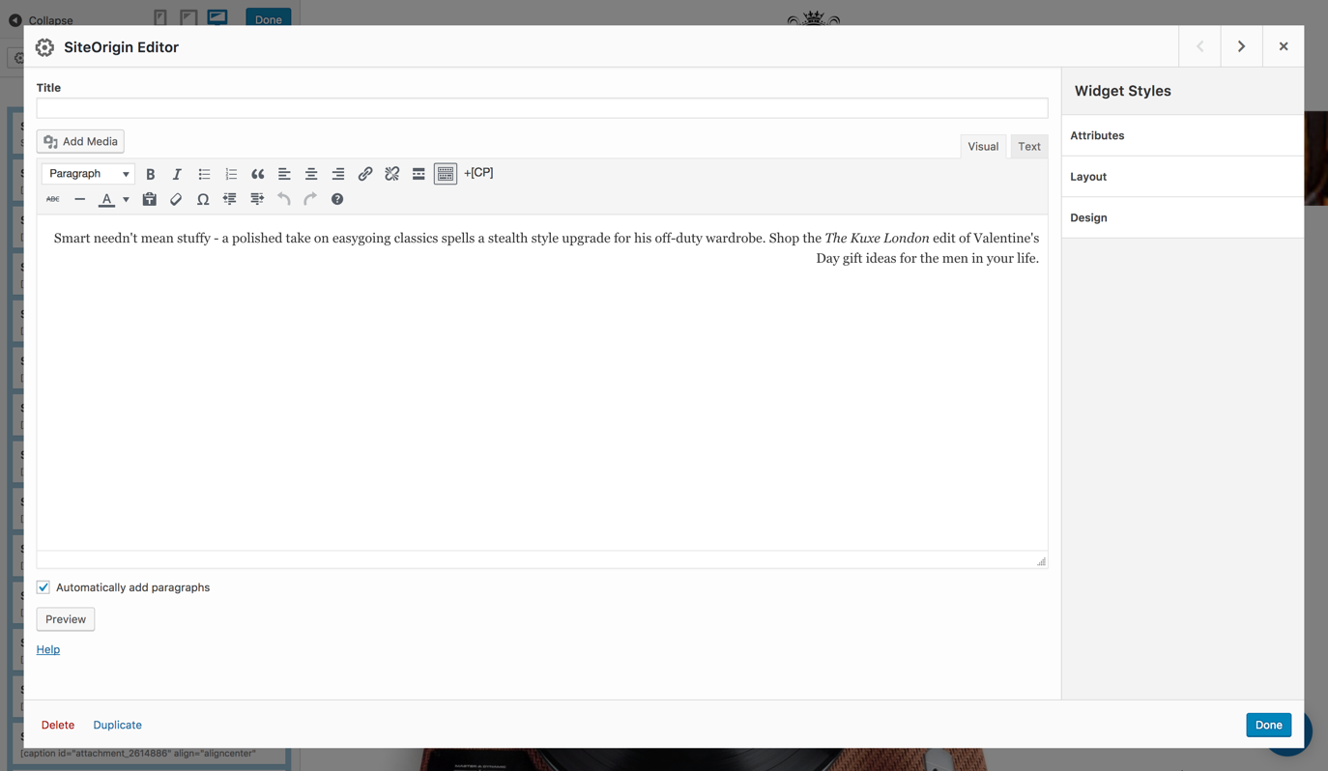

For under images with a title and a brand name please leave the title as is in English and above it write the Farsi translation

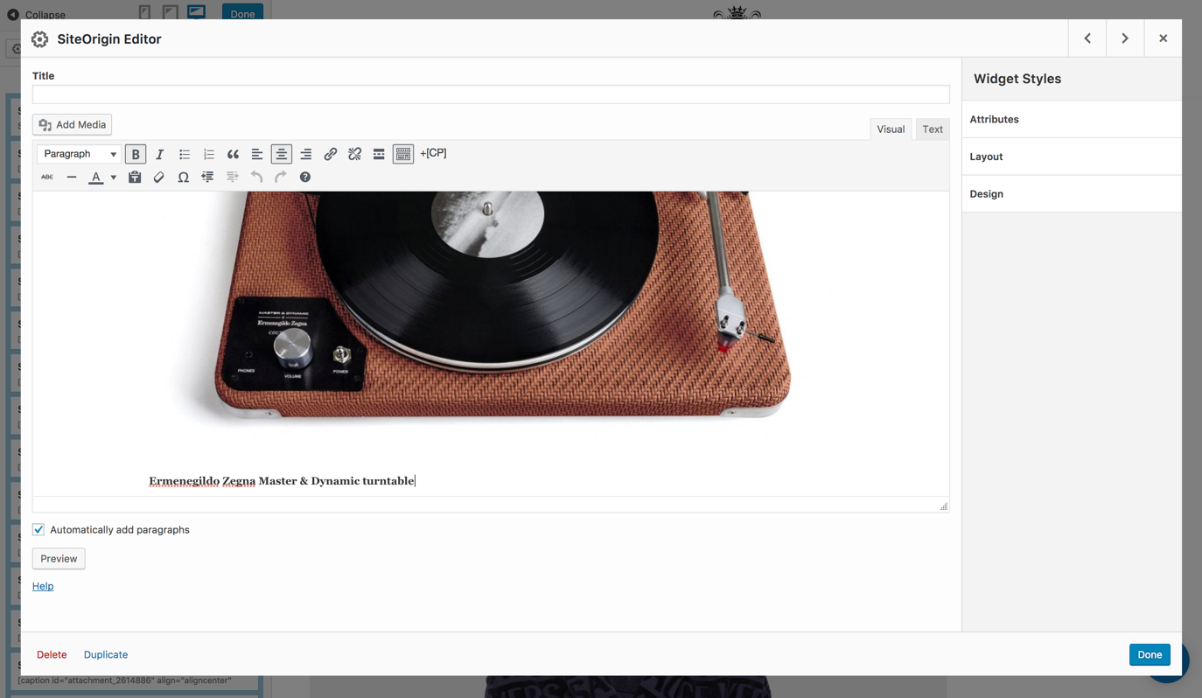

Once finished click on ‘Done’ on both screens until you get to the blog edit page. Here click on the ‘Schedule’ button on the right.

