Bangladesh: it politics, election, its relation with USA and India
Bangladesh: it politics, election, its relation with USA and India
Introduction
The People’s Republic of Bangladesh, formerly East Pakistan, became an independent state after the civil war of 1971. It is a densely populated South Asian country with some 160m people who commonly experience natural disasters in the form of floods and cyclones in the flat land and delta of rivers on the Bay of Bengal. Since independence, Bangladesh has experienced political turbulence and spent 15 years under military rule until democracy was restored in 1991. Continuing unrest has been a major impediment to economic growth, set alongside the increasing strength of Islamic fundamentalism (Knox, C; 2009).
Capital city
Dhaka is its capital and largest city, followed by Chittagong, which has the country's largest port. Bangladesh forms the largest and easternmost part of the Bengal region (Mahmood, M & Akhter, S; 2011).
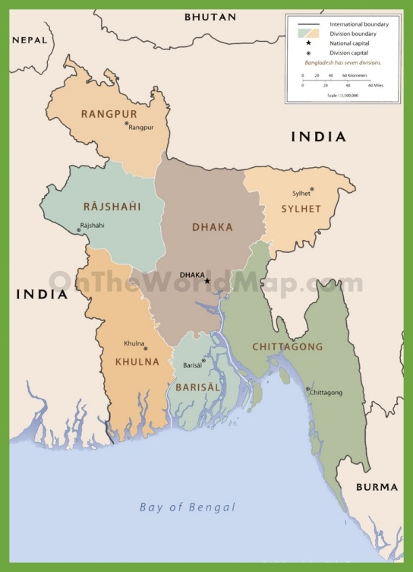
Figure 1. Map of Bangladesh.
Flag
The national flag of Bangladesh was adopted officially on 17 January 1972.

Figure 2. New flag of Bangladesh.

The flag is based on a similar flag used during the Bangladesh Liberation War of 1971, which had a yellow map of the country inside the red disc. In 1972 this map was removed from the flag. One reason given was the difficulty for rendering the map correctly on both sides of the flag.

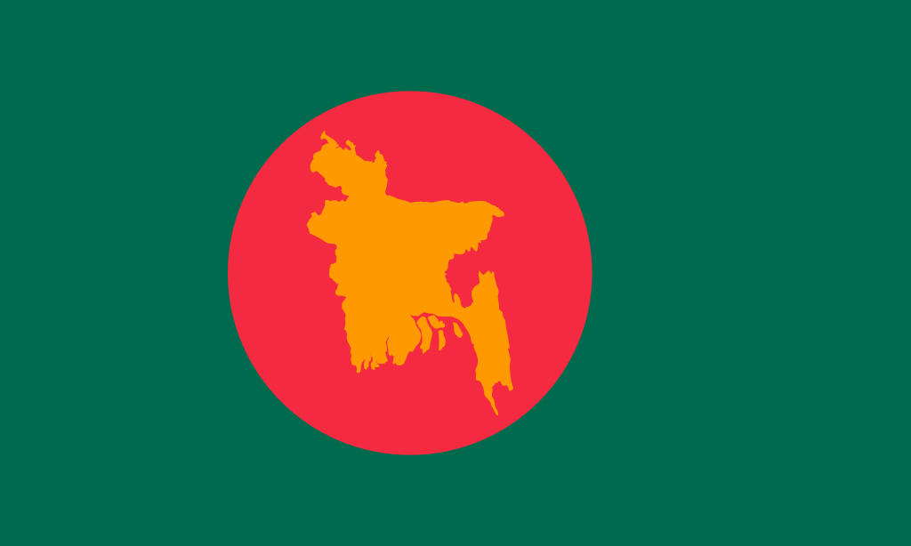
Figure 3. Old flag of Bangladesh.

Language
More than 98 percent of people in Bangladesh speak Bengali, sometimes called Bangla, as their native language (Constitution of Bangladesh; 2004). Dialects of Bengali are spoken in some parts of the country, which include non-standard dialects (sometimes viewed as separate languages). Pakistani Biharis, stranded since 1971 and living in Bangladeshi camps, speak Urdu. Rohingya refugees from Myanmar, living in Bangladeshi camps since 1978, speak Rohingya. Several indigenous minority languages are also spoken.
Bengali is the official language. However, English is sometimes used secondarily for official purposes (especially in the legal system). Although laws were historically written in English, they were not translated into Bengali until 1987. Bangladesh's constitution and laws now exist in English and Bengali. English is used as a second language by the middle and upper classes, and is widely used in higher education.
Religion
Islam is the largest and the official state religion of Bangladesh, followed by 86.6 percent of the population. The country is home to most Bengali Muslims, the second-largest ethnic group in the Muslim world.
Hinduism is followed by 12.1 percent of the population; most are Bengali Hindus, and some are members of ethnic minority groups. Bangladeshi Hindus are the country's second-largest religious group and the third-largest Hindu community in the world
Buddhism is the third-largest religion, at 0.6 percent. Bangladeshi Buddhists are concentrated among ethnic groups in the Chittagong Hill Tracts (particularly the Chakma, Marma and Tanchangya peoples), and coastal Chittagong is home to a large number of Bengali Buddhists. Christianity is the fourth-largest religion, at 0.4 percent.

Climate
Straddling the Tropic of Cancer, Bangladesh's climate is tropical with a mild winter from October to March, and a hot, humid summer from March to June. The country has never recorded an air temperature below 0 °C (32 °F), with a record low of 1.1 °C (34.0 °F) in the north west city of Dinajpur on 3 February 1905. A warm and humid monsoon season lasts from June to October and supplies most of the country's rainfall.
Independency from Pakistan
In the meantime, a new Constitution came into effect in 1962. According to Article 155 of the Constitution, East and West Pakistan were divided into 40,000 election units. On average, voters elected one representative per unit. Those elected from both provinces became members of the Electoral College. They in turn elected the President as well as members of the Provincial and National Assemblies (Khan 1989). The assemblies lacked legitimacy because of the indirect system.
Bangladesh has a long tradition of political struggle for the assertion of its democratic rights which goes back half a century. These struggles first challenged Pakistani rule and the usurpation of democratic rights by the military regime. This struggle culminated in a war of national liberation in 1971 associated with the emergence of an independent Bangladesh. This struggle continued against the usurpation of power by military regimes which again culminated in the ouster of the autocratic regime of General Ershad at the end of 1990. This tradition of struggle has left a legacy of an assertive civil society, the urge for a free media and recognition that any usurpation of democratic rights will not go unchallenged for long (Sobhan, R; 2018).
Election
The first general elections on the basis of universal franchise in Pakistan were held in 1970. AL won an absolute majority of seats in the National Assembly and secured all but 12 seats in the Provincial Assembly. Rather than handing over power to AL, the generals in Pakistan tried unsuccessfully to suppress a pro-independence movement in Bangladesh on 26 March 1971. After a nine-month war, Bangladesh emerged as an independent state on 16 December 1971.
The resignation of President Hossain Muhammad Ershad on December 8, 1990, was followed by the assumption of power by Chief Justice Shahabuddin Ahmed as acting president. Ahmed had been appointed as vice-president by Ershad in a tidy following of constitutional process in the midst of political chaos. Ahmed was the agreed-upon candidate of the two principal opposition groups headed by the Awami League and the Bangla- desh Nationalist Party (BNP). He was given two tasks. First, he was to run the country but without being overly innovative, pending the election of a new parliament. Second, he was to organize and conduct the free and fair election of the parliament as early as possible. Although there was some muttering from the BNP that the council of "advisers" (not minis- ters) appointed by the president to assist him was biased toward the Awami League, he carried out his assigned tasks admirably (Baxter, C; 2018).
Parliamentary system
In 1991, a parliamentary system of government was established by the enactment of the twelfth amendment to the Constitution. Under the Act, the Prime Minister became the executive head, and the President the constitutional head. Accordingly, the executive power of the Republic was to be exercised by the Prime Minister and his/her cabinet was to be collectively responsible to the JS. However, all executive actions of the government were taken in the name of the President. The fifth JS election of 27 February 1991 ushered in a new era in Bangladesh, a remarkable feat for many reasons. First, the election was held under a non-party caretaker government (NCG).1 Second, the election was fair. Third, the parliamentary form of government was reestablished. Parliament and parliamentary committees became much more effective than previously. It may be mentioned here that the second, third and fourth JS elections were held under military rule and the JS was ineffective (Baxter, C; 2018).
New government system
Few would dispute that democracy is the best form of government (Hadenious 1997: 7). About 40 per cent of the states in the world may be classified today as democratic. Bangladesh too opted for parliamentary democracy at the time of its independence from Pakistan in 1971. However, an unstable political environment ensued in the 1970s and Bangladesh experienced autocratic military rule in the 1980s. Massive demonstrations against the military government and international pressure made it possible to re-establish parliamentary democracy in 1991. Just after parliamentary elections that year, unity among the political parties diminished and the ‘politics of confrontation’ began.
Relations with India
India and Bangladesh share a common border of 4096 km running through five Indian states, West Bengal, Assam, Meghalaya, Tripura and Mizoram. India’s relations with Bangladesh are traditionally, cultural, social and economic. There is a much that brings them together-a shared history and common heritage, linguistic and cultural ties, passion for music, literature and the arts. India shares not only a common history of struggle for freedom and liberation but also enduring feeling of both fraternal as well as familial ties. This commonality is reflected in the multi-dimensional relations with Bangladesh at several levels of interaction. While India played a critical role in 1971 in the birth of Bangladesh, this does not however result in close bilateral ties. The paper seeks to provide a framework of recent trends in the relations between the two nations. Currently, both nations are enjoying extremely good quality relations (Vaughn, B; 2007).

Relations with United States
The United States has long-standing supportive relations with Bangladesh and has viewed Bangladesh as a moderate voice in the Islamic world. Major U.S. interests in Bangladesh include political stability and democratization; continuation of economic reform and market-opening policies; social and economic development; environmental issues; counterterrorism; and improvement of the human rights situation. Many in the United States would particularly like to bolster Bangladesh’s democracy, which is destabilized by political violence. In early 2003, Dhaka was the site of modestly-sized street demonstrations in opposition to the U.S.-led invasion of Iraq(Vaughn, B; 2007)

.
Conclusion
Historically, the government and the opposition in Bangladesh have confronted each other more on the streets than in the JS, inflicting a serious cost on the country. In a parliamentary democracy, the Parliament is in fact the only national forum to hold discussions on any national issue. The Parliament serves as a forum of public debate and opinion. In short, an effective Parliament is an important tool in rooting out corruption, promoting democracy and good governance, and hastening development. As the public in general and international donors in particular are becoming increasingly impatient with confrontational politics and the worsening governance situation in Bangladesh, the nation deserves the practice of standard parliamentary norms such as respect for contrary opinions and consensual politics by political parties. But democratic norms and values will be reflected in the behavior of politicians at the national level only when they practice democracy inside the party itself. That is why the speaker of the Bangladeshi JS urged politicians to practice democracy within the parties first (Daily Star 2005d).

References
Ahmed, N; Demaine, H and Muir, J.F. (2008). Freshwater prawn farming in Bangladesh: history, present status and future prospects. Aquaculture Research, 39, 806.-819.
Ali, H; Haque, M.M. and Belton, B. (2013). Striped catfish( Pangasianodon hypophthalmus, Sauvage, 1878) aquaculture in Bangladesh: overview. Aquaculture Research, 44, 950.-965.
Baxter, C. (1992). Bangladesh in 1991: A Parliamentary System. Asian Survey, 32(2), 162-167.
Bhuiyan S.H. (2010). A crisis in governance: Urban solid waste management in Bangladesh. Habitat International, 34, 125.-133.
Kang, K. and Kim, J.H. (2010). Exploring the Spectrum of export destination: The geographic spread of Korean exports, it’s determinates, and policy implications. The developing econommics, 48(4), 421-449.
Knox, C. (2009). Dealing with spectral corruption in Bangladesh: Developing citizen involvement. Wiley , 29, 117-132.
Mahmood, M. and Akhter, S. (2011). International briefing 24: training and development in Bangladesh. International Journal of Training and Development, 15(4).
Nialsen, M. (2005). The politics of corporate responsibility and child labour in the Bangladeshi garment industry. International Affairs , 81(3), 559-580.
Nurul Alam, S.M. (2011). Health service delivery: The state of government non-government relations in Bangladesh. Wiley Online library, 31, 273.-281.
Oh, J. and Sardar, R.R. (2013). Gravity matters: International trade of Bangladesh. The Applied Regional Science Conference, 25(1).
Rahman, M.M. (2007). Origins and pitfalls of confrontational politics in Bangladesh. South Asian Survey, 14(1), 101-115.
Rashiduzzaman, M. (2018). Political unrest and democracy in Bangladesh. Asian Survey, 37(3), 254-268.
Riaz, A. (2004). Islamic Militancy in Bangladesh. New York, NY: Routeledge.
Sobhan, R. (2004). Structural Dimensions of Malgovernance in Bangladesh. Economic and Political Weekly, 39(36), 4101-4108.
Zafarullah, H. and Akhtar, M.Y. (1993). Non-political caretaker administration and democratic elections in Bangladesh: an assessment. Asian Affairs, 19(4), 248-261.
Zaman Khan, S. (2018). The Politics and Law of Democratic Transition. New York, NY: Routeledge.

.

.

