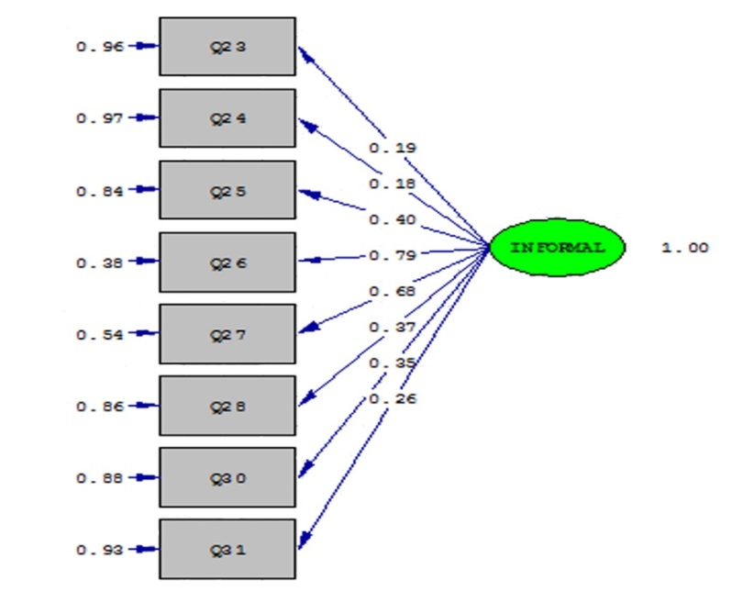

Chi-Square=56.16 df = 20 P-value =0.0000 RMSEA=0.061

Fig.1. LISREL output for confirmatory factor analysis the latent factor of the informal learning.

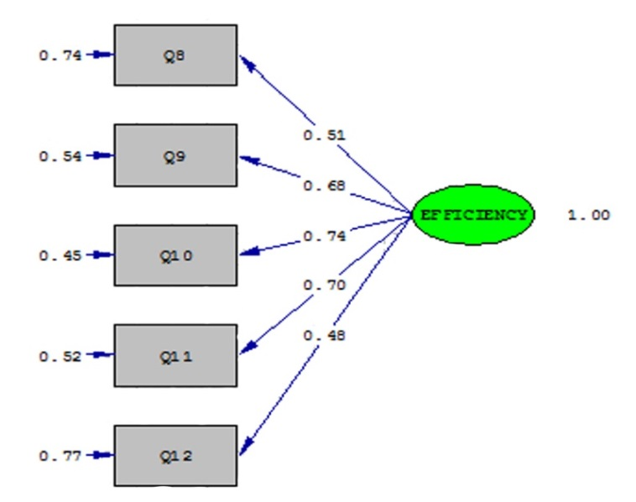

Chi-Square =12.91 df =5 P-value=0.00200 RMSEA= 0.07

Fig. 2. LISREL output for for confirmatory factor analysis the latent factor of job self-efficacy.

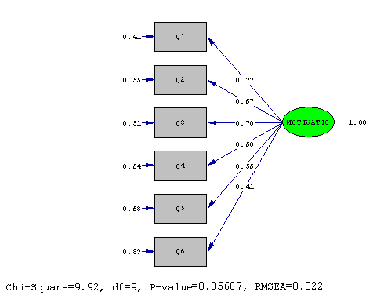

Chi-Square = 9.92 df = 9 P-value = 0.35687 RMSEA= 0.022

Fig. 3. LISREL output for confirmatory factor analysis the latent factor of learning motivation.

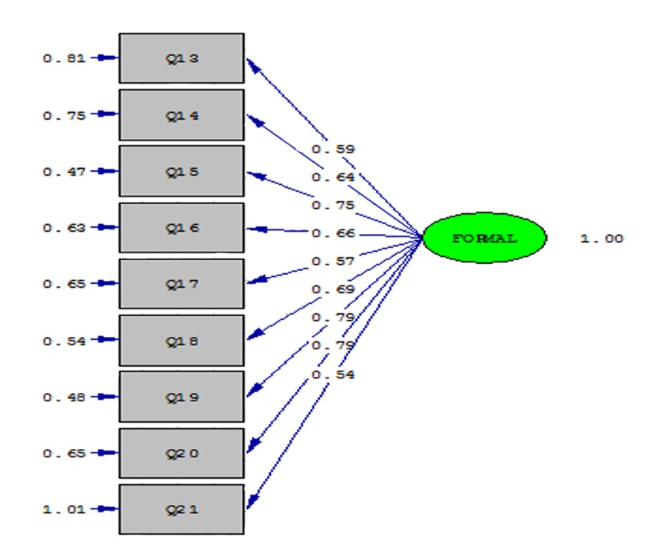

Chi-Square 66.35 df = 27 P-value = 0.0000 RMSEA= 0.08

Fig. 4. LISREL Output for confirmatory factor lnalysis the latent factor of formal learning.

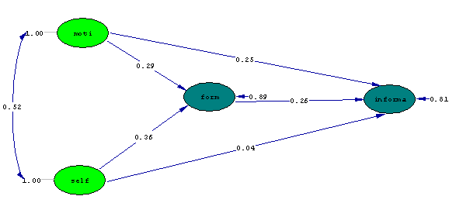

Chi-Square= 827.57 df= 344 P-value= 0.0000 RMSEA= 0.071

Fig. 5. Software output based on standard coefficients.

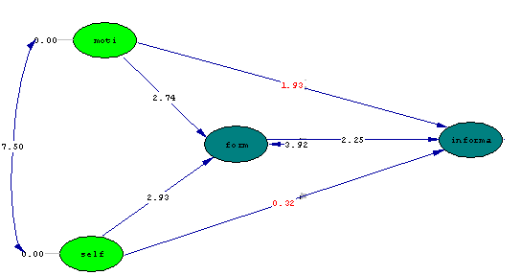

Chi-Square= 827.57 df= 344 P-value= 0.0000 RMSEA= 0.071

Fig. 6. Software output based on t coefficients.