# Translating emails for customers

Login to Mailchimp at mailchimp.com

Under “Campaigns” tab click on “Ready to Post” folder

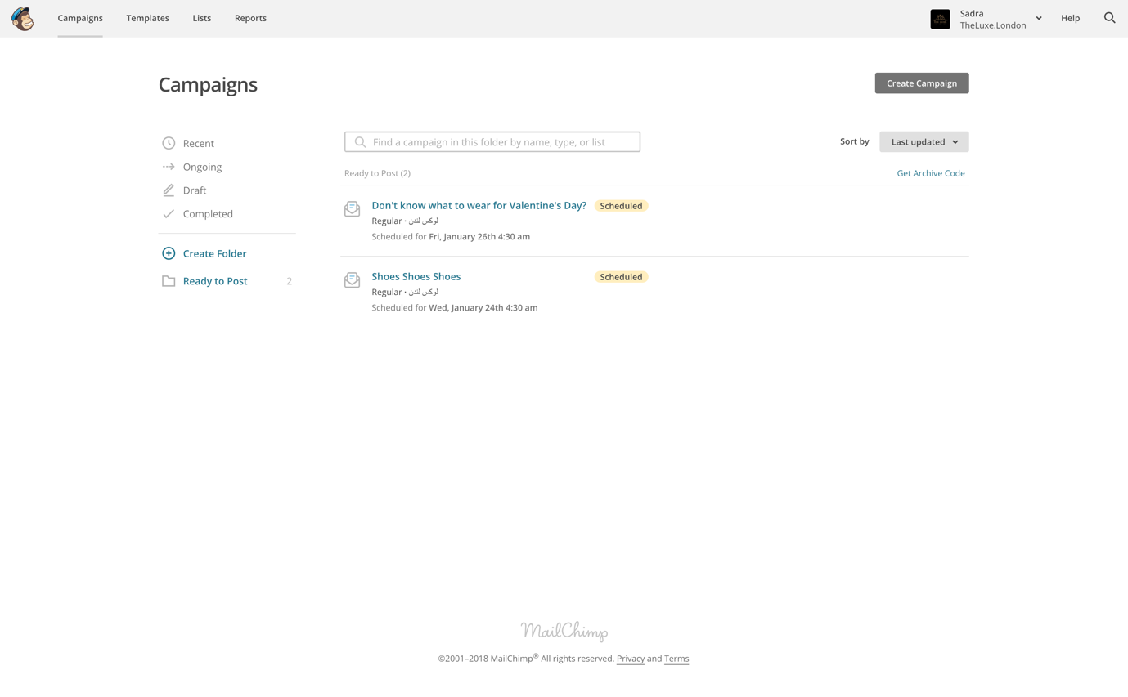

The emails go out Monday, Wednesday and Friday. Here you can see posts that are ready to be translated and posted.

Click on the email to be translated, then click on “Pause”

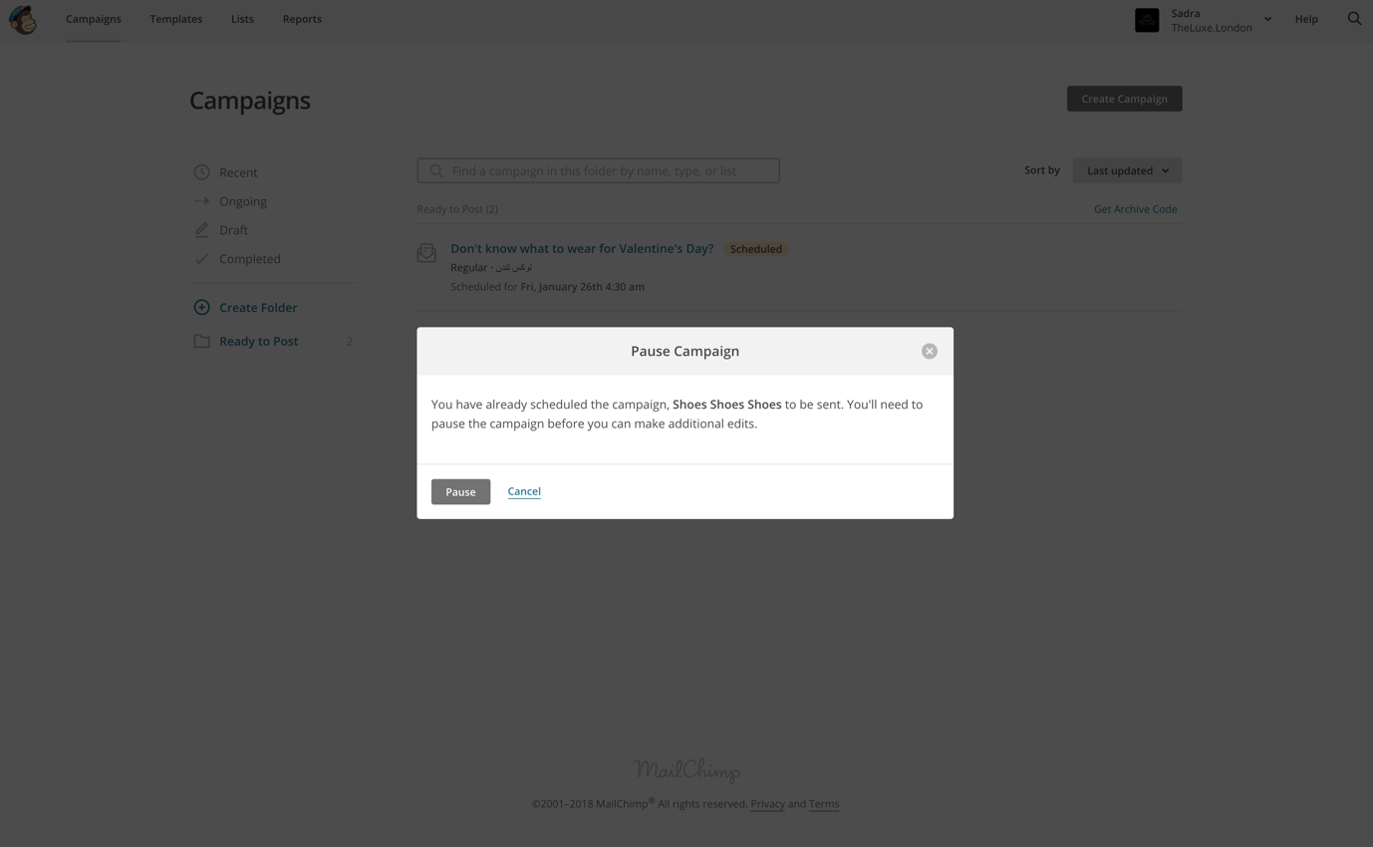

Click on “Edit Design” and translate post

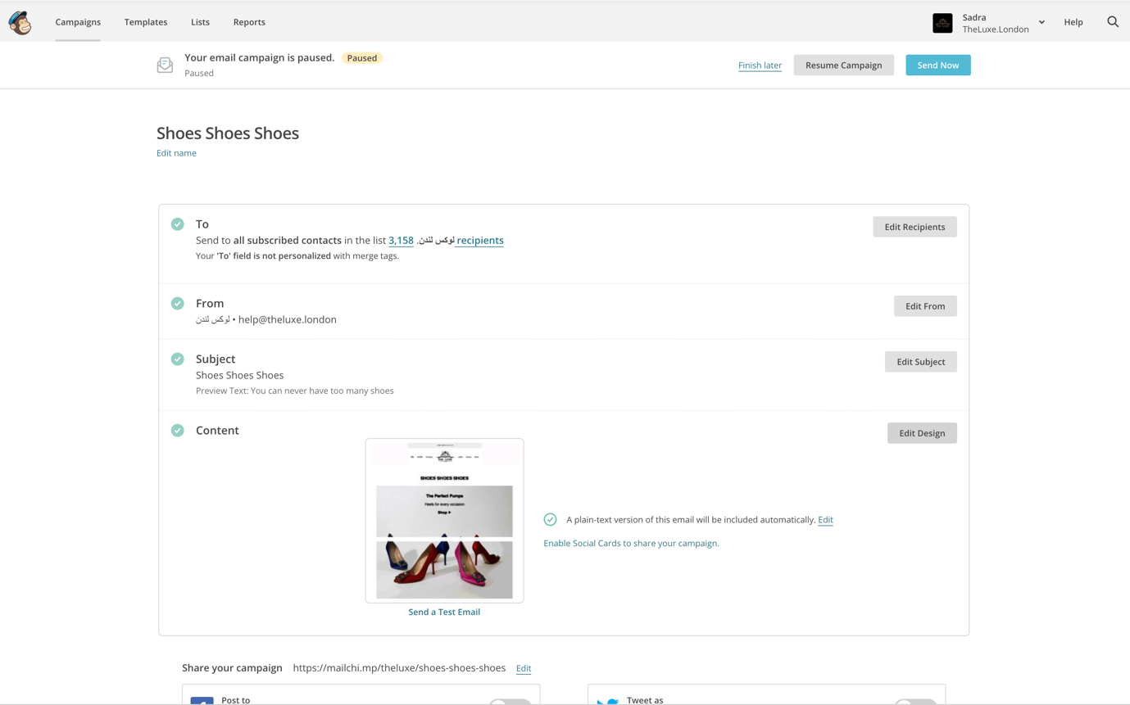

Click on “Save & Close” once translated

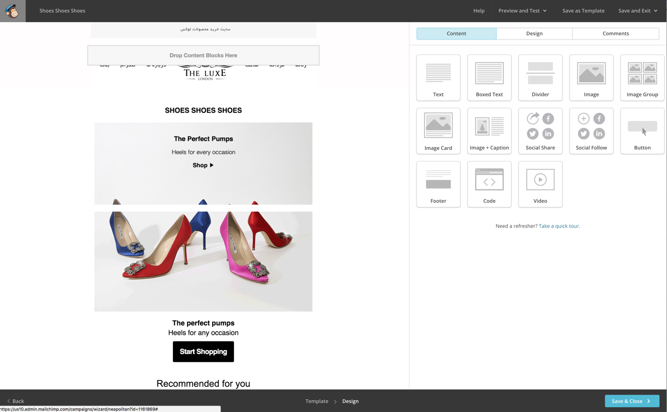

Click on “Resume Campaign”

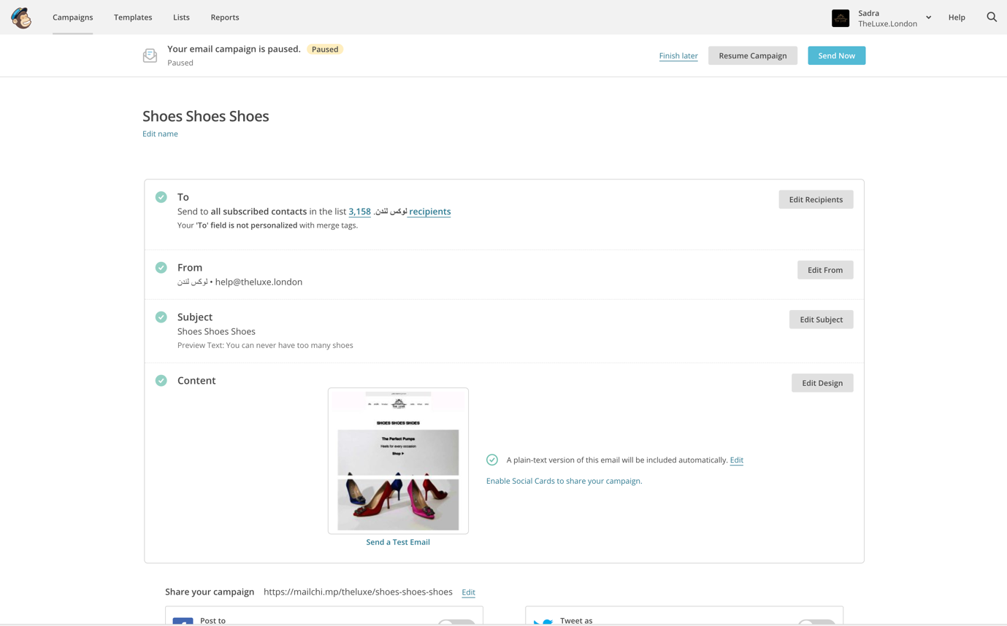

Then click on “Schedule Campaign”

