**The Relationship between Job Self-Efficacy and Learning Motivation with Informal Learning: The Test of the Mediating Role of Formal Learning among Employees of Regional Water Company of Khorasan Razavi**

**1. Introduvtion**

In today's competitive world, organizations have always focused their attention on the importance of human resources as the most important source of obtaining competitive advantage. One of the most important objectives of the current organizations that has been considered by many researchers is the development of motivational, purposeful, progressive, and efficient employees. Extensive environmental changes have led organizations to continually seek the best practices and procedures in order to adapt to their changes in the environment; in this regard, one of the most important actions in dealing with such changes is to pay attention to a set of factors called continuous and informal learning in the workplace, thus providing competitive and rapid action to employees and organizations (Slater, 2004; quoted from Zeratkar, 2015) On the other hand, according to Bandura, attention to job self-efficacy means of employee as cognitive assessments, in which employees have their own abilities to perform a better job, and the motivation of each one to improve formal and informal learning in work environments. Success and achievement of these objectives will play a significant role (Ashouri et al., 2011).

Marquardt (2006) believes learning ability, discovering change and implementing it is an important feature that is crucial for excellence in today's evolving world. According to many scholars, learning occurs in both formal and informal ways. For example, Hager (1998) views the distinction between informal learning from formal learning based on unplanned, unorganized, nonstructural concepts. Informal learning refers to a set of conscious activities of employees in the workplace, which results in their knowledge and professional skills growing (Cofer, 2000; Lohman, 2000) and obtain the freedom to make changes (Mariotti, 1999; Cseh, 1998). This type of learning is a personal and interpersonal process that can be used to help team macking in education, and team members can be strengthened by identifying and applying informal learning strategies (Marsick & Watkins, 1999). Formal learning is the type of learning in which a person is trained in a predetermined process. This type of learning is also known as academic, structural, classroom learning. Examples of informal learning include things like talking and sharing resources together, searching the internet, learning experiences, and testing new methods and tools. The most important part of informal learning is the growth of the characteristics of job efficiency and the interaction effect between informal learning activities, the learning environment and the efficiency of those involved in learning (Billett, 2001; Ellstrom, 2001).

Job self-efficacy is another factor directly affecting informal learning (Lohman, 2005). This variable is the key construct of cognitive-social theory of Bandura. According to this theory, change in behavior and its maintenance is a function of individual expectations about its ability to perform certain behavior (self-efficacy or efficacy expectation) and expectations of the outcome of doing that behavior (Karimi Torghabeh, Shajieh, Adle Ghahreman, Mohammadi, 2009). Research has argued that self-efficacy strengthens people's willingness and tendency to learn and try to achieve their objectives, as well as to maintain continuity in difficult tasks. Self-efficacy beliefs regulate human performance in four main stages: cognitive, motivational, emotional, and selection processes (Azimzadeh, 2012). In order to improve learning motivation and obtaining a job self-efficacy, we must be deeply committed to our work, value for it and have that passion, but many people have not motivation for having a commitment to work and learning due to their circumstances. (Lanch, 2011).

Choi and Jacobs (2011) in their research entitled The Effect of Formal Learning, Personal Learning Orientation, and Supporting the Learning Environment on Informal Learning showed that formal learning and personal learning orientation have a positive and significant effect on informal learning. Although the support of the learning environment does not directly affect informal learning, but on mean, it has a significant indirect effect through formal learning on informal learning.

Park and Choi (2016), as a result of the research on the effects of formal learning and informal learning on job performance and the mediating role of learning at the user's place on one sample of employees in the small and medium enterprises of South Korea, showed that formal learning has a direct relationship with job performance and affects it, and There is also a direct and significant relationship between informal learning and employees' job performance, and the level of learning at work also affects the relationship between formal and informal learning and the type of employee's job performance.

Shelly, Berg & Chyung (2008) in a study entitled Factors Affecting Informal Learning in the Workplace on the 400 teachers found that learning and improving people's performance was more than new knowledge acquired through informal learning than formal learning and participation in informal learning activities alone are not sufficiently good predictors of organizational learning characteristics. In their research, many factors affect the participation in informal learning. Various informal learning strategies are also used for this purpose.

Lohman (2009) explores the factors influencing the participation of IT professionals in informal learning activities oncluding: Six Environmental factors: lack of time, lack of access to working areas of colleagues, unprotected organizational culture, lack of availability of people, lack of equipment and technology and lack of adequate encounter in the work space were identified as barriers to the participation of technology professionals in informal learning activities.

Cunningham & Hillier (2013), in another study entitled Informal learning in the workplace, activities and processes in a public sector in Canada, seek to improve understanding of the ways in which formal education programs completion when reducing on funding for professional development. In this study, a period of savings has encouraged managers to create an deomestic coaching program and use a variety of self-constituted activities to evaluate employees to improve their new skills. The mentioned research provides ways to promote informal learning activities based on coaching and self-constituted activities that the organization is committed to doing. When we asked the employees about positive and negative examples of informal learning, they considered important informal learning activities as well as their processes.

Nikolova et al. (2014), in a research entitled Work-based learning: developing and validating a measure of the potential of learning from workplace, have satated that to now, many studies have attempted to measure informal learning from workplace, but most of them have a common limit: they are dependent on the context that may prevent them from being used in a variety of job environments.

Marcik and Watkins (2008), in a research entitled Demonstrating the value of organizational learning culture, the dimensions of the organization's questionnaire, define oblique or informal learning as an outsourced component of some other activities, such as doing work, interpersonal interactions, organizational culture, testing or failure, or even formal learning. Informal learning can be encouraged directly by the organization, or it can happen in an environment that does not lead to learning. In other words, informal learning is almost always the case, although people are often unaware of it.

In his research, Self-efficacy in the workplace, implications for motivation and performance, Loonenberg (2011) showed that self-efficacy (the belief in their ability to fulfill a particular task) on the task that employees choose for learning and objectives were affected. Self-efficacy also affects the amount of people learning to continue trying when faced with problems.

A study by Choi (2010) entitled Assessing job self-efficacy and organizational commitment by considering the mediating role of asymmetric data concluded that opportunism (political behavior) does not affect job self-efficacy, and this is because job self-efficacy has more autonomous beliefs than emotional feelings and also concluded that there is a direct and significant relationship between high self-efficacy and high quality of organizational commitments and decisions.

Regarding the mentioned issues, one of the ways to achieve sustainable competitive advantage is to emphasize the self-efficacy of employees and improve continuous motivation in informal learning in order to achieve organizational objectives with maximum effectiveness. Certainly, today's changing environment will not allow organizations to be held in a way that is traditionally and permanently managed in response to pressures from competitors' skills, abilities and technologies. Establishing and preparing of faster learning than competitors can help organizations move faster and better than competitors. Therefore, the tendency toward learning is the basis of survival and organizational performance improvement (Shahabi, 2005, quoted by Sobhaninejad, 2006). As workplace professionals often believe that development is through informal learning and can include a variety of methods, such as classroom-based education and computer-based education, to carry out a key task or some of the other traditional planning methods (Conlon, 2005). Since the regional water company of Khorasan Razavi has a strategic and central role in the management and conservation of the country's water resources as the most basic of vital assets. Therefore, this research objectives to investigate the relationship between job self-efficacy, which has wide applications in learning and development situations, and an important factor in the system of employee competence, along with learning motivation, through informal learning while paying attention to the mediating role of formal learning.

**4. Research objectives**

**1.4.1. Major objective**

Identifying the relationship between job self-efficacy and learning motivation with informal learning of employees by considering the role of mediating of formal learning.

**1.4.2. Minor objectives**

1. Identifying the relationship between job self-efficacy and informal learning.

2. Identifying the relationship between learning motivation with informal learning.

3. Identifying the relationship between learning motivation with formal learning.

**1. Mayjor hypothesis**

There is a significant relationship between job self-efficacy and employee's learning motivation with their informal learning and formal learning mediation.

**1.5.2. Minor hypotheses**

1. There is a relationship between job self-efficacy and informal learning.

2. There is a relationship between learning motivation and informal learning.

3. There is a relationship between job self-efficacy and formal learning.

**2. Research Method**

Since the purpose of this study is to identify the relationship between job self-efficacy with informal learning and considering the role of mediating of formal learning among employees of the regional water company of Khorasan Razavi, the present study in terms of collecting data is descriptive and correlational specifically on the basis on the model of structural equations. In the analytical model of research, job self-efficacy and learning motivation, exogenous (independent) variables is formal learning, and mediating variables, and informal learning is endogenous (dependent) variables.

**3.3. Statistical Population**

The statistical population of this research includes all employees of Khorasan Razavi Regional Water Company, working in 2016. The size of the statistical population is 400 people. Of these, there are 370 official personnel and 30 contractors personnel in the CEO and 5 departments of deputy (planning and improving management, planning and development, financial and support, baseline water resources studies, and deputy conservation and operation).

**3.4. Estimated sample size and sampling method**

In the present study, a stratified random sampling method was used proportional to the size of each of the five deputy of company, in addition to the CEO department. First, based on the total volume of the statistical population, the number of statistical samples was determined and then from the HR department of the company, the number employees were selected in each section; with the above data, the sample size for each section was determined to complete the questionnaire as follows: At first, the total volume of the sample was divided into the total volume of the statistical society and the resulting output was multiplied by the number of employees in each section. For example, given that the total statistical population was 400 people, the total sample was 205 people, and for example, the number of employees in a deputy was 60; the number of questionnaires that had to be completed on the basis of relative stratified sampling was 31 peoples []. The number of samples of the rest of the sections was obtained as follows. Data on the number of employees and examples of each section is presented in Table 3-1. According to the obtained ratios, the questionnaires were randomly distributed among the employees. Morgan table was used to determine the sample size. In accordance with the above table of 400 employees, 196 people were selected. In order to ensure the return of the questionnaires, 240 questionnaires were distributed in the statistical population. Finally, 205 valid questionnaires were analyzed. One of the reasons for increasing the sample size from 196 to 205 was to use a larger sample to analyze the structural model.

**5. Research variables**

The main objective of this research is to identify the relationship between job self-efficacy and learning motivation with informal learning and taking into account the mediating effect of formal learning among employees of the regional water company of Khorasan Razavi. To measure research hypotheses with operational definition, concepts and research structures became indicators and reagents. The description of the types of research variables is presented below. The scale of variables is a distance because all questionnaires are measured on a five point Likert scale.

The control variables in this study include the variables gender, age, work experience and education.

**3.5.4. Mediating variables**

The mediating variable is used to describe a certain independent variable and is the second independent variable that is selected to determine its effect on the relationship between the first independent variable and the dependent variable. The mediating variable is a factor chosen, measured or manipulated by the researcher to determine whether the change would change the relationship between the independent variable and the phenomenon observed. In the present study, the variable of formal learning is considered as a mediating variable.

In this study, a questionnaire was used to collect the required data. The questionnaire is among the commonly used measurement tools in research and a direct method for obtaining research data. In this study, four standard questionnaires were used as the main tool for collecting data. The research questionnaire consists of 30 questions, all of which are presented as news statements with a five point of Likert scale. In the following, we will give a detailed description of them.

**3.6.1. Standard questionnaire of informal learning**

To measure this variable, the standard questionnaire of Lohman (8 questions) (2005) was used. According to Lohman, the basis for this questionnaire is the findings of a qualitative research on the informal learning of public-school teachers (Lohman & Woolf, 2001). The questionnaire is scored on a five point Likert scale (never= 1, rarely= 2, sometimes= 3, often= 4, and always= 5). In this way, individuals, after studying each item on the 5 points Likert scale, identify the option that indicates their status. The scale used in this questionnaire attempts to evaluate the dominant methods of informal learning of individuals in learning job tasks. The validity of the tool was confirmed by two panels of experts, including educational and training researchers and a field survey (Choi, 2009, 74), and reliability with Cronbach's alpha of 0/63 was confirmed in previous studies by Lohman (2005). (Choi, 2009, 74).In this research, the opinions of the supervisors and counselors were used to ensure content validity. The validity of the construct of the measurment tools was also verified by CFA analysis. Cronbach's alpha method was used to determine the reliability of the questionnaire. The Cronbach's alpha coefficient for informal learning questions was 0.65.

**3.6.2. Standard questionnaire of job-efficacy**

To measure this variable, the questionnaire of 5 questions of Muscle (2008) was used. This questionnaire is also graded according to the 5 points Likert scale (full disagree= 1, disagree= 2, Neutral= 3, agree = 4, and full agree= 5). After studying each item, the 5 points Likert scale selects an option that is more in line with their condition. The scales used in this questionnaire attempt to assess one's perceptions and judgments about their ability to conduct job and professional homework. The content validity and reliability of the present questionnaire were confirmed by Cronbach's alpha of 0.69 in previous studies by Bosscher & Smit (1998) and Sherer (1982) and 0.87 in Barnard (2005) research (Choi, 2009, 69). In this research, the opinions of the supervisors and counselors were used to ensure content validity. The construct validity of the measurement tool was also measured by the CFA analysis method. Cronbach's alpha method was used to determine the reliability of the questionnaire. Cronbach's alpha coefficient for job self-efficacy questions was 76%.

**3.6.4. Standard questionnaire of formal learning**

To measure this variable, a standard 10-questions questionnaire developed by Jacobs & Park, 2009; Krivet, 2008), which has two components of learning while doing work and learning outside of the doing work time were used. The questionnaire is answered based on a 5-point Likert scale (very low= 1, low= 2, mean= 3, high= 4, and very high= 5). Which the first five questions of the questionnaire measures learning at doing work time and the next five questions measures learning outside of the doing work time. Individuals after each items, identify the option that best describes their status (It should be noted that in the present research, the question 10 of the questionnaire that is related to learning outside of the doing work time that was wliminated due to the low factor load). The scales used in this questionnaire attempt to measure the level of learning of individuals from a variety of learning methods at doing work and outside of doing work time. Content validity and reliability of the present questionnaire were confirmed by Cronbach's alpha of 0.89 for formal learning component at doing work time and 0.88 for formal learning outside of doing work time in previous studies by Jacobs & Park (2009) and Krivet (2008). (Jacobs and Choi, 2011,264). In this study, the assurance of the supervisor and counselors was obtained to ensure the content validity of the measurement tool. The construct validity of the measurement tool was also measured by CFA analysis. Cronbach's alpha method was used to determine the reliability of the questionnaire. The Cronbach's alpha coefficient for formal learning questions was 0.86.

**3.7. Validity Tool**

The validity of the tool indicates that the measuring tool measures the concept or phenomenon under study (Ary et al., 2002; quoted from Choi, 2009, 75). Without the knowledge of the validity of the measuring tool, it is not possible to accurately obtain the data obtained. Therefore, the significance of validity is that inadequate measurements can make any scientific research worthless and unworkable (Khaki, 1391). The measurement tool may be valid for measuring a particular attribute, while in order to measure the same attribute in another society, no credit is not available, in this study, despite the use of standard questionnaires, in addition to the content validity of the measurements tool after the translation confirm by supervisor and counselor professors. In order to ensure the validity of the questions and the items evaluated for the concepts used in the research, an initial questionnaire was tested on 10 subjects in the research population, so that the possible defects of the questionnaire, which could have been due to the inadequacy of the translated questions, the inappropriate order of the questions, etc., were eliminated. In this regard, respondents and experts were asked to register the questions and possible problems of the questionnaire against each question. After receiving the comments and resolving the general ambiguities expressed in the questionnaire, the executive version was finalized after the endorsement of the supervisor.

Therefore, in this research, the reliability of the measurement tool was calculated among the statistical population of the research (employees of the regional water company of Khorasan Razavi). Cronbach's alpha method was used to determine the reliability of the measurement tools. Firstly, the variance of the scores of each subset of the questionnaire and the total variance were calculated and then the alpha coefficient was calculated using the corresponding formula.

Table 3.2. Cronbach's alpha coefficient obtained for each of the research indicators

|  |  |
| --- | --- |
| Indices | Cronbach's alpha coefficient |
| Informal learning | 65/0 |
| Job self-efficacy | 76/0 |
| Learning motivation | 76/0 |
| Formal learning | 86/0 |

Cronbach's alpha coefficient indicates the level of internal consistency of the entire measuring tool in a given context structure (Choi, 2009). As shown in Table (2-3), the Cronbach's alpha was calculated for each of the research indices. However, an alpha value greater than 0.7 is desirable (Ary et al., 2002; Kline, 2005; quoted by Choi, 2009). But a value greater than 0.6 is accepted as a trusted level (Wendyon & Frei, 1980; quoted by Choi, 2009). Accordingly, given that the Cronbach's alpha coefficient of the informal learning indicator in the present study, according to previous studies of Lohman (2005), was higher than 0.6, and exceeded 0.7 in three other indicators, this issue indicates the internal correlation between the variables for measuring the desired concepts, which means that our research has the reliability or reliability required.

**3.9. Data collection method**

The data of the present study were collected through both library and field studies (implementation of the questionnaire). Therefore, in the library method, after the approval of the subject of research, they studied the specialized texts, in internal and external academic journals, and thesis and taking notes. To implement the research questionnaires, due to the knowledge about the regional water company of Khorasan Razavi and the human resources industry's needs in the field of human resource education and training, which was previously achieved through doing training course (Office for improvement of management and human resources). First, the approval of the director of the Office for Improvement of Management and Human Resources on the selection of the company as the statistical population of the research was agreed upon, then, by specifying the number of statistical samples for each department of the company, the we were randomly referred to the employees and after providing the necessary explanations in specifically, the method of implementation and the objectives of the research, the questionnaire was delivered to the person in question, and after the specified time, to receive a questionnaire. Since this company has 5 different deputies along with the managerial area and the number of employees in each deputy is different and almost intimately, the data of the questionnaire were collected based on the stratified sampling method mentioned above. If some employees were not cooperating, taking into account the relevant deputy department from among the remaining members of the same department, one person would randomly replace that person.

**3.10. Measurement Model: Confirmatory Factor Analysis**

The most important goal of confirmatory factor analysis is to determine the power of a predetermined operating model with a set of observed data. In other words, the confirmatory factor analysis attempts to determine whether the number of factors and loads of variables measured on these factors is consistent with what was expected based on theory and theoretical model. This type of factor analysis examines the degree of confirmatory and consistency between the theoretical construct and the experimental structure of research (Habibpour and Safari, 2012). Therefore, before evaluating the structural model in order to establish a grateful and acceptable measurement model and determining whether the markers well measure the constructive theoretical structure, a confirmatory factor analysis was carried out on all the existing factors. The model evaluated in this study included 4 latent variables: 1. informal learning, 2. self-efficacy, 3. learning motivation, and 4. formal learning.

As shown in Figures 3.1 to 3-4, the LISREL outputs for the confirmatory factor analysis of the variables considered are significant, each of the variables of informal learning (with 8 indices), job self-efficacy (with 5 indices), learning motivation (with 6 indices) and formal learning (with 9 indices) that had the highest functional load.

Factor loads (standard estimates) of the variables for the informal learning factor were between 0.18 and 0.79, for the job self-efficacy latent factor between 0.48 and 0.74, learning motivation between 0.41 and 0.77 for the formal learning ranged from 0.54 to 0.79. As shown in the following figures, the factor load of all indices of the variables is significant at the level of 0.01. This indicates the convergence validity of the markers (Figs. 3-1 to 3-4).

Fig.1-1. LISREL output for confirmatory factor analysis the latent factor of the informal learning

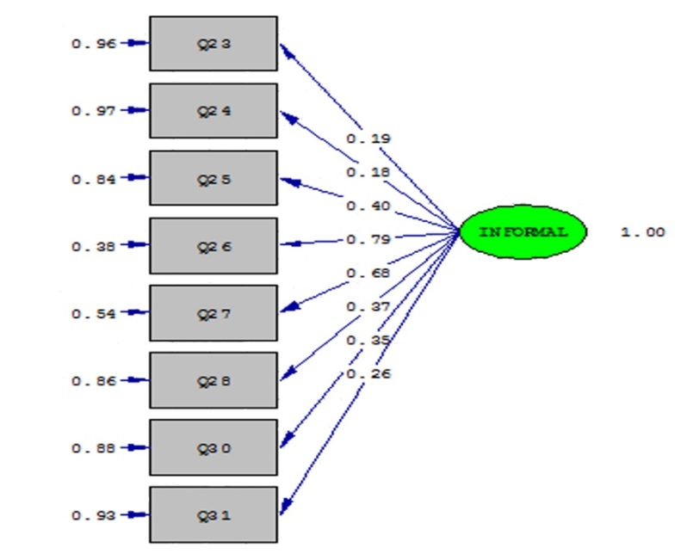

Chi-Square=56.16 df = 20 P-value = 0.00000 RMSEA=0.061

Fig.3-2. LISREL output for for confirmatory factor analysis the latent factor of job self-efficacy

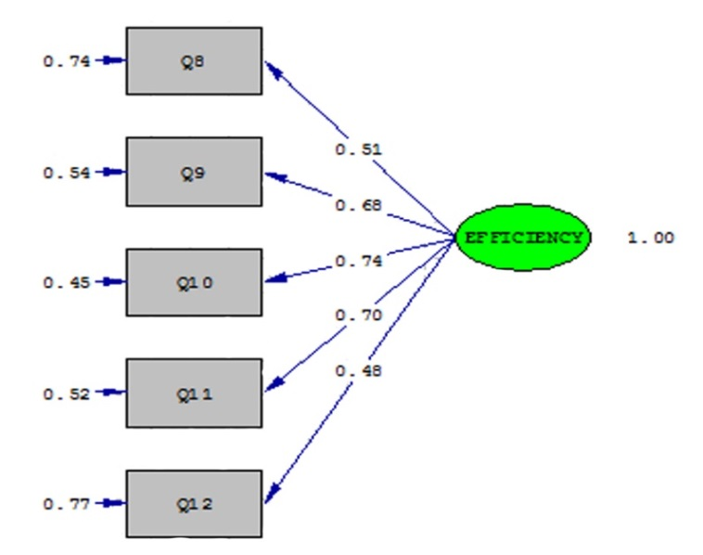

Chi-Square =12.91 df = 5 P-value=0.00200 RMSEA= 0.07

Fig.3-3. LISREL output for confirmatory factor analysis the latent factor of learning motivation

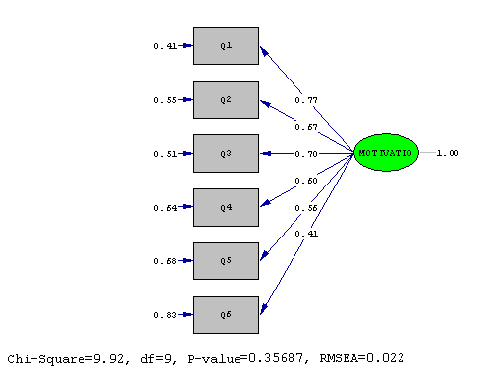

Chi-Square = 9.92 df = 9 P-value = 0.35687 RMSEA= 0.022

Fig.3-4. LISREL Output for confirmatory factor lnalysis the latent factor of formal learning

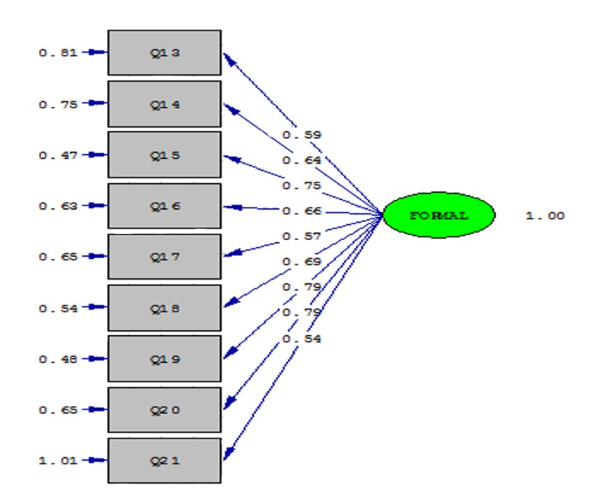

Chi-Square = 66.35 df = 27 P-value = 0.00000 RMSEA= 0.08

According to the results of confirmatory factor analysis and evaluation indicators, the measurement models have acceptable fitting and are valid based on the infrastructure hypothesis model.

According to the results of confirmatory factor analysis and evaluation indicators, the measurement models have acceptable fitting and are valid based on the infrastructure hypothesis model.

**3.10. Methods of Analyzing the Findings**

In this research, the correlation between two variables and the relationship between more than one variable and its other variables were determined. Descriptive and inferential statistics were used. In the descriptive statistics section, mean and standard deviation were used to show the status of data and Pearson correlation coefficient. In the inferential statistics section, the relationship between the variables and the test of research hypotheses was investigated through the method of confirmatory factor analysis and structural equation modeling with using SPSS16 and LISREL8.5 software. In the present study, the two-step approach recommended by (Anderson & Gerbing, 1988; quoted by Vosoughi, 2010) was used to evaluate the models while standardizing them. In the first step, a confirmatory factor analysis method was used to assess the fitting of the measured models of the used variables. In other words, in this step, we examined the issue of whether the observed dimensions correctly measure the structure. In the second step, structural equation modeling was used to evaluate the structural model. To evaluate and compare the model of measurement and structural model, several indices have been used: 1. Chi square, 2. Chi square ratio to degree of freedom, 3. GFI fitting index, 4. NNFI index, 5. CFI comparative fitting index, 6. IFI incremental fitting index and 7. Root mean square error of approximation(RMSEA*).* As stated, structural equation method was used to analyze the data of this study.

In this chapter, descriptive findings are first examined and subsequently correlations of latent variables are presented in the form of matrix tables. Data collected from the questionnaires were then analyzed statistically. To summarize and describe the data of demographic factors, descriptive statistics such as frequency table, columnar graph, mean and standard deviations of variables were used. In the second part, for testing hypotheses, inferential statistics of Pearson correlation coefficient and structural equation model tests were used. SPSS16 and LISREL8.5 software have been used.

**4.2. Descriptive Findings**

**Describing Demographic Data**

Considering that the first part of the questionnaire is related to the completing questionnaire specifications, four questions were arranged in this regard (gender, age, work experience, education level). The following is a description of the resulting data. Of the 205 employees of the regional water company of Khorasan Razavi, the descriptive data is as follows:

**4.2.1. Gender:**

Table 4-1. Descriptive data by gender

|  |  |  |  |
| --- | --- | --- | --- |
| Nominal group | Frequency | % | Cumulative % |
| Male | 130 | 6/63 | 64 |
| Female | 75 | 4/36 | 100 |
| Total | 205 | 100 |  |

## **4.2.2. Age:**

Table 4-2. Descriptive data by age

|  |  |  |  |
| --- | --- | --- | --- |
| Nominal group | Frequency | % | Cumulative % |
| 30 –20 | 48 | 23 | 23 |
| 40 -31 | 85 | 42 | 65 |
| 50-41 | 54 | 27 | 92 |
| 60-51 | 18 | 8 | 100 |
| Total | 205 | 100 |  |

**3. Data Description**

To investigate and describe the data obtained from the sample, central indices and dispersion (mean and standard deviation) of the research variables were used to obtain data about how the scores obtained from the study variables were scattered. These data are in Table 4-5.

Table 4.5. Description o the research variables

|  |  |  |  |  |  |  |
| --- | --- | --- | --- | --- | --- | --- |
| variables | frequency | Minimum | Maximum | Mean | Standard deviation | Minimum and maximum possible score |
| Informal learning | 205 | 75/1 | 62/4 | 30/3 | 552/0 | 5-1 |
| Job self-efficacy | 205 | 60/1 | 5 | 18/4 | 530/0 | 5-1 |
| Learning motivation | 205 | 17/2 | 5 | 12/4 | 536/0 | 5-1 |
| Formal learning | 205 | 10/1 | 5 | 27/3 | 729/0 | 5-1 |
| (Learning at doing work) | 205 | 20/1 | 5 | 37/3 | 790/0 | 5-1 |
| (Learning outside of work) | 205 | 1 | 5 | 17/3 | 846/0 | 5-1 |

*Minimum and maximum possible score 0f 1-5 (Theoretical mean= 3)

The first objective of the present study was to measure the variables of the subjects in the study. The variables evaluated by the range of items responses from 1 (fully disagree) to five (fully agree) are ranked. This spectrum can be quantitatively converted to a score in order to be a criterion for judgment. The variables in this study varied from 1 to 5. In addition, the mean and standard deviation of the above variables were also calculated. According to the results of the implementation of questionnaires which indicates the amount of research variables among employees of the regional water company of Khorasan Razavi, the data about each of them is presented in the table in Table 4-5. Taking into account the minimum score of 1 and the maximum score of 5, the mean informal learning variable among the employees of the statistical sample was 3.30, the mean of the variable of job self-efficacy was 4.18, the mean of the learning motivation variable was 4.12, the mean of the formal learning variable was 3.27, the mean of formal learning during work is 3.37 and the mean of formal learning outside of work is 3.17. Therefore, it can be said that the mean of all research variables is above 3, namely, the theoretical mean and this result indicates a higher level than the mean level of research variables in the regional water company of Khorasan Razavi. The highest mean was related to job self-efficacy and the lowest mean was related to formal learning outside of work.

**3.4. Inferential Findings and Analysis**

In this study, the structural equation modeling method has been used to analyze the hypotheses and examine the relationships between variables. In the following, a general explanation is given about this method, then the fitting indices of the structural model of the present study are discussed and finally, based on the structural model, the research hypotheses will be analyzed.

Before discussing the analysis of hypotheses using the structural model, first, the normal distribution of variables was studied through the Kolmogorov-Smirnov test (Table 4-6), because the normal distribution of variables in structural studies is one of the pre-assumptions of the structural equation modeling method. According to the data obtained from the preliminary data analysis, it was found that there was no significant difference between the employees in relation to the research variables. So, based on these results, employees were considered as a group and analyzed.

Table 4-6. Kolmogorov-Smirnov test for research variables

|  |  |  |
| --- | --- | --- |
| Group | Test-statistic | P – value |
| Informal learning | 31/1 | 64/0 |
| Job self-efficacy | 61/1 | 11/0 |
| Learning motivation | 70/1 | 11/0 |
| Formal learning | 10/1 | 17/0 |

The contents in the table above shows that since Z values of Kolmogorov-Smirnov are all variables greater than p> 0.01, then Z values are not statistically significant at the alpha level of 0.01. This result shows the normal distribution of all four variables.

In this section, using Pearson correlation coefficient test, research variables are investigated.

**4.4. Investigation and Analysis of Pearson Correlation Test**

Table 4-7. Correlation coefficient between research variables

|  |  |  |  |  |
| --- | --- | --- | --- | --- |
| Variables | Informal learning | Job self-efficacy | Learning motivation | Formal learning |
| Informal learning | 1 |  |  |  |
| Job self-efficacy | *18/0 | 1 |  |  |
| Learning motivation | **28/0 | **41/0 | 1 |  |
| Formal learning | **33/0 | 13/0 | **28/0 | 1 |

The covariance matrix of the latent variables ** <0.01, * <0/05

As shown in Table 4-7, the correlation coefficient between the job self-efficacy variable and the informal learning is positive and significant and the intensity of this correlation is 0.18. Also, the correlation coefficient between learning motivation and informal learning is positive and significant, and the intensity of this correlation is 0.28. The highest correlation coefficient is between job self-efficacy and learning motivation (r= 0.41). The correlation coefficient between the learning motivation variable and the formal learning with a coefficient of 0.28 is positive and significant. However, the correlation coefficient between job self-efficacy and formal learning is not significant with a coefficient of 0.13. Also, the correlation coefficient between formal learning and informal learning is positive and significant, and the intensity of this correlation is 0.33.

From correlation analysis between exogenous and endogenous variables, it can be concluded that any increase in the level of self-efficacy will be accompanied by an increase in informal learning. Altough any increase in the level of self-efficacy is not accompanied by an increase in formal learning. There would also be any increase in the amount of learning motivation along with increased formal learning and informal learning, and eventually any increase in formal learning along with an increase in informal learning.

**4.5. Structural Model**

To better understand each other the causal relationships and how to influence the job self-efficacy on its possible implications, the path analysis was carried out using the structural equation model. In the modeling of structural equations and confirmatory factor analysis for the evaluation of the goodness of the fitting of the model, statistics are provided by the software of this method, LISREL. LISREL offers several fitting tests that, according to some experts, at least three tests are necessary (Jadrised & Choi, 1996; quoted by Vosoughi, 2010). In this research, several indices have been used to evaluate the structural model: 1. Chi square, 2. Chi square ratio to degree of freedom, 3. GFI fitting index, 4. NNFI index, 5. CFI comparative fitting index, 6. IFI incremental fitting index and 7. Root mean square error of approximation (RMSEA). In the formulation of structural equations, Chi squares show that the structure of the covariance of the findings corresponds to the theoretical propositional model. The smaller numbers of the Chi square represent the fitting of the model of the test case. In some sources, it is suggested that for the model to be adopted, the Chi square ratio to degree of freedom should be less than 3 (Klein, 1380). GFI is the observed covariance correlation index with the theoretical model covariance. The number of this index is between 0 and 1, and as the number is closer to 1, the model is more appropriate and graceful. CFI is also known as the Comparative fitting Index of Bentler, which compares the predicted covariance matrix with the model with the zero model covariance (theoretical model). This index is also between 0 and 1, and the size is close to an appropriate fitting (Garson, 2004; quoted by Vosoughi, 2010). The RMSEA index measures the pattern fitting, and the smaller amounts it shows a better fitting (Korpita and Tedrisan, 2000; quoted by Bakhshipour, 2004). The NNFI and IFI indices, which each represent the fitting of the structural model, vary from 0 to 1, and the more indices are closer to each other, they indicate a better fitting of the pattern. Accordingly, the results of the analysis of the structural model showed (Table 4-8): The amount of Chi square for judging the linearity of the relationship between the latent construct is 827.57 at a significant level of p <0.01. The Ch-2 square value on degrees of freedom is 2.55. Based on this index, the resulting number of these ratios should not exceed 3 in order to confirm the pattern (Klein, 1380). Given that the Chi square ratio degree of freedom is less than 3, it can be said that the data are consistent with the hypothesized model. The RMSEA is 0.071. Based on this index, if the RMSEA value is equal 0.10 or greater than 0.10, it indicates a weaker fitting (Houman, 2006). Other indices of NNFI, IFI, GFI, and CFI, each of which represent the fitting of a structural model, which are listed in Table 4-8. According to the evaluation indices of general fitting model in Table 4-8 particularly, the ratio of the Chi square to the degree of freedom equal to 2.55, the CFI index of 0.89, the GFI index equal to-, the IFI index of 0.90, the NNFI index of 0.91, the RMSEA index of 0.071 and other indices, we can say that the final model has a good fitting:

Table 4-8. The general structural model's fitting indices

Indices X2 df GFI CFI NNFI RMSEA IFI Final models 57/827 344 90/0 90/0 071/0 91/0 89/0

Fig.4-5. Software output based on standard coefficients

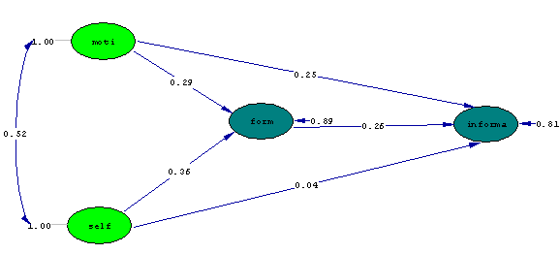

Chi-Square= 827.57, df= 344, P-value= 0.00000, RMSEA= 0.071

Fig. 4.6 Software output based on t coefficients

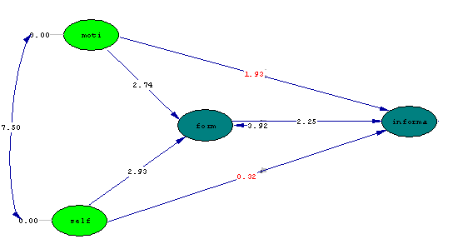

Chi-Square= 827.57, df= 344, P-value= 0.00000, RMSEA= 0.071

In the structural model, the significance of the path coefficient is determined using t (t- value). If t is between 1.96 and 2.57, the relationship between two structures is significant at level p <.05. If t value is greater than 2. 57, then the relationship is significant at the level of p <.01.

According to the data obtained in (Figs. 3-5 and Table 4-10), the most effect on job self-efficacy was on informal learning with a coefficient of 0.36 (t=2.93, ß=0.36), and then related to the effect learning motivation on formal learning with a coefficient of 0.29 (t= 2.74, ß= 0.29).

**4.6. Analysis of Hypotheses**

In the test of the above hypothesis, in general, according to the results obtained from the structural model (Figs. 3-5 and Table 4-9), we can say:

Hypothesis 1: There is a relationship between job self-efficacy and informal learning.

Based on the lack of significance of the path coefficient between job self-efficacy and informal learning with (T=0.32 ß= 0/04) at the level of <0.01 show that the hypothesis 1 (there is a relationship between job self-efficacy and informal learning) is not confirmed.

Hypothesis 2: There is a relationship between learning motivation and informal learning.

Based on the lack of significance of the path coefficient between learning motivation and informal learning with (T=1.93 ß= 0/25) at the level of <0.01 show that the hypothesis 2 (there is a relationship between learning motivation and informal learning) is not confirmed.

Hypothesis 3: There is a relationship between job self-efficacy and formal learning.

Based on the lack of significance of the path coefficient between job self-efficacy and formal learning with (T=2.93, ß= 0/36) at the level of <0.01 show that the hypothesis 3 (there is a relationship between job self-efficacy and formal learning) is confirmed.

The purpose of the present study was to identify the relationship between job self-efficacy and learning motivation with informal learning and the role of mediating formal learning among employees of the regional water company of Khorasan Razavi. The research method of this research is descriptive and correlational type and specifically based on structural equation modeling. The studied community includes all employees of regional water company of Khorasan Razavi, which according to the statistics received from the company in 2016, the number of employees were 400 people. A sample of 196 persons was considered based on the Morgan table by stratified random sampling method which based on sample numbers were specified for each section. Data were collected by standard questionnaire of Lohman (2005), self-efficacy of Muscle (2008), learning motivation of Tareno (2001), and formal learning of Jacobs (2009) as a measuring tool for standard data learning. The content validity and confirmatory factor analysis were used to assess the validity of the questionnaires and Cronbach's alpha test was used for reliability of questionnaires. The alpha coefficients for each informal learning questionnaire, job self-efficacy, learning motivation and formal learning were 0.65, 0.76, 0.76 and 0.86 respectively. SPSS16 and LISREL8.5 software were used to analyze the data. Job self-efficacy and learning motivation in this research are independent variables, informal learning is dependent variable, and formal learning are considered as mediating variables. Due to the fact that all questionnaires are measured on a 5-point Likert scale, the measurment scale is interval scale. This chapter will first refer to the results obtained from this research and then outline the research and applied suggestions and the limitations and strengths of the research.

**5.2. Expression of Findings and Research Results**

Hypothesis 1: There is a relationship between the job self-efficacy and informal learning of the employees of the regional water company of Khorasan Razavi.

Based on the lack of significance of the path coefficient between job self-efficacy and informal learning with (T=0.32 ß= 0/04) at the level of <0.01 show that the hypothesis 1 (there is a relationship between job self-efficacy and informal learning) is not confirmed. Therefore, it can be concluded that there is no direct and significant relationship between the self-efficacy and informal learning of the employees of regional water company of Khorasan Razavi, and this relationship is indirectly significant. Considering that research has not been done with such a hypothesis, this finding can be indirectly correlated with the results of the researches of Mirkamali and Hosseini (2008) and Jenser (2011), which believes that job self-efficacy plays an important role in enhancing the learning and efficiency of coaches working in the Turkish Coca-Cola Soccer League (Jenser, 2011), and this eficacy will be the exciting way to the informal learn. Therefore, job self-efficacy does not directly affect informal learning and with an mediating role, another variable affects it. Also, Mirkamali and Hosseini (2008) believe that managers with high self-efficacy may believe that they can have a positive effect on their learning and career success and may have an increased emphasis on academic learning and, accordingly, an informal learning was reinforced in them. Findings of this study are consistent with similar foreign investigations, including the research of Vujo Choi (2009), Lohman and Margaret (2009), Van Varkam, Nich Huff and Niodehiush (2002), Salaz, Canan Bowers (2001), Tanenbum, Matthew, Salaz and Conan Baver (1991); Machin and Forgthy (2003); Lohman (2005); Lohman (2006); Gagock (1982); Harish and Camero (1990); Livinston (2001); Maurer and Palmer (1999); Noeh and Wilek ); Berg, Shelly, and Shelly & Chyung (2008). Based on the above, it can be argued that job self-efficacy as a person's beliefs or judgments about his ability to perform the job duties and responsibilities indirectly involves informal learning, which includes the awareness activities of employees in the workplace is in communication, and as a result of which their professional knowledge and skills grow. One of the reasons why this hypothesis is not significant can be directly explained by the diversity of duties and responsibilities of employees of the regional water company of Khorasan Razavi in an organizational post and the presence of employees with unrelated posts in a work space. In other words, based on the results of many studies, employees who have high job self-efficacy are also inclined to the informal learn due to maintain the available status. In the regional water company of Khorasan Razavi, because employees can not easily exchange data and share knowledge informally with their colleagues, the desire for informal learning in them is minimized, شnd only if they deal with an important issue, they will learn this way.

Hypothesis 2: There is a relationship between the learning motivation and informal learning unformal learning of the regional water company of Khorasan Razavi.

Based on the lack of significance of the path coefficient between learning motivation and informal learning with (T=1.93 ß= 0/25) at the level of <0.01 show that the hypothesis 2 (there is a relationship between learning motivation and informal learning) is not confirmed. Therefore, it can be concluded that there is no direct and significant relationship between the learning motivation and informal learning of the employees of the regional water company of Khorasan Razavi. This finding was conducted in a similar research in 2012 by Frozeshniya and is consisent with its research results that the learning motivation variable does not direct relationship with the free (informal) learning of Iranian learners and have achieved roughly similar results. Also, with the study of Ashouri, Tale sanad and Bigdeli (2011), which there is no significant relationship between motivational strategies for learning and learning from peers (informal learning) in academic achievement, and this finding has been consistent with the researcher. However, the findings of this study are similar to internal and external investigations such as Bijani, Moradi and Karami (2011), Seyed Javadin (2002), Ghorbani, Hakim Zadeh and Gashmardi (2012), Bane (2006), Noeh and Smith (1986); Brady, Allen and War (1997), Noeh and Wilek (1993), Tareno (2001); Baldwin and Magjoka (1991); Kevin Van (1995); Klardi (2000); Sambruck (2005); Lohman (2002, 2006) are inconsistent and do not achieve the same results. According to the data obtained in this study, the learning motivation as a particular learner's desire for learning the content of a program (Noeh and Smith, 1986), which is the main cause of behavior (Gage and Berliner, 1984; Bradley, 1993), with informal learning which according to Elinger (2005), describes the learning of the natural opportunities occurring in work life, in which the learning control is in the hands of employees, has an indirect and significant relationship; that is, employees of the regional water company of Khorasan Razavi, as long as they have not sufficient motivation to learn the content of an educational program, learning does not really happen because need to learn in such content is not createdin them. So, if there was an motivation to learn, can hope to learn, while this learning is done by the individual and in an autonomous and informal manner, which requires the learning of a subject along with the structure and context necessary to eliminate it, while employees of regional water company of Khorasan Razavi for various reasons such as compactness of duties and responsibilities, insufficient attention of the organization to providing training courses and employee interest, diversity of expertise and responsibility in a work space, lack of rewards to active, committed and skilled employees who pay enough attention to informal learning, the presence of specialist employees in non-specialized positions, the relatively large displacement of employees in organizational posts with various specialized fields is some case that rejects the direct relationship between learning motivation and informal learning.

Hypothesis 3: There is a relationship between the job self-efficacy and formal learning of the employees of the regional water company of Khorasan Razavi.

Based on the lack of significance of the path coefficient between job self-efficacy and formal learning with (T=2.93, ß= 0/36) at the level of <0.01 show that the hypothesis 3 (there is a relationship between job self-efficacy and formal learning) is confirmed. The results of this study is confirmed by the findings of researchers such as Mirheidari et al. (2012), Marashian and Safarzadeh (2013); Kadivar, Tavousi and Yousefi (2010); Ashouri, Tale sanad and Bigdeli (2011); Eliot (1999). For example, the research hypothesis of Ashouri et al. (2011) showed that the variables of job self-efficacy, mental retardation, and excellence-objective orientation in a model could predict 37% of the progress variance in learning, and the share of job self-efficacy in predicting learning progress was more than other variables. Therefore, it can be concluded that there is a relationship between the self-efficacy of the employees of the regional water company of Khorasan Razavi and their formal learning. That is, the higher the level of self-efficacy of the employees of the regional water company, the greater the degree and willingness to the formal learn in the organization's employees. In other hand, the higher the employee's belief in their job ability, the more motivations and willingness to formal learning in the organization and more likely to result in a more favorable outcome. One of the most important reasons for such a relationship is that employees who believe that they can handle the assigned job tasks in a desirable manner always try to maintain themselves at a desirable level in terms of knowledge and practice. Given the rapid pace of technology and organizational change, this issue puts employees learning first priority.

**3. Conclusions**

Using the findings, it can be concluded that any increase in the level of self-efficacy with the increase in formal learning will be accompanied. Also any increase in formal learning will be accompanied by an increase in informal learning. Any increase in learning motivation will also be accompanied by an increase in formal learning. Job self-efficacy and learning motivation as (first and second independent variables) do not directly affect informal learning as an (dependent variable), but through the role of mediating of formal learning indirectly affect informal learning.

**5.4. Suggestions**

**5.4.1. Practical Suggestions**

Based on the results obtained from the analysis of the present research, the following suggestions are presented:

1. According to the findings of the first hypothesis that there is no direct relationship between job self-efficacy and informal learning of employees, but according to the findings of this research and previous studies, these two variables have an indirect relationship; the regional water company of Khorasan Razavi should have reinforced self-efficacy of its employees through appropriate employees displacements in specialized posts related to their academic and experimental background, and by providing in-service training courses, as well as creating opportunities for college education, upgraded employees' beliefs about their abilities so that autonomous employees to learn informally in the workplace should be encouraged.

2. According to the finding of the second hypothesis, there is no direct relation between the learning motivation and informal learning of employees, but according to the findings of this research and previous researches, these two variables have an indirect relationship; the regional water company of Khorasan Razavi should first of all absorb the required manpower tailored to the specialty and interests of the employee in order to create the motivation for learning and career progression in the employee. Then, with the needs assessment and survey of the relevant employee at the time of entering the organization and beyond, he was informed about the skills and expertise of the employee to meet his needs and obstacles in order to identify the necessary training programs to meet the needs and to improve job performance for the executive employees. In this way, the learning motivation was enhanced to improve informal learning in the organization. An example of this can be interaction with other colleagues in order to complete the learning process.

3. According to the findings of the third hypothesis, it can be stated that the perceptions that employees have about their ability to perform a task or responsibility under the title of self-efficacy are directly related to their willingness to learn and try to achieve their intended objectives, and it also results in persistence in difficult tasks. Therefore, the managers of the Regional Water Company of Khorasan Razavi can help them with their success rate by increasing their awareness of the success of their work and increasing their willingness to receive formal learning and training. One way to do this is to break down the tasks into smaller parts so that the employee can be easier to carry out the tasks assigned and to be encouraged to the formal learn more in performing more tasks.

**5.4.3. Research Limitations**

1- Due to the high volume of duties and the squeezing of responsibilities, the society population did not have enough time to fill the questionnaires. After explaining the research objectives and some emphasis, the employees was carefully involved in completing the questionnaire and, the possibility of bias in answering the questions of the questionnaire have been existed.

2. The statistical population of this research includes employees of Regional Water Company of Khorasan Razavi, therefore, it is necessary to observe cautious aspects in generalizing the results to employees of other organizations.

3. In the present study, only a questionnaire was used to collect the data, and methods such as interviewing and viewing may yield different results.

4. Due to the dissatisfaction of a large number of employees with the way that the company's formal learning and training programs are conducted, which in this study has a mediating role, it was also possible to influence the questions related to other variables.

5. The lack of belief and trust of some of the company's employees to the results of the research and to reduce the incentive to cooperate and participate in the research.

6. New variables of informal learning and lack of strong empirical evidence about the existence or non-existence of this variable's relationship with other variables of this research.  
7. Because of the new and neglected topic of research in internal research, it was much more time consuming to explain the scientific reasons for the relationship of variables to employees.

8. The lack of a translated version of Persian and a standard for measuring the variables of the research given that the Latin questionnaire was prepared for collective culture and the work culture in our country and our organizations is more individual.

9. Lack of control of all unwanted variables that might affect the results of the research.  
10. Due to high corporate missions, access to all employeeswas not possible.  
11. Despite the lack of names of questionnaires and the lack of receiving confidential data, respondents refused to provide some answers as well as age and work experience, leading to the removal of the questionnaire.