|  |  |  |
| --- | --- | --- |
| Consultant:  FekrAvaran Pars Jonub industrial group and company consultant | Report on the justification of working capital facilities  Phase one (rebar manufacturing)  Moderator: Atieh Khalij Fars Steel Complex |  |

Chapter Six

Human Resources

|  |  |  |
| --- | --- | --- |
| Consultant:  FekrAvaran Pars Jonub industrial group and company consultant | Report on the justification of working capital facilities  Phase one (rebar manufacturing)  Moderator: Atieh Khalij Fars Steel Complex |  |

Salary :

1. Production staff:

The staff costs and wages of the operational part are calculated as follows. Also, 90% is added as additional benefits to annual salary costs.

|  |  |  |  |
| --- | --- | --- | --- |
| Annual salary  (Million rials) | monthly salary  (Thousand rials) | Number |  |
| 2520 | 30000 | 7 | Technical expert |
| 5040 | 20000 | 21 | Expert |
| 7200 | 15000 | 40 | Technician |
| 14400 | 12000 | 100 | Skilled and semi-skilled worker |
| 29160 | - | 168 | Total |
| 26244 | Job benefits 90% | | |
| 55404 | Total | | |

1. Administrative staff:

Employees' salaries are calculated as follows. Also, 70% are added as additional benefits to annual salary

|  |  |  |  |
| --- | --- | --- | --- |
| Annual salary  (Million rials) | monthly salary  (Thousand rials) | Number | Post |
| 1200 | 100000 | 1 | Chief Executive officer |
| 1620 | 15000 | 9 | Administrative and Financial Officer |
| 2160 | 12000 | 15 | Service and Guardian |
| 720 | 12000 | 5 | Secretary |
| 5700 | - | 30 | Total |
| 3990 | Job benefits 70% | | |
| 9690 | Total | | |

|  |  |  |
| --- | --- | --- |
| Consultant:  FekrAvaran Pars Jonub industrial group and company consultant | Report on the justification of working capital facilities  Phase one (rebar manufacturing)  Moderator: Atieh Khalij Fars Steel Complex |  |

Chapter Seven

Investment costs

|  |  |  |
| --- | --- | --- |
| Consultant:  FekrAvaran Pars Jonub industrial group and company consultant | Report on the justification of working capital facilities  Phase one (rebar manufacturing)  Moderator: Atieh Khalij Fars Steel Complex |  |

Investment costs

All investment costs the design and forecast of working capital in the first year of operation of the project are estimated as follows:

(Million Rials)

|  |  |  |  |  |
| --- | --- | --- | --- | --- |
| Percent | Total | Need | Done | Description |
| 11 | 134400 | 0 | 134400 | Land |
| 5 | 66800 | 0 | 66800 | Land area |
| 30 | 361700 | 0 | 361700 | Building |
| 42 | 513000 | 0 | 513000 | Equipment |
| 11 | 139974 | 0 | 139974 | Installation |
| 0 | 2000 | 0 | 2000 | Tools |
| 0 | 0 | 0 | 0 | vehicles |
| 0 | 2000 | 0 | 2000 | Office furniture |
| 0 | 0 | 0 | 0 | Miscellaneous and unpredictable |
| 0 | 5800 | 1100 | 4700 | Before exploiting |
| 47 | 1225674 | 1100 | 1224574 | Total fixed costs |
| 53 | 1401880 | 1401880 | 0 | Working capital |
| 100 | 2627554 | 1402980 | 1224574 | Total cost of the plan |

|  |  |  |
| --- | --- | --- |
| Consultant:  FekrAvaran Pars Jonub industrial group and company consultant | Report on the justification of working capital facilities  Phase one (rebar manufacturing)  Moderator: Atieh Khalij Fars Steel Complex |  |

Details of project investment expenses

1- Land:

(Million Rials)

|  |  |  |  |  |  |  |
| --- | --- | --- | --- | --- | --- | --- |
| Lands plan | | | | | | |
| Total Physical Progress | Cost progress | Time progress | Total costs | Remaining costs | Costs incurred | Description |
| 100 | 100 | 100 | 134400 | 0 | -134400 | Ground The site of the project is located at 192000 square meters located 10 km from Ahvaz road, Imam Bandar-Industrial Town No. 5 in Ahwaz. This land has been awarded by Khuzestan Industrial Township by contract. The cost of land, including 700,000 Rials per square meter, has been purchased |

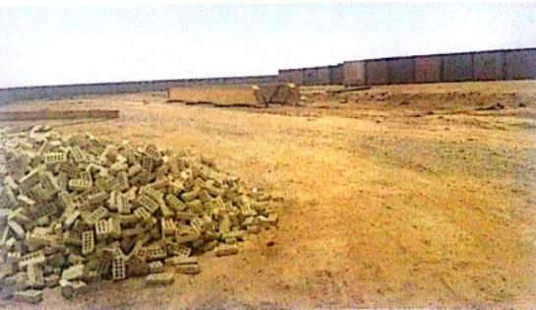

|  |  |  |
| --- | --- | --- |
| Consultant:  FekrAvaran Pars Jonub industrial group and company consultant | Report on the justification of working capital facilities  Phase one (rebar manufacturing)  Moderator: Atieh Khalij Fars Steel Complex |  |

2- Details of the cost of land areas (Million Rials)

|  |  |  |  |  |
| --- | --- | --- | --- | --- |
| Status of plan costs | | | Description | Row |
| Total | Needed to complete | Costs incurred |
| 6=(4+5) | (5) | (4) |
| 25000 | 0 | 25000 | Excavating, embanking and leveling up 6 hectares of land to 100,000 cubic meters | 1 |
| 6000 |  | 6000 | Fencing 4000 square meters |
| 500 | 0 | 500 | Steel entrance door with electric motor for opening and closing the door  To number one | 2 |
| 7000 | 0 | 7000 | Tabling and channeling 10,000 meters in length | 3 |
| 25000 | 0 | 25000 | Street and Asphalt first phase at a rate of 15,000 square meters | 4 |
| 1500 | 0 | 1500 | Parking with foundation, Concrete floor, Indoor hangar at a rate of 1000 square meters | 5 |
| 1000 | 0 | 1000 | First phase green space | 6 |
| 1800 | 0 | 800 | First phase lighting | 7 |
| 66800 | 0 | 66800 | Total | |

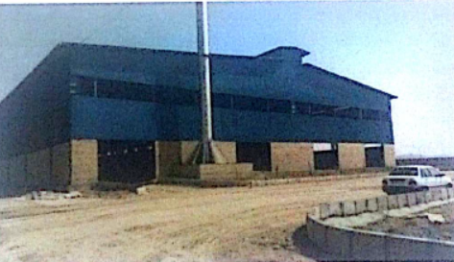

|  |  |  |
| --- | --- | --- |
| Consultant:  FekrAvaran Pars Jonub industrial group and company consultant | Report on the justification of working capital facilities  Phase one (rebar manufacturing)  Moderator: Atieh Khalij Fars Steel Complex |  |

3- Details of costs in the buildings section

(Million Rials)

|  |  |  |  |  |  |  |
| --- | --- | --- | --- | --- | --- | --- |
| Status of plan costs | | | | unit costs | Description of the buildings | Row |
| Total | Needed to complete | | Costs incurred |
| 6=(4+5) | (5) | | (4) |
| 145200 | 0 | 145200 | | 22000 | Buildings for the production of rebar with a total area of 6600 square meters Production niches 9 meters high to the columns and 11 meters to the corona with foundation and flooring and fencing | 1 |
| 176000 | 0 | 176000 | | 22000 | 8000 square meters of warehouses and 9 meters high to the columns and 11 meters to the corona with foundation and flooring and fencing | 2 |
| 24000 | 0 | 24000 | | 15000 | 1600 square meters of building facility with a height of 7 meters to the canopy | 3 |
| 9000 | 0 | 9000 | | 15000 | 600 square meters of office building and first phase services | 4 |
| 7500 | 0 | 7500 | | 15000 | 500 square meters of security buildings and electrical installations and other | 5 |
| 361700 | 0 | 361700 | | - | Total | |

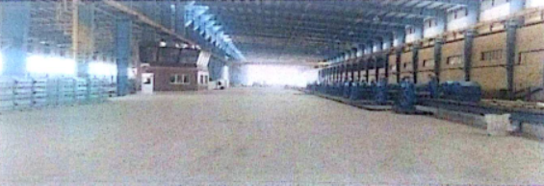

|  |  |  |
| --- | --- | --- |
| Consultant:  FekrAvaran Pars Jonub industrial group and company consultant | Report on the justification of working capital facilities  Phase one (rebar manufacturing)  Moderator: Atieh Khalij Fars Steel Complex |  |

4- A description of the details of the costs in the machine section:

|  |  |  |  |  |
| --- | --- | --- | --- | --- |
| Machine costs | | | Description |  |
| Total  (Million Rials) | Required to completed | costs incurred |
| (Million Rials) | (Million Rials) |
| 20000 | 0 | 20000 | Furnace 60 tons per hour | 1 |
| 90000 | 0 | 90000 | Preheater furnace | 2 |
| 70000 | 0 | 70000 | Three raffle racking racks 2000 kilowatts | 3 |
| 25000 | 0 | 25000 | Ruffing Rack 2 Roller | 4 |
| 5000 | 0 | 5000 | upside down cutting scissor after the group of two middle stand | 5 |
| 65000 | 0 | 65000 | Medium Group shelves 6 devices | 6 |
| 3000 | 0 | 3000 | upside down cutting scissor after the middle group | 7 |
| 80000 | 0 | 80000 | Ultimate Shelf 8 calibrated devices | 8 |
| 2000 | 0 | 2000 | Product transfer rollers to Thermex | 9 |
| 10000 | 0 | 10000 | Thermic Thermometer 13 Meter | 10 |
| 1000 | 0 | 1000 | Pony roll and channels between the trimmers and scissors | 11 |
| 6000 | 0 | 6000 | Pumps and auxiliary systems for shelves and thermex | 12 |
| 35000 | 0 | 35000 | Electric system and automation | 13 |
| 80000 | 0 | 80000 | Cooling bed | 14 |
| 5000 | 0 | 5000 | Butterfly scissors | 15 |
| 20000 | 0 | 20000 | Installation and Warranty | 16 |
| 513000 | 0 | 513000 | Total Equivalent Rials (million rials) | |

|  |  |  |
| --- | --- | --- |
| Consultant:  FekrAvaran Pars Jonub industrial group and company consultant | Report on the justification of working capital facilities  Phase one (rebar manufacturing)  Moderator: Atieh Khalij Fars Steel Complex |  |

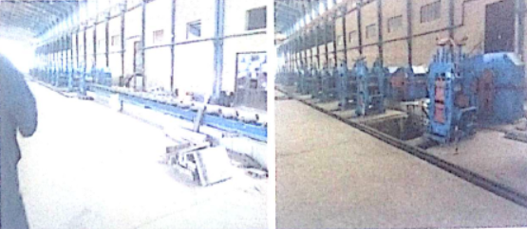

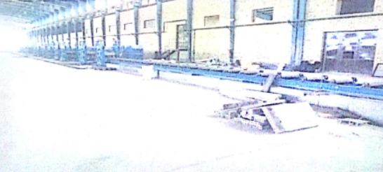

|  |  |  |
| --- | --- | --- |
| Consultant:  FekrAvaran Pars Jonub industrial group and company consultant | Report on the justification of working capital facilities  Phase one (rebar manufacturing)  Moderator: Atieh Khalij Fars Steel Complex |  |

5- Details of the costs of the facility:

|  |  |  |  |  |
| --- | --- | --- | --- | --- |
| Total  (million rials) | Cost needed  (million rials) | Accomplished Costs  (million rials) | Description | |
| 4584 | 0 | 4584 | Power branch costs | The cost of electricity |
| 55000 | 0 | 55000 | The cost of ground-based post-electricity substations for 6800 kwh The first phase of the production of rebar(Cable, Fuse, Trans and Installation) |
| 25000 | 0 | 25000 | The cost of the boards and high voltage cable and The average distribution is in the set section and Distribution Room in Machine Parts |
| 10000 | 0 | 10000 | The cost of 4 generators |
| 2890 | 0 | 2890 | Cost of water split and Install the meter | The cost of  Irrigation |
| 10000 | 0 | 10000 | Water plumbing cost and pumps and installation |
| 3000 | 0 | 3000 | Water reservoir 50000 liters |
| 2000 | 0 | 2000 | Internet and connections and closed-circuit television camera | |
| 6500 | 0 | 6500 | Announcement system and fire extinguishing | |
| 3000 | 0 | 3000 | Heating and cooling system | |
| 2000 | 0 | 2000 | Branching | Gas Supply Cost |
| 5000 | 0 | 5000 | Tanks and stations |
| 4000 | 0 | 4000 | piping |
| 900 | 0 | 900 | 60 ton Weighbridge | |
| 5000 | 0 | 500 | 20 and 10 ton crane with installation | |
| 300 | 0 | 300 | 20000 liter fuel tank | |
| 800 | 0 | 800 | Telecommunication costs and internet and other | |
| 139974 | 0 | 139974 | Total | |

|  |  |  |
| --- | --- | --- |
| Consultant:  FekrAvaran Pars Jonub industrial group and company consultant | Report on the justification of working capital facilities  Phase one (rebar manufacturing)  Moderator: Atieh Khalij Fars Steel Complex |  |

6- Estimated cost of tools:

|  |  |  |  |
| --- | --- | --- | --- |
| Total  (million rials) | Cost needed  (million rials) | Accomplished Costs  (million rials) | Description |
| 1000 | 0 | 1000 | The cost of the equipment and Workshop Tools |
| 1000 | 0 | 1000 | The cost of a series of equipment and Safety clothing |
| 2000 | 0 | 2000 | Total |

7- Estimated cost of vehicles:

|  |  |  |  |
| --- | --- | --- | --- |
| Total  (million rials) | Cost needed  (million rials) | Accomplished Costs  (million rials) | Description |
| 0 | 0 | 0 | Vehicles are needed but not seen in this report |
| 0 | 0 | 0 | Total |

8- Estimated cost of office furniture:

|  |  |  |  |
| --- | --- | --- | --- |
| Total  (million rials) | Cost needed  (million rials) | Accomplished Costs  (million rials) | Description |
| 2000 | 0 | 2000 | The cost of a variety of office and welfare facilities |
| 2000 | 0 | 2000 | Total |

Unforeseen costs:

Approximately - percent of the fixed costs required for the project are considered as miscellaneous and unforeseen costs of 0 million rials.

|  |  |  |
| --- | --- | --- |
| Consultant:  FekrAvaran Pars Jonub industrial group and company consultant | Report on the justification of working capital facilities  Phase one (rebar manufacturing)  Moderator: Atieh Khalij Fars Steel Complex |  |

Cost before operation:

(Million Rials)

|  |  |  |  |
| --- | --- | --- | --- |
| Total | Required | Accomplished | Cost items |
| 1100 | 500 | 600 | Expert cost and project evaluation |
| 1500 | 0 | 1500 | The cost of obtaining a license and Map and miscellaneous |
| 1200 | 600 | 600 | The cost of the insurance office and bills |
| 2000 | 0 | 2000 | Trial setup cost |
| 5800 | 1100 | 4700 | Total costs before the operation |